MAPPING OF HUMAN BRAIN FOR RECOGNITION OF MENTAL STATE OF PATIENT

Electrode positions:

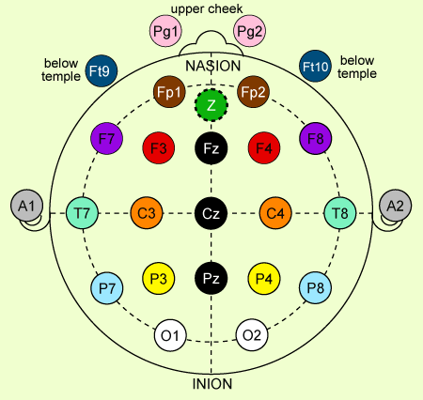

Circuit diagram:

