LAB1: DAD
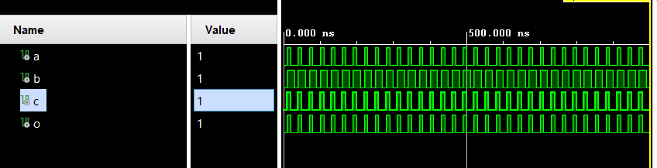
With 5 inputs
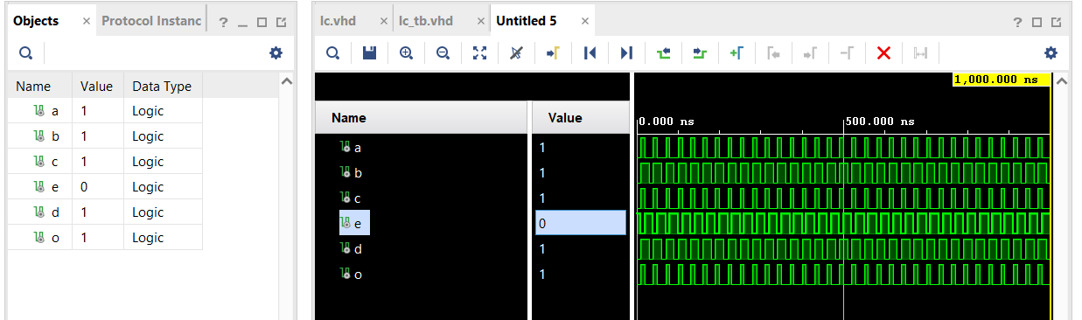
library ieee;
use ieee.std_logic_1164.all;

-- define entity
entity myLogicFunction_tb is
end entity;

architecture ben of myLogicFunction_tb is
-- define component
component myLogicFunction is port(
a,b,c,d,e : in std_logic;
o : out std_logic);
end component;
-- These are the internal wires
signal a,b,c,e,d,o : std_logic;
constant N: natural:=5;
begin
-- uut is the instance name
uut : myLogicFunction port map(a => a, b => b, c => c,d =>d, e=>e, o => o);
stim : process
begin
a <= '0'; b <= '0'; c <= '0'; d<='0'; e<='1';
wait for 10 ns;
assert ((o = '0'))
report "test failed for input combination 000" severity error;
a <= '1'; b <= '1'; c <= '1'; d<='1'; e<='0';
wait for 10 ns;
assert ((o = '1'))
report "test failed for input combination 111" severity error;
a <= '0'; b <= '1'; c <= '0'; d<='1'; e<='1';
wait for 10 ns;
assert ((o = '0'))
report "test failed for input combination 010" severity error;
end process;
end ben;

library ieee;
use ieee.std_logic_1164.all;

entity myLogicFunction is port (
a : in std_logic;
b : in std_logic;
c : in std_logic;
d :in std_logic;
e :in std_logic;
o : out std_logic
); end myLogicFunction;

architecture arch of myLogicFunction is
begin
o <= (a and b and c) and (d or e);
end arch;

task2: 5 inputs
library ieee;
use ieee.std_logic_1164.all;
use ieee.numeric_std.all;

-- define entity
entity myLogicFunction_tb is
end entity;

architecture ben of myLogicFunction_tb is
-- define component
component myLogicFunction is port(
a,b,c,d,e : in std_logic;
o : out std_logic);
end component;
-- These are the internal wires

signal a,b,c,e,d,o : std_logic;
constant N: natural:=5;

begin
-- uut is the instance name
uut : myLogicFunction port map(a => a, b => b, c => c,d =>d, e=>e, o => o);
stim : process
variable vec : unsigned(N-1 downto 0);
begin
for i in 0 to 2**N - 1 loop
vec := to_unsigned(i,N);
a <= vec(0);
b <= vec(1);
c <= vec(2);
d <= vec(3);
e <= vec(4);
wait for 10ns;
end loop;
wait;
end process;
end ben;
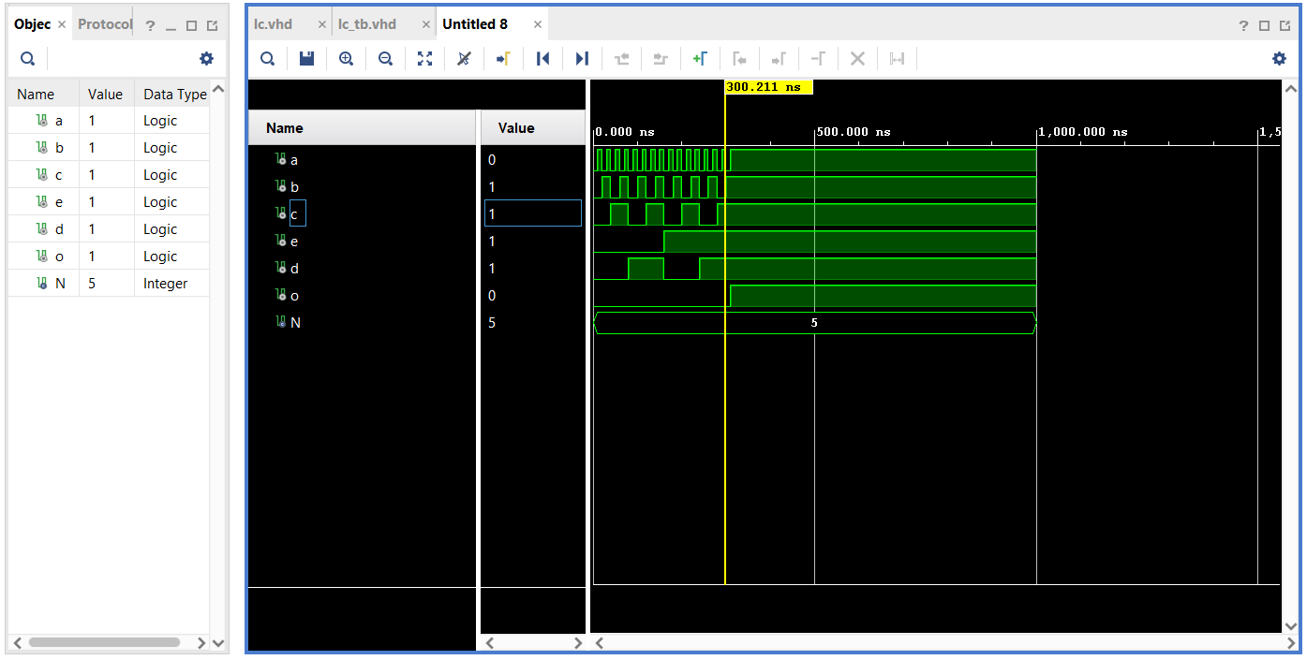

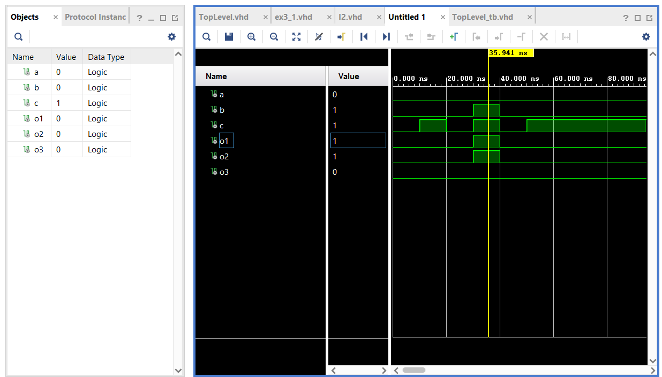
library IEEE;
use IEEE.STD_LOGIC_1164.ALL;

entity TopLevel is port (
a: in std_logic;
b: in std_logic;
c: in std_logic;
o1: out std_logic;
o2: out std_logic;
o3: out std_logic
); end TopLevel;

architecture Bh3 of TopLevel is
signal t1, t2, t3: std_logic;

begin
m1: entity work.I1 port map(a=> a, b => b, c=>c, o1=>t1, o2=>t2, o3=>t3);
m2: entity work.I2 port map(a=>t1, b=>t2, c=>t3, o1=>o1, o2=>o2, o3=>o3);

end Bh3;

library ieee;
use ieee.std_logic_1164.all;

entity TopLevel_tb is
end entity;

architecture Behavioral of TopLevel_tb is
signal a, b, c : std_logic := '0';
signal o1, o2, o3 : std_logic;
begin

-- Direct entity instantiation (simplest & correct)
uut1 : entity work.TopLevel
port map (
a => a,
b => b,
c => c,
o1 => o1,
o2 => o2,
o3 => o3
);

stim : process
begin
a <= '0'; b <= '0'; c <= '0';
wait for 10 ns;

a <= '0'; b <= '0'; c <= '1';
wait for 10 ns;

a <= '0'; b <= '0'; c <= '0';
wait for 10 ns;

a <= '0'; b <= '1'; c <= '1';
wait for 10 ns;

a <= '0'; b <= '0'; c <= '0';
wait for 10 ns;

a <= '0'; b <= '0'; c <= '1';
wait for 10 ns;

wait; -- stop simulation
end process;

end architecture Behavioral;

