Hydraulic and Hydrologic Modelling Tool HHMT

User’s Manual



March 2017

UNESCO-IHE

Institute of Water Education

Water Science & Engineering

[Hydroinformatics department](https://www.unesco-ihe.org/msc-programmes/specialization/hydroinformatics-modelling-and-information-systems-water-management-2)

**Module 5: Modelling Systems Development**

**Mostafa Farrag**

**No: 53699**

**Locker No:31**

Contents

1. Introduction 4

2. Programme Specifications 4

3. Working with HHMT- An overview 4

4. Starting HHMT 4

5. Back water curve 6

5.1. Assumptions 6

5.2. BWC interface 6

5.3. Methodology of the code 6

5.4. Step-by-Step Procedure 9

5.4.1. Input data 9

5.4.2. Calculation Approach 9

5.4.3. Results 10

5.4.4. Sliders 10

5.4.5. Optional buttons 11

6. HBV 12

6.1. Assumptions 12

6.2. HBV interface 13

6.3. Methodology of the code 13

6.4. Step-by-Step Procedure 16

6.4.1. Input data 16

6.4.2. Results 17

6.4.3. Sliders 17

6.4.4. Tank Simulation 18

6.4.5. Monte Carlo Simulation 18

6.4.6. Optional buttons 19

7. Free Surface Flow Simulation (FSF) 20

7.1. Assumptions 20

7.2. FSF interface 20

7.3. Methodology of the code 21

7.4. Step-by-Step Procedure 24

7.4.1. Input data 24

7.4.2. Results 25

7.4.3. Optional buttons 25

figure 4.1 main window interface 4

Figure 5.1 interface of the BWC 6

Figure 5.2 flow chart of the methodology of calculation & validation 7

Figure 5.3 flow chart of the methodology of calculation & validation 8

Figure 5.4 input data 9

Figure 5.5 input data file 9

Figure 5.6 calculation approach 10

Figure 5.8 results 10

Figure 5.9 optional buttons 11

Figure 6.1 interface of the HBV 13

Figure 6.2 Structure of buttons in the GUI 14

Figure 6.3 Procedures of calculate, sliders, Monte Carlo & Tank simulation buttons 14

Figure 6.4 procedures of Run calibration 15

Figure 6.5 procedures of Run calibration & save parameters buttons 16

Figure 6.6 input data 16

Figure 6.7 input data file 17

Figure 6.8 Results 17

Figure 6.9 Tank Simulation 18

Figure 6.10 Tank Simulation 18

Figure 7.1 interface of the FSF 20

Figure 7.2 Structure of buttons in the GUI 21

Figure 7.3 procedures of Run button 23

Figure 7.4 input data 24

Figure 7.5 input data file 25

Figure 7.6 optional buttons 25

Figure 7.7 Saved file from save parameters button 25

# Introduction

The objective of this software tool is to develop a modelling system that can solve several hydrological problems and set up certain kinds of conceptual and physical-based models. The modelling system consists of three part, Backwater Curve Calculator, HBV Modeller and Free Surface Flow Simulator. Each of the system allows you to input parameters and obtain the results of the model in the form of plots as well as tables. It also allows you to save the results in files.

# Programme Specifications

This software tool was coded in the Matlab programming language using Matlab version 2016, this code may be incompatible with older or newer versions of Matlab

# Working with HHMT- An overview

HHMT is an integrated package of hydraulic and hydrologic analysis tools, in which the user interacts with the system through the use of a graphical user interface (GUI). The system is capable of performing steady and unsteady flow water surface profile calculation and several hydraulic computations

# Starting HHMT

When you first start the HHMT, you will see the main window as shown in figure 4.1

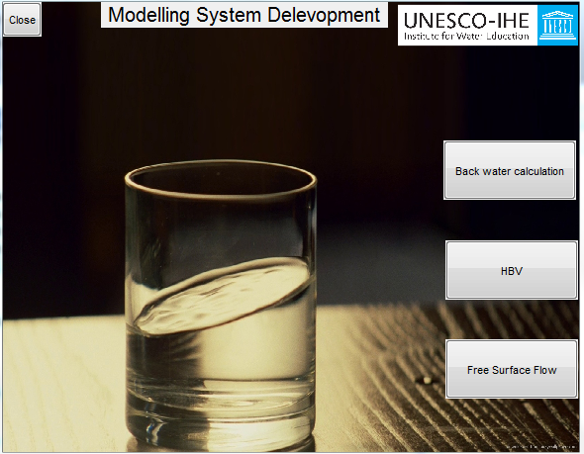

#### **figure 4.1 main window interface**

**figure 4.1 HHMT Main window**

at the left of the HHMT main window user will find the tools included in the package

1. Back water curve
2. Hydrologic modelling calculation
3. Free surface flow calculation
4. Help
5. Developer

# Back water curve

The backwater curve tool has been coded to calculate the water depth along a channel knowing the water depth at the downstream end of the channel and the characteristics of the channel

Such that length, slope, width, chezy coefficient, discharge

And the results will be presented on a graph showing the water level, ground level, along the length of the channel also these data will be presented in a table

## Assumptions

The modelled channel was assumed to be rectangular, the flow is steady, low velocities all of these assumptions was assumed to simplify the numerical calculation.

## BWC interface

The following figure represents the interface of the BWC, to the left of the window user will find all the channel properties with predefined values

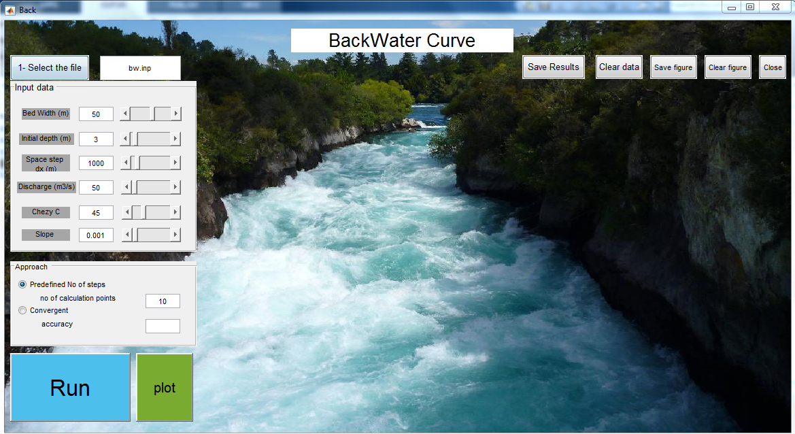

#### **Figure 5.1 interface of the BWC**

## Methodology of the code

The code has been designed in a way that every button will validate all the data that will be included in the calculation process inside such that if the user pressed plot before running the calculation process then the code will send an error message

Here is a flow chart of the methodology of calculation & validation for all the buttons in the GUI

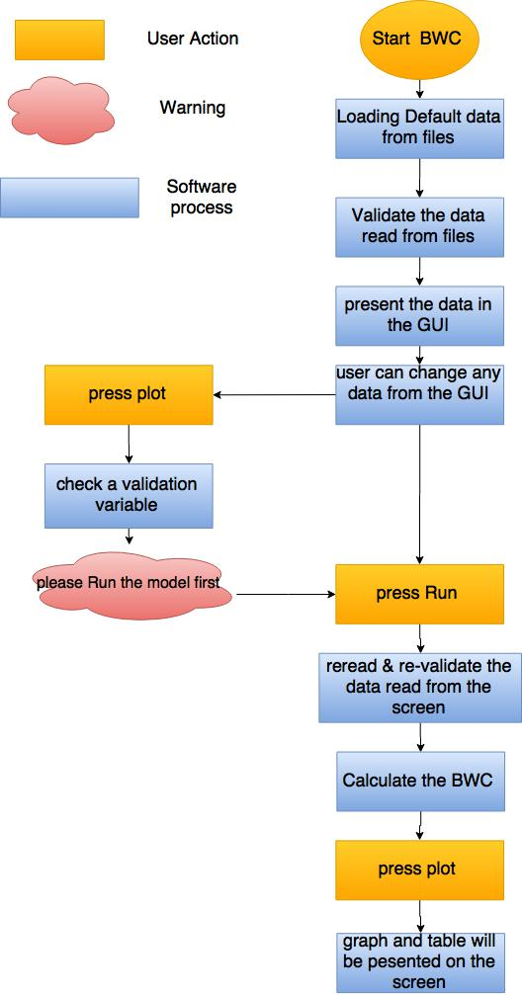

#### Figure 5.2 flow chart of the methodology of calculation & validation

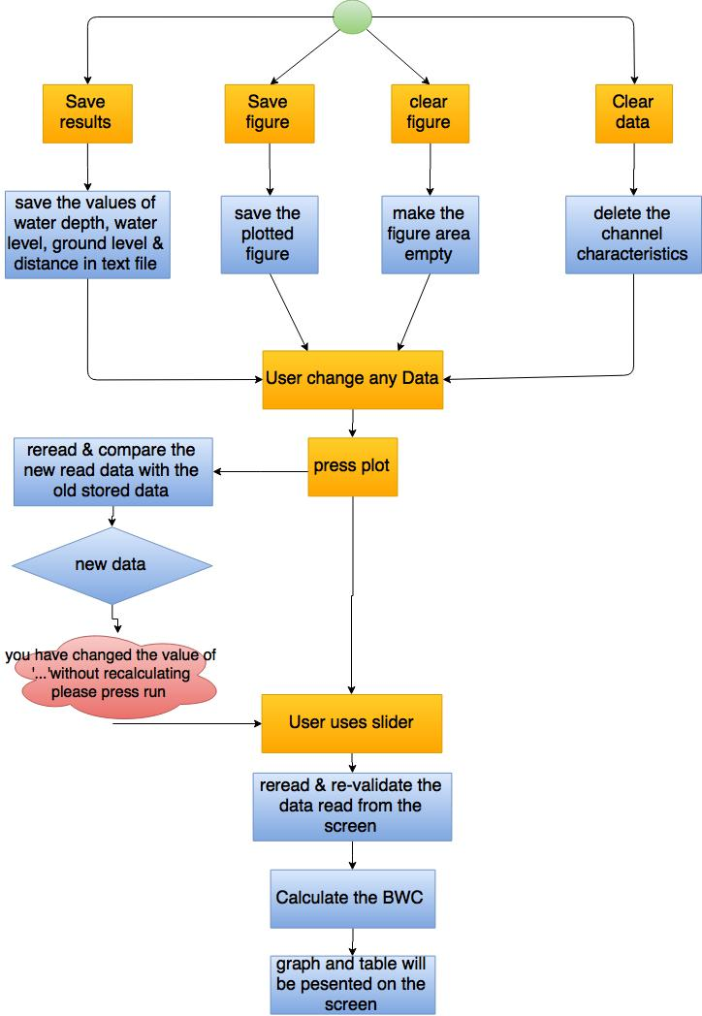

#### Figure 5.3 flow chart of the methodology of calculation & validation

## Step-by-Step Procedure

Whoever if the user has tried to use the interface without knowing the procedure the messages from the program will be a guide to get a result but it in this section the logical procedure of using the BWC interface will be listed

### Input data

As mentioned before the interface is usually opened with default values that are read from attached text file

If the user wants to read the data from a file data should be stored in a text file in the same arrange and style as shown below in figure 5.5

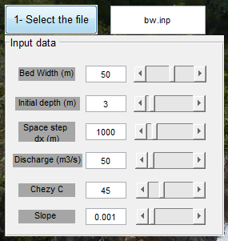

#### Figure 5.4 input data

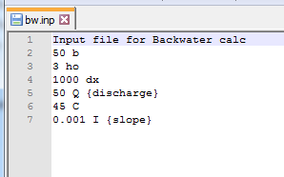

#### Figure 5.5 input data file

### Calculation Approach

User should choose a calculation approach either to calculate the water level for a specific number of points or run the calculation till the water depth becomes equal to the normal depth

The numerical method used in both approaches to calculate the water depth at every point is the implicit method (with accuracy 10-5) more information about the numerical method Can be found in the following [link](https://drive.google.com/file/d/0B4ixdLAkFQgHQ3RHLS01Zjd1T0k/view?usp=sharing)

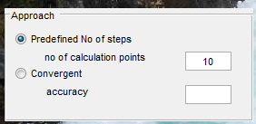

#### Figure 5.6 calculation approach

### Results

User should press on run then plot, then Results will be presented on a form of table and figure

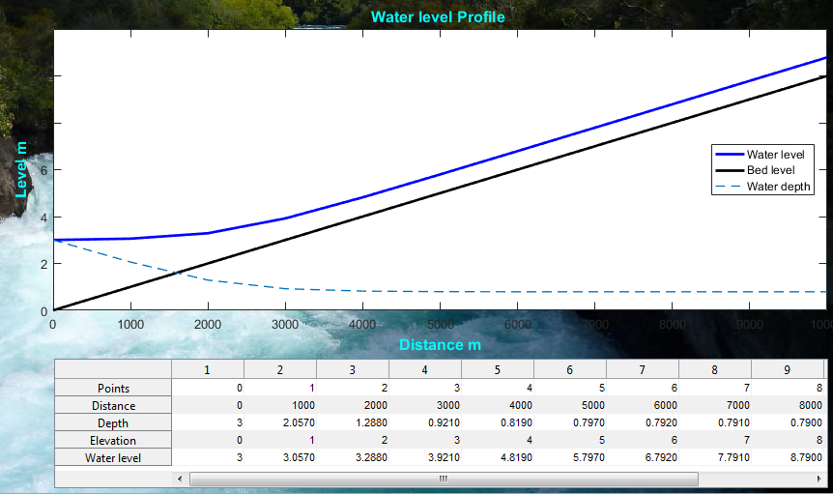

### Figure 5.8 results

### Sliders

sliders buttons are included in the interface to enable the user from assessing the sensitivity of the calculation to each parameter

also, slider buttons work as independent calculator that will read all the parameters from the screen and validate all the data and print the results

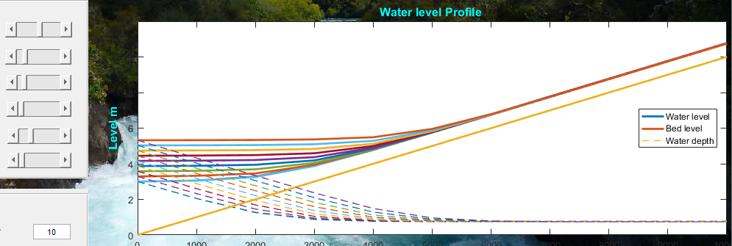Figure 5.8 Sliders

### Optional buttons

User can save figures or results also can clear the panel of data or the figure area from the plots



#### Figure 5.9 optional buttons

# HBV

* The HBV tool has been coded to run and evaluate the hydrologic process in the catchment using the observed values of precipitations, Evapotranspiration, temperature and run off Recalculating any of the observed variables using the catchment parameters enable us to use these data to calibrate the parameters and also to measure the uncertainty in each parameter
* The catchments used are described with 18 parameters to describe the water process during the whole water cycle
* HBV model takes into account the catchment area & the time basis of the observed data either it is in hourly basis or in daily basis
* HBV model includes Calibration process, validation, Monte Carlo, and Tank simulation process
* Accuracy of the calibration process is assessed based on three types of errors

1. Nash-Sutcliffe Efficiency (NSE)

NSE = 1 means that the modelled data perfectly matches the measured data. A NSE = 0 means that the modelled data is as accurate as the mean of the observed data. An NSE < 0 means that the observed mean is a better predictor than the modelled data. The user should try and maximize the NSE through parameter calibration, either manually or using the automatic calibration.

1. The Root Mean Squared Error (RMSE)

It measures model performance. RMSE is a measure of difference between the measured and simulated discharge values. The units RMSE are in the units of measure for discharge. The ideal calibrated value of RMSE is 0.

1. Percent Bias (PBIAS)

It measures the tendency of the modelled values to be larger or smaller than the measured values. The ideal calibrated value of PBIAS is 0.

1. The RMSE-observation standard deviation ratio (RSR)

The ideal calibrated value of RSR is 0.

## Assumptions

* all parameters and variables represent average values over the entire catchment
* the equations are semi empirical, but still with a physical basis
* model parameters cannot usually be assessed from field data alone, but have to be obtained through the help of calibration.

## HBV interface

The following figure represents the interface of the HBV, to the left of the window user will find all the catchment properties with predefined values and in the bottom at the left

The calibration parameters (calibration equation, percentage of the data used in the calibration process & and number of iterations)

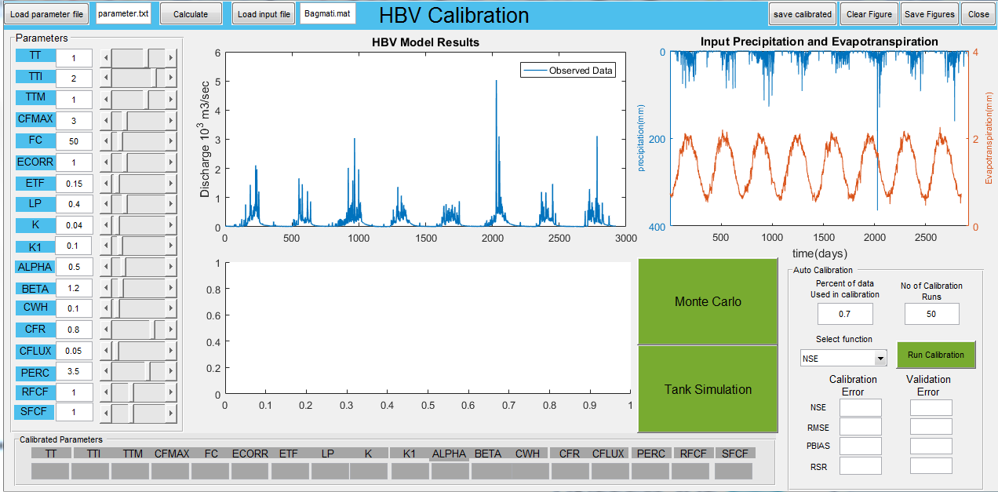

#### **Figure 6.1 interface of the HBV**

## Methodology of the code

The code has been designed in a way that every button will validate all the data that will be included in the calculation process inside, such that if the user pressed plot before running the calculation process then the code will send an error message

Here is a flow chart of the methodology of calculation & validation for all the buttons in the GUI

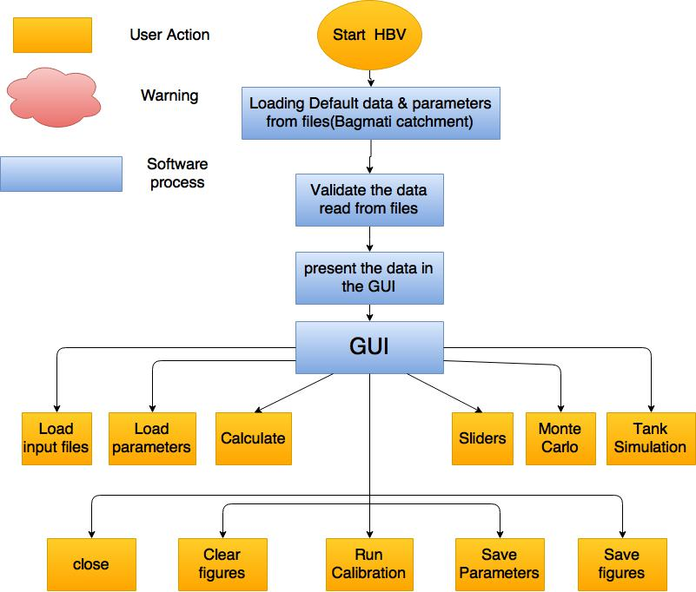

#### Figure 6.2 Structure of buttons in the GUI

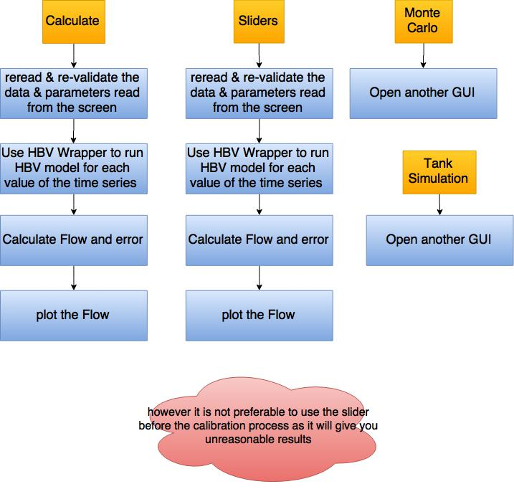

#### Figure 6.3 Procedures of calculate, sliders, Monte Carlo & Tank simulation buttons

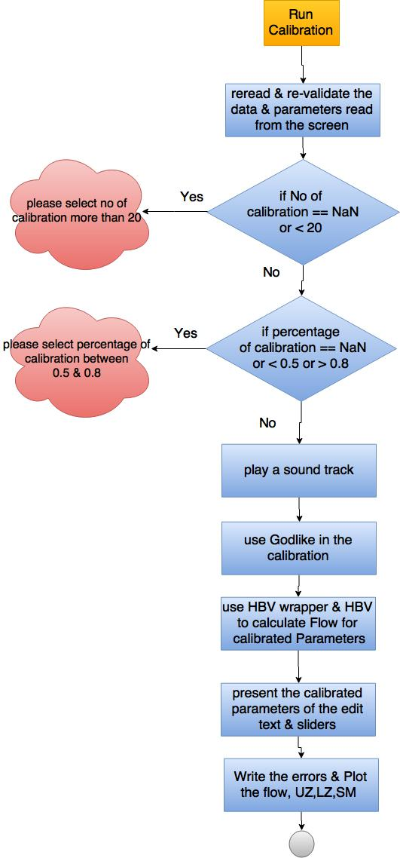

#### Figure 6.4 procedures of Run calibration

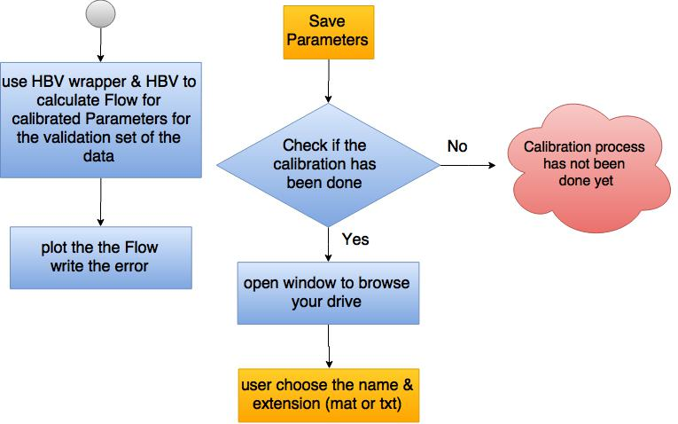

#### Figure 6.5 procedures of Run calibration & save parameters buttons

## Step-by-Step Procedure

### Input data

As mentioned before the interface is usually opened with default values that are read from attached text file

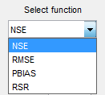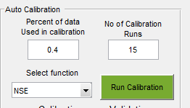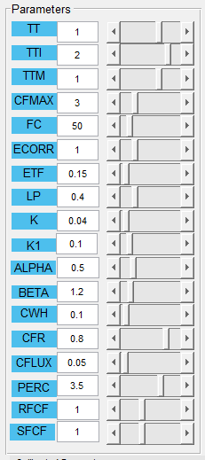

#### Figure 6.6 input data

If the user wants to read the data from a file data should be stored in a text file in the same arrange and style as shown below in figure 6.5

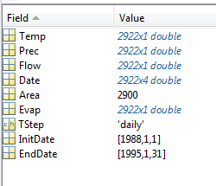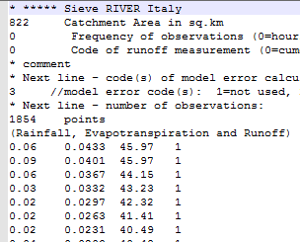

#### Figure 6.7 input data file

### Results

User should press on run calibration, then Results will be presented on the figure

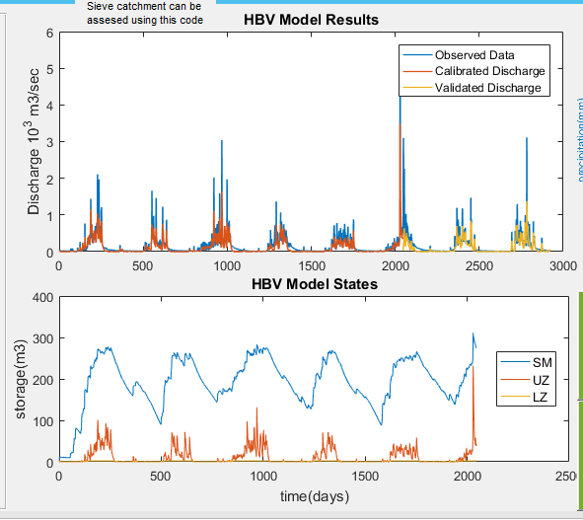

#### Figure 6.8 Results

### Sliders

sliders buttons are included in the interface to enable the user to use manual calibration of the parameter

also, slider buttons work as independent calculator that will read all the parameters from the screen and validate all the data and print the results

### Tank Simulation

Using the tank simulation user will be able to visualise and interpret the results got from the calibration process and would also be able to change them according to the physical understanding of the catchment properties as the percolation parameters results from the calibration process might be to high which will lead to ground water recharge with low values of surface runoff

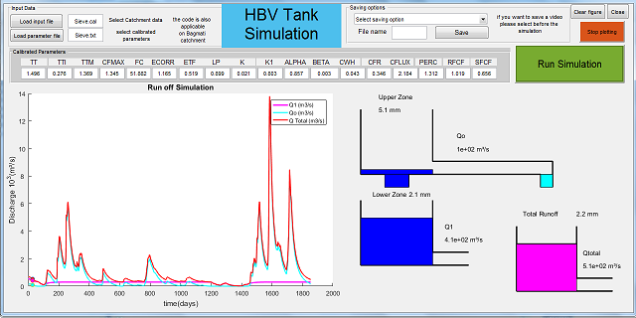

#### Figure 6.9 Tank Simulation

### Monte Carlo Simulation

Using monte Carlo simulation user would be able to determine who much the certainty in the results at high or low flow values

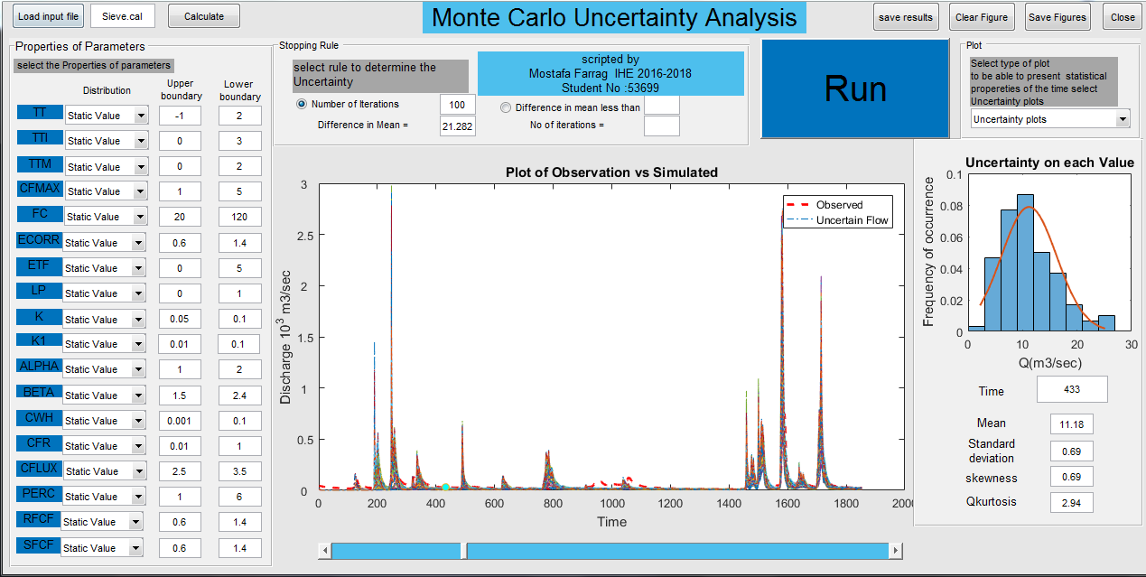

#### Figure 6.10 Tank Simulation

### Optional buttons

User can save figures or results also can clear the panel of data or the figure area from the plots

It worthy to mention that in order to be able to use the Tank simulation user should use the calibrated parameters saved from this model also user can input all the parameters manually from the screen



*Figure 6.11 optional buttons*

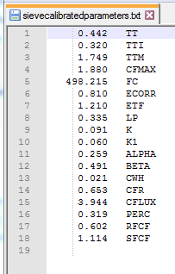

*Figure 6.12 Saved file from save parameters button*

# Free Surface Flow Simulation (FSF)

The Free Surface Flow (FSF) uses Preissmann numerical scheme to solve one-dimensional Saint Venant equations for continuity and momentum.

This code could be used to simulate the steady and unsteady free surface flow in channel

## Assumptions

The assumptions adopted in the numerical method (Preissmann scheme) has the same assumption of 1D Venant equations

* Water surface is horizontal across any section perpendicular to the longitudinal axis.
* Flow is gradually varied with hydrostatic pressure prevailing at all points in the flow.
* Longitudinal axis of the channel can be approximated by a straight line.
* Bottom slope of the channel is small, i.e., tan h = sin h. (h =10 yields 1.5% variation).
* Bed of the channel is fixed, i.e., no scouring or deposition is assumed to occur.
* Resistance coefficient for steady uniform turbulent flow is considered applicable and an empirical resistance equation such as the Manning equation describes the resistance effect.
* Flow is incompressible and homogeneous in density

## FSF interface

The following figure represents the interface of the FSF, to the left of the window user will find all the channel properties, the numerical parameters & test cases with predefined values

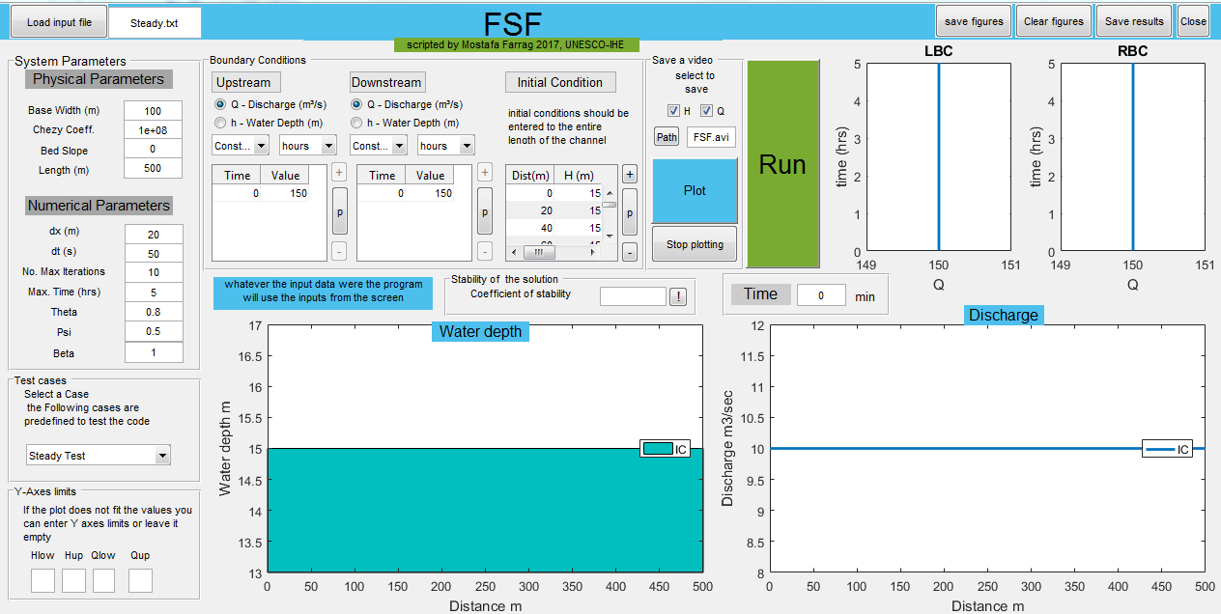

#### **Figure 7.1 interface of the FSF**

## Methodology of the code

The code has been designed in a way that every button will validate all the data that will be included in the calculation process inside, such that if the user pressed plot before running the calculation process then the code will send an error message

Here is a flow chart of the methodology of calculation & validation for all the buttons in the GUI

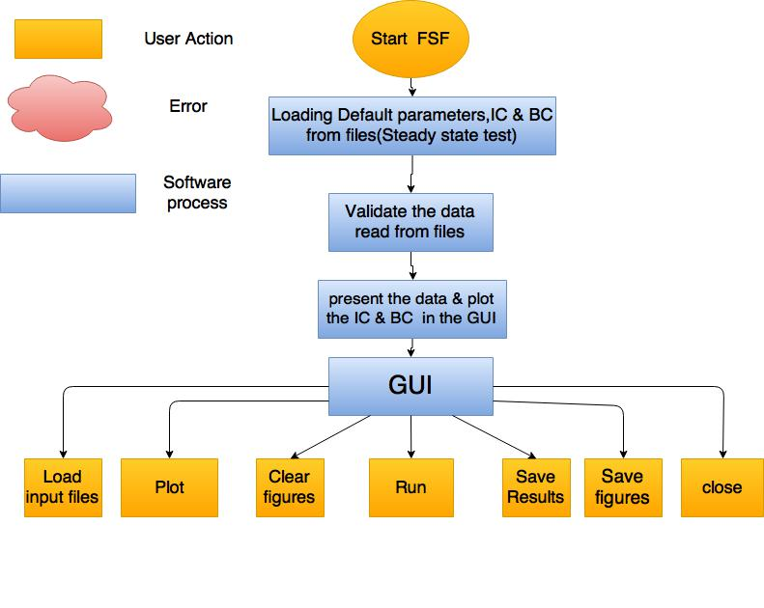

#### Figure 7.2 Structure of buttons in the GUI

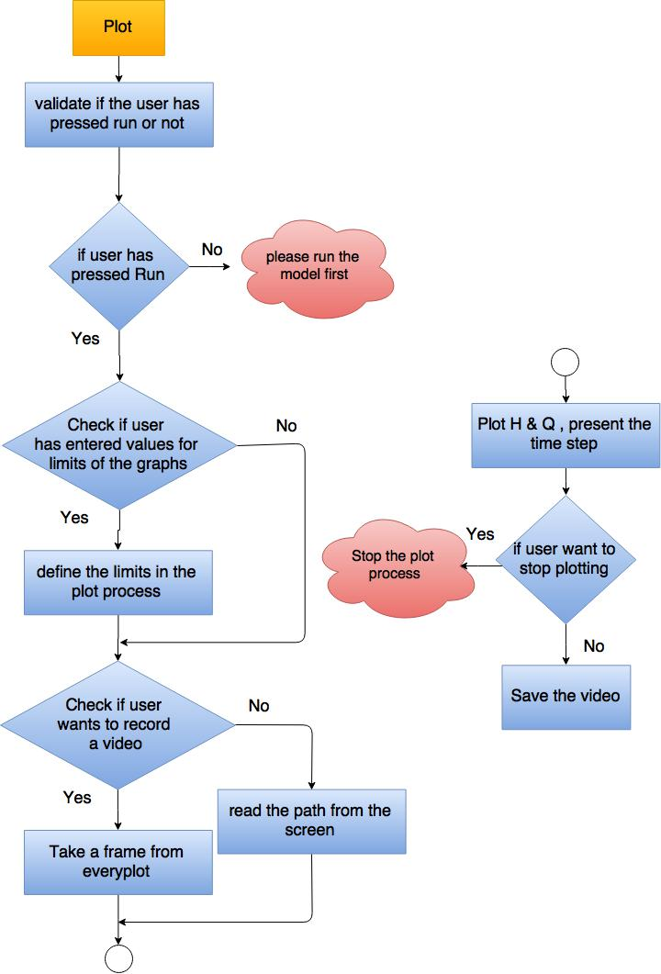Figure 7.3 procedures of plot button

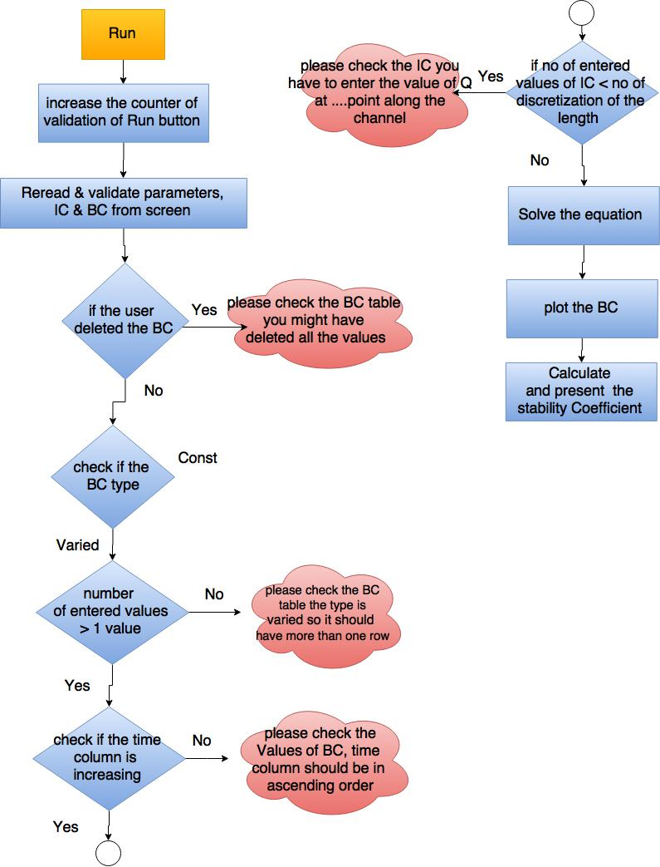

Figure 7.3 procedures of Run button

## Step-by-Step Procedure

### Input data

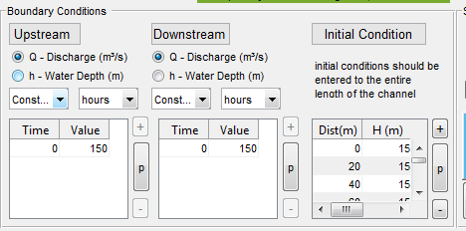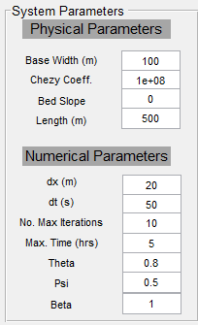As mentioned before the interface is usually opened with default values that are read from attached text file

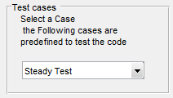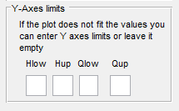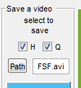

#### Figure 7.4 input data

If the user wants to read the data from a file data should be stored in a text file in the same arrange and style as shown below in figure 7.5

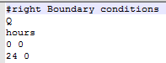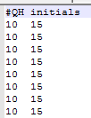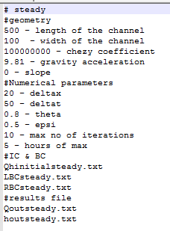

#### Figure 7.5 input data file

### Results

User should press on run, then press plot will be presented on the figure

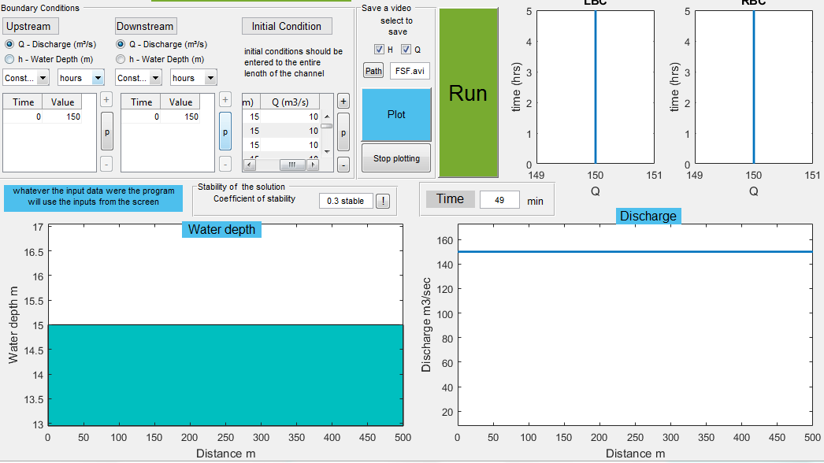

### Optional buttons

User can save figures or results also can clear the panel of data or the figure area from the plots



#### Figure 7.6 optional buttons

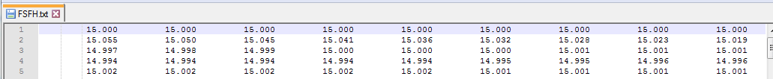

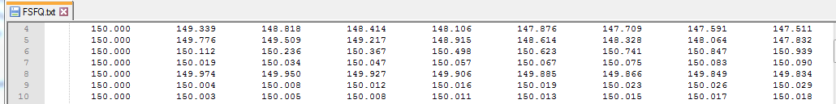

#### Figure 7.7 Saved file from save parameters button