Results

Experimental Native SVG Cutoff and ROC Explorer (Python)
Experimental comparison with the existing dotplot. Use independent rows and validate selected cutoffs in separate data. Browser snapshots are not saved analysis options.
Native applied rule: Measurement >= 2.0; reference positive: Positive. Complete rows: 6; excluded: 0. Native tables and static images use saved jamovi options. The SVG previews Python-computed threshold states locally. Apply updates only its local snapshot label. Export captures the displayed SVG. Edit native options to persist an analysis rule; reopening interactive content starts from saved options.
Native SVG Cutoff Explorer
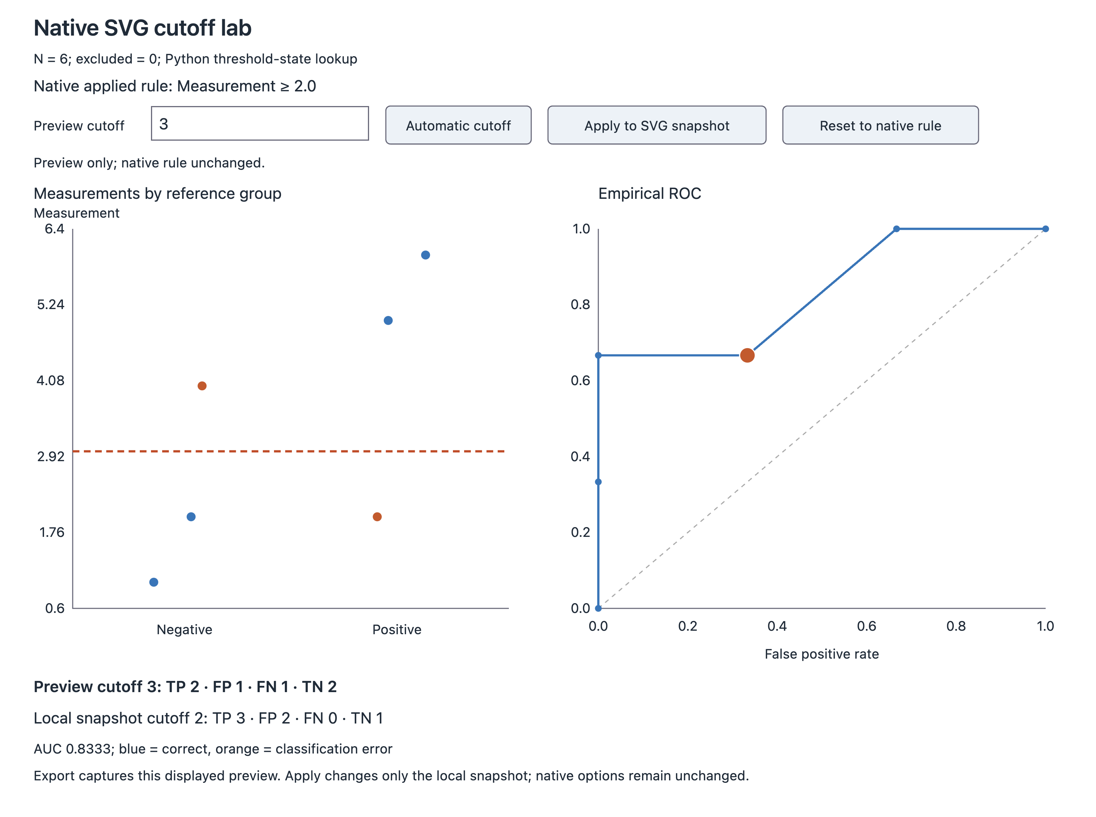
Applied Cutoff Classification
Classification | Count
True positive | 3
False positive | 2
False negative | 0
True negative | 1

Applied Cutoff Accuracy
Metric | Estimate | CI Lower | CI Upper
Sensitivity | 100.0 % | 29.2 % | 100.0 %
Specificity | 33.3 % | 0.8 % | 90.6 %
PPV | 60.0 % | 14.7 % | 94.7 %
NPV | 100.0 % | 2.5 % | 100.0 %
Accuracy | 66.7 % | 22.3 % | 95.7 %
Note. 95% exact intervals assume independent observations and a fixed cutoff; selection uncertainty is excluded. PPV, NPV and accuracy reflect this sample's group proportions. Undefined proportions are blank.

Applied Cutoff Dotplot
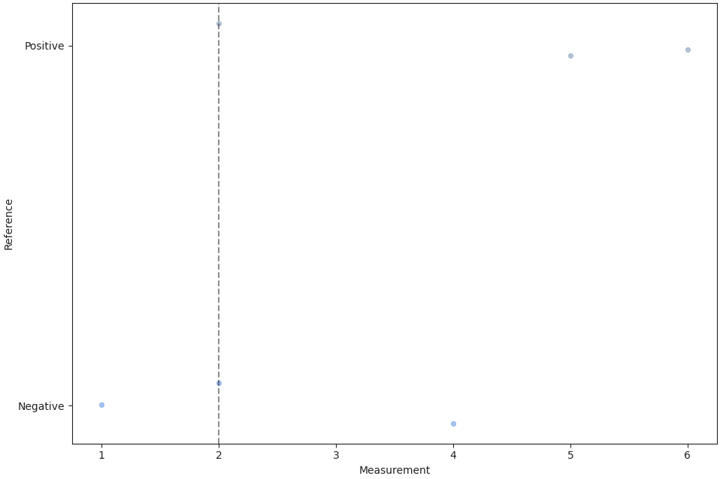
Applied ROC Summary
Metric | Value
Empirical AUC | 0.833
Youden index | 0.333
Applied cutoff | 2.000
Weighted error cost | 2.000
Complete rows | 6.000
Excluded rows | 0.000
Tied optimal boundaries | 1.000
Note. Empirical AUC uses tied observations together; no AUC inference. Optimal boundaries include both endpoint classifications; ties select the lowest numeric cutoff. Error weights are simple FP/FN weights, not an economic model.

Applied ROC Curve
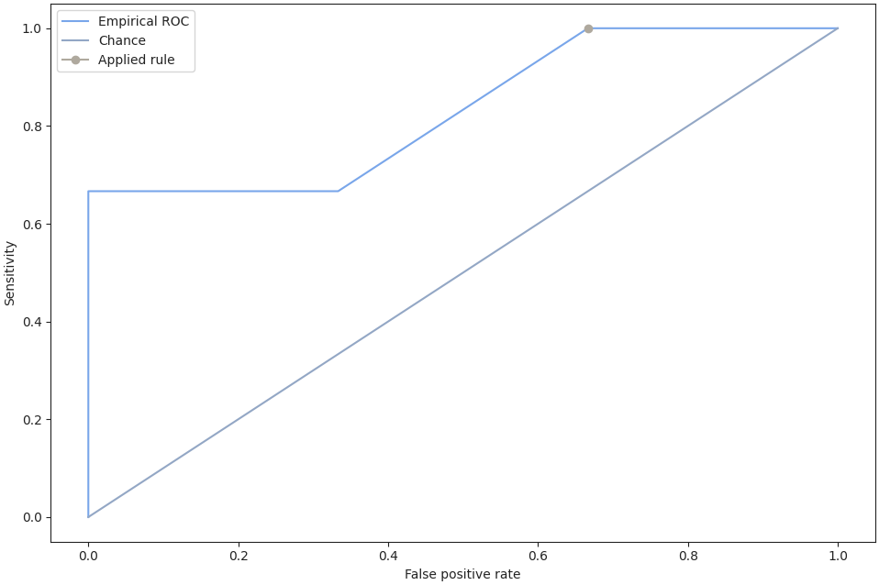

References
[1] R Core Team (2026). R: A Language and environment for statistical computing. (Version 4.6) [Computer software]. Retrieved from https://cran.r-project.org. (R packages retrieved from CRAN snapshot 2026-05-11).
[2] The jamovi project (2026). jamovi. (Version 28) [Computer Software]. Retrieved from https://www.jamovi.org.

