## Installation Procedure

Firstly, install Jamovi app into your computer. Secondly, download the FuzzyDelphiMethod jmo from <https://github.com/lerlerchan/FuzzyDelpiJmv>

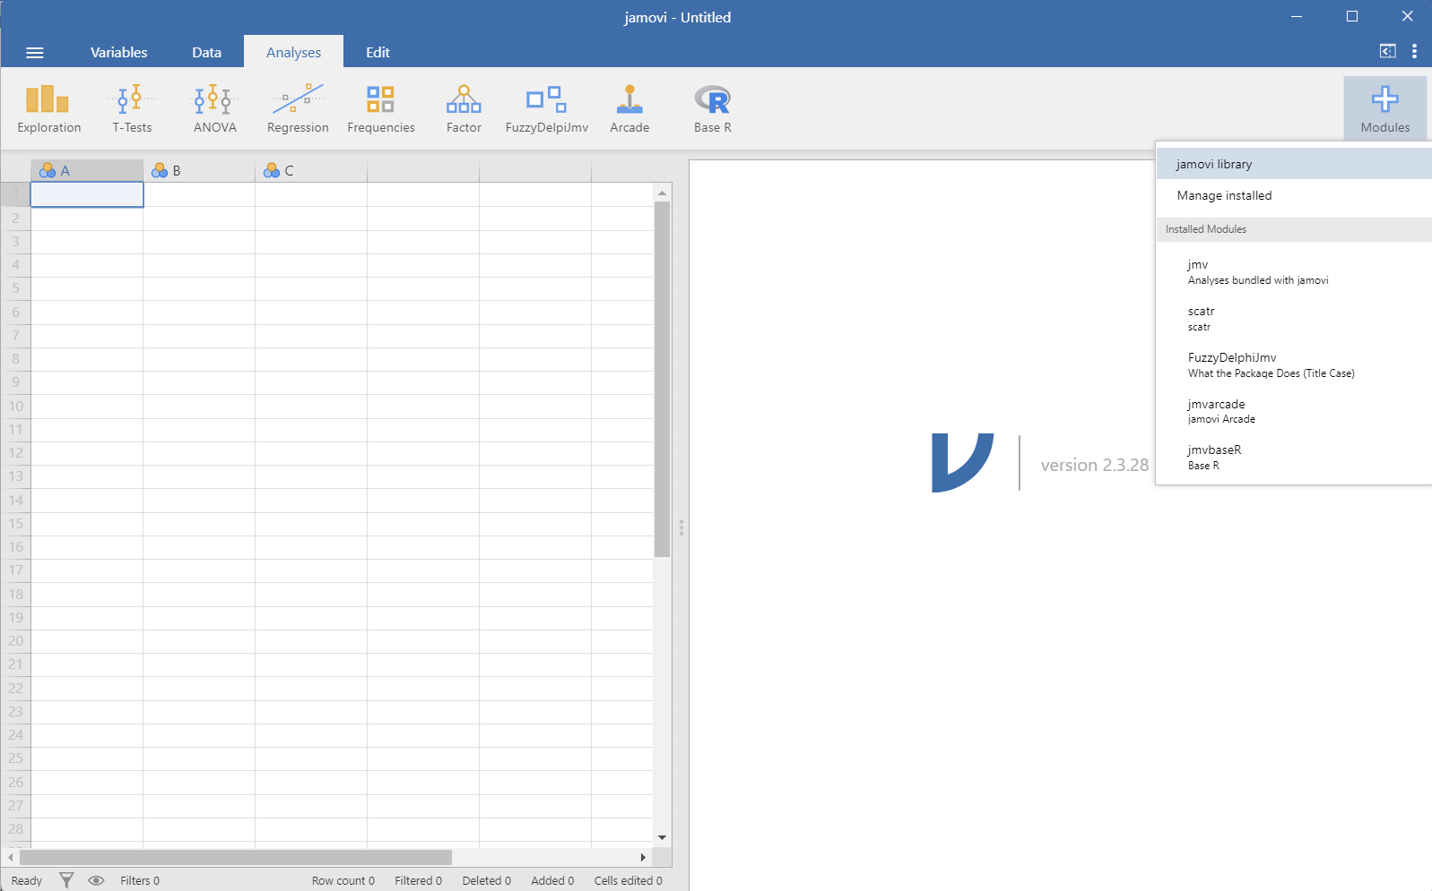

Figure 1 Steps to add modules

Once Jamovi app is installed and opened, click on Modules icon on the top right of the app. Choose Jamovi library.

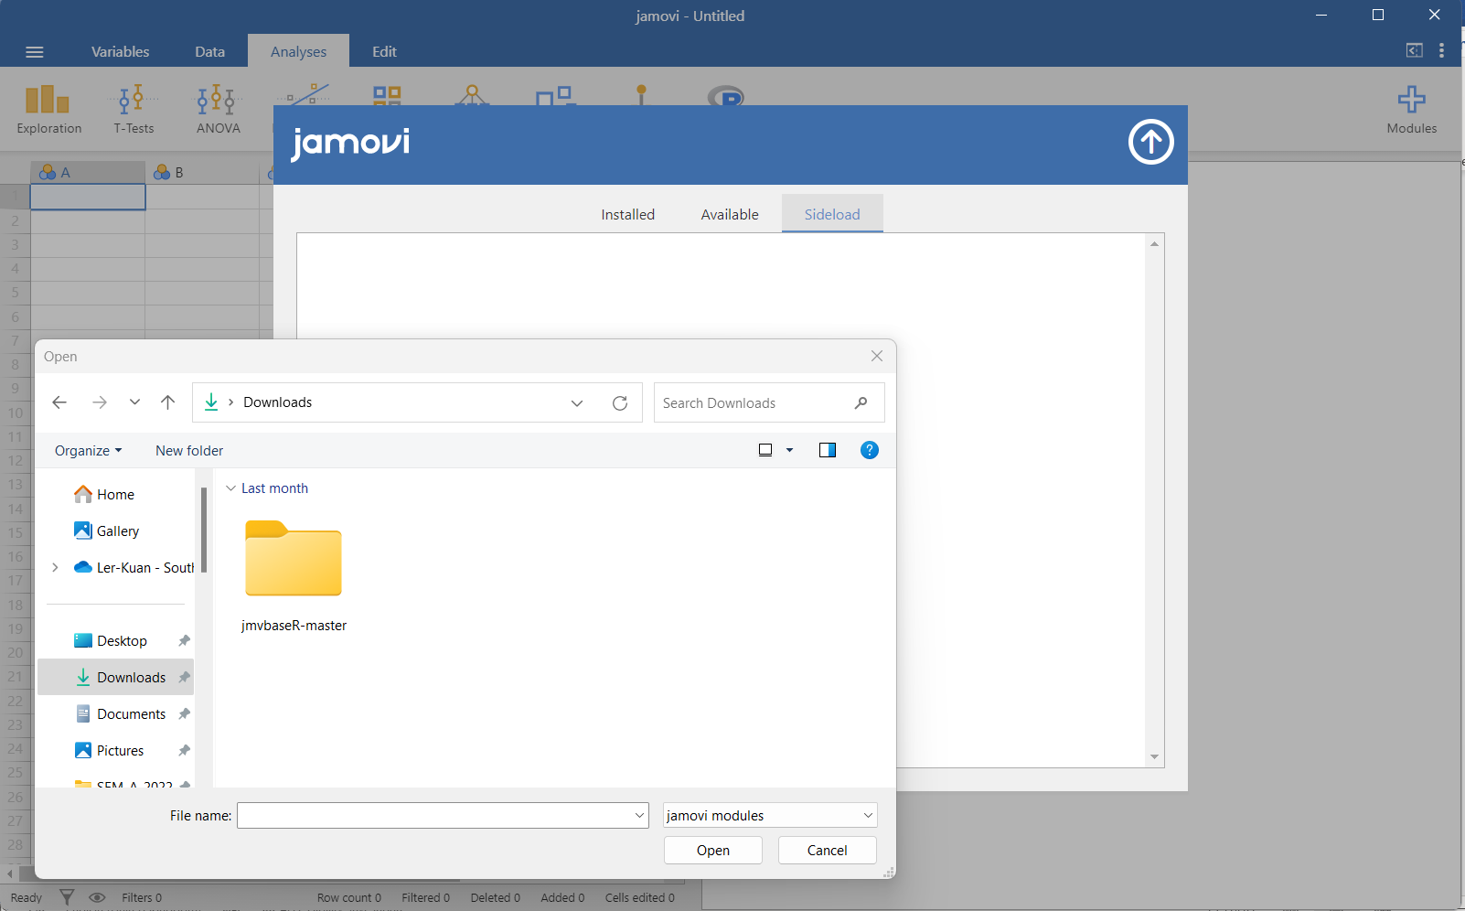

Figure 2 Load downloaded module to Jamovi

Select Sideload tab. Select the middle button and load the downloaded jmo file.

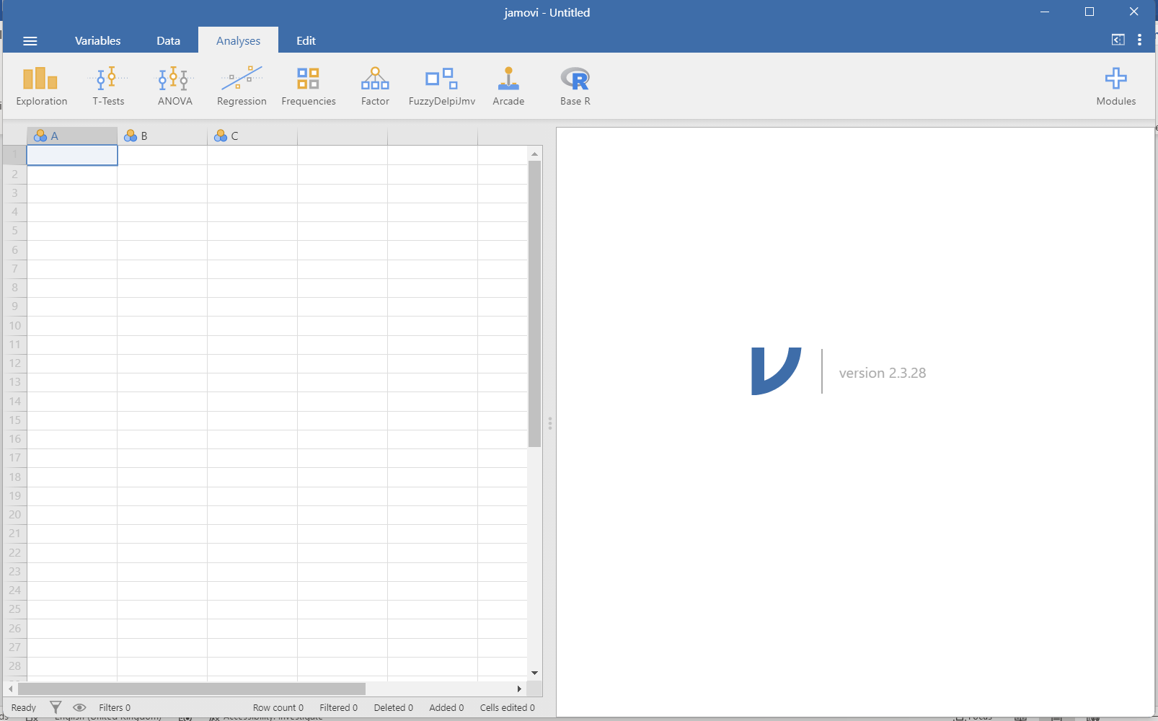

Figure 3 Module added to Jamovi

FuzzyDelphiJmv will display on the gray menu area.