صورة تحتوي على نص, نبات, قصاصة فنية

تم إنشاء الوصف تلقائياً

المملكة العربية السعودية

وزارة التعليم

جامعة الأمير سطام بن عبد العزيز

كلية العلوم والدراسات الإنسانية – الافلاج

قسم علوم الحاسب

Kingdom of Saudi Arabia

Ministry of Education

Prince Sattam bin Abdulaziz University

College of Science and Humanities - Al- Aflaj

Department of computer science

**Arabic Spoken Language Identification System**

**Submitted by:**

Mohammed Ibrahim Alabdulhadi 441850756

Ibrahim Abdulmajeed Alsaif 439050466

Zeyad Sulalman Alhoti. 438850187

**Supervised by:**

Dr.Mohammed Alatiyyah

Department of Computer Science

College of Sciences and Humanities

Prince Sattam bin Abdulaziz University

AlAflaj – Saudi Arabia

February,2022 - Rajab,1443 H

**Contents**

Chapter1 : introduction……….........................................…………………...1

1.1 Problem statement…………………………….………………….………2

1.2 Proposed system……………...……………..……………………………2

1.3 The target………………………………………………………................2

1.4 Project plan………………………………………………………..…...…3

1.5 Project requirements………………………….3

1.6 conclusion…………………………………….3

Chapter 2: Literature Review………………...…...4

2.1 introduction…………………………………...5

2.2 application …………………………………....6

2.2.1 Soundhound..

2.2.2 Shazam

2.2.3 MusixMatch

2.2.4 Rateel

2.3 algorithms……………………………………

2.4 Features extraction……….………………….

2.5 proposal system……………………………..

2.6 comparison of the reseach………………..…12

2.7 conclusion…………………………………..13

Chapter 3: requirements……………………..….15

3.1 Functional requirements…………………….16

3.1.1 User requirements…………………………17

3.1.2 System requirements…………………….17

3.2 non - Functional requirements……………..19

3.2.1 Quality…………………………….…...…20

3.2.2 response time………………………….….21

3.2.3 I/O device……………………………..….22

Chapter 4: System design

Chapter 5: Conclusion

Chapter 2

**Chapter 2: Literature Review**

**2.1 introduction(محمد ال عبدالهادي)**

In this chapter, the steps taken by the researcher in studying and selecting research samples and the principles he followed in applying the research in its practical framework are reviewed. And previous studies that are related to the research topic, which number four research

**2.2 application**

**2.2.1 Soundhound**



**SoundHound :** has applied audio processing and machine learning on millions of songs to extract features that are characteristic of each song

**The users of the application** are all those who are looking for the speaker in a particular music

**Features of the SoundHound App**

* 1-Immediately identifies the song.
* 2-Supports hands-free use.
* 3-Offline assistance.
* 4-Built-in virtual assistant.
* 5-Integration with Spotify and Pandora.
* 6-LiveLyrics feature for finding out the lyrics.

The application works with natural language understanding technology.

**2.2.2 Shazam(إبراهيم السيف)**



**Definition of Shazam application:-**

Shazam is an application that can identify music, movies, advertising, and television shows, based on a short sample played and using the microphone on the device.

The software is available for Android, macOS, iOS, Wear OS, watchOS and as a Google Chrome-extension.

**Who are the users of the application-:?**

Users of the Shazam application who want to get a song or an audio clip, but do not know the name of the song or the sound clip, in the Shazam application, it allows them to find the audio clip they want.

**Shazam application features:-**

One of the advantages of Shazam is that it is easy to use. Just with a single click or tap on the screen of a mobile phone or computer, you can know an unknown song, the singer and information about him and the album, and also, his expressions only through the program to the song, voice and external melody.

**Technology used in Shazam application:-**

Shazam identifies songs using an audio fingerprint based on a time-frequency graph called a spectrogram. It uses a smartphone or computer's built-in microphone to gather a brief sample of audio being played. Shazam stores a catalogue of audio fingerprints in a database. The user tags a song for 10 seconds and the application creates an audio fingerprint.

**2.2.3 MusixMatch(زياد الحوطي)**



1. **How does the program work and how does it work?**

Musixmatch uses the access permission to be able to read the transmission in the output and use that to search, identify the song, and provide the lyrics. Unlike apps like shazam that recognizes the song from the microphone, musixmatch directly hits the output because there is no interference to any noise and as a result finds the song with the lyrics faster and more accurate than its competitors

# One of the algorithms applied is:

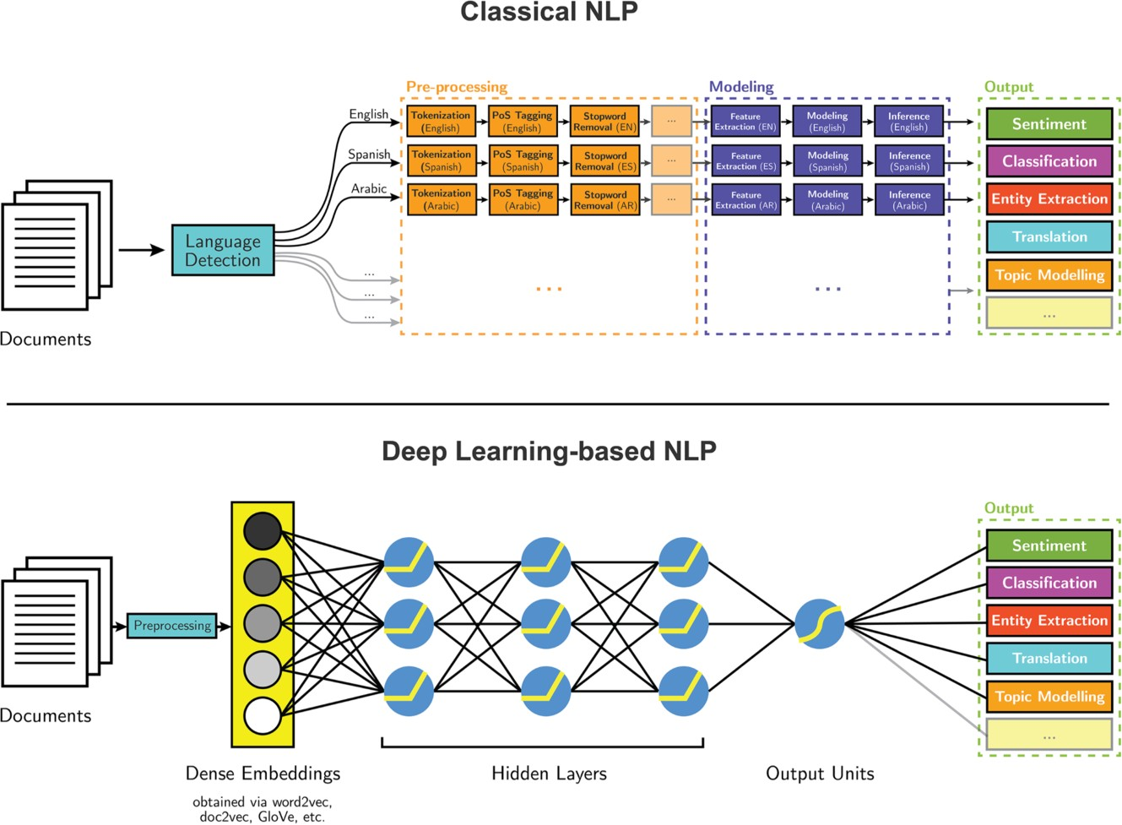

## Classical NLP:

A Classical NLP pipeline expects a language detection system as first step: the reason is that next steps can differ depending on it. After this detection, the *corresponding pipeline* of preprocessing steps is performed, which includes Tokenization, Part-Of-Speech tagger and Named Entity Recognition. Human-designed features come from the output of these preprocessing steps. Then a model can be created and the inference for the desired task executed.

## Deep Learning:

Deep Learning is based on a completely different approach. After an initial preprocessing of raw data, the input is embedded in *dense vectors*, which can be generated by different techniques like word2vec, GloVe and doc2vec. This becomes the new input of the neural network which feeds the hidden layers. Through these layers the network learns how to reach the goal of the task.

# Features in MusixMatch:

1. **Lyrics Search**

People most likely remember part of lyrics rather than the song title. Musixmatch will let you search by lyrics and enrich your search experience to feel just magical.

1. **Synchronized Lyrics**

Engage users with perfectly-synced lyrics, line by line or word by word.

Deliver new experiences on sing-along or contextual display to enrich the music experience.

1. **Translated Lyrics**

Lyrics translations break down language barriers and add meaning to music.

Combining time synchronization with lyrics translations Musixmatch is able to offer the ultimate experience for multi-lingual listeners.

**2.2.4 Rateel (محمد ال عبدالهادي)**

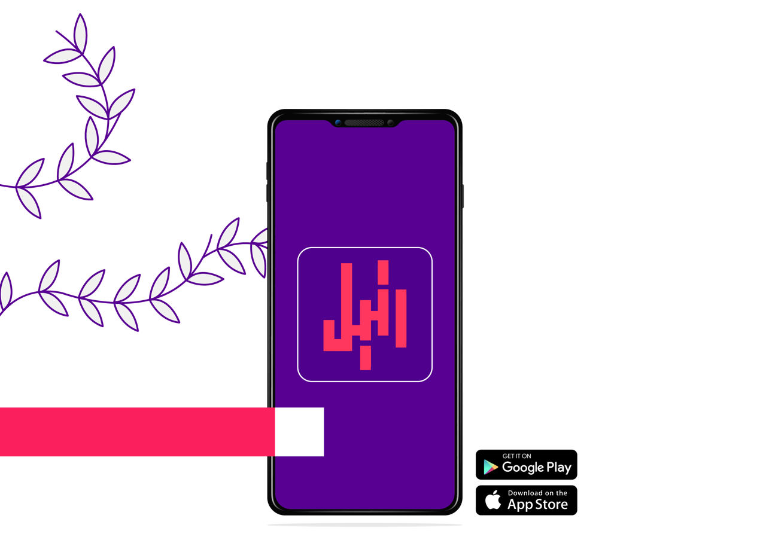

Rateel : Application to identify the reader of the Qur'an

The users of the application : Everyone who wanted to search for the voice of the reciter of the Qur’an.

* The application helps you identify the reciter of the Holy Qur’an and determine the surah from any audio or video you have.
* The application enables you to browse and download recitations of more than 650 elite reciters through more than 400 thousand audio files, which equals to more than 18 thousand playback hours.
* After downloading the Surah, you can listen to it without using the internet.
* The application includes prayer times and time left for the prayer in your location or the city you choose.
* You can read the entire Qur’an and make bookmarks that you can return to it later.
* The application makes it easy for you to make a schedule to conclude the reading of the Holy Quran by specifying the times of reading and the appropriate duration for the conclusion.
* Reminder to read morning and evening remembrances ” Azkar” and Surat Al-Kahf on Friday, and fasting on voluntary days “Sonan”.
* The application provides you with a compass that enables you to determine the direction of the Qiblah.
* The application enables you to view the interpretation of all verses of the Holy Quran by selecting the required verse.
* The application enables you to switch the display between night and day modes.

**2.3 algorithms**

**2.4 Features extraction**

**2.5 proposal system**

**2.6 comparison of the research**

**2.7 conclusion**