صورة تحتوي على نص, نبات, قصاصة فنية

تم إنشاء الوصف تلقائياً

المملكة العربية السعودية

وزارة التعليم

جامعة الأمير سطام بن عبد العزيز

كلية العلوم والدراسات الإنسانية – الافلاج

قسم علوم الحاسب

Kingdom of Saudi Arabia

Ministry of Education

Prince Sattam bin Abdulaziz University

College of Science and Humanities - Al- Aflaj

Department of computer science

**Arabic Spoken Language Identification System**

**Submitted by:**

Mohammed Ibrahim Alabdulhadi 441850756

Ibrahim Abdulmajeed Alsaif 439050466

Zeyad Sulalman Alhoti. 438850187

**Supervised by:**

Dr.Mohammed Alatiyyah

Department of Computer Science

College of Sciences and Humanities

Prince Sattam bin Abdulaziz University

AlAflaj – Saudi Arabia

February,2022 - Rajab,1443 H

**Contents**

Chapter1 : introduction……….........................................…………………...1

1.1 Problem statement…………………………….………………….………2

1.2 Proposed system……………...……………..……………………………2

1.3 The target………………………………………………………................2

1.4 Project plan………………………………………………………..…...…3

1.5 Project requirements………………………….3

1.6 conclusion…………………………………….3

Chapter 2: Literature Review………………...…...4

2.1 introduction…………………………………...5

2.2 application …………………………………....6

2.2.1 Soundhound..

2.2.2 Shazam

2.2.3 MusixMatch

2.2.4 Rateel

2.3 algorithms……………………………………

2.4 Features extraction……….………………….

2.5 proposal system……………………………..

2.6 comparison of the reseach………………..…12

2.7 conclusion…………………………………..13

Chapter 3: requirements……………………..….15

3.1 Functional requirements…………………….16

3.1.1 User requirements…………………………17

3.1.2 System requirements…………………….17

3.2 non - Functional requirements……………..19

3.2.1 Quality…………………………….…...…20

3.2.2 response time………………………….….21

3.2.3 I/O device……………………………..….22

Chapter 4: System design

Chapter 5: Conclusion

Chapter 2

**Chapter 2: Literature Review**

**2.1 introduction(محمد ال عبدالهادي)**

In this chapter, the steps taken by the researcher in studying and selecting research samples and the principles he followed in applying the research in its practical framework are reviewed. And previous studies that are related to the research topic, which number four research

**2.2 application**

**2.2.1 Soundhound**



**SoundHound :** has applied audio processing and machine learning on millions of songs to extract features that are characteristic of each song

**The users of the application** are all those who are looking for the speaker in a particular music

**Features of the SoundHound App**

* 1-Immediately identifies the song.
* 2-Supports hands-free use.
* 3-Offline assistance.
* 4-Built-in virtual assistant.
* 5-Integration with Spotify and Pandora.
* 6-LiveLyrics feature for finding out the lyrics.

The application works with natural language understanding technology.

**2.2.2 Shazam(إبراهيم السيف)**



**Definition of Shazam application:-**

Shazam is an application that can identify music, movies, TV shows and clips in general by taking a sample of the audio clip, and this is done using the device's microphone.

**Who are the users of the application-:?**

Users of the Shazam application are the ones who want to find the name of the music or audio track that was searched, the Shazam application allows them to find the name of the music or audio track that they want.

**Shazam application advantages and disadvantages:-**

* **Advantages:**
* easy to use.
* Easy to discover music.
* Recognizes the voice in ten second.
* **Disadvantages**:
* The user can not sing the song and search for it.
* It is not easy to recognize the reader.

**Technology used in Shazam application:-**

The Shazam application uses the microphone of the mobile phone or the device in which the application is located to identify the audio clip, and Shazam uses fingerprint technology to puts it in a graph through which the audio clip is fragmented and searched in databases.

**2.2.3 MusixMatch(زياد الحوطي)**



**How does the program work and how does it work?**

A program that can use some algorithms to obtain music through the microphone, after which it is read and extracted the results from the sounds of the Qur’an, poem or music in general.

Who is using the app or who needs it?

Those who use the app or who need it are people who have some music and want to know more about it.

Features and Disadvantages:

-Some of the features

* Some words can be captured in offline mode.
* Tracking the fast download feature of the subscribed user.
* Can read static characters from within a page.

-Some of the Disadvantages

* Sometimes the lyrics are not accurate.
* Classical music instruments cannot be read.
* It may not be possible to get all the lyrics correctly.

**2.2.4 Rateel (محمد ال عبدالهادي)**

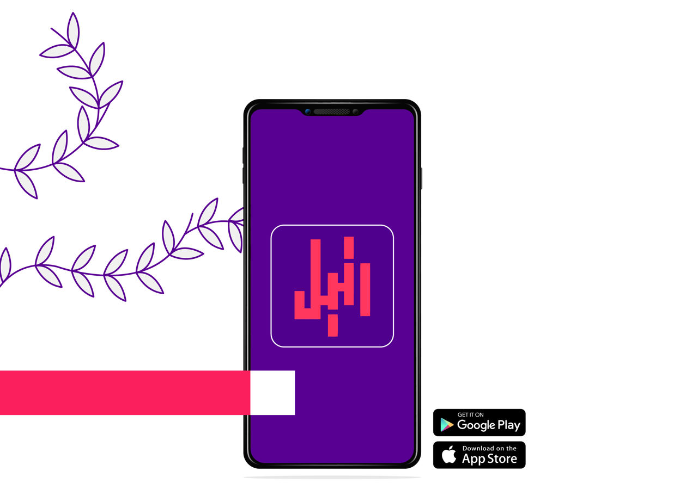

Rateel : Application to identify the reader of the Qur'an

The users of the application : Everyone who wanted to search for the voice of the reciter of the Qur’an.

* The application helps you identify the reciter of the Holy Qur’an and determine the surah from any audio or video you have.
* The application enables you to browse and download recitations of more than 650 elite reciters through more than 400 thousand audio files, which equals to more than 18 thousand playback hours.
* After downloading the Surah, you can listen to it without using the internet.
* The application includes prayer times and time left for the prayer in your location or the city you choose.
* You can read the entire Qur’an and make bookmarks that you can return to it later.
* The application makes it easy for you to make a schedule to conclude the reading of the Holy Quran by specifying the times of reading and the appropriate duration for the conclusion.
* Reminder to read morning and evening remembrances ” Azkar” and Surat Al-Kahf on Friday, and fasting on voluntary days “Sonan”.
* The application provides you with a compass that enables you to determine the direction of the Qiblah.
* The application enables you to view the interpretation of all verses of the Holy Quran by selecting the required verse.
* The application enables you to switch the display between night and day modes.

**2.3 algorithms**

**2.4 Features extraction**

**2.5 proposal system**

**2.6 comparison of the research**

**2.7 conclusion**