صورة تحتوي على نص, نبات, قصاصة فنية

تم إنشاء الوصف تلقائياً

المملكة العربية السعودية

وزارة التعليم

جامعة الأمير سطام بن عبد العزيز

كلية العلوم والدراسات الإنسانية – الافلاج

قسم علوم الحاسب

Kingdom of Saudi Arabia

Ministry of Education

Prince Sattam bin Abdulaziz University

College of Science and Humanities - Al- Aflaj

Department of computer science

**Arabic Spoken Language Identification System**

**Submitted by:**

Mohammed Ibrahim Alabdulhadi 441850756

Ibrahim Abdulmajeed Alsaif 439050466

Zeyad Sulalman Alhoti. 438850187

**Supervised by:**

Dr.Mohammed Alatiyyah

Department of Computer Science

College of Sciences and Humanities

Prince Sattam bin Abdulaziz University

AlAflaj – Saudi Arabia

February,2022 - Rajab,1443 H

**Contents**

Chapter1 : introduction……….........................................…………………...1

1.1 Problem statement…………………………….………………….………2

1.2 Proposed system……………...……………..……………………………2

1.3 The target………………………………………………………................2

1.4 Project plan………………………………………………………..…...…3

1.5 Project requirements………………………….3

1.6 conclusion…………………………………….3

Chapter 2: Literature Review………………...…...4

2.1 introduction…………………………………...5

2.2 application …………………………………....6

2.2.1 Soundhound..

2.2.2 Shazam

2.2.3 MusixMatch

2.2.4 Rateel

2.3 algorithms……………………………………

2.4 Features extraction……….………………….

2.5 proposal system……………………………..

2.6 comparison of the reseach………………..…12

2.7 conclusion…………………………………..13

Chapter 3: requirements……………………..….15

3.1 Functional requirements…………………….16

3.1.1 User requirements…………………………17

3.1.2 System requirements…………………….17

3.2 non - Functional requirements……………..19

3.2.1 Quality…………………………….…...…20

3.2.2 response time………………………….….21

3.2.3 I/O device……………………………..….22

Chapter 4: System design

Chapter 5: Conclusion

Chapter 2

**Chapter 2: Literature Review**

**2.1 introduction(محمد ال عبدالهادي)**

In this chapter, the steps taken by the researcher in studying and selecting research samples and the principles he followed in applying the research in its practical framework are reviewed. And previous studies that are related to the research topic, which number four research

**2.2 application(محمد ال عبدالهادي)**

In this section, we will talk about the applications that apply the idea of ​​our applications, and we will explain each application and its features

**2.2.1 Soundhound(محمد ال عبدالهادي)**



SoundHound: has applied audio processing and machine learning on millions of songs to extract features that are characteristic of each song.

The users of the application : are all those who are looking for the speaker in a particular music.

Features of the SoundHound App

* Immediately identifies the song.
* Extract words from audio) LiveLyrics( .
* Getting to know the Quran reciter but not well

Disadvantages of the SoundHound app

* Doesn't always play the correct song
* Has a slight learning curve.
* does not recognize the sound in Arabic well

The application works with natural language understanding technology.

**2.2.2 Shazam(إبراهيم السيف)**



**Definition of Shazam application:-**

Shazam is an application that can identify music, movies, TV shows and clips in general by taking a sample of the audio clip, and this is done using the device's microphone.

**Who are the users of the application-:?**

Users of the Shazam application are the ones who want to find the name of the music or audio track that was searched, the Shazam application allows them to find the name of the music or audio track that they want.

**Shazam application advantages and disadvantages:-**

* **Advantages:**
* easy to use.
* Easy to discover music.
* Recognizes the voice in ten second.
* **Disadvantages**:
* The user can not sing the song and search for it.
* It is not easy to recognize the reader.

**Technology used in Shazam application:-**

The Shazam application uses the microphone of the mobile phone or the device in which the application is located to identify the audio clip, and Shazam uses fingerprint technology to puts it in a graph through which the audio clip is fragmented and searched in databases.

**2.2.3 MusixMatch(زياد الحوطي)**



**How does the program work and how does it work?**

A program that can use some algorithms to obtain music through the microphone, after which it is read and extracted the results from the sounds of the Qur’an, poem or music in general.

Who is using the app or who needs it?

Those who use the app or who need it are people who have some music and want to know more about it.

Features and Disadvantages:

-Some of the features

* Tracking the fast download feature of the subscribed user.
* Can read static characters from within a page.
* easy to use.

-Some of the Disadvantages

* Sometimes the lyrics are not accurate.
* Classical music instruments cannot be read.
* It may not be possible to get all the lyrics correctly.

**2.2.4 Rateel (محمد ال عبدالهادي)**

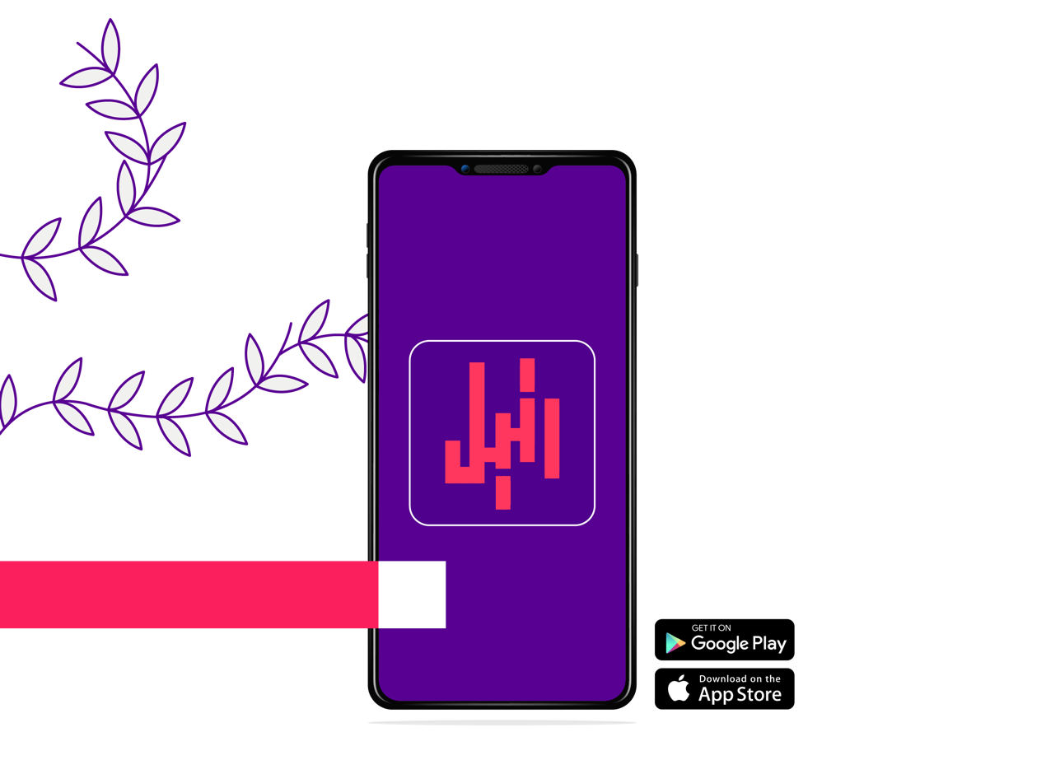

Rateel : Application to identify the reader of the Qur'an.

The users of the application : Everyone who wanted to search for the voice of the reciter of the Qur’an.

Features of the Rateel App

* Get to know the reciter of the Qur'an

Disadvantages of the Rateel app

* Does not recognize the reader in the short voice
* It takes a long time to get to know the reader
* Has a slight learning curve.

**2.3 algorithms**

**2.4 Features extraction**

**2.5 proposal system**

This system aims to identify and know the voice of the reciters in the Qur’an and make this application recognize quickly and correctly and make the application learn to help identify the new reader

**2.6 comparison of the research**

|  |  |  |  |  |
| --- | --- | --- | --- | --- |
|  | SoundHound | Shazam | MusixMatch  Install Musixmatch on Linux | Snap Store | Rateel  Manage, redeem, transfer, and more... just like that |
| recognition speed | علامة تحديد مع تعبئة خالصة | علامة تحديد مع تعبئة خالصة | علامة تحديد مع تعبئة خالصة |  |
| Arabic speaker recognition | علامة تحديد مع تعبئة خالصة | علامة تحديد مع تعبئة خالصة | علامة تحديد مع تعبئة خالصة | علامة تحديد مع تعبئة خالصة |
| Often recognized correctly |  | علامة تحديد مع تعبئة خالصة | علامة تحديد مع تعبئة خالصة |  |
| recognition the reader of the Qur'an | علامة تحديد مع تعبئة خالصة | علامة تحديد مع تعبئة خالصة | علامة تحديد مع تعبئة خالصة | علامة تحديد مع تعبئة خالصة |
| high learning curve |  | علامة تحديد مع تعبئة خالصة |  |  |
| easy to use. | علامة تحديد مع تعبئة خالصة | علامة تحديد مع تعبئة خالصة | علامة تحديد مع تعبئة خالصة |  |

**2.7 conclusion**