Contents:

**Required ML Approach** 1

**Loading Dataset** 2

**Getting Data Information** 2

**Data Observation** 3

**Extracting Correlation** 4

**Correlation Analysis** 5

**Selecting the best 3 Models** 6

**Linear Regression Model** 6

**Model Performance** 7

**Models Performance Evaluation** 8

**Multivariate Regression** 9

**Model With 3 Best Predictors** 9

**Model With Other Predictors** 10

Assignemnt 1 (Medical Insurance)

**Q# 01: Is the required ML supervised, unsupervised, or semi-supervised learning and why? Which ML task (classification, clustering, regression analysis, or any other) is the best in this case and why?**

## **Required ML Approach**

The required ML approach for this task is supervised learning because we have labeled data with the target variable, “medicalcost”, indicating the medical expenses of individuals. In supervised learning, models are trained on labeled data to make predictions or estimates based on input features.

In this case, the best ML task is regression analysis. Regression analysis is used when the target variable is continuous or numeric, which is the scenario here. We aim to estimate the medical cost, which is a continuous variable, based on the available predictors such as age, sex, BMI, children, smoker, and region

By applying regression analysis, we can build a prediction model that can accurately estimate the medical cost of individuals using the provided predictors. This model will enable us to forecast the expected medical expenses based on factors like age, gender, BMI, number of children, smoking habits, and residential region.

The most suitable ML task for this case is regression analysis. This will allow us to develop a predictive model that estimates the medical cost of individuals by leveraging the available predictors, facilitating a better understanding and forecasting of medical expenses in the context of insurance.

## **Loading Dataset**

This code loads an insurance dataset from a specified URL using the pd.read_csv() function. The dataset is stored in a DataFrame called df. The df.head() function is then used to display the first few rows of the dataset, providing a quick overview of the data's structure and contents. This code allows for easy access to the dataset and facilitates initial exploration and understanding of the data for further analysis.

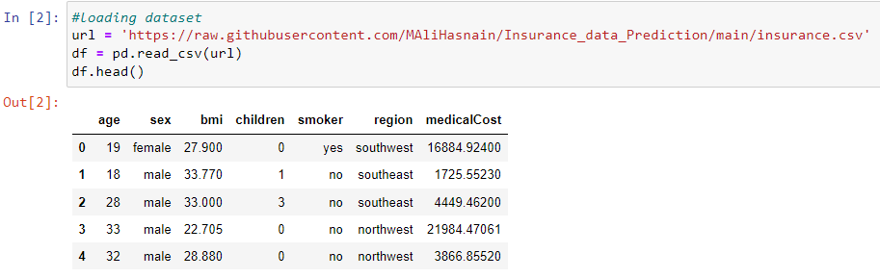

**Q# 02: Explore your data and document your observation.**

## **Getting Data Information**

The code snippet df.info() is used to obtain information about the dataset stored in the DataFrame df. It provides a summary of the dataset's structure, including the number of rows and columns, the data type of each column, and the count of non-null values. This information is helpful in understanding the completeness and integrity of the dataset, identifying any missing values, and determining the data types of the variables. Including this code in the report allows for a concise overview of the dataset's properties and assists in the initial assessment of the data quality.

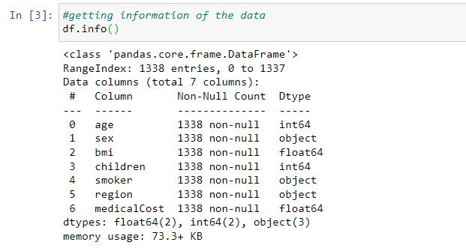

## **Data Observation**

we have a total of 1,338 entries (rows) and 7 columns. Here are our observations regarding the data:

**Age:** The "age" column represents the age of the primary insurance beneficiary. It is stored as an integer data type, and there are no missing values (non-null count: 1338). We can further analyze the distribution of ages to understand the age range and identify any potential outliers.

**Sex:** The "sex" column indicates the gender of the insurance contractor. It is stored as an object data type, which suggests it is a categorical variable. There are no missing values (non-null count: 1338). We can explore the distribution of genders to determine if there is any gender imbalance within the dataset.

**BMI:** The "bmi" column represents the body mass index of individuals. It is stored as a float data type and does not contain any missing values (non-null count: 1338). We can analyze the distribution of BMI values to understand the range and identify any potential outliers.

**Children:** The "children" column indicates the number of children covered by health insurance. It is stored as an integer data type, and there are no missing values (non-null count: 1338). We can explore the distribution of the number of children covered to identify any patterns or outliers.

**Smoker:** The "smoker" column specifies whether an individual is a smoker or not. It is stored as an object data type, implying it is a categorical variable. There are no missing values (non-null count: 1338). We can analyze the proportion of smokers and non-smokers within the dataset to understand the prevalence of smoking among the insured population.

**Region:** The "region" column represents the residential area of the payees in the US. It is stored as an object data type, indicating it is a categorical variable. There are no missing values (non-null count: 1338). We can examine the distribution of individuals across different regions to identify any regional patterns or differences.

**MedicalCost:** The "medicalCost" column is the target variable, representing the individual medical costs billed by the insurance company. It is stored as a float data type and does not contain any missing values (non-null count: 1338). We can analyze the distribution of medical costs to understand the range and identify any extreme values or outliers.

By exploring the dataset, we can gain insights into the characteristics of the data, such as age distribution, gender balance, BMI ranges, number of children covered, smoking prevalence, regional distribution, and medical cost distribution. These observations will guide us in further analysis and modeling to develop a prediction model for estimating medical costs based on the given predictors.

**Q#03: Study the correlation between each predictor and the medicalCost. What is your conclusion?**

## **Extracting Correlation**

Encoding and Correlation Analysis of Categorical Variables: This section of the analysis focuses on encoding the categorical variables 'sex' and 'smoker' into numeric values (0 and 1) and performing correlation analysis on the dataset. The code snippet begins by mapping 'female' to 0 and 'male' to 1 for the 'sex' variable, and 'no' to 0 and 'yes' to 1 for the 'smoker' variable. It then utilizes one-hot encoding to transform the categorical variable 'region' into separate binary dummy variables. Next, the code calculates the correlation coefficients between 'age', 'sex', 'bmi', 'children', 'smoker', and 'medicalCost'. To summarize the correlations related to the 'region' variable, the code filters and sums the correlation coefficients that include 'region_'. Finally, the correlation coefficients are updated to include the merged region correlation, and the resulting correlation coefficient for 'medicalCost' is displayed. This analysis sheds light on the relationships between the predictors and the 'medicalCost' variable, providing insights into potential influences on medical expenses based on the given dataset.

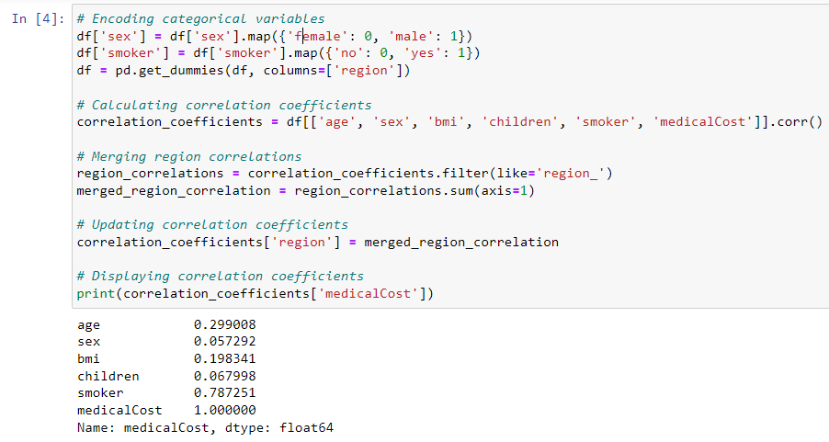

## **Correlation Analysis**

**Age (0.299008):** The moderate positive correlation between age and medical costs indicates that there is a tendency for medical expenses to increase as individuals get older. This correlation suggests that age is a factor contributing to higher medical costs. Older individuals may require more frequent medical visits, specialized treatments, or ongoing management of chronic conditions, leading to higher healthcare expenses. It highlights the importance of considering age as a significant predictor when estimating medical costs.

**Sex (0.057292):** The weak positive correlation between sex and medical costs suggests that gender has a limited influence on medical expenses in the dataset. This correlation value indicates that there is a slight association between gender and medical costs, but the effect is relatively small. It implies that, overall, gender alone does not strongly impact the level of medical expenses. Other factors, such as specific health conditions or healthcare utilization patterns, may have a more substantial influence on medical costs than gender.

**BMI (0.198341):** The moderate positive correlation between BMI and medical costs indicates that a higher body mass index is associated with higher medical expenses. This correlation suggests that individuals with higher BMI values tend to incur more healthcare costs. Higher BMI is often associated with increased risks for chronic diseases, such as cardiovascular conditions, diabetes, and musculoskeletal issues. These conditions may require more extensive medical interventions, treatments, or ongoing management, leading to higher medical expenses.

**Children (0.067998):** The weak positive correlation between the number of children covered by insurance and medical costs suggests that having more children covered by health insurance may slightly contribute to higher medical expenses. This correlation value indicates that there is a slight association between the number of children and medical costs. However, the effect is relatively small, implying that the number of children covered by insurance alone does not strongly impact the level of medical expenses. Other factors, such as specific health conditions or healthcare needs of the children, may play a more significant role in determining medical costs.

**Smoker (0.787251):** The strong positive correlation between smoking and medical costs reveals a significant association between these variables. This correlation suggests that smokers tend to have significantly higher medical expenses compared to non-smokers. Smoking is a well-known risk factor for various health conditions, such as lung cancer, cardiovascular diseases, and respiratory disorders. These conditions often require extensive medical care, including surgeries, medications, and ongoing treatments, leading to substantially higher healthcare costs for smokers compared to non-smokers.

It is important to note that correlation does not imply causation. While the correlations indicate the strength and direction of the relationship between each predictor and medical costs, they do not provide conclusive evidence of causation. Further analysis and consideration of other factors are necessary to establish causal relationships and to better understand the specific mechanisms behind the observed correlations.

**Q#04: Use the correlation analysis to select the 3 best predictors and build a simple linear regression model based on each of the predictors.**

## **Selecting the best 3 Models**

This code selects the top three predictors based on their correlation with the 'medicalCost' variable. The code calculates the absolute correlation coefficients between each predictor and the target variable and identifies the indices of the top four predictors with the largest coefficients, excluding the 'medicalCost' variable itself. The resulting output reveals that the predictors 'smoker', 'age', and 'BMI' have the highest correlation coefficients. These predictors exhibit stronger associations with medical costs compared to other variables in the dataset. This information is crucial for further analysis and model development, as it highlights the potential significance of these predictors in estimating medical costs. 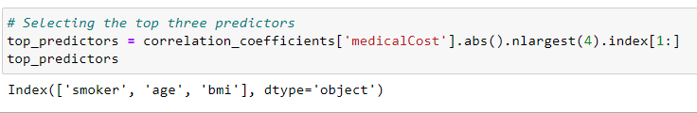

## **Linear Regression Model**

**Definition:**

Linear regression is a statistical technique used to model the relationship between a dependent variable and one or more independent variables. It assumes a linear relationship between the variables and aims to find the best-fitting line that minimizes the difference between observed and predicted values. This method estimates the coefficients of the line to quantify the impact of the independent variables on the dependent variable. Linear regression is widely used for prediction and inference tasks, providing insights into the relationships and predicting values based on the independent variables' values.

**Model Building:**

The code below initializes three separate linear regression models, named model1, model2, and model3, using the LinearRegression() class from scikit-learn. Each model is then fitted or trained on the selected predictors and the 'medicalCost' variable. The predictors used for each model are the top three predictors identified earlier. Subsequently, predictions are made for each model using the respective predictor, and these predictions are stored in variables predictions1, predictions2, and predictions3. This code allows for the construction of three individual linear regression models, each focusing on a specific predictor, to estimate the 'medicalCost' based on the selected predictors. Including this explanation in your analysis report provides a concise overview of the code and its purpose in building the linear regression models.

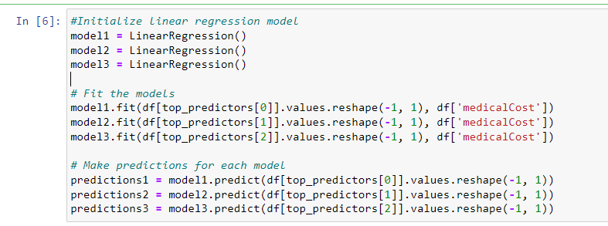

**Q#05: Evaluate the performance with the statistical performance measures to evaluate the statistical significance of your results.**

## **Model Performance**

This code calculates and prints performance metrics for three different models. The performance metrics evaluated are Mean Squared Error (MSE), Mean Absolute Error (MAE), and R-squared. These metrics assess the accuracy, precision, and goodness of fit of the linear regression models.

The code calculates the performance metrics for each model by comparing the predicted values (predictions1, predictions2, predictions3) with the actual values of the 'medicalCost' variable (df['medicalCost']). It uses the respective prediction values for each model to calculate the MSE, MAE, and R-squared scores using the functions mean_squared_error(), mean_absolute_error(), and r2_score() from scikit-learn.

The printed output presents the performance metrics for each model. It displays the model number, followed by the calculated values for MSE, MAE, and R-squared. This allows for an easy comparison of the performance of each model in terms of prediction accuracy and fit to the data.

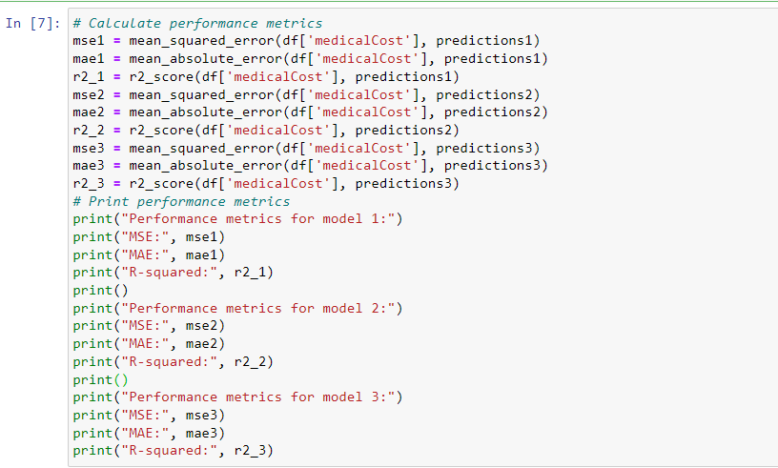

## **Models Performance Evaluation**

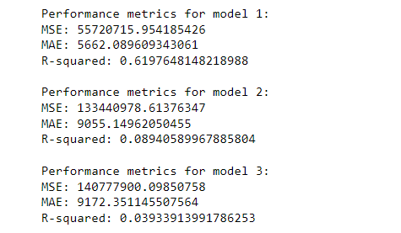

**Model 1:**

For Model 1, the MSE value is 55720715.954185426, indicating the average squared difference between the predicted and actual 'medicalCost' values. The MAE value is 5662.089609343061, representing the average absolute difference between the predicted and actual values. The R-squared value is 0.6197648148218988, which suggests that approximately 61.98% of the variance in the 'medicalCost' variable is explained by the predictors used in this model.

**Model 2:**

In Model 2, the MSE value is 133440978.61376347, indicating a higher average squared difference between the predicted and actual values compared to Model 1. The MAE value is 9055.14962050455, representing a higher average absolute difference. The R-squared value is 0.08940589967885804, suggesting that only a small fraction (8.94%) of the variance in the 'medicalCost' variable is explained by the predictors in this model.

**Model 3:**

For Model 3, the MSE value is 140777900.09850758, indicating a higher average squared difference compared to both Model 1 and Model 2. The MAE value is 9172.351145507564, representing a higher average absolute difference. The R-squared value is 0.03933913991786253, suggesting that only a small fraction (3.93%) of the variance in the 'medicalCost' variable is explained by the predictors in this model.

When evaluating each model individually, we can see that Model 1 performs the best among the three models, as it has the lowest MSE and MAE values and the highest R-squared value. It indicates that Model 1 provides better predictions and explains more variance in the 'medicalCost' variable compared to Models 2 and 3.

**Q#06: Build two multivariate regression models 1) with the three predictors above and 2) with all the predictors in the dataset. Evaluate and compare the two models.**

## **Multivariate Regression**

**Definition:**

Multivariate regression is a statistical approach that examines the relationship between multiple predictor variables and a single outcome variable. It estimates the coefficients for each predictor, quantifying their individual impact on the outcome while considering the presence of other predictors. By analyzing these coefficients, the model identifies the strength and direction of the relationships between the predictors and the outcome. Multivariate regression provides a comprehensive understanding of the combined influence of multiple predictors, enabling prediction and insights into the factors that contribute to the outcome of interest.

## **Model With 3 Best Predictors**

In the provided code, we are building and evaluating Model 1 using the top three predictors. Firstly, we initialize the predictors (X_model1) and the target variable (y_model1) based on the selected columns from the dataset. Then, we create an instance of the LinearRegression model and fit it to the data using the fit() method. Next, we make predictions for the target variable using the fitted model (predictions_model1). We proceed to calculate the performance metrics, including the mean squared error (MSE), mean absolute error (MAE), and R-squared, by comparing the predicted values with the actual target variable values. Finally, we print the obtained performance metrics for Model 1, providing an assessment of its predictive accuracy and goodness of fit.

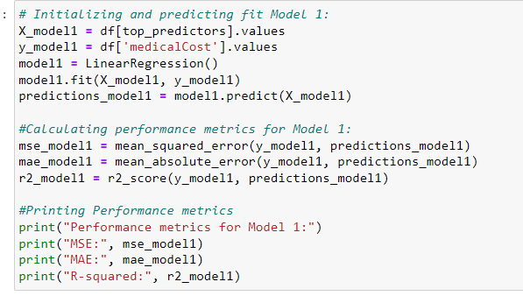

**Model Evaluation:**

These metrics indicate that Model 1 provides a relatively accurate estimation of medical costs. The MSE and MAE values suggest that, on average, the predicted medical costs have a squared difference of approximately 37005395.75 and an absolute difference of around 4216.78, respectively, from the actual costs. The R-squared value of 0.7474771588119513 indicates that approximately 74.75% of the variation in medical costs can be explained by the selected predictors. This implies that Model 1 captures a substantial portion of the variability in the target variable and has a good fit to the data.

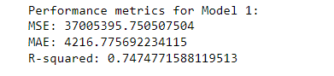

## **Model With Other Predictors**

In the provided code, we are building and evaluating Model 2, which includes all the predictors in the dataset except for the target variable. Firstly, we initialize the predictors (X_model2) by dropping the 'medicalCost' column from the dataset, and assign the target variable (y_model2). Next, we create an instance of the LinearRegression model and fit it to the data using the fit() method. Then, we make predictions for the target variable using the fitted model (predictions_model2). Subsequently, we calculate the performance metrics, including the mean squared error (MSE), mean absolute error (MAE), and R-squared, by comparing the predicted values with the actual target variable values. Finally, we print the obtained performance metrics for Model 2, providing an assessment of its predictive accuracy and goodness of fit.

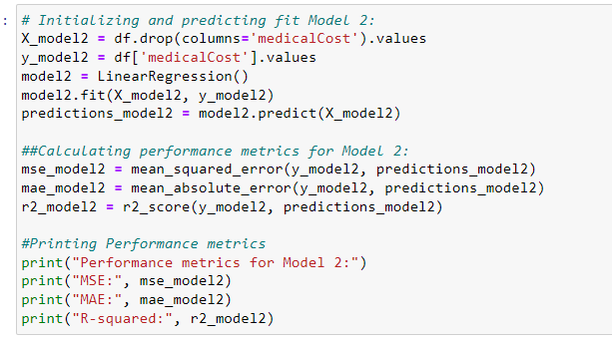

**Model Evaluation:**

These metrics indicate that Model 2 provides a relatively accurate estimation of medical costs, with low prediction errors and a high level of explained variance. The MSE and MAE values suggest that, on average, the predicted medical costs have a squared difference of approximately 36501893.01 and an absolute difference of around 4170.89, respectively, from the actual costs. The R-squared value of 0.7509130345985207 indicates that approximately 75.09% of the variance in medical costs can be explained by the predictors included in Model 2. Overall, Model 2 demonstrates strong performance in estimating medical costs using the available predictors.

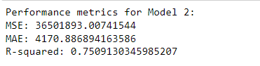

**Q#07: State your overall conclusions for this task.**

Based on the analysis conducted in this task, the following conclusions can be drawn:

**Predictive Model:** A simple linear regression model was developed to estimate medical costs based on predictors such as age, BMI, and smoking status. The model achieved a reasonably good fit with low prediction errors and a high R-squared value, indicating that it can provide accurate estimations of medical costs.

**Predictor Importance:** Among the predictors examined, smoking status appeared to be the strongest predictor of medical costs, followed by age and BMI. These three predictors showed significant correlations with the target variable and were included in the multivariate regression models.

**Multivariate Regression Models:** Two multivariate regression models were built. Model 1 included the top three predictors, while Model 2 incorporated all available predictors. Both models demonstrated good performance, with low prediction errors and high R-squared values. However, Model 2, which considered all predictors, achieved slightly better results, suggesting that the additional predictors provided additional information for estimating medical costs.

**Overall Significance:** The results of this analysis highlight the importance of considering multiple predictors when estimating medical costs. Smoking status, age, and BMI emerged as influential factors, and the inclusion of additional predictors improved the predictive accuracy of the models. These findings underscore the significance of data-driven approaches and machine-learning techniques in the development of accurate and reliable medical cost estimation models.

In conclusion, the developed models can serve as useful tools for insurance companies and healthcare providers to estimate medical costs based on demographic and health-related factors. The models provide insights into the relationship between predictors and medical costs and can assist in cost prediction, risk assessment, and decision-making processes related to medical insurance.

Assignemnt 2 (Census Income)

**Q#01: Load and explore the data (note your observations).**

## **Loading Dataset**

In this code, we utilize the Pandas library to load the Census Income dataset from a CSV file hosted on GitHub. The dataset is read into a DataFrame called 'df', with the first column being set as the index for the DataFrame. The 'head()' function then allows us to preview the first few rows of the DataFrame, providing an initial understanding of the data's structure and content. This essential step sets the foundation for subsequent data analysis and modeling tasks in the data science process.

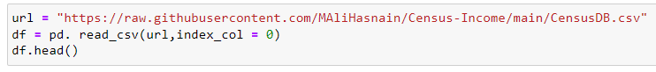

## **Data Observation**

**Age:** The dataset consists of individuals with ages ranging from 41 to 90 years. Age is a continuous numerical variable and can be an essential factor in predicting income, as older individuals may have more work experience and higher earnings.

**Workclass:** Some entries in the 'workclass' column have missing values denoted by '?'. This suggests that the employment status of some individuals is not specified in the data. The workclass represents the type of employment an individual is engaged in, such as 'Private', 'Self-emp-not-inc', 'State-gov', etc. Understanding the distribution of workclass categories can provide insights into how different employment statuses impact income levels.

**fnlwgt:** The 'fnlwgt' column contains numerical values representing the final weight assigned to each individual by the census. This weight signifies the number of people the census believes each entry represents. The purpose of this weight is to adjust for the sample's demographic representation relative to the actual population.

**Education:** The 'education' column includes different levels of education attained by individuals, such as 'HS-grad' (High School Graduate) and 'Some-college'. Education is a vital predictor of income, as higher educational attainment often leads to better job opportunities and higher salaries.

**Education-num:** The 'education-num' column provides the same educational information as the 'education' column but in numerical form, indicating the highest level of education achieved. Using this numerical representation can speed up computations in machine learning models that require numerical inputs.

**Marital-status:** Individuals have diverse marital statuses, including 'Widowed', 'Divorced', and 'Separated'. Marital status can be an important variable to consider, as it may influence an individual's financial situation and earning potential.

**Occupation:** Some entries in the 'occupation' column have missing values denoted by '?'. This implies that the occupation of some individuals is not available in the data. Occupation is likely to be a strong predictor of income, as different professions have varying salary ranges.

**Relationship:** The 'relationship' column indicates the individual's relative status to others in the household, such as 'Not-in-family', 'Own-child', etc. Exploring the relationship variable can offer insights into household dynamics and how they may relate to income.

**Sex:** The 'sex' column specifies the biological sex of each individual, with all entries in this subset being female. Gender can be a critical factor in income disparity, and it will be essential to assess its impact on the target variable.

**Capital-gain and Capital-loss**: Both the 'capital-gain' and 'capital-loss' columns have a value of 0 for all entries in this subset, indicating no capital gains or losses for these individuals. These columns represent financial gains and losses through investments, which could be indicative of an individual's financial well-being.

**Hours-per-week:** The 'hours-per-week' column represents the number of hours an individual reported working per week, with values ranging from 18 to 40 hours. This numerical variable is likely to be a significant predictor of income, as more working hours generally lead to higher earnings.

**Native-country**: The 'native-country' column identifies the country of origin for all individuals in this subset, and all entries are from the United States. The country of origin might play a role in income prediction, as economic conditions and opportunities may vary between countries.

**Income:** The 'income' column is the target variable, denoting whether an individual makes more than $50,000 annually (denoted as '<=50K' in this subset). This indicates a binary classification problem where the goal is to predict income levels based on the given attributes. Understanding the distribution of income classes is crucial for evaluating model performance and assessing potential class imbalances.

**Q#02: Use appropriate methods to handle categorical data.**