Akmedoids R-package for longitudinal dataset: A guide to measuring long-term inequality in the exposure to crime at micro-area levels

Adepeju, M., Langton, S., and Bannister, J.

Big Data Centre, Manchester Metropolitan University, Manchester, M15 6BH

2019-03-10

**Abstract**

The akmedoids advances a set of R-functions for longitudinal clustering of trajectories based on the similarities of their long-term trends and determines the optimal solution based on the Calinski-Harabatz criterion (Caliński and Harabasz 1974). The package also include a number of useful functions for addressing common data issues prior to any advanced analysis. The primary goal of the akmedoids package is to aid replication of crime inequality investigation under crime drop for cities around the world (see Adepeju et al. 2019). In this document, we provide a guide to replicating this investigation. Meanwhile, it is argued that both the data manipulation and clustering functions provided in this package can be applied in any field.

# Introduction

The longitudinal clustering analysis is ubiquitous in social and behavioural sciences for investigating the developmental processes of a phenomenon over time. Examples of the commonly used techniques in these areas include the group-based trajectory modelling (GBTM) and the non-parametric kmeans methods. A key feature of these techniques is their high sensitivity to outliers and short-term fluctuations in the trajectories, thereby minimising the power of the techniques to identify long-term linear trends in the data. In crime and place research, for example, the identification of such long-term linear trends may help to develop some theoretical understanding of criminal victimisation within a geographical space (Griffith and Chavez 2004). In order to address this challenge, we advance a novel technique named anchored kmedoids (akmedoids) which implements three key modifications to the existing longitudinal kmeans approach. First, it approximates trajectories using ordinary least square regression (OLS) and second, it anchors the initialisation process with median observations. And third, it uses medoid observations as new anchors for each iteration of the expectation-maximisation procedure (Celeux and Govaert 1992). These modifications ensure that the impacts of short-term fluctuations and outliers are eliminated. By linking the final groupings back to the original trajectories, a clearer delineation of the long-term linear trends of trajectories are obtained.

We provide the akmedoids as an open-source package using R platform. The goal is to facilitate easy uptake of the package in any field. Leading to the main clustering functions are a number of useful data manipulation functions for addressing common data issues, such as missing entries and extreme outliers in a longitudinal dataset. We provided a worked example using a small sample dataset that should allow users to get a clear understanding of the operation of each function.

# 1. Data manipulation

Table 1 shows the main data manipulation functions and their descriptions. The data manipulation functions is to help prepare data for advance analysis. They also include functions to convert longitudinal data from count measure to the proportion measure required for the crime inequality investigation. In order to demonstrate the utility of these functions, we provide a simulated dataset traj which can be called by typing traj in R console after loading the akmedoids library.

### 



### (i) "dataImputation" functions

This function calculates any missing entries in a data, according to a chosen method. This function recognises three types of data entries as missing, namely NA, Inf, null, with an option to either consider 0 as a missing value or not. Furthermore, the function provide a replacement option for the missing entries, based on two methods. First, an arithmetic method which uses the mean, minimum or maximum value from the corresponding rows or columns in which a missing value is located. Second, a regression method which uses a linear regression line to estimate the missing values. Using the regression method, only the missing data points derive values from the regression line while the remaining (observed) data points retain their original values. The function terminates if there are trajectories with only one observation. Below is a demonstration of how the regression option estimates the missing values using the traj dataset.

#installing the `akmedoids` packages  
install.packages("devtools")  
devtools::install_github("manalytics/packages/akmedoids")

#loading the package  
library(akmedoids)

#viewing the first 6 rows of 'traj' object  
head(traj)  
#> location_ids X2001 X2002 X2003 X2004 X2005 X2006 X2007 X2008 X2009  
#> 1 E01012628 3 0 1 2 1 0 1 4 0  
#> 2 E01004768 9 NA 2 4 7 5 1 3 1  
#> 3 E01004803 4 3 0 10 2 3 6 6 8  
#> 4 E01004804 7 3 9 3 2 NA 6 3 2  
#> 5 E01004807 2 Inf 5 5 6 NA 3 5 4  
#> 6 E01004808 8 5 8 4 1 5 6 1 1  
  
#no. of rows  
nrow(traj)   
#> [1] 10  
  
#no. of columns  
ncol(traj)   
#> [1] 10

The first column of the traj object is the id (unique) field. In many applications, it is necessary to preserve the id column in order to allow the linking of outputs to other external datasets. Many of the functions in the akmedoids provides an option to recognise the first column of an input dataset as the unique field. The dataImputation function can be used to imput the missing data point of traj object as follows:

imp_traj <- dataImputation(traj, id_field = TRUE, method = 2,   
 replace_with = 1, fill_zeros = FALSE)  
#> [1] "8 entries were found/filled!"  
  
#viewing the first 6 rows  
head(imp_traj)  
#> location_ids X2001 X2002 X2003 X2004 X2005 X2006 X2007 X2008 X2009  
#> 1 E01012628 3 0.00 1 2 1 0.00 1 4 0  
#> 2 E01004768 9 6.44 2 4 7 5.00 1 3 1  
#> 3 E01004803 4 3.00 0 10 2 3.00 6 6 8  
#> 4 E01004804 7 3.00 9 3 2 3.90 6 3 2  
#> 5 E01004807 2 3.92 5 5 6 4.36 3 5 4  
#> 6 E01004808 8 5.00 8 4 1 5.00 6 1 1

The argument method = 2 in the function refers to the regression technique, while the argument replace_with = 1 indicate linear option (which is currently the only available option for the regression method). Figure 1 is a graphical illustration of how the function approximates the missing values for the dataset.

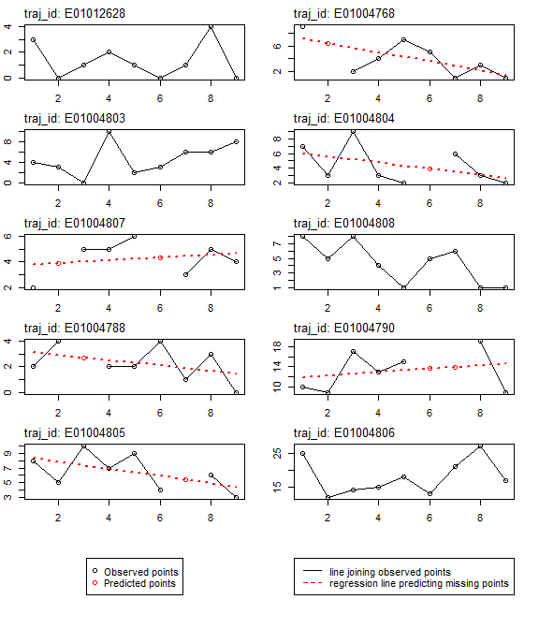

Figure 1: data imputation with regression

### A special use of ‘dataImputation’ function:

Generally, obtaining the denominator information (i.e. population) for non-census years is a difficult task in longitudinal studies. This challenge pose a significant drawback to accurate estimation of measures, such as crime rates and population-at-risk of an infectious disease, across a geographical space. Given a limited number of denominator information, an alternative way of obtaining the missing data points is to interpolate and/or extrapolate the missing population information using the available data points. The dataImputation function can be used for perform this task.

The key step towards using the function for this purpose is to create a matrix (in Excel), containing both the available fields and the missing fields arranged in their appropriate order. All the entries of the missing fields can be filled with either NA or null. An example of this type of problem is demonstrated below with a population data with only two available data fields. The corresponding input matrix of the population data is also shown.

#viewing the data first 6 rows  
head(population)  
#> location_id census_2003 census_2007  
#> 1 E01004809 300 200  
#> 2 E01004807 550 450  
#> 3 E01004788 150 250  
#> 4 E01012628 100 100  
#> 5 E01004805 400 350  
#> 6 E01004790 750 850  
  
nrow(population) #no. of rows  
#> [1] 11  
  
ncol(population) #no. of columns  
#> [1] 3

The corresponding input dataset is prepared as follows and saved as population2:

#> location_ids X2001 X2002 X2003 X2004 X2005 X2006 X2007 X2008 X2009  
#> 1 E01004809 NA NA 300 NA NA NA 200 NA NA  
#> 2 E01004807 NA NA 550 NA NA NA 450 NA NA  
#> 3 E01004788 NA NA 150 NA NA NA 250 NA NA  
#> 4 E01012628 NA NA 100 NA NA NA 100 NA NA  
#> 5 E01004805 NA NA 400 NA NA NA 350 NA NA  
#> 6 E01004790 NA NA 750 NA NA NA 850 NA NA

The missing values are estimated as follows using the regression method of the dataImputation function:

pop_imp_result <- dataImputation(population2, id_field = TRUE, method = 2,   
 replace_with = 1, fill_zeros = FALSE)  
#> [1] "77 entries were found/filled!"  
  
#viewing the first 6 rows  
head(pop_imp_result)  
#> location_ids X2001 X2002 X2003 X2004 X2005 X2006 X2007 X2008 X2009  
#> 1 E01004809 350 325 300 275 250 225 200 175 150  
#> 2 E01004807 600 575 550 525 500 475 450 425 400  
#> 3 E01004788 100 125 150 175 200 225 250 275 300  
#> 4 E01012628 100 100 100 100 100 100 100 100 100  
#> 5 E01004805 425 412.5 400 387.5 375 362.5 350 337.5 325  
#> 6 E01004790 700 725 750 775 800 825 850 875 900

Given that there are only two data points in each row, the regression method simply generates the missing values by fitting a straight line to the available data points. In other words, the higher the number of available data points for any trajectory the better the estimation of the missing points.

### (ii) "rates" function

Given a longitudinal data ($m×n$) and its associated denominator data ($s×n$), the rates function converts the longitudinal data to ‘rates’ measures (e.g. counts per 100 residents). Both the longitudinal and the denominator data may contain different number of rows, but they must have the same number of columns, and must include the id (unique) field in their respective first column. They do not have to be sorted. The output contains only rows whose id values match in both data. We demonstrate the utility of this function with the imp_traj object (above) and the estimated population data (‘pop_imp_result’).

#example of estimation of 'crimes per 200 residents'  
crime_per_200_people <- rates(imp_traj, denomin=pop_imp_result, id_field=TRUE,   
 multiplier = 200)  
  
#view the full output  
crime_per_200_people  
#> location_ids X2001 X2002 X2003 X2004 X2005 X2006 X2007 X2008 X2009  
#> 1 E01012628 6 0 2 4 2 0 2 8 0  
#> 2 E01004768 3.6 2.86 1 2.29 4.67 4 1 4 2  
#> 3 E01004803 2.29 1.6 0 4.71 0.89 1.26 2.4 2.29 2.91  
#> 4 E01004804 5.09 1.92 5.14 1.55 0.94 1.69 2.4 1.12 0.7  
#> 5 E01004807 0.67 1.36 1.82 1.9 2.4 1.84 1.33 2.35 2  
#> 6 E01004808 6.4 3.64 5.33 2.46 0.57 2.67 3 0.47 0.44  
#> 7 E01004788 4 6.4 3.63 2.29 2 3.56 0.8 2.18 0  
#> 8 E01004790 2.86 2.48 4.53 3.35 3.75 3.3 3.29 4.34 2  
#> 9 E01004805 3.76 2.42 5 3.61 4.8 2.21 3.09 3.56 1.85  
  
#check the number of rows  
nrow(crime_per_200_people)  
#> [1] 9

It can be observed that the number of rows of the output data is 9. This implies that only 9 location_ids match between the two dataset. The unmatched ids are ignored. **Note**: the calculation of rates often returns output with some of the cell entries having Inf and NA values due to calculation errors and character inputs in the data. We therefore recommend that users re-run the dataImputation function after generating rates measures for a large data matrix.

### (iii) "props" function

Given a longitudinal data, the props function converts each data point (i.e. entry in each cell) to the proportion of the sum of their corresponding column. Using the crime_per_200_people estimates above, we can derive the proportion of crime per 200 people for each entry as:

#Proportions of crimes per 200 residents  
prop_crime_per200_people <- props(crime_per_200_people, id_field = TRUE)  
  
#view the full output  
prop_crime_per200_people  
#> location_ids X2001 X2002 X2003 X2004 X2005 X2006 X2007 X2008 X2009  
#> 1 E01012628 0.17 0.00 0.07 0.15 0.09 0.00 0.10 0.28 0.00  
#> 2 E01004768 0.10 0.13 0.04 0.09 0.21 0.19 0.05 0.14 0.17  
#> 3 E01004803 0.07 0.07 0.00 0.18 0.04 0.06 0.12 0.08 0.24  
#> 4 E01004804 0.15 0.08 0.18 0.06 0.04 0.08 0.12 0.04 0.06  
#> 5 E01004807 0.02 0.06 0.06 0.07 0.11 0.09 0.07 0.08 0.17  
#> 6 E01004808 0.18 0.16 0.19 0.09 0.03 0.13 0.16 0.02 0.04  
#> 7 E01004788 0.12 0.28 0.13 0.09 0.09 0.17 0.04 0.08 0.00  
#> 8 E01004790 0.08 0.11 0.16 0.13 0.17 0.16 0.17 0.15 0.17  
#> 9 E01004805 0.11 0.11 0.18 0.14 0.22 0.11 0.16 0.13 0.16  
  
  
#A quick check that sum of each column of proportion measures adds up to 1.   
colSums(prop_crime_per200_people[,2:ncol(prop_crime_per200_people)])  
#> X2001 X2002 X2003 X2004 X2005 X2006 X2007 X2008 X2009   
#> 1.00 1.00 1.01 1.00 1.00 0.99 0.99 1.00 1.01

As first demonstrated in Adepeju, Langton, and Bannister (2019) in their long-term inequality study, we will use this proportion measure to demonstrate the main clustering function of this package.

### (iv) "outlierDetect" function

This function is aimed at allowing users to identify any outlier observations in a longitudinal data, and replace or remove them accordingly. The first step to addressing outliers in any data is to first visualise (plot) the data. A user can then decide the cut-off for isolating the outliers. The outlierDetect function provides two options for doing this: (i) a quantile method, while isolate any observation with a value higher than a specified quantile of the values distribution, and (ii) a manual method, in which a user defines the cut-off value. The ‘replace_with’ argument is used to determine whether the outlier value should be replaced with the mean value of the row or the column in which they are located. The user also has the option to simply remove the trajectory that contains the outlier value. In deciding whether a trajectory contains outlier or not, the count argument allows the user to set the horizontal threshold (i.e. number of outlier values that must detected in a trajectory) in order for the trajectory to be considered as having an outlier observations. Below, we demonstrate the utility of the outlierDetect function using the imp_traj data above.

#Plotting the data using ggplot library  
library(ggplot2)  
library(reshape2)  
  
#converting the wide data format into stacked format for plotting  
imp_traj_long <- melt(imp_traj, id="location_ids")   
  
#view the first 6 rows  
head(imp_traj_long)  
#> location_ids variable value  
#> 1 E01012628 X2001 3  
#> 2 E01004768 X2001 9  
#> 3 E01004803 X2001 4  
#> 4 E01004804 X2001 7  
#> 5 E01004807 X2001 2  
#> 6 E01004808 X2001 8  
  
#plot function  
p <- ggplot(imp_traj_long, aes(x=variable, y=value,  
 group=location_ids, color=location_ids)) +   
 geom_point() +   
 geom_line()  
  
print(p)

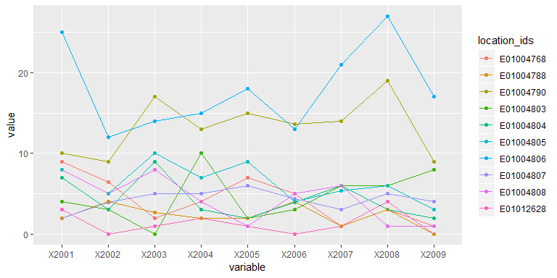

Figure 2 Identifying outliers

Figure 2 is the output of the above plot function.

Based on Figure 2, if we assume that observations of x2001, x2007 and x2008 of trajectory with id E01004806 are outliers, we can set the threshold argument as 20. In this scenario, we do not have to bother about the count argument as the trajectory is clearly separable from the rest of the trajectories using only the threshold argument. Setting replace_with = 2, that is to replace the outlier points with the mean of the row observations, the function generates results re-plotted in Figure 3.

imp_traj_New <- outlierDetect(imp_traj, id_field = TRUE, method = 2,   
 threshold = 20, count = 1, replace_with = 2)  
#> [1] "1 trajectories were found to contain outlier observations and replaced accordingly!"  
#> [1] "Summary:"  
#> [1] "*--Outlier observation(s) was found in trajectory 10 --*"  
  
imp_traj_New_long <- melt(imp_traj_New, id="location_ids")   
  
#plot function  
p <- ggplot(imp_traj_New_long, aes(x=variable, y=value,  
 group=location_ids, color=location_ids)) +   
 geom_point() +   
 geom_line()  
  
print(p)

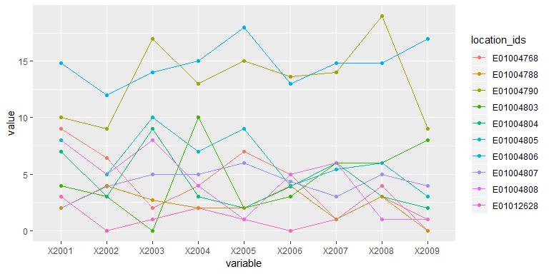

Figure 3: Replacing outliers with mean observation

### (v) ‘Other’ functions

Please see the akmedoids user manual for other useful data manipulation functions.

# 2. Data Clustering

Table 2 shows the two main functions for performing the longitudinal clustering and representing the results. These are the akmedoids.clust function and the statPrint function. The akmedoids.clust function cluster trajectories according to the similarities of their long-term trends, while the statPrint function extracts descriptive and change statistics of the clusters. Furthermore, the latter also generates performance plots for the best clustering solution as determined by the quality criterion.

The long-term trends of trajectories is defined in terms of a set of OLS regression lines. This allows the clustering function to classify the final groupings in terms of their slopes as rising, stable, and falling. The key benefit of this implementation is that it allows the clustering function to ignore the short-term fluctuations of the trajectories, and focus on their long-term linear trends. Adepeju, Langton, and Bannister (2019) were the first to demonstrate the utility of this idea in crime concentration research for measuring long-term inequalities in the exposure to crime at micro-area levels. They proposed the conceptual (inequality) framework shown in Figure 4 to describe trend lines to be clustered and mapped the final clustering output back to the original trajectory in order to allow the extraction of the performance statistics.

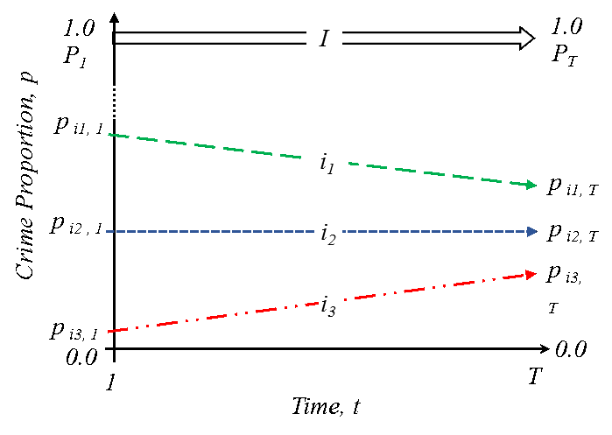

Figure 4: Long-time linear trends of relative (proportion, p) crime exposure. Three inequality trends: trajectory i1: crime exposure is falling faster, i2, crime exposure is falling at the same rate, and i3, crime exposure is falling slower or increasing, relatively to the citywide trend. (Source: Adepeju et al. 2019)

In addition to the use of trend lines, the akmedoids made two other modifications to the kmeans-like clustering routines. First, the akmedoids uses anchored initialisation strategy stage in order to represent ‘anchors’ for the algorithm to begin. The purpose behind this initial step is to give the algorithm a theoretically-driven starting point and try and ensure that heterogenous trends end up in different clusters (Khan and Ahmad (2004); Steinley and Brusco (2007)). Second, instead of recomputing centroids based on the mean distances between each trajectory trend lines and the cluster centers, the median of each cluster is selected and then used as the next centroid. This then becomes the new anchor for the current iteration of the expectation-maximisation step (Celeux and Govaert 1992). This strategy is implemented in order to minimise the impact of the outlier trend lines. The iteration is then continue until an objective function is maximised.

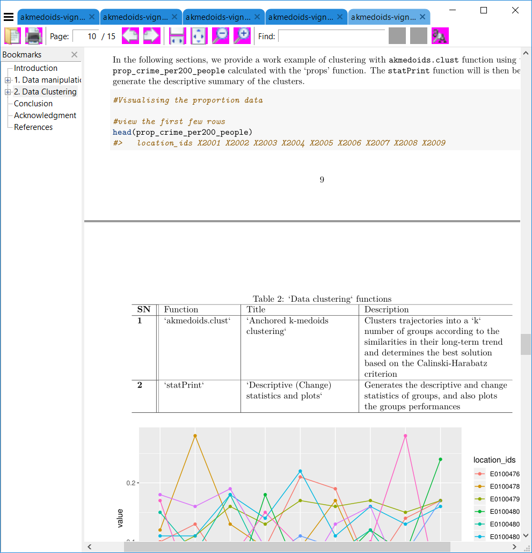

#Visualising the proportion data  
  
#view the first few rows  
head(prop_crime_per200_people)  
#> location_ids X2001 X2002 X2003 X2004 X2005 X2006 X2007 X2008 X2009  
#> 1 E01012628 0.17 0.00 0.07 0.15 0.09 0.00 0.10 0.28 0.00  
#> 2 E01004768 0.10 0.13 0.04 0.09 0.21 0.19 0.05 0.14 0.17  
#> 3 E01004803 0.07 0.07 0.00 0.18 0.04 0.06 0.12 0.08 0.24  
#> 4 E01004804 0.15 0.08 0.18 0.06 0.04 0.08 0.12 0.04 0.06  
#> 5 E01004807 0.02 0.06 0.06 0.07 0.11 0.09 0.07 0.08 0.17  
#> 6 E01004808 0.18 0.16 0.19 0.09 0.03 0.13 0.16 0.02 0.04  
  
prop_crime_per200_people_melt <- melt(prop_crime_per200_people, id="location_ids")   
  
#plot function  
p <- ggplot(prop_crime_per200_people_melt, aes(x=variable, y=value,  
 group=location_ids, color=location_ids)) +   
 geom_point() +   
 geom_line()  
  
print(p)

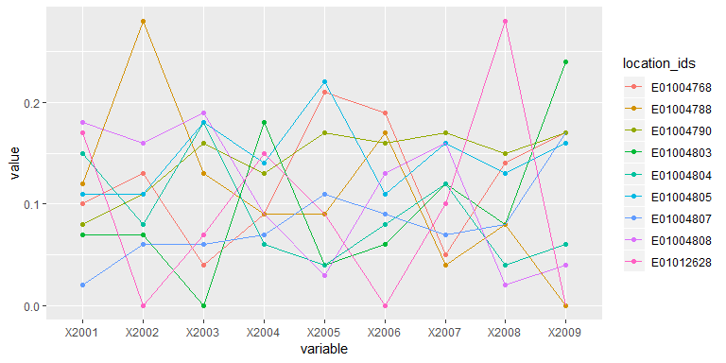

Figure 5: Trajectory of crime proportions over time

The above plot function generate the plot shown in Figure

### (i) akmedoids.clust function

***Data***: Figure 5 is the plot of the prop_crime_per200_people object from the ‘props’ function. Each trajectory in Figure 5 represents the proportion of crimes per 200 residents in each location over time. In other words, they represent the inequality trajectories and the goal is to first extract the inequality trend lines such as in Figure (4) and cluster them accordingly. For the akmedoids.clust function, a user sets the k value which may be an integer or a vector of length two specifying the minimum and maximum numbers of clusters to loop through. In the latter case, the akmedoids.clust function employs the Calinki-Harabatz score (Caliński and Harabasz (1974); Genolini and Falissard (2010)) to determine the best cluster solution. The function is ran as follows:

#clustering  
cluster_output <- akmedoids.clust(prop_crime_per200_people, id_field = TRUE,   
 method = "linear", k = c(3,8))  
#> [1] "solution of k = 3 determined!"  
#> [1] "solution of k = 4 determined!"  
#> [1] "solution of k = 5 determined!"  
#> [1] "solution of k = 6 determined!"  
#> [1] "solution of k = 7 determined!"  
#> [1] "solution of k = 8 determined!"  
  
#print cluster solution  
cluster_output  
#> [[1]]  
#>   
#> $qualitycriterion  
#> [1] "Quality criterion: Calinski-Harabatz criterion"  
#>   
#> $optimSolution  
#> [1] "C" "D" "E" "B" "E" "A" "A" "D" "C"  
#> attr(,"k")  
#> [1] 5

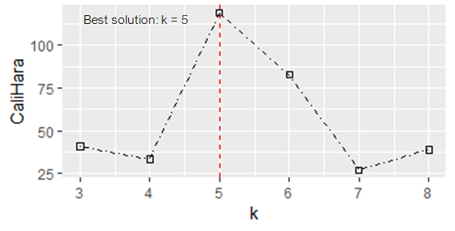

Figure 6: Clustering performance at different values of k

In addition to printing the output messages (as above), the akmedoids.clust function generates a performance plot (Figure 6) that shows the Calinki-Harabatz scores at different values of k. From the plot, the best value of k is highest at k=5, and therefore determined the best solution. Note that the group membership (labels) listed in the output message is that of the best solution determined (i.e. group A to group E). These labels can be extracted by typing the following command:

#vector of group memberships  
as.vector(cluster_output$optimSolution)   
#> [1] "C" "D" "E" "B" "E" "A" "A" "D" "C"

Also, note that the indexes of the group memberships correspond to that of the trajectory object (prop_crime_per200_people) inputted into the function. That is, the labels, "C", "D", "E", .... are the group membership of the trajectories "E01012628","E01004768","E01004803",... of the object prop_crime_per200_people.

### (ii) statPrint function:

Given the vector of group membership (labels), such as = c("C", "D", "E", "B",....) in the example above, and its corresponding trajectory object prop_crime_per200_people, the statPrint function generates both the descriptive and the change statistics of the groups. The function also generates the plots of the group memberships and their performances in terms of their share of the proportion measure captured over time. An important argument of statPrint function is the bandw parameter which determines the final classification of the groups in terms of slope. The bandw argument classify each groups into Rising, Stable, or Falling class. Please, see the package user manual for more details about this parameter. Using the current example, the function can be ran as follows:

#assigning cluster membership to a variable  
clustr <- as.vector(cluster_output$optimSolution)   
  
#plotting the group membership  
print(statPrint(clustr, prop_crime_per200_people, id_field=TRUE,   
 bandw = 0.40, type="lines", y.scaling="fixed"))  
#> $descriptiveStats  
#> group n n(%) %Prop.time1 %Prop.timeT Change %Change  
#> 1 A 2 22.2 30 4 -26 -650  
#> 2 B 1 11.1 15 5.9 -9.1 -154.2  
#> 3 C 2 22.2 28 15.8 -12.2 -77.2  
#> 4 D 2 22.2 18 33.7 15.7 46.6  
#> 5 E 2 22.2 9 40.6 31.6 77.8  
#>   
#> $changeStats  
#> group sn %+ve Traj. %-ve Traj. class  
#> 1 A 1 0 100 Rising  
#> 2 B 2 0 100 Rising  
#> 3 C 3 100 0 Stable  
#> 4 D 4 100 0 Falling  
#> 5 E 5 100 0 Falling

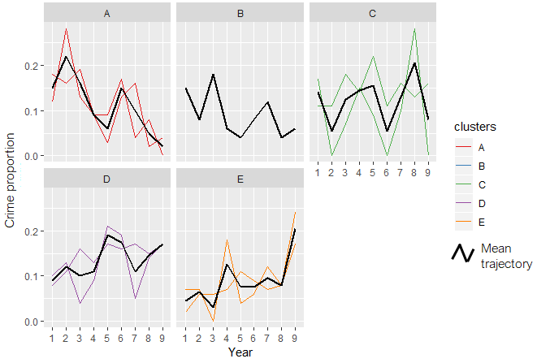

Figure 7: group memberships

See Table 3 for the description of the output table fields. These outputs are generated along with the plot of group memberships as shown in Figure 7. By changing the argument type="line" to type="stacked", a performance plot is generated instead (see Figure 8). Note that these plots draw from the ggplot2 library (Wickham 2016). For a more customised visualisation, we recommend that users deploy the ggplot2 library directly.

In the context of long-term inequality study, the these outputs should allow inferences to be made regarding relative crime exposure of crime in the area represented by each group or class (Adepeju, Langton, and Bannister 2019). For example, whilst relative crime exposure have declined in 33.3% (groups A and B) of the area, the relative crime exposure have risen in 44.4% (groups D and E) of the area. The relative crime exposure can be said to be stable in 22.2% (group C) of the area, based on the bandw parameter.

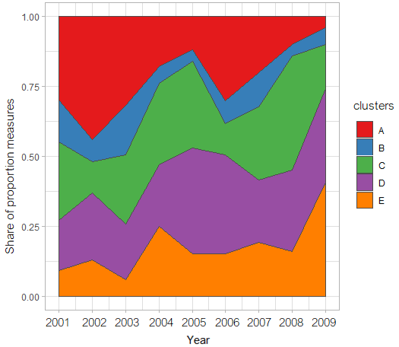

Figure 8: group performance over time



# 

# Conclusion

The akmedoids package is developed in order to aid the replication of crime inequality investigation conducted in Adepeju, Langton, and Bannister (2019). Meanwhile, the utility of the functions in this package is not limited to this study, but rather applicable to any longitudinal datasets. This package is being updated on a regular basis to add more functionalities to the existing functions or add new functions to perform new longitudinal data analysis.

Lastly, we employ users to report any bugs encountered while using the package so that they can be fixed immediately. Also, we welcome contributions to this package and such contributions shall be acknowledged accordingly.

# Acknowledgment

# References

Adepeju, M., S. Langton, and J. Bannister. 2019. “Anchored K-Medoids: A Longitudinal Clustering Technique for Measuring Long-Term Inequality in the Exposure to Crime at the Micro-Area Levels.” *Journal of Quantitative Criminology*. (Submitted).

Caliński, T., and J. Harabasz. 1974. “A Dendrite Method for Cluster Analysis.” *Communications in Statistics-Theory and Methods* 3(1): 1–27.

Celeux, G., and G. Govaert. 1992. “A Classification Em Algorithm for Clustering and Two Stochastic Versions.” *Computational Statistics* 14(3): 315–32.

Genolini, C., and B. Falissard. 2010. “Kml and Kml3d: R Packages to Cluster Longitudinal Data.” *Computational Statistics* 25(2): 317–28.

Griffith, E., and J.M. Chavez. 2004. “Communities, Street Guns and Homicide Trajectories in Chicago, 1980–1995: Merging Methods for Examining Homicide Trends Across Space and Time.” *Criminology* 42(4): 941–78.

Khan, S. S, and A. Ahmad. 2004. “Cluster Center Initialization Algorithm for K-Means Clustering.” *Pattern Recognition Letters* 25(11): 1293–1302.

Steinley, D., and M. J. Brusco. 2007. “Initializing K-Means Batch Clustering: A Critical Evaluation of Several Techniques.” *Journal of Classification* 24(1): 99–121.

Wickham, H. 2016. *Elegant Graphics for Data Analysis*. Spring-Verlag New York.