#Indiref2: Twitter and the Potential for a Second Scottish Independence Referendum

Author: Monsuru Adepeju

On Twitter, conversations around Scotland’s independence, dampened momentarily by a failed referendum in 2014, have been reinvigorated with advent of Brexit. By downloading tweets from January of this year, this article examines how public sentiment towards Scottish independent varies across the United Kingdom four constituent nations (i.e. England, Wales, Northern Ireland, and Scotland).

Perhaps not surprisingly, the majority of tweets (71.4%) on the subject were sent from the mainland of Scotland. 22.2% were sent from England, and collectively, Wales and Northern Ireland account for less than 6% of the tweets (see Figure 1).

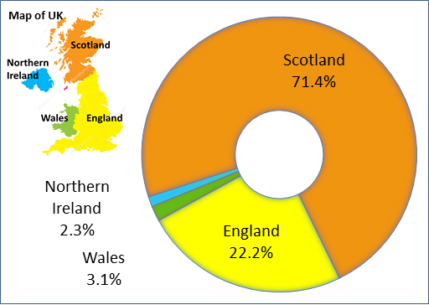

Figure 1. Percentage of tweets on Scottish Independence across the United Kingdom, between January 1st and January 30th, 2020

**Words used in tweets**

Figure 2 showcases the most commonly used words in these tweets by country. The bigger and bolder a word appears, the more often it is mentioned in the posts. The most common words, such as ‘Indiref2’, ‘Scottish’, ‘independence’, and names of countries were removed in order to enable clearer visualization.

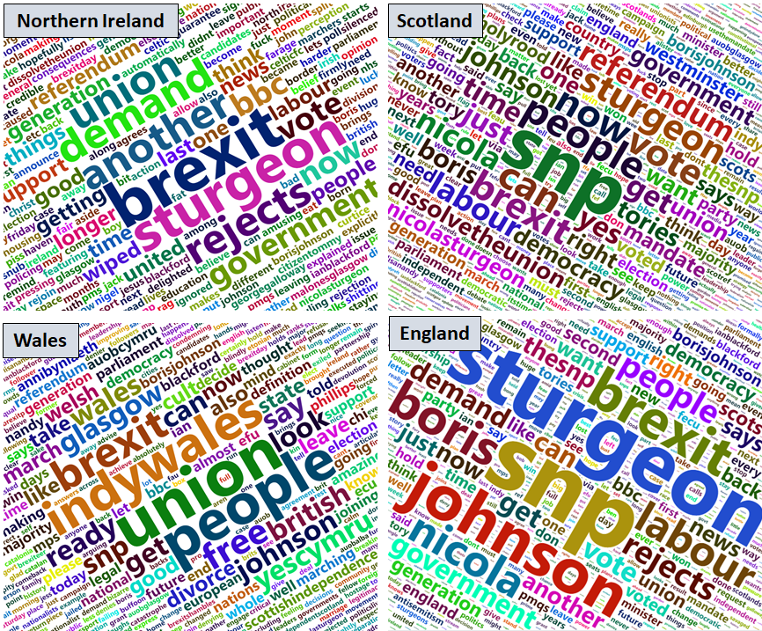

Figure 2. Words used in tweets

There are both similarities and differences between the four countries. Names, such as ‘Boris,’ ‘Johnson,’ and ‘Sturgeon’ are amongst the most commonly used words. Interestingly, ‘Brexit’ proves highly significant in each country. This appears to support the fact that the anxieties around Brexit may have given some momentum to the elevated calls for a second Scottish referendum. For example, following the December 2019 general election which has increased the likelihood of Brexit taking place, the Scottish National Party (SNP) has intensified their campaign for the second referendum.

There are a few distinct words associated with Scotland and Wales as compared with the rest of the UK due to both nation’s independence movements For example, the word ‘referendum’ in Scotland clearly emphasizes the discussion around the call for another referendum. In Wales,, words such as ‘Indywales’ and ‘yescymru,’ can be attributed to the rising nationalist sentiments across the nation. Despite the Welsh having supported Brexit, it appears that the discussion of Scottish independence, on Twitter, may have prompted renewed interest for an independence amongst the Welsh people. . Whilst there were no such words in Northern Ireland and England, the word ‘rejects’ was found to stand out in both countries, in which it was mostly used to express negative sentiments about the idea of another Scottish independence.

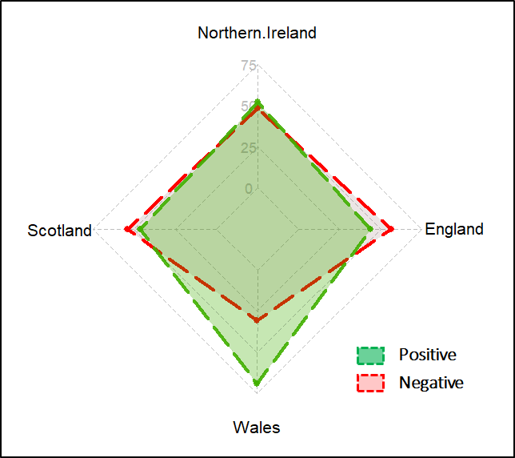

Figure 3 Binary classification of sentiment (%)

**Emotions expressed in tweets**

Using a text mining technique, in which the sentiments expressed in a text can be discovered, I extracted the purported emotions expressed in these tweets, performing a binary classification of tweets in each country into positive or negative sentiment. Wales and Northern Ireland appear to have more positive sentiments (69% and 51%, respectively), as compared to the negative sentiments (31% and 49%, respectively). On the other hand, both England and Scotland have higher negative sentiments (58% and 53%, respectively) as compared to their positive sentiments of 42% and 47%, respectively (See Figure 3). The results for Scotland, in particular, appear to contrast the [YouGov poll](https://yougov.co.uk/topics/politics/articles-reports/2020/01/30/scottish-independence-yes-leads-remainers-increasi?utm_source=twitter&utm_medium=website_article&utm_campaign=scottish_independence_Jan_2020).), published on the eve of Brexit, which has Yes in the lead for the first time since 2015, by 51% to 49%.

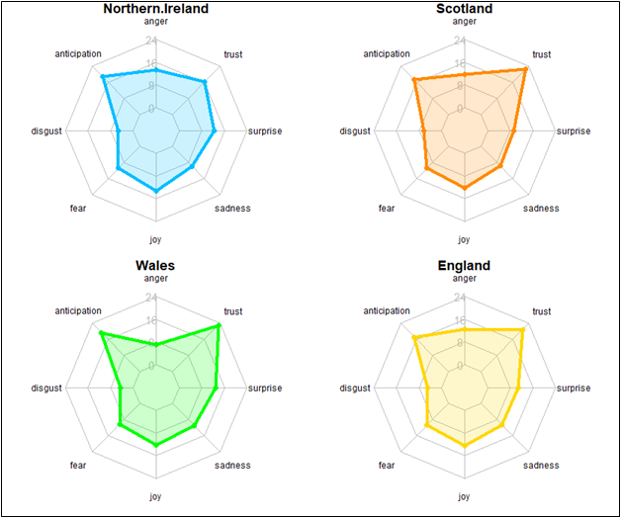

Figure 3. Sentiment analysis of tweets (%)

Figure 3 provides further insight into a range of common human sentiments, such as trust, surprise and joy. Generally speaking, the patterns across all four countries are comparable. Most notably, the figure shows similar levels of ‘fear’, ‘joy’ and ‘sadness‘ across all four countries. ‘Anticipation’ and ‘trust’ are the two most expressed emotions, with Wales showing slightly higher percentages in both categories. ‘Disgust’ is the least expressed sentiment relating to the subject.

.

In conclusion, this article highlights the significance of the new big data sources, such as Twitter, in providing windows into the raw emotions behind the conversations around key political issues, such as the second Scottish Independence referendum, in the UK. There are three key takeaways based on the results presented in this article: first, the potentials for second Scottish independence referendum may have energized similar political movements in other part of UK, especially in Wales. Second, that Brexit might have contributed to the recent calls for another referendum in Scotland. Lastly, that the expressed emotions on the subject of second Scottish referendum is mixed, but many Twitter users from Wales appear to have overwhelmingly positive view of the political.