Analyzing the national variations in the political sentiments using Twitter data – A case of Scottish Independence

Author: Monsuru Adepeju

In the three and half years since the Brexit referendum, the conversations around Scotland’s independence, dampened momentarily by a failed referendum in 2014, has been reinvigorated with the ‘certainty’ of Brexit, thanks to the 2019 UK general election. Scottish independence is the political movement for Scotland to become a sovereign state, independent from the United Kingdom. On Twitter, a significant amount of conversation about another Scottish referendum on a daily basis, with specific tags such as ‘#Indyref2’, ‘#scottishreferendum and so on, which makes it possible to download the posts and analyse them. By using the posts (excluding ‘retweets’ and ‘replies’) between the January 1 and January 25, 2020, I compare the variations in the political sentiments expressed, in relation to the potential Scottish Independence, across the four constituents nations (i.e. England, Wales, Northern Ireland and Scotland) of the United Kingdom. Figure 1 shows that the majority of the tweets (73%) were sent out from the mainland of Scotland, while another 24% from England. Northern Ireland and Wales have small share of 1% and 2% respectively (Inserted is a map of the UK, showing the relative position of each country).

Figure 1. Percentage of tweets post about Scottish Independence (on Twitter) in the UK

In Figure 2, the ‘Wordclouds’ is used to show the relative importance of the words used in the posts in each country. The bigger and bolder a word appears, the more often it is mentioned in the posts and the more important it is. Dominant words, such as ‘Scotland’, Scottish and all the hashtags, across the four nations have been filtered out in order to enable better representation. There are similarities and differences between the four countries. Words such as “Brexit” “Johnson” “Independence” can be seen across all countries, with more importance in Scotland compared to others. These are words that are most connected with the Scottish independence conversation in recent time. In terms of the differences, we found words that have specific meaning within the political context of each country. For example, in Wales, “Indywales”, is a word that has been attributed to the nationalist sentiments in the past few years. Conversely, the word “union” also appear to be of similar importance in the conversations. The limitation of this technique is that is not able to capture the context in which a word is used. In other words, we cannot decipher whether the sentence in which a word is used carries a negative or positive emotion.

Polarity of Sentiment

Polarity is used to.

the That is, the emotional whether the For example, we cannot detect sarcasm from the representation.

Although, Also, ‘wordcloud’ is able to provide a q what idea of subjects of discussion.

For example, In what context is a word used.

Although, this technique is not able to detecting sarcasm, it will detect it as a negative sentiment.

Given the limitation, in what context there words are used. Polarity of sentiment.. So, in this context, it is difficult to learnt whether “rohingyacrisis” used in positive or negative reference.

nation-based analysis has never been more necessary, when nationalist sentiments

“Union” stand out, which portray the sentiments that words that are important within the political context

You can easily see the similarities and differences between the two speeches at a glance. “America” and “Americans” are still major words, but “help,” “work,” and “new” are more prominent than in 2012.

, size indicates the importance (frequency) of words in tweets. showing the importance of word quantify in terms of their frequency.

First, is a ‘Wordcloud’ of important words in tweets (of each country) wrapped within the UK boundary. The second figure is a chart that visualises is the polarity of sentiments (positive or negative) across each country, and the third figure shows the subjectivity of sentiments (i.e. representation of sentiments into a broad range of emotional classification). Images are created in high-quality png format.

Sentiment analysis or opinion mining is the computational study of opinions, sentiments and emotions expressed in text.

Generated word clouds need to be used carefully but they present a quick and easy way of data visualization.

Also, the twitter sentiment is not effective for detecting sarcasm, it will detect it as a negative sentiment.

Also giving hashtag under wrong category will also give positive, negative or neutral results

Given the limitation, in what context there words are used. Polarity of sentiment.. So, in this context, it is difficult to learnt whether “rohingyacrisis” used in positive or negative reference.

Sentiment and subjectivity classification: This is the area that has been researched the most in academia. It treats sentiment analysis as a text classification problem. Two sub-topics that have been

we only focus on opinion expressions that convey people’s positive or negative sentiments. Much of the existing research on textual information processing has been focused on mining and retrieval of factual information, e.g., information retrieval, Web search, text classification, text clustering and many other text mining and natural language processing tasks. Little work had been done on the processing of opinions until only recently. Yet, opinions are so important that whenever we need to make a decision we want to hear others’ opinions. This is not only true for individuals but also true for organizations.

extensively studied are: (1) classifying an opinionated document as expressing a positive or negative opinion, and (2) classifying a sentence or a clause of the sentence as subjective or objective, and for a subjective sentence or clause classifying it as expressing a positive, negative or neutral opinion. The first topic, commonly known as sentiment classification or document-level sentiment classification, aims to find the general sentiment of the author in an opinionated text. For example, given a product review, it determines whether the reviewer is positive or negative about the product. The second topic goes to individual sentences to determine whether a sentence expresses an opinion or not (often called subjectivity classification), and if so, whether the opinion is positive or negative (called sentence-level sentiment classification).

to allow other words to manifest.

r to allow important words une

# Analyzing the word cloud

It appears that words like **data, million,users, private, information, prison** etc are used several times in the tweets that were extracted. These words alone sometimes may not make sense, but if read in context then it can tell a million dollar story.

In Figure 2,

Using the public twitter API and geospatial (GIS) techniques, I scrapped any tweets that include any of the hashtags: ‘Indiref’, ‘indiref2’, ‘scottishreferendum’, ‘scottishref’, and ‘Scottishindependence’. The data covers the last three weeks before January 31st, producing a total of 1.3 million tweets. In Figure 1, the bar chart shows the density of the ‘tweets’, ‘retweet’ and ‘replies’ across each nation. Scotland carries the largest number of tweets on brexit… The chart indicate a significant inequality in the tweet density with Scotland and England 90% being generated from Scotland, followed by scotland.. .

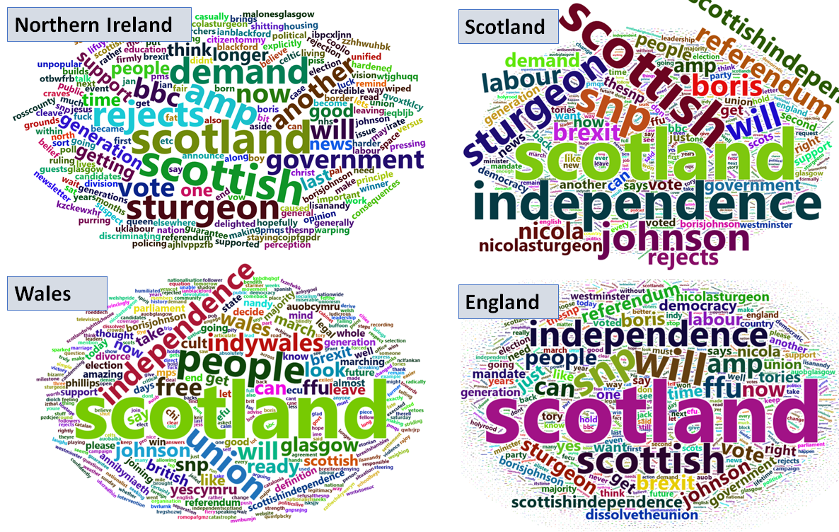

Figure 1. Importance of words used in tweets

Figure 1 illustrates the relative important of terminologies been used in the tweets within each country. The ‘importance’, represented by the font size is quantified in terms of the number of times a word has appeared across all tweets. In Scotland, words, such as are most frequently used and they all have almost equal importance. This implies that the discussions around the referendum are very focussed. This is followed by England with higher variances in the importances. Both Wales and . Northern Ireland has the highest variances.

Fig. 1.

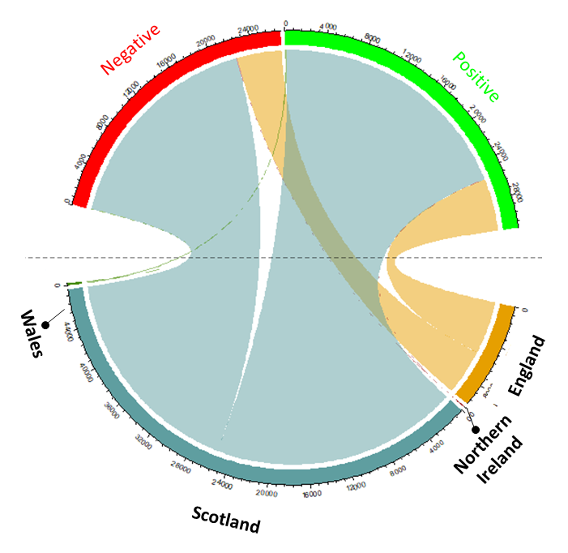

The width indicates the proportion of tweet in size. Combine.

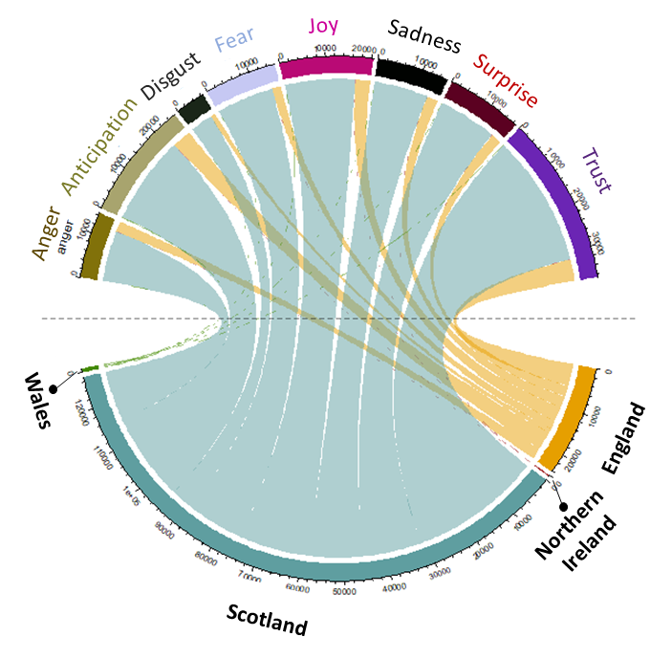

were sent out within the mainland of Scotland primarily on tweets with hashtag discussions taking place in Scotland referendum being perculiar to the Scottish people, the discussion where people are able to voice their own opinion, free-of-censorship. To data analysts, Twitter provides a valuable source of diverse range of political sentiments subject on Scottish referendum. To date however, sentiment analysis of the Twitter data have focused on the entire United Kingdom in unison, minimizing the ability to reveal the variation of those political sentiments across the constituent nations, namely the England, Scotland, Wales, and Northern Ireland. The nation-based analysis has never been more necessary, when nationalist sentiments are on the rise across each nation, even in Northern Ireland which voted overwhelmingly to remain in the EU. This article provides a glimpse into the variances in the political sentiments about the Scottish referendum prior to the UK exiting the EU on the 31st January 2020.

Organic

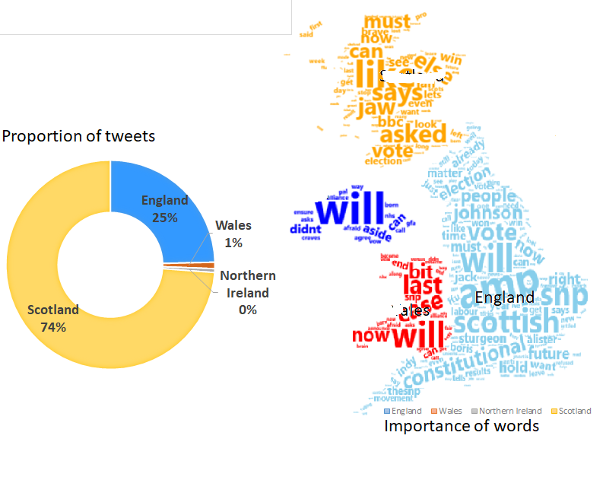

Fig. 2. Sentiments across the countries

I employ a naïve Bayes classifier technique to classify the tweets in different types of emotion: anger, disgust, fear, joy, sadness, and surprise.

The Topic analysis is used to examine the type of adjacent is most common in the tweets of each nation. Figure 1 maps the top 10 words. It can be seen that appears in the top 5, only 1 appear in top 1.

Comparing the polarity of expressions

it extracts the polarity of the expressed opinion in a range spanning from positive to negative. As a result, one may also refer to sentiment analysis as opinion mining (Pang and Lee 2008).

### **Comparison Cloud**

A comparison cloud compares the relative frequency with which a term was used in two or more documents. It does not simply merge two word clouds. Rather, it plots the difference between the word usage in the documents. For example, in 2008, President Bush used the word “america” 30 times. In 2016, President Obama used it 21 times. In the word cloud below, “america” is printed on President Bush’s side with a frequency of 9. It does not appear at all on President Obama’s side because it is “cancelled out.” So this shows you that President Bush used the word “america” more.

The comparison.cloud() function takes as an argument the Term Document Matrix created above with separate columns for each document. The rest of the arguments are for customization.

From the comparison cloud, we can see that issues like Iraq were more front-and-center in 2008 than in 2016. We also see ISIL, which didn’t exist (at least by that name) in 2008, pop up in President Obama’s speech. “Change” was used more by President Obama and, interestingly, “hope” was used more often in President Bush’s 2008 speech.

par(mfrow=c(1,1))

comparison.cloud(tdm, random.order=FALSE, colors = c("indianred3","lightsteelblue3"),

title.size=2.5, max.words=400)

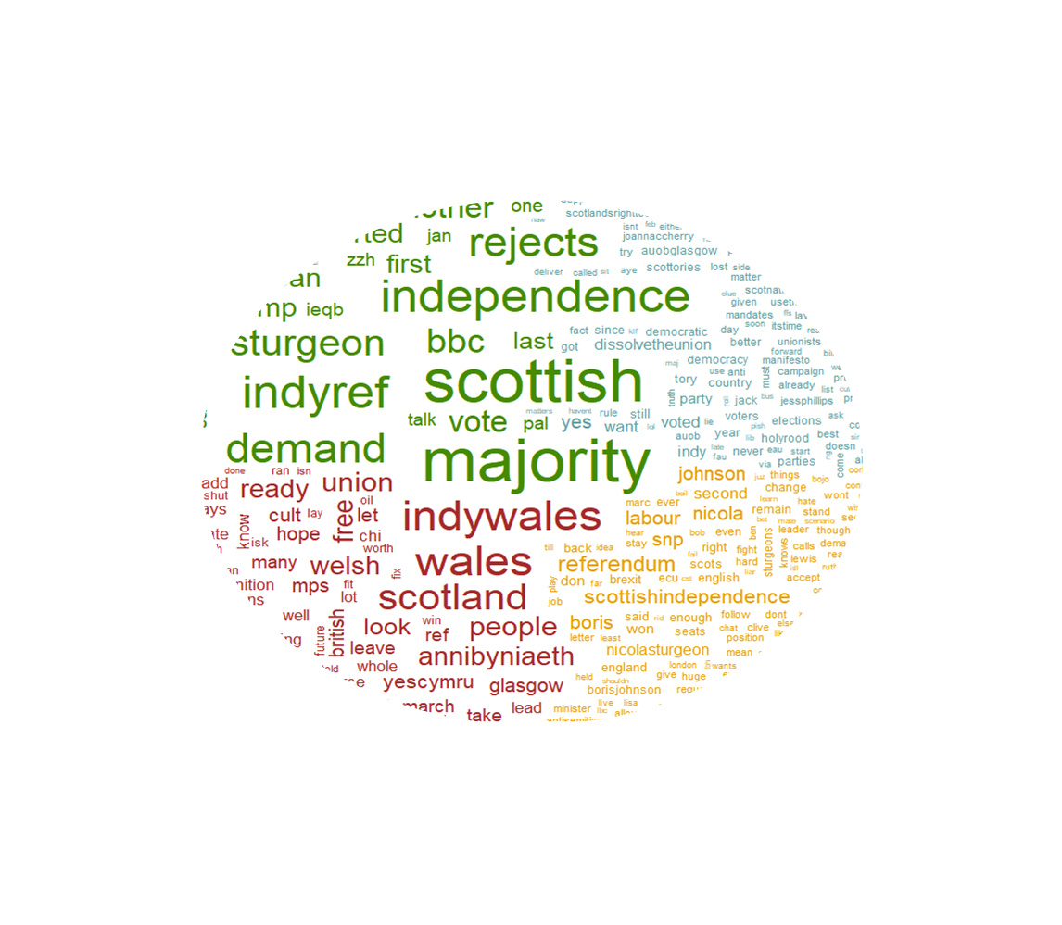

### **Commonality Cloud**

The commonality cloud is the complement to the comparison cloud. It shows only those words that appear in all documents and their combined frequency across documents. A commonality cloud is useful for showing the amount of conceptual overlap between two documents.

It’s understandable that all presidents would use words like “people” and “america.” Perhaps most interesting here is that the commonality cloud makes it obvious that the SOTU is about the “future,” “american” and “world” issues, and “new” proposals. Also prominent are words like “security” which at least for the recent past has been a hot topic.

**library**(RColorBrewer)

commonality.cloud(tdm, random.order=FALSE, scale=c(5, .5),colors = brewer.pal(4, "Dark2"), max.words=400)

Expanded sentiments

* It can classify emotions (anger, disgust, fear, joy, sadness, surprise); trained using Naive Bayes on a dataset of approximately 1500 words [Carlo Strapparava and Alessandro Valitutti, “WordNet-Affect: an affective extension of WordNet”. In Proceedings of the 4th International Conference on Language Resources and Evaluation (LREC 2004), Lisbon, May 2004, pp. 1083-1086].
* It can also classify polarity (positive/negative); trained using Naive Bayes classifier on Janyce Wiebe’s subjectivity lexicon [Riloff and Wiebe (2003). Learning extraction patterns for subjective expressions. EMNLP-2003].

The sentiment analysis is conducted using text mining techniques. For a comprehensive analysis, we employ the three different sentiment lexicons (‘bing’, ‘abing’ and ‘other’) in order to map the tones and emotion of the tweets. Each dictionary contains starts by comparing relative number tweets with of positive, negative and neutral sentiments. We can see that ..

With nationalist sentiments appearing to be on the rise, particularly in Northern Ireland and Wales, the national level analysis has better potentials to highlights the sentiments of the people on the state of the union.

Which which originated from

I then employ used another sentiment lexison to generate a much richer categorization of the tweets for each nation.

In order to examine the actual topics that people discussion, we mapped out most common words in the tweets. Most common words

Histograme on 3d map

Although Scottish referendum is

Shows that independence.

**My Pitch**

**Section: Politics + Society**

**Story**

To date, the sampling/analysis of the political opinions on the potential Scottish Independence have focused primarily on the mainland of Scotland. It is therefore unclear how the rest of the United Kingdom feel about the political issue. Using Twitter data, a hybrid geo-text mining technique is used to reveal the sentiments of UK citizens about the political issue in the few weeks to the 31st January 2020, the brexit date. My analysis reveals a wide range of sentiments across the UK, with a markedly varying nature across the four countries (i.e. Scotland, England, Wales, and Northern Ireland). The results of the analysis also reveal that ‘Brexit’ is a key issue driving most of the expressed sentiments on the subject.

**Significance**

The article presents a framework for a multi-national analysis of political sentiments using Twitter data. With the access to the open-source codes (on GitHub <http://github.com/manalytics/sentiment-analysis> used for the data download, analysis and visualization, the article presents a significant reproducibility values for social scientists and academics.

**Timeliness: now**

**Multimedia**

There are three figure in total. First, is a ‘Wordcloud’ of important words in tweets (of each country) wrapped within the UK boundary. The second figure is a chart that visualises is the polarity of sentiments (positive or negative) across each country, and the third figure shows the subjectivity of sentiments (i.e. representation of sentiments into a broad range of emotional classification). Images are created in high-quality png format.

**Key Points**

* Provides a glimpse into the variances in the political sentiments about the Scottish referendum prior to the UK exiting the EU on the 31st January 2020.
* Open-source piece of software in R for use for replicating similar analysis.

In the three and half years since the Brexit referendum, the discussions around Scotland’s independence, dampened momentarily by a failed referendum in 2014, has been reinvigorated by the ‘certainty’ of Brexit, thanks to the outcome of last UK general election. A significant amount of these discussions take place on Twitter where people are able to voice their own opinion, free-of-censorship. To data analysts, Twitter provides a valuable source of diverse range of political sentiments subject on Scottish referendum. However, the analysis of Twitter datao date however, sentiment analysis of the Twitter data have focused on the entire United Kingdom in unison, minimizing the ability to reveal the variation of those political sentiments across the constituent nations, namely the England, Scotland, Wales, and Northern Ireland. The nation-based analysis has never been more necessary, when nationalist sentiments are on the rise across each nation, even in Northern Ireland which voted overwhelmingly to remain in the EU. This article provides a glimpse into the variances in the political sentiments about the Scottish referendum prior to the UK exiting the EU on the 31st January 2020.

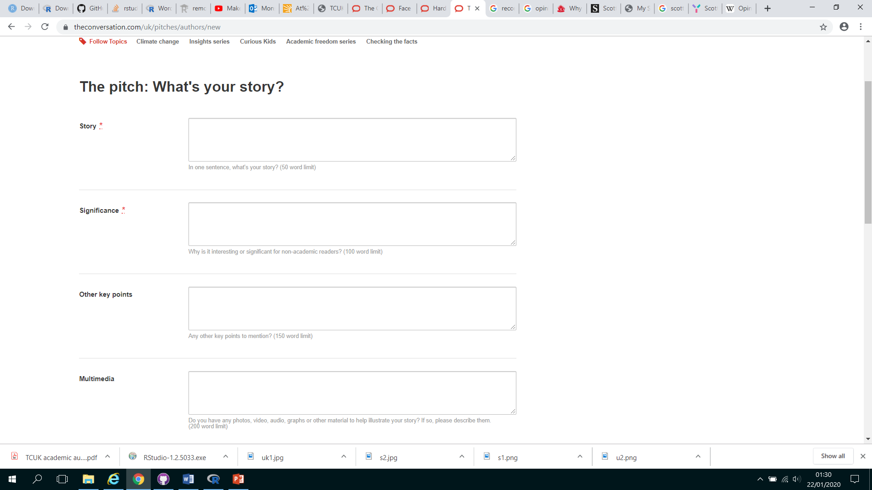

Enhancement to data analyst.

A road map to alternative

In the three and half years since the Brexit referendum, the discussions around Scotland’s independence, dampened momentarily by a failed referendum in 2014, has now been reinvigorated by the ‘certainty’ of Brexit. Polls have shown that the public opinions, particularly in Scotland, on the referendum is shifting in favour of ‘Yes’ to leaving the UK. It is however, unclear what the remainder of the country (namely the England, Wales and Northern Ireland) the referendum. The article will show how the polarity of sentiment on Twitter tallies with the traditional opinion polls (such <https://lordashcroftpolls.com/2019/08/my-scotland-poll-yes-to-independence-takes-the-lead/> and ). An extended analysis of sentiments shows that the public do possess quite an expansive range of sentiment on the subject.

political setting and polling.

. the analysis could be replicated by providing an open-source code.

the national variations in the political sentiments on the subject of

I provide link to an open-source codes for replicating the analysis for real-life policy application

Both polarity and The current sentiments in Scotland stands at 51% positive and 48% negative. , days to the brexit.

breaking up the union.

Up to now, it is unclear what the sentiment of the remainder of the country. This article found

In the few days leading to the UK leaving the EU, 51% of the country feels positive about the idea of holding the second Scottish referendum, a sentiment analysis of Twitter data reveals. Breaking the results down by nations (i.e. England, Wales, Northern Ireland, and Scotland), I found that the general public do possess quite an expansive range of sentiments over the subject. The analysis were made possible by a novel adaptation of text mining and geospatial techniques.

Generally positive.

Taken to twitter to discuss.

We employed an advance text mining .

political sentiment on the Scottish referendum and employing an advance text mining technique, sentiment analysis of twitter data shows.at the scale, sentiment analysis of Twitter data reveals.

Using Twitter data, the article will compare the political sentiments across the United Kingdom on the subject of Scottish independence, just before the UK leaves the European Union. The article improves over the existing articles on the subject in three ways: first, it compares the four constituent nations (England, Wales, Northern Ireland and Scotland) of the UK and second, it provide a link to an open-source code for replicating the analysis and discusses how the analysis could be used for decision making in politics.

Maps are commonly used by mainstream media to convey complex data to the public. Most recently, the BBC published a map to report on the latest Index of Multiple Deprivation data release (see <https://www.bbc.co.uk/news/uk-england-49812519>). These maps are widely shared by the public, who tend not to be aware of the misrepresentation that such visualisations can create. By visualising the deprivation of neighbourhoods in the top 10 most deprived Local Authorities in England (2019), using a variety of mapping techniques, this article will demonstrate the impact of these different approaches.

amount of discussion. , which shows that most of the discussion. is a chart showing relative size of the positive and negative tweets in each constituent nations (i.e. England, Scotland, Wales, and Northern Ireland), that made up the United Kingdom. This is further In Figure 2 which shows the , the relative number of tweets relating to . The generalization of . the concern may be different.

Sentiment

provide recommendation on how to the result could discusses how the analysis could be replicated provides an open-source code for future replication of the analysis ng for policy purposes.

replicating similar analysis, and lastly, it provides recommendations on how the and provide an

TwitterThe analysis will present an improved analysis of this subject in three ways: first, it usemake threewo significant contribution. First, the analysis is and then compare the sentiment between the four nations.

presents the

Nowadays, Twitter has become one of the most valuable source of diverse range of opinions on political issues in the United Kingdom, such as Brexit and Scottish referendum. The proposed article will examine

on political sentiments. To date however, the analysis of Twitter data have focused on entire country in unison, thereby minimizing the opmajority of analyst analysis of it has been very difficult to geocode tweets such that

However, the analysis of Twitter data is faced with one big challenge –

data have focused on the entire United Kingdom in unison, minimizing the ability to reveal the variation of those political sentiments across the constituent nations, namely the England, Scotland, Wales, and Northern Ireland. The nation-based analysis has never been more necessary, when nationalist sentiments are on the rise across each nation, even in Northern Ireland which voted overwhelmingly to remain in the EU. This article provides a glimpse into the variances in the political sentiments about the Scottish referendum prior to the UK exiting the EU on the 31st January 2020.

The analysis of political sentiment using Twitter data Sentiment analysis of social media data

Beyond

Traditional methods for mapping out the geographic distribution of phenomena such as deprivation can be misleading, but new approaches to visualising spatial data, such as hexagonal tile grids, can remedy these shortcomings.

. Further complicated by the cated In particular, now that the U.K. is leaving the EU – an outcome that was overwhelmingly rejected in Scotland and Northern Ireland - some have raised the question of whether the status quo can be begun to question whether devolved powers alone are enough.

tweet evident that a wide variety of perspectives will be provided.

point of view

for example, calls for a similar referendum, particularly in Northern Ireland and Wales, has been on the increase in each nation, it is apparent that

It has become imperative that sentiment regarding Scottish referendum may vary. This require an indepth nation-based analysis

Call for sIn each nation tweets references With the nationalist sentiments in each nation, particularly in Wales and Northern Ireland, appearing to be rising, references are being made to the Scottish referendum.

Referencing Scottish referendum, certain nationalist sentiments appear to be rising, even in WalesMany

Clearly taking precedence

It is known that there have been calls for a similar poll in Northern Ireland with references to the Scottish referendum. have been , which would raise the [prospect of reunification](https://www.theatlantic.com/international/archive/2019/10/ireland-britain-brexit-reunification/600328/) with the Republic of Ireland, have grown. Even in Wales—which, unlike Scotland and Northern Ireland, favored leaving the EU—nationalist sentiment appears to be [increasing](https://www.politicshome.com/news/uk/uk-regions/wales/news/106511/shock-poll-reveals-four-ten-welsh-voters-would-back).

Hope

Asfdl

Sfdasf

The United Kingdom is made up of four nations: England, Scotland, Wales, and Northern Ireland. Since the first Calls for a similar poll in Northern Ireland, which would raise the [prospect of reunification](https://www.theatlantic.com/international/archive/2019/10/ireland-britain-brexit-reunification/600328/) with the Republic of Ireland, have grown. Even in Wales—which, unlike Scotland and Northern Ireland, favored leaving the EU—nationalist sentiment appears to be [increasing](https://www.politicshome.com/news/uk/uk-regions/wales/news/106511/shock-poll-reveals-four-ten-welsh-voters-would-back). Which participation across different nations, with some .. .. .

In the three and half years since the Brexit referendum, Scotland’s independence movement, which was dampened momentarily by a failed referendum in 2014 (Indiref1), has been reinvigorated with the certainty of Brexit. Debate

However, Although, most of the sentiment analysis to date have focused on without looking at the national variation across the country. This article provides

, researchers in the analysis of the subject of Scottish referendum. Whist the referendum issue is an issue of national

political sentiments around the country. However, sentiment analysis

source to gain insights into the

of on the issues of Scottish referendum. Whilst a number of analysis of the political sentiment have the sentiment analysis of these tweets data analysts have provided sentiment analysis of politicallymotivated tweets, limited attention has been paid to how the output might vary in relation to each constituent geographical contexts.

around issues that have dominated political discussion within the last five years, such as

have do so by analyzing all data together, ignoring the significance of constituent nations.

Limited attention.

the data of the entire country considering the entire United Kingdom in Unision.

of national interests, including as Brexit, general elections, and Scottish referendum. Dominated political discussion within the last 5 years.

To provide Political analysts have used twitter contents to provide general analysis on people’s services analyse to gain insights into which may be valuable for campaigning prediction and policy decisions. attempted informing real decision making. Gain valuable insights Whilst the analysis of tweets relating to these issues have focused on the entire Unison

one of the most widely used social media platforms for voicing political sentiments about issues of national concerns in the UK. In the last three yearsThe body of content available on Twitter provides a valuable channel into a diverse range of political sentiments and commentaries amongst the citizens.

An open research question is how might we analyse this data to produce results that approximate what can be achieved through traditional market research.

In recent years, . . . . .The body of content available on Twitter provides a valuable channel into a diverse range of political sentiments and commentaries amongst the citizens.

Iincreasingly being used election campaign

A great source of political insights and commentary.

Nowadays, the body of content available on social media has provided the opportunity to analyse a diverse range of political opinion and commentary.valuable platform for voicing political opinion, though the use of hashtags

Valuable window into

Out of c0ncern for National unity or motivated for . . Sentiment national movement in each nation.

Provided a window into a diverse range of political opinion about issues of national interest. Such is are the hashtags relating to the Scottish referendum

Nowadays, social media has become a major source of political sentiments voicing political opinion been the easiest means has taken a wide range of channels

Has become a major source of political sentiments around the world.

Channel for voicing political opinion around the world.

The United Kingdom is made up of four nations: England, Scotland, Wales, and Northern Ireland. In the three and half years since the Brexit referendum, Scotland’s independence movement, which was dampened momentarily by a failed referendum in 2014 (Indiref1), has been reinvigorated with the certainty of Brexit. Debate

Share

[Download full-text PDF](https://www.researchgate.net/profile/Tara_Elsen/publication/320566620_Social_Media_on_Political_Opinion_How_Sentiment_Contagion_Can_Incite_the_Electorate's_Involvement_Information_Science_SOCIAL_MEDIA_SENTIMENT_ON_POLITICAL_OPINION_2/links/59ee22014585154350e80472/Social-Media-on-Political-Opinion-How-Sentiment-Contagion-Can-Incite-the-Electorates-Involvement-Information-Science-SOCIAL-MEDIA-SENTIMENT-ON-POLITICAL-OPINION-2.pdf)

Social Media on Political Opinion: How Sentiment Contagion Can Incite the Electorate's Involvement Information Science SOCIAL MEDIA & SENTIMENT ON POLITICAL OPINION 2

**Article (PDF Available)** · May 2017 *with* 114 Reads

[Cite this publication](https://www.researchgate.net/publication/320566620_Social_Media_on_Political_Opinion_How_Sentiment_Contagion_Can_Incite_the_Electorate's_Involvement_Information_Science_SOCIAL_MEDIA_SENTIMENT_ON_POLITICAL_OPINION_2/citation/download)

[**Tara Elsen**](https://www.researchgate.net/profile/Tara_Elsen)

* + [Amsterdam University College](https://www.researchgate.net/institution/Amsterdam_University_College)

Abstract

The field of text sentiment analysis provides a unique indication of the electorate's response towards political issues. The topic of social media campaigns has grown in interest as political decisions appear to have hung on these strategies of outreach to the electorate. We address this question by making use of a sentiment analysis lexicon, which specifically analyse microblog corpora, and statistical methods for temporal analysis. This approach was utilised to analyse the Facebook pages of the Leave campaign and the largest Remain advocacy group on social media for the UK-EU membership referendum of 2016, to test the hypothesis that sentiment is contagious through social media, and enquire if emotion acts as the backbone of the electorate's decision. Our findings suggest that contrary to popular belief, the Leave campaign Facebook audience of Facebook followers became no more positive after the initial sentiment spike of the referendum results, and moreover sentiment polarized in the negative scale. Additionally, the sentiment expressed by the Leave campaign statuses was not significantly higher but was maintained more continuously in the lead up to the referendum date. The implications of these findings are that a successful political campaign through social media requires constant maintenance and coverage for followers to experience a continuous news-stream as described in the relevant literature. Lastly, we discuss the use of microblogging message content as a valid gauge of political sentiment and glean suggestions for further research

Political opinions has transcended the mainstream channels, such is the Scottish referendum, which is being discussed under the various hashtags such as ‘indiref1’, scotref etc.

has never gained so much momentum than now, when it almost certain that the UK will leave the EU. Debates

#Indiref2: Mapping the political sentiments across the United Kingdoms

How sentiments on Scottish referendum vary across the United Kingdom.

which was stymied by a failed referendum in 2014,[has resurfaced](https://www.theatlantic.com/international/archive/2017/04/scotland-sturgeon-may-brexit-britain-independence/523623/).