#Indiref2 - What political sentiments are been expressed on Twitter?

Author: Monsuru Adepeju

On Twitter, the conversations around Scotland’s independence, dampened momentarily by a failed referendum in 2014, has been reinvigorated with the anticipation of Brexit, comes the 31st of January 2020. Scottish independence is the political movement for Scotland to become a sovereign state, independent from the United Kingdom (UK). The author downloaded the texts of these conversations between the January 1 and January 30, 2020, in order to examine how the public sentiment vary across the four constituents nations (i.e. England, Wales, Northern Ireland and Scotland) that make up the UK. In terms of the volume, the majority of tweets (71.4%) on the subject were sent out from the mainland of Scotland, while another 22.2% sent out from England (Figure 1). Both Wales and Northern Ireland account for less than 6% of the tweets (see Figure 1).

Figure 1. Percentage of tweets on Scottish Independence across the United Kingdom, between January 1st and January 30th 2020

Words used in tweets

Figure 2 highlights the most commonly used words in the tweets. The bigger and bolder a word appears, the more often it is mentioned in the posts and the more important it is. Regular words, such as ‘Indiref2’, ‘Scotland, ‘Scottish’, and ‘independence’, and hashtags have all been filtered out, in order to enable clearer visualization.

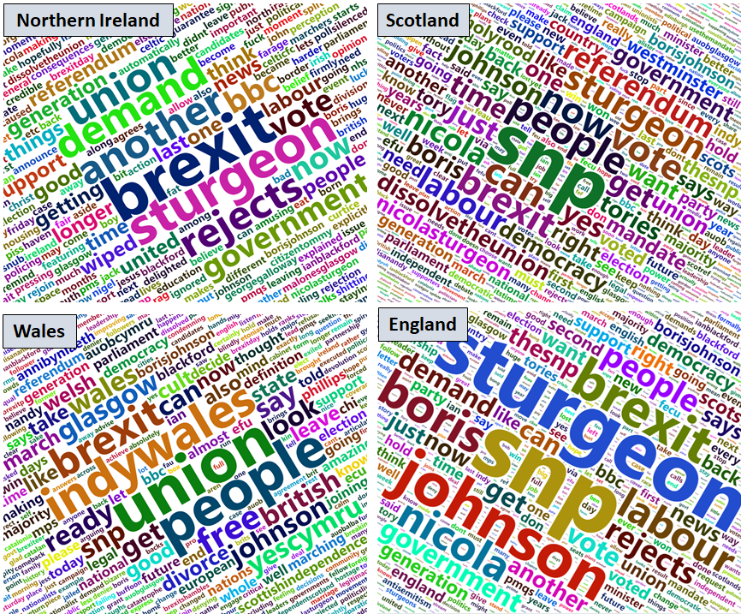

Figure 2. Words used in tweets

There are similarities and differences across the four countries. Names, such as ‘Boris’, ‘Johnson’, and ‘Sturgeon’ are amongst the most commonly used words. These are names of the politicians that directly associated with the prospect of a 2nd referendum in a near future. For example, the Scottish First Minister ‘Nicola Sturgeon’ would have to officially write to UK Prime Minister Boris Johnson, in order to hold another Scottish referendum. (<https://www.telegraph.co.uk/politics/2020/01/14/boris-johnson-officially-rejects-second-independence-referendum/>). The word ‘Brexit’ appear to be highly important in each country, with a relatively higher importance in Scotland. This appear to support recent polls that shows that many people who voted for Scotland to remain part of the UK in the first referendum may have changed their mind due to anxieties around ‘Brexit’ (http://\*).

There are few distinct, but important words associated with Wales and Scotland. These words describe specific political sentiment in relation to the subject of independence. For example, the word ‘referendum’ in Scotland clearly emphasizes the discussion around the call for another referendum. Similarly, words such as ‘Indywales’ and ‘yescymru’, can be attributed to the rising nationalist sentiments across Wales, which have prompted call for Welsh independence in recent years. However, similar words were not found in Northern Ireland or in England.

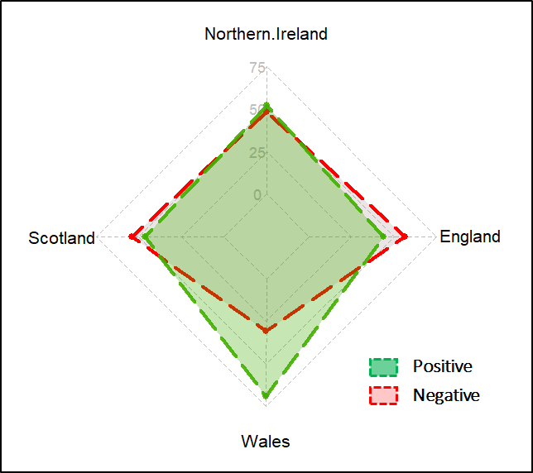

Figure 3 Binary classification of sentiment (%)

Emotions expressed in tweets

The author then extracts the purported emotions expressed in the tweets. The author first performed a binary classification of the tweets in each country into a positive or a negative sentiment. Wales and Northern Ireland have majority positive sentiments (69% and 51%, respectively), while both England and Scotland have majority negative sentiments (69% and 52%, respectively) (See Figure 3). The results for Scotland, in particular, corresponds to the most recent opinion polls that show that majority of Scottish people would still vote to remain part of the UK (See \*).

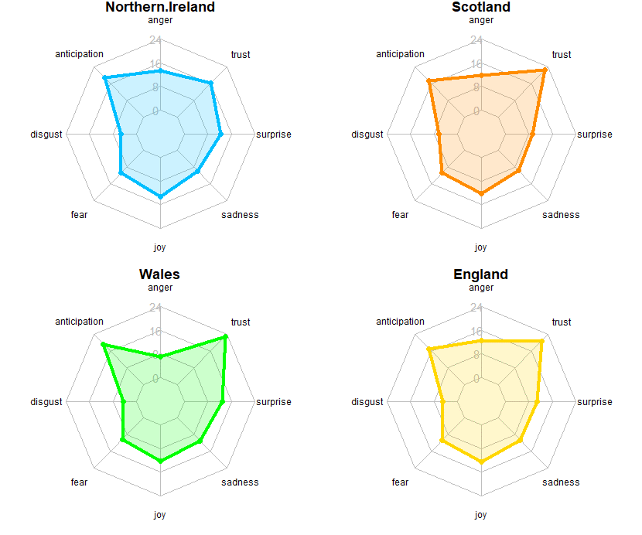

Figure 3. Sentiment analysis of tweets (%)

Figure 3 provide further insights into a range of common human sentiments. Overall, the patterns across all four countries are comparable. Most notably, the figure shows very similar level of ‘fear’, ‘joy’ and ‘sadness‘ across all four countries. ‘Anticipation’ and ‘trust’ are the two most expressed emotion, with Wales showing slightly higher percentages in both categories. ‘Disgust’ is the least expressed sentiments relating to the subject. More analysis is required in order to understand the justifications for the observed patterns. In all, the analysis demonstrate the potential of social media forum for understanding political opinion across a country.

Declaration

The author of this article affirm that this analysis has neither been funded by any political groups nor the author in any way affiliated to any institutions with access to groups with biased political interests. This research work has been carried out independently in the interests of research in data mining and related fields