#Indiref2 - What political sentiments are being expressed on Twitter?

Author: Monsuru Adepeju

On Twitter, conversations around Scotland’s independence, dampened momentarily by a failed referendum in 2014, have been reinvigorated with the anticipation of Brexit on 31st of January 2020. Scottish independence is the political movement for the country to become a sovereign state, independent from the United Kingdom (UK). By downloading tweets from January of this year, we can examine how public sentiment towards Scottish independent varies across the four constituent nations (i.e. England, Wales, Northern Ireland and Scotland).

Perhaps not surprisingly, the majority of tweets (71.4%) on the subject were sent out from mainland of Scotland, while another 22.2% were sent from England. Both Wales and Northern Ireland account for less than 6% of the tweets (see Figure 1).

Figure 1. Percentage of tweets on Scottish Independence across the United Kingdom, between January 1st and January 30th, 2020

Words used in tweets

Figure 2 showcases the most commonly used words in these tweets by country. The bigger and bolder a word appears, the more often it is mentioned in the posts. Regular words and hashtags, such as ‘Indiref2’, ‘Scotland, ‘Scottish’ and ‘independence’, whilst useful for identifying tweets discussing the topic, were removed in order to enable clearer visualization.

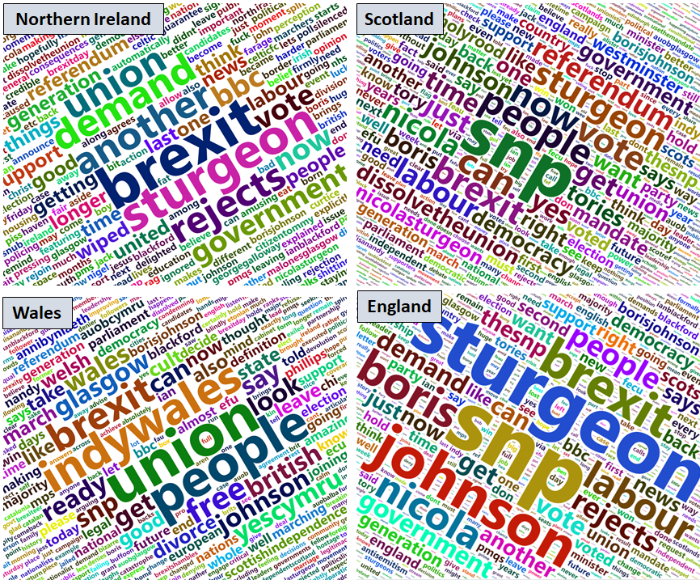

Figure 2. Words used in tweets

There are both similarities and differences between the four countries. Names, such as ‘Boris’, ‘Johnson’, and ‘Sturgeon’ are amongst the most commonly used words. Interestingly, ‘Brexit’ proves highly significant in each country. This appears to support recent polls which that many people who voted for Scotland to remain part of the UK may have changed their mind due to anxieties around ‘Brexit’ (http://\*).

There are a few distinct words associated with Wales and Scotland. These words describe specific political sentiment in relation to the subject of independence. For example, the word ‘referendum’ in Scotland clearly emphasizes the discussion around the call for another referendum. Similarly, words such as ‘Indywales’ and ‘yescymru’, can be attributed to the rising nationalist sentiments across Wales, which have prompted calls for Welsh independence. However, similar words were not found in Northern Ireland or in England.

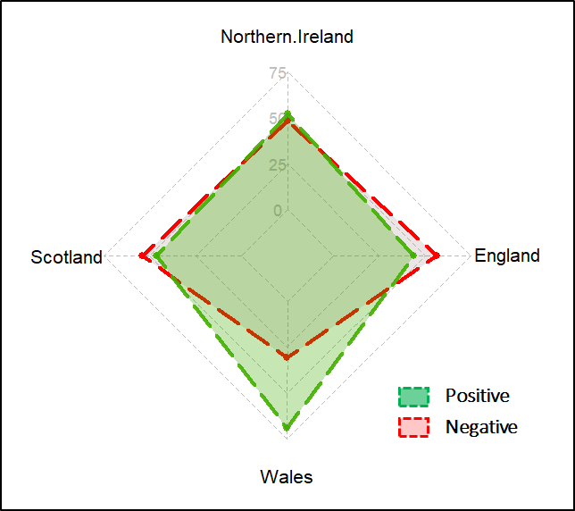

Figure 3 Binary classification of sentiment (%)

Emotions expressed in tweets

I then extract the purported emotions expressed in these tweets, performing a binary (one or the other) classification of tweets in each country into positive or negative sentiment. Wales and Northern Ireland appear to have predominantly positive sentiments (69% and 51%, respectively), whilst both England and Scotland have mainly negative sentiments (69% and 52%, respectively) (See Figure 3). The results for Scotland, in particular, correspond to the most recent opinion polls that show that majority of Scottish people would still vote to remain part of the UK (See \*).

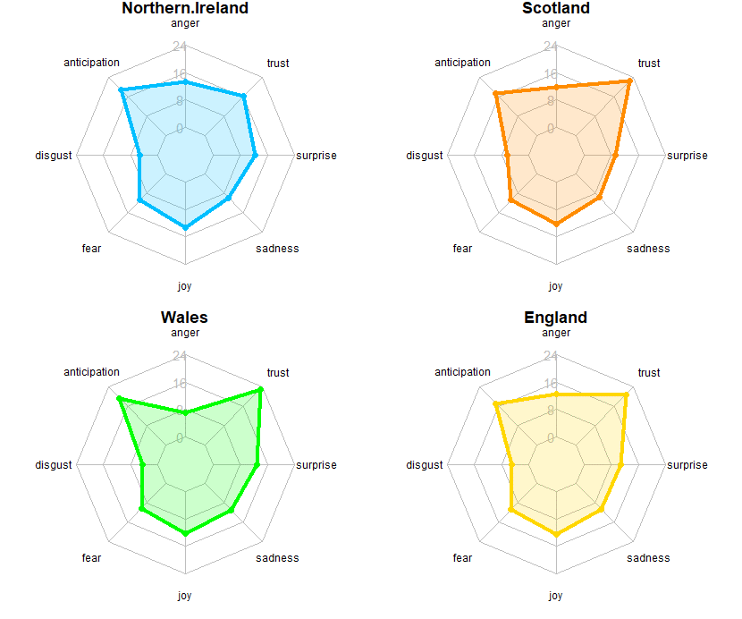

Figure 3. Sentiment analysis of tweets (%)

Figure 3 provides further insight into a range of common human sentiments, such as trust, surprise and joy. Generally speaking, the patterns across all four countries are comparable. Most notably, the figure shows similar levels of ‘fear’, ‘joy’ and ‘sadness‘ across all four countries. ‘Anticipation’ and ‘trust’ are the two most expressed emotion, with Wales showing slightly higher percentages in both categories. ‘Disgust’ is the least expressed sentiments relating to the subject. In all, the analysis demonstrates the how social media data can be used as a source for gauging public sentiment on political issues.

Declaration

The author of this article affirm that this analysis has neither been funded by any political groups nor the author in any way affiliated to any institutions with access to groups with biased political interests. This research work has been carried out independently in the interests of research into data mining and political science.