‘#Indiref2’ - How political sentiments differ across the United Kingdom.

Author: Monsuru Adepeju

In the three and half years since the Brexit referendum, the conversations around Scotland’s independence, dampened momentarily by a failed referendum in 2014, has been reinvigorated with the ‘certainty’ of Brexit, thanks to the December 2019 UK general election. Scottish independence is the political movement for Scotland to become a sovereign state, independent from the United Kingdom (UK). Following the general election, there has been a continuous conversation, mostly on Twitter, about the potentials of another Scottish referendum. The related tweets are easily identified using the associated tags, such as ‘#Indyref2’, and ‘#scottishreferendum. By downloading these data sets (excluding ‘retweets’ and ‘replies’) between the January 1 and January 25, 2020 (days before Brexit), I examine how the differences in the sentiments expressed in these tweets, across the four constituents nations (i.e. England, Wales, Northern Ireland and Scotland) that make up the UK. Expectedly, the majority (73%) of the tweets relating to Scottish independence were sent out from the mainland of Scotland, with 24% from England (Figure 1). However, Wales and Northern Ireland have significantly small shares of 1% and 2%, respectively.

Figure 1. Percentage of tweets on Scottish Independence across the United Kingdom, between January 1st and January 31st 2020 (Inserted is the map of the UK, showing the relative position of the four countries).

Words used in tweets

In Figure 2, the ‘Wordclouds’ is used to highlight the most commonly used words in the conversations. The bigger and bolder a word appears, the more often it is mentioned in the posts and the more important it is. Regular words, such as ‘Indiref2’, ‘Scotland, ‘Scottish’, and ‘independence’, and hashtags have all been filtered out, in order to enable clearer visualization.

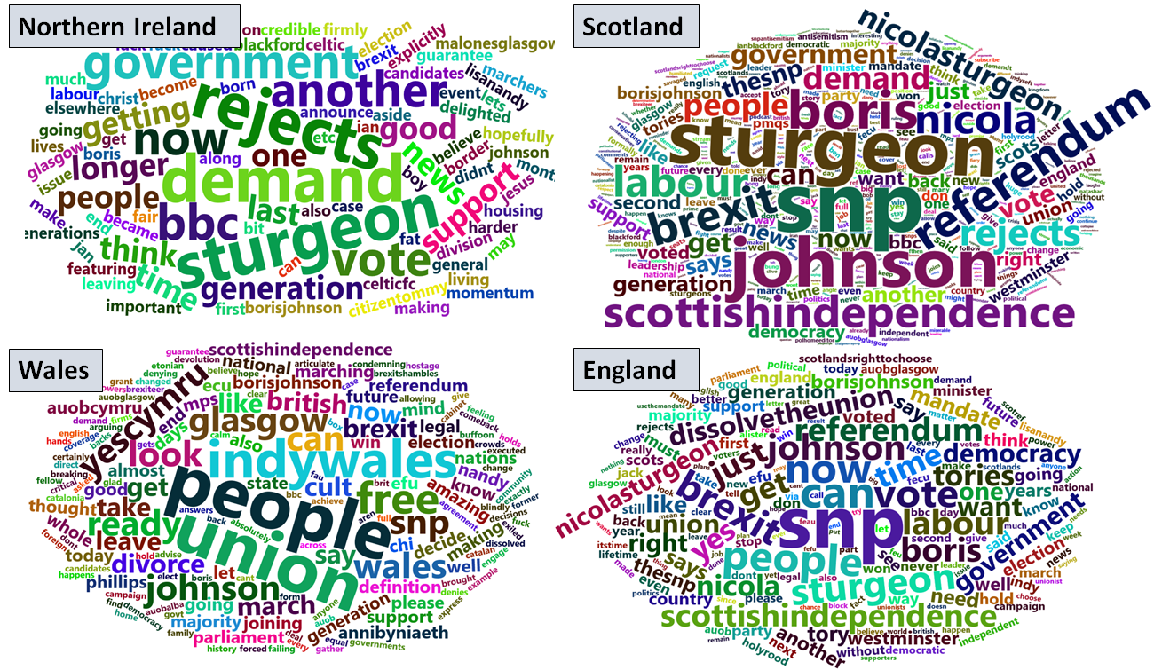

Figure 2. Words used (..work on Brexit)

There are similarities and differences across the four countries. Names, such as ‘Boris’, ‘Johnson’, and ‘Sturgeon’ are amongst the most commonly used words. These are names of the politicians that directly associated with the prospect of a 2nd referendum in a near future. For example, the Scottish First Minister ‘Nicola Sturgeon’ would have to officially write to UK Prime Minister Boris Johnson, in order to hold another Scottish referendum. (<https://www.telegraph.co.uk/politics/2020/01/14/boris-johnson-officially-rejects-second-independence-referendum/>). The word ‘Brexit’ appear to be highly important in each country, with a relatively higher importance in Scotland. This appear to support recent evidence that shows that many people who ‘No’ in the first referendum may have changed their mind due to anxieties around ‘Brexit’.

There are few distinct, but important words associated with certain country, including Wales and Scotland. These words describe specific political sentiment in relation to the subject of independence. For example, the word ‘referendum’ in Scotland clearly emphasizes the discussion around the call for another referendum. Similarly, words such as ‘Indywales’ and ‘yescymru’, can be attributed to the rising nationalist sentiments across Wales, which have prompted call for Welsh independence in recent years.

Emotions expressed in tweets

The technique, *sentiment mining,* is used to extract the purported emotions expressed in a conversation. First, I deployed a polarity classifier to categorise words in tweets in a binary fashion into positive and negative sentiments, and then compute the percentage emotion scores. Figure 3 compares the percentage of tweets with positive and negative sentiments in each country. Wales and Northern Ireland have majority positive sentiments (69% and 51%, respectively). This contrast England and Scotland with majority negative sentiments (69% and 52%, respectively).

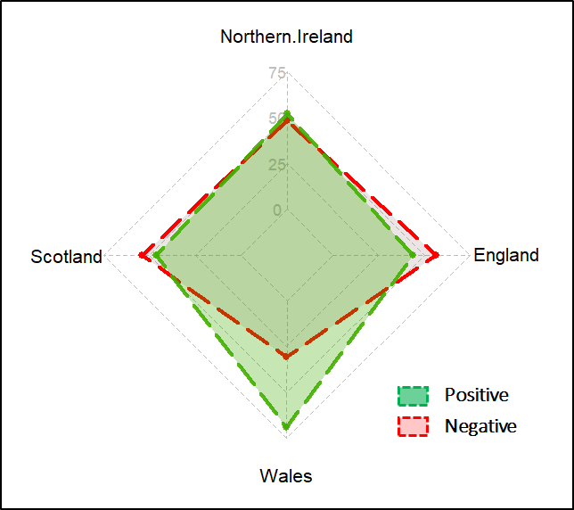

Figure 3 Polarity sentiment (%)

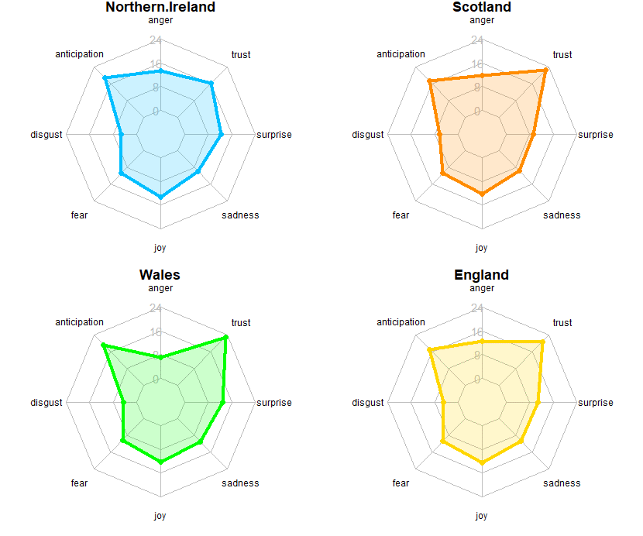

Figure 3. Emotion sentiment (%)

Second, a subjective classifier is used to fain further insights into different kind of emotions carried by the tweets. Figure 3 shows the percentages of tweets across a range of emotion classes in each country. Overall, the patterns of the emotions are comparable across all the four countries. The Figure shows very similar level of ‘surprise’, ‘sadness’, ‘joy’, and fear about the political issue across the four countries. ‘Anticipation’ and ‘trust’ are the two most expressed sentiments across all countries, with Wales showing slightly higher percentages in both categories. ‘Disgust’ is the least expressed sentiments relating to the issue. More analysis is required in order to understand the justifications for the observed patterns, and their association with the polarity of sentiment in Figure 3.

This analysis demonstrates the potentials of big data platforms such as Twitter for unveiling the sentiments around certain political issues in the UK and around the word. The analysis also provides the opportunity to discover key issues that may be very important across different geographical context.

Declaration

The author of this article affirm that this analysis has neither been funded by any political groups nor the author in any way affiliated to any institutions with access to groups with biased political interests. This research work has been carried out independently in the interests of research in data mining and related fields