**Analytics**

1. What is the average volume of tweets referencing Scottish referendum across the UK in two weeks leading to the Brexit day? (Number per 10miles). Use the circular chart. By country?

2. What is the proportion of positive and negative sentiment over time? What is the pattern? In each country. Use score function [Bing Liu] book

3.

<https://monkeylearn.com/blog/sentiment-analysis-of-twitter/> for introduction.

**Find a way to do the same thing in R**

[**https://www.analyticsvidhya.com/blog/2018/07/hands-on-sentiment-analysis-dataset-python/**](https://www.analyticsvidhya.com/blog/2018/07/hands-on-sentiment-analysis-dataset-python/)

**also feature using logistic regression for tweet prediction**

**3. Story Generation and Visualization from Tweets**

In this section, we will explore the cleaned tweets text. Exploring and visualizing data, no matter whether its text or any other data, is an essential step in gaining insights. Do not limit yourself to only these methods told in this tutorial, feel free to explore the data as much as possible.

Before we begin exploration, we must think and ask questions related to the data in hand. A few probable questions are as follows:

* What are the most common words in the entire dataset?
* What are the most common words in the dataset for negative and positive tweets, respectively?
* How many hashtags are there in a tweet?
* Which trends are associated with my dataset?
* Which trends are associated with either of the sentiments? Are they compatible with the sentiments?

1. WordCloud
2. Sadafdasfds
3. Asdfadsfafsa
4. Understanding the impact of Hashtags on tweets sentiment

Hashtags in twitter are synonymous with the ongoing trends on twitter at any particular point in time. We should try to check whether these hashtags add any value to our sentiment analysis task, i.e., they help in distinguishing tweets into the different sentiments.

For instance, given below is a tweet from our dataset:

**6. What’s Next?**

If you are interested to learn about more techniques for Sentiment Analysis, we have a well laid out [**video course on NLP**](https://trainings.analyticsvidhya.com/courses/course-v1:AnalyticsVidhya+NLP101+2018_T1/about?utm_source=blog&utm_medium=hands-on-sentiment-analysis-dataset-python/) for you.This course is designed for people who are looking to get into the field of Natural Language Processing. It provides you everything you need to know to become an NLP practitioner.

Key topics covered in the course:

* Extracting named entities from the text
* Topic Modelling
* Feature engineering for text
* Text classification
* Deep Learning for NLP
* 3 real life projects

Good for the introduction sentiment analysis (definition)

<https://brand24.com/blog/twitter-sentiment-analysis/>

<https://brand24.com/blog/sentiment-analysis/>

definitions and all….

Monitor the positive and negative sentiments

## <https://monkeylearn.com/blog/trump-vs-hillary-sentiment-analysis-twitter-mentions/>

## Using the interface

There are **three graphs** on the main view. The first one shows the ratio of the number of positive tweets to the number of negative tweets mentioning each of the candidates. This is, **how positive the discussion** is on Twitter surrounding that candidate. A higher value on this graph means that there are more positive tweets for each negative tweet and vice-versa:

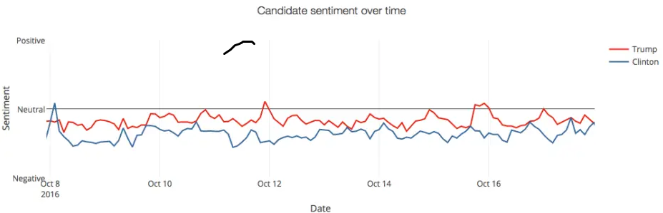

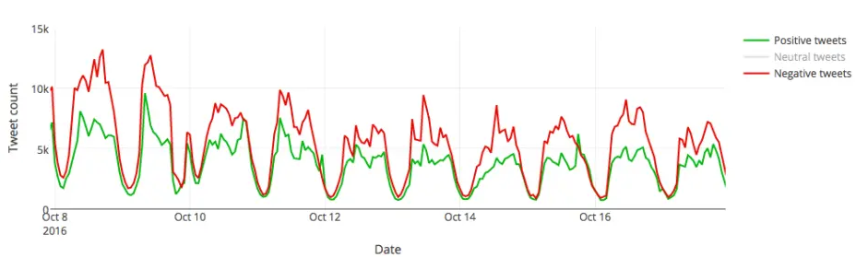

Number of tweet per 100km….

WordCloud

Some general insights

* There are ***more tweets*** that mention @realDonaldTrump than @HillaryClinton:

The first thing that stands out is that @realDonaldTrump gets mentioned much more than @HillaryClinton. Trump’s Twitter presence is much larger than Clinton’s. On an average day, Donald Trump’s account gets about 450,000 mentions, while Hillary Clinton’s account only gets 250,000.

* Out of those tweets, ***Trump has a better positive*** to negative ratio than Clinton:

Out of those tweets, the majority are tagged as “neutral”. These are factual tweets that don’t convey a sentiment. If you click on a specific date on the graphs, you can see some examples of what these tweets look like by going to the right side panel, selecting *neutral* and going to the *tweets* tab:

For *both* candidates, there are usually***more negative*** than positive tweets. This means that whenever a candidate is mentioned on a tweet, it’s more likely for that tweet to have a *negative* sentiment than a *positive*one. What this implies is a long suspected truth: that on the internet, people are more likely to criticize something than they are to praise it.

It is important to note that this doesn’t mean that, for instance, all the negative tweets that mention @realDonaldTrump are criticizing him. Some (probably most) are critical of Trump, but some are critical of Clinton, or Obama, or other issues.

Going deeper with the insights

Now move on to something more oriented to ***specific dates and keywords***. Something along the lines of “this allows you to see a picture of what was being talked about in a particular day”. Check out the keywords of a particular day, and you can see ***what was on the news that day***.

We looked into some landmark dates of the campaign to find out what people were saying on Twitter that day.

* ***July 5th: the FBI says it’s not going to end Clinton’s email probe and will not recommend prosecution:***

You can see a considerable rise in traffic that day. A lot of ***people were not happy***, and they were vocal about it. There’s a significant rise in traffic on Clinton’s side, with negative tweets taking off:

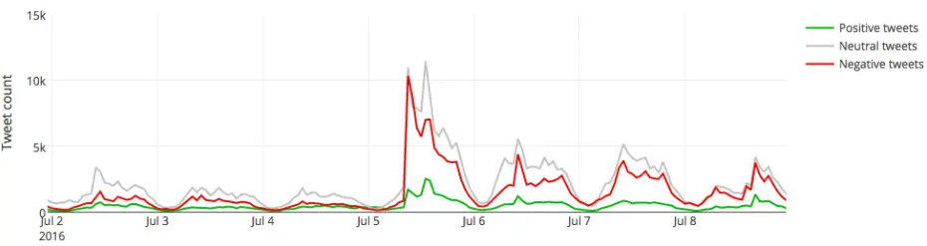

Approaching

More than even, it is likely that Brexit is going to happen. However, how is the political conversaion regarding indiref is changing on the social media. I examine the conversation online including the positive and negative conversation online.

The conversation around the Scottish referendum has never been

## Final words

The conversation around the US elections has been omnipresent and highly polarized. There is a clear and deep division in the US political landscape and these are arguably the most controversial elections in recent history.

We feel that [Tarsier](http://tarsier.monkeylearn.com/) is a simple but powerful tool that helps to understand how people are talking about the candidates on social media. We believe that it can bring some clarity to what’s going on with this particular elections and get some valuable insights from the data.

We invite you to play around with [Tarsier](http://tarsier.monkeylearn.com/) and share in the comments what type of insights you find!

conversation Now is more than likely that the Brexit is going to happen.

**Examine cities in the UK.**