AQLIO
MVP IMPLEMENTATION
SPECIFICATION
The AI Workforce Platform for Everyone

VERSION 2.0 Experience-first product blueprint • Recommended MVP baseline • 13 August 2026

Hide technical complexity. Expose human and business value.

Document Control
Field | Value
Document | Aqlio MVP Implementation Specification
Version | 2.0
Status | Recommended implementation baseline
Product position | Aqlio — The AI Workforce Platform for Everyone
Primary audience | Product, design, engineering, operations, partnerships, and leadership
Supersedes | MVP Implementation Specification v1.0
Scope | Phase 1 MVP and its path to growth

Purpose
This specification defines the smallest coherent Aqlio product that enables technical and non-technical people to create, deploy, demonstrate, and improve useful AI solutions. It is a product blueprint first and an engineering implementation contract second.
INTERPRETATION RULE When user simplicity and internal component naming conflict, the user-facing experience governs the interface; the internal architecture remains available to engineers through this specification and the technical architecture.

Contents
Part | Sections
Product direction | 1 Executive Summary • 2 Product Design Principles • 3 MVP Objectives and Scope
People and experience | 4 Users, Jobs, and Experience Levels • 5 Core User Journey • 6 User-Facing Product Specification
Commercial and ecosystem | 7 Advanced and Hidden Integrations • 8 Freemium and Value Model • 9 Success Metrics
Engineering contract | 10 Architecture • 11 AI Provider Abstraction • 12 Workflow, Agent, RAG, and Deployment
Delivery and assurance | 13 Trust, Security, Privacy, and Reliability • 14 Implementation Guidance • 15 Roadmap • 16 Acceptance
Appendices | A Naming and Concept Map • B Repository Structure • C Decision Summary

1. Executive Summary
Aqlio is being built on one belief: artificial intelligence should be accessible to everyone—not only software engineers, AI specialists, or large enterprises. The MVP gives individuals and organizations one simple place to move from an idea to a useful, running AI solution, while Aqlio coordinates the models, workflows, source control, deployment infrastructure, metering, and operational safeguards behind the scenes.
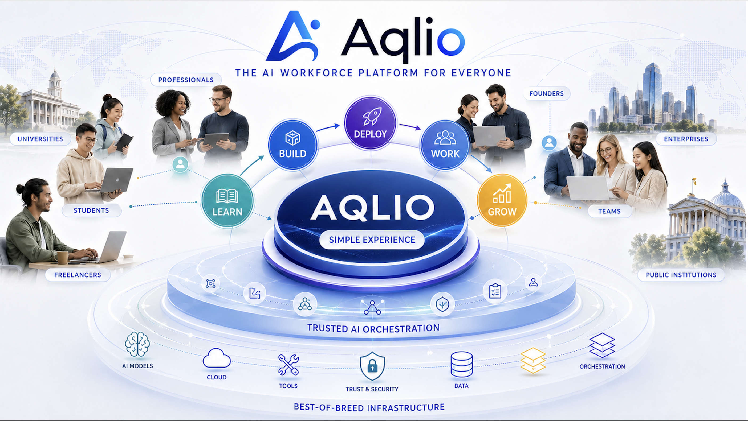
The organizing question for v2.0 is not “Which services should Aqlio expose?” It is “What is the simplest experience that enables a person to become productive with AI?” The answer is a memorable experience model: Workspace, Projects, AI Builder, Deploy, Portfolio, and Grow.
MVP NORTH STAR Enable anyone to build and deploy a useful AI solution with confidence, regardless of technical background.

The architecture established in v1.0 is preserved: a modular monolith with explicit domain boundaries; API-first interfaces; PostgreSQL, pgvector, JSONB, and object storage; provider adapters; workflow and agent execution; event publication; deployment adapters; trust, analytics, billing, entitlement, and cost metering. What changes is the contract with users. Technical systems become implementation components, not concepts that every customer must learn.

Here is the MVP implementation architecture:
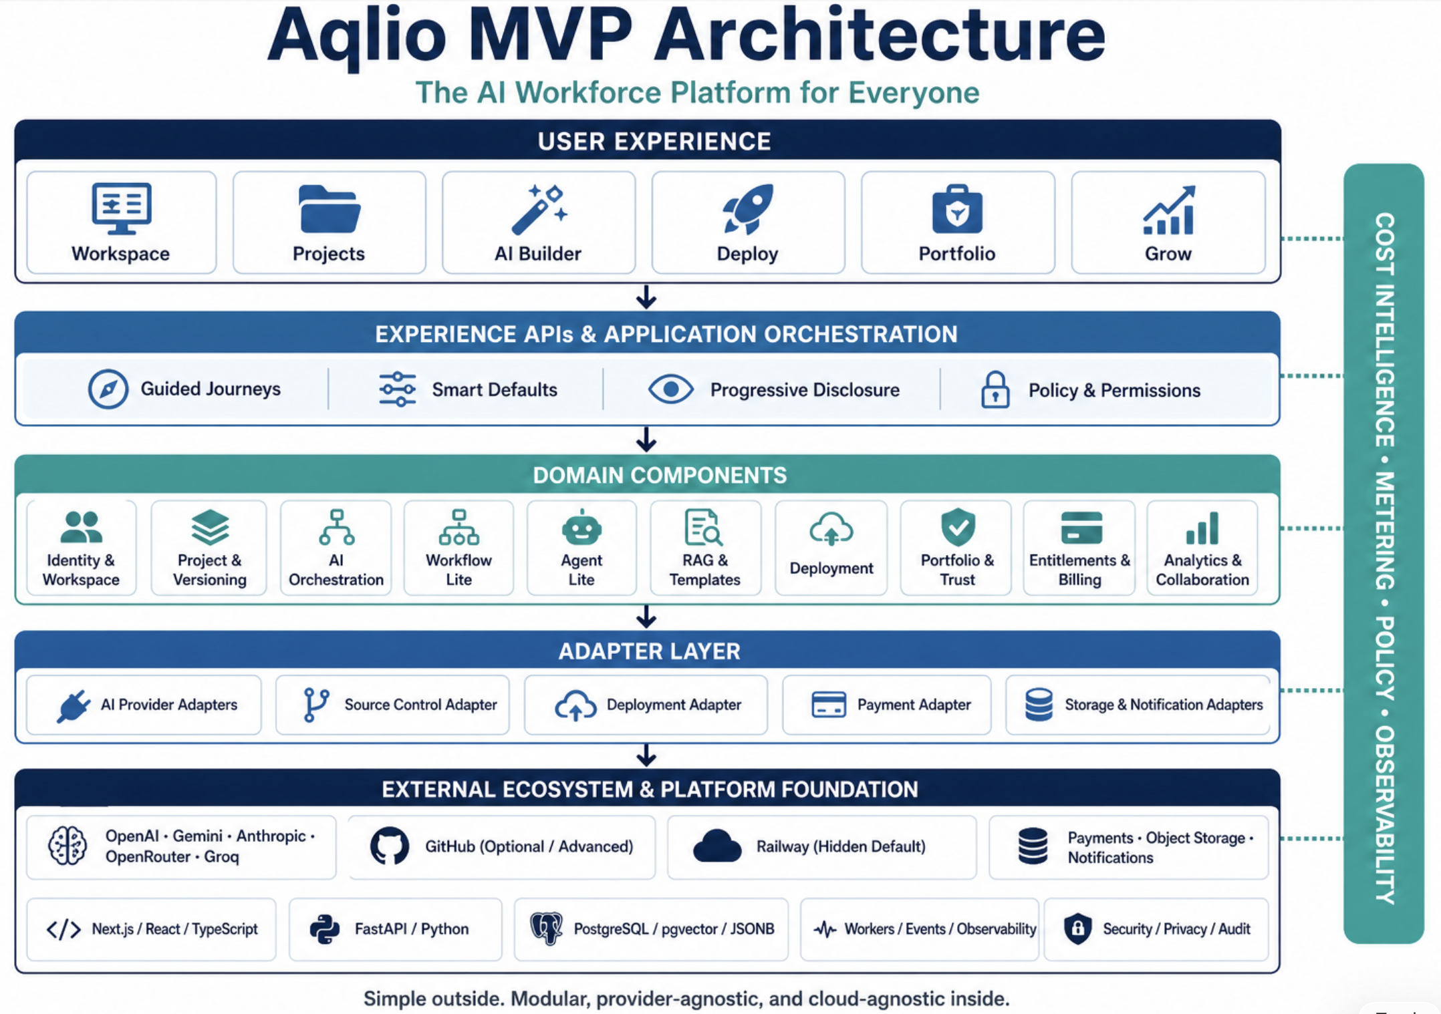

1.1 MVP proposition
- Begin at little or no cost and receive value before being asked to upgrade.
- Describe an outcome in familiar language; use templates and smart defaults to start quickly.
- Build applications, assistants, automations, RAG experiences, and small agent teams inside one AI Builder.
- Deploy with one clear action and receive a running application and share link.
- Automatically turn completed work into credible portfolio evidence.
- Progress from learning and experimentation to collaboration, paid work, or organizational transformation.

1.2 Explicit non-goals
- Rebuilding foundation models, hyperscale cloud infrastructure, Git hosting, or mature payment rails.
- Exposing every provider, model, runtime, repository, branch, container, pipeline, or environment to beginners.
- Launching the complete Learn, Transform, Work, Scale, and marketplace vision in Phase 1.
- Starting with a distributed microservices estate before scale or isolation requirements justify it.
2. Product Design Principles

2.1 AI for Everyone
Every critical journey must be understandable and completable by technical and non-technical users. Accessibility includes language, affordability, guidance, mobile responsiveness, and recovery from mistakes.

2.2 Simplicity by Design
Hide technical complexity and expose outcomes. Every feature must make AI easier, reduce complexity, or accelerate user success.

2.3 Leverage the Best
Integrate leading commercial and open-source models, tools, cloud services, and platforms rather than reproducing commodity capability.

2.4 Cost Optimization First
Choose the lowest sustainable cost that satisfies capability, quality, speed, security, privacy, geography, and policy requirements.

2.5 Progressive Complexity
Show essential choices first. Reveal provider controls, credentials, repositories, workflows, and deployment configuration only when a user needs or requests them.

2.6 Invisible Infrastructure
Git, GitHub, Railway, containers, databases, CI/CD, APIs, model routing, and cloud resources should normally operate without entering the user’s mental model.
30-SECOND RULE After sign-in, a new user must understand what to do next within 30 seconds. If a capability requires substantial explanation, simplify it or move it behind Advanced settings.

2.7 Feature decision test
Question | Pass condition
Does it make AI easier? | The user completes a meaningful task with less learning or fewer decisions.
Does it reduce complexity? | Aqlio absorbs configuration, integration, or operational work.
Does it accelerate success? | The user reaches a useful, shared, or measurable outcome faster.
Can it stay hidden? | If it is infrastructure, the default journey does not require awareness of it.

3. MVP Objectives and Scope

3.1 Objectives
- Deliver a complete idea-to-deployment journey through one coherent interface.
- Prove that non-technical and technical users can reach a first deployment with comparable confidence.
- Validate Aqlio’s provider-agnostic and cloud-agnostic abstraction without exposing provider complexity by default.
- Establish evidence-based portfolios and the first bridge from creation to economic or organizational value.
- Validate daily free usage, transparent limits, and seamless value-led conversion.
- Collect product, cost, quality, reliability, and trust signals needed for responsible scaling.

3.2 Phase 1 user-facing scope
Experience | MVP promise | Included
Workspace | A clear home for the person or team. | Identity, profile, organization, settings, credentials, role, usage summary.
Projects | One place for everything being created. | Create/import, intent, members, assets, lifecycle, versions, activity.
AI Builder | Turn an outcome into a working solution. | Guided build, templates, prompts, workflow/agent/RAG capabilities, preview, testing.
Deploy | Make the solution usable and shareable. | Smart defaults, environment handling, health checks, versions, redeploy, share link.
Portfolio | Show credible evidence of capability. | Automatic project/deployment evidence, skills, documentation, visibility controls.
Grow | Convert successful work into the next opportunity. | Recommendations, improve prompts, collaboration invitation, upgrade and opportunity paths.

3.3 Deferred or constrained
- Full learning management system; MVP provides guided practice and contextual help only.
- Open talent and application marketplaces; MVP captures evidence and supports controlled opportunity referrals.
- Complex multi-agent swarms; MVP supports a supervisor and up to two worker agents.
- Arbitrary workflow graphs; MVP supports guided linear flows, bounded branching, approval, retry, and RAG steps.
- Multi-cloud self-service control plane; MVP implements adapters and defaults to one managed deployment path.
- Advanced enterprise transformation, governance, and institutional programs; introduced after product-market evidence.
4. Users, Jobs, and Experience Levels

4.1 Primary launch cohort
The first cohort includes graduates of the Pak Angels Generative & Agentic AI Training and comparable learners who want to turn acquired knowledge into real applications, work samples, freelance delivery, startup experiments, or employer automation. The experience must also generalize to professionals, entrepreneurs, SMEs, teams, universities, and nonprofit programs.
User | Primary job | Proof of success
New builder | Turn an idea into a first AI solution. | Working share link and confidence to improve it.
Professional or freelancer | Create credible, reusable evidence of capability. | Portfolio item that can be shared with a client or employer.
Founder | Validate a product idea economically. | Live pilot, usage evidence, and clear cost path.
SME lead | Automate a bounded business problem. | Useful pilot with owner, controls, and measurable outcome.
Advanced developer | Use Aqlio without losing control. | Optional source, provider, workflow, and deployment controls.

4.2 Progressive disclosure
Level | Default navigation and controls | Unlocked capabilities
Beginner | Workspace, Projects, AI Builder, Deploy, Portfolio, Grow. | Templates, guided prompts, preview, smart defaults, basic usage.
Intermediate | Adds collaboration and selected preferences. | Provider preferences, template configuration, deployment settings, team roles.
Advanced | Adds implementation controls. | GitHub, BYO API keys, workflow graph, agent configuration, logs, cost and deployment controls.

Level is not a permanent label. Users may opt in, and contextual prompts may reveal a control when needed. Aqlio must never require Advanced mode to complete the core MVP journey.
5. The Core User Journey
ONE MEMORABLE JOURNEY Join → Create Workspace → Start Project → Build with AI → Deploy → Share → Improve → Grow

5.1 Journey requirements
Stage | User sees | Aqlio does invisibly | Exit condition
Join | Simple registration and purpose selection. | Creates identity, default workspace, entitlements, and starter allowance. | User lands on a useful next action.
Start | New Project, template, or Import Existing Project. | Creates project record, storage, audit event, and optional internal version control. | Project has a clear outcome.
Build | Conversation, guided form, canvas, preview. | Routes AI, executes bounded workflows, stores versions, meters cost, applies safety policy. | Preview satisfies acceptance check.
Deploy | Deploy button, progress, plain-language recovery. | Builds artifact, injects secrets, provisions runtime, checks health, records version. | Running URL is healthy.
Share | Share link and visibility settings. | Applies authorization, records evidence, updates portfolio. | Intended audience can access safely.
Improve | Feedback, usage signals, suggested next steps. | Correlates versions, logs, cost, quality, and errors. | New version is deployed or saved.
Grow | Portfolio, collaboration, plan, opportunity options. | Updates trust evidence and recommendations. | User returns or begins next value motion.

5.2 Experience acceptance criteria
- No mandatory provider selection, API key, GitHub connection, repository, branch, container, or hosting choice in the beginner path.
- Project state survives failures, quota boundaries, and interrupted upgrades.
- Every long-running action displays current status, expected next step, and recoverable error guidance.
- Every deployment produces a stable record linking project version, runtime version, environment, cost events, and portfolio evidence.
- All generated or imported content remains subject to visibility, access, retention, and deletion controls.
6. User-Facing Product Specification

6.1 Workspace
Workspace is the user’s trusted home. It consolidates identity, personal or organizational context, settings, credentials, usage, and invitations without presenting an “Identity Service” or “Entitlement Service.”
- Automatic personal workspace at registration; optional organization workspace.
- Profile, roles, credentials, verified achievements, and portfolio ownership.
- Simple usage summary with remaining free allowance and no surprise charges.
- Credential vault for optional BYO AI keys and integrations, protected and masked.
- Role-based membership and invitation flows for team workspaces.

6.2 Projects
Project is the central unit of work and context. It may contain an application, assistant, automation, knowledge experience, agent configuration, documents, tests, deployments, and evidence. “Repository” is never the primary object.
- Create from description, template, guided practice, or optional import.
- Capture problem, audience, desired outcome, constraints, owner, collaborators, and status.
- Save versions automatically and provide restore points in plain language.
- Maintain documentation and activity history with each meaningful change.
- Support private by default, team sharing, and explicit publishing.

6.3 AI Builder
AI Builder is the unified creation environment. It combines AI application generation, prompt assistance, workflow execution, bounded agents, RAG, templates, preview, testing, and iteration. Internal engines remain modular but do not become separate primary navigation destinations.
- Start with “What do you want to accomplish?” and recommend a suitable pattern.
- Offer guided templates for assistants, document Q&A, business automation, content tools, and simple agent teams.
- Provide preview, sample data, test cases, clear validation, and version save points.
- Use smart defaults for model, routing, project structure, storage, and deployment target.
- Explain important risks or limitations in context, especially data sharing, external actions, cost, and human approval.

6.4 Deploy
Deploy turns an approved project version into a running solution. The default action is “Deploy,” never “Deploy to Railway.”
- Preflight checks for required configuration, policy, secrets, and test status.
- One action provisions or updates the runtime and returns a shareable Aqlio URL.
- Clear status: Preparing, Deploying, Checking, Running, or Needs Attention.
- Health monitoring, deployment history, safe redeploy, and rollback to a known version.
- Advanced mode may expose environment variables, logs, regions, runtime size, domain, and provider-specific settings.

6.5 Portfolio
Portfolio converts completed work into evidence. It should be useful without manual résumé-style data entry and trustworthy without overstating capability.
- Automatically suggest evidence from projects, deployments, documentation, tests, collaboration, and outcomes.
- Let users review, edit, hide, or publish every portfolio item.
- Describe verified evidence separately from user-authored claims.
- Support shareable profiles and project pages with privacy controls.
- Create the foundation for future Trust and Work experiences.

6.6 Grow
Grow is the post-success experience: improve a solution, learn the next skill, invite collaborators, expand usage, or pursue an opportunity. It is not a full marketplace in the MVP.
- Recommend the next highest-value action based on project state.
- Surface usage and cost insights before upgrade choices.
- Support controlled invitations to mentors, team members, clients, or program administrators.
- Offer upgrade paths only when a limit or sustained value makes the benefit clear.
- Capture outcome signals such as client use, employer adoption, pilot completion, or repeat activity.
7. Advanced and Hidden Integrations

7.1 GitHub
GitHub remains a valuable source-code system of record and collaboration integration, but it is optional. Beginner projects may use Aqlio-managed versioning or an internal Git repository. Advanced users can connect, create, or import a GitHub repository without changing the Project experience.
Default experience | Advanced experience | Engineering requirement
Create Project; versions saved automatically. | Connect GitHub, import repository, view branch/commit context. | SourceControlAdapter decouples project records from GitHub.
Deploy without repository terminology. | Use pull requests or external developer tools. | Project/version/deployment IDs correlate with source revision.
Share portfolio evidence. | Link public or authorized repository evidence. | OAuth scopes are minimal, revocable, and audited.

7.2 Railway and deployment infrastructure
Railway may remain the initial managed deployment provider, but users see Aqlio Deploy, a running status, and an Aqlio share link. The DeploymentAdapter must permit future Streamlit, Vercel, Cloudflare, container, or enterprise targets without changing the product model.

7.3 AI providers and credentials
The default control is “Use AI.” Aqlio selects a provider and model using a policy that balances capability, quality, cost, latency, availability, privacy, geography, and workspace rules. Provider names appear only where disclosure, consent, policy, billing, or advanced choice requires them.
- Aqlio-managed credits for fast onboarding and promotions.
- Optional BYO API keys for users who prefer direct provider billing.
- Workspace-level allow/deny lists and data-handling rules.
- Fallback only within approved providers and constraints; no silent policy bypass.
- Provider and model are recorded internally for cost, audit, evaluation, and reproducibility.
8. Freemium and Value Model

8.1 Free Every Day
Every registered individual receives a configurable daily allowance. The experience leads with possibility, not subscription. Browsing, documentation, portfolio review, and basic project management should generally remain free; meaningful compute and external resource use are metered.
Included category | MVP treatment
Platform access | Workspace, Projects, guided AI Builder, Portfolio, and basic Grow access.
AI capacity | Limited Aqlio-managed credits and/or BYO credentials where supported.
Executions | Bounded build, workflow, agent, RAG, and deployment operations.
Projects and deployments | Configurable limits designed to support a real first success.
Reset behavior | Daily allowance resets; unused allowance does not accumulate unless explicitly promoted.

8.2 Upgrade principles
- Never lose state or terminate a running task merely because a free limit is reached.
- Notify at useful thresholds and explain what consumed allowance.
- Offer additional usage, a Builder plan, or a Professional/team plan in context.
- Separate Aqlio platform charges from third-party AI charges.
- Do not unnecessarily mark up usage billed directly through a user’s provider credentials.
- Require explicit confirmation before a paid action; provide budgets and hard limits.

8.3 Metering model
Meter meaningful activity: AI requests, input/output tokens, embeddings, RAG ingestion and retrieval, workflow and agent executions, build operations, deployment operations, storage, and managed compute. Each usage event includes workspace, user, project, feature, provider/model or infrastructure target, quantity, estimated cost, entitlement decision, and correlation ID.
9. Success Metrics and Instrumentation
PRIMARY OUTCOME METRIC Activation-to-first-useful-deployment rate, segmented by technical confidence and cohort.

Metric | Definition | Initial target / guardrail
Next-step clarity | New users selecting a relevant action within 30 seconds. | ≥ 80% in usability tests.
Time to first project | Median from verified sign-in to meaningful project creation. | ≤ 5 minutes.
First-day completion | Activated users reaching a working preview on day one. | ≥ 50%.
Time to first deployment | Median active time from project start to healthy share link. | ≤ 60 minutes for a guided template.
Deployment success | Deploy attempts reaching healthy state without support intervention. | ≥ 90%.
Non-technical completion | Self-identified non-technical users reaching first deployment. | Within 15 points of technical users.
First-week return | Activated users returning within seven days. | ≥ 35%.
Shared projects | First deployments intentionally shared. | ≥ 40%.
Confidence score | Post-journey agreement: “I can build or improve an AI solution.” | ≥ 4.0 / 5.
Free-to-paid conversion | Users upgrading after demonstrated recurring value. | Monitor by cohort; no dark patterns.
Cost guardrail | Gross managed cost per activated/deployed user. | Within configurable cohort budget.
Reliability guardrail | Sev-1 security/privacy incidents. | 0.

9.1 Required event taxonomy
- workspace_created, project_created, template_selected, builder_preview_succeeded
- deployment_requested, deployment_succeeded, deployment_failed, project_shared
- portfolio_item_suggested, portfolio_item_published, grow_action_selected
- allowance_threshold_reached, upgrade_viewed, purchase_confirmed
- provider_routed, fallback_used, policy_blocked, human_approval_requested
Analytics must avoid capturing prompts, source documents, secrets, or customer content by default. Product events use identifiers and safe metadata; content observability follows explicit privacy and retention policy.
10. Architecture: Experience Outside, Components Inside
Aqlio v2.0 preserves the underlying architecture while enforcing a clean boundary between product language and engineering language. The experience layer presents six stable concepts. Application services coordinate domain components. Adapters isolate third-party providers. Data and events maintain traceability.
User-facing concept | Application/domain components | External or infrastructure adapters
Workspace | Identity, authorization, organization, credentials, entitlement, billing. | Managed auth, payment provider, secret storage.
Projects | Project, assets, versions, membership, documentation, activity. | Object storage, optional source control.
AI Builder | Build, AI orchestration, workflow lite, agent lite, RAG, templates, policy. | LLM/embedding providers, tool adapters.
Deploy | Deployment, release, health, configuration, rollback. | Railway initially; future deployment targets.
Portfolio | Portfolio, evidence, credentials, Trust V1. | Source/deployment verification adapters.
Grow | Recommendations, collaboration, analytics, billing, opportunity signals. | Messaging, payments, future marketplace partners.

10.1 Logical flow
Web/PWA → Experience APIs → Application orchestration → Domain modules → Adapter interfaces → External providers. Domain events feed analytics, metering, trust evidence, notifications, and billing. Long-running work is executed asynchronously by workers with idempotent commands and observable status.

10.2 Modular monolith baseline
- One deployable API codebase with explicit modules, ownership, interfaces, and database migration boundaries.
- Separate web, API, worker, scheduler, PostgreSQL, and object-storage runtime roles.
- Internal service contracts and events are designed for later extraction where scale, compliance, team autonomy, or fault isolation requires it.
- No direct cross-module table writes; use application interfaces or events.
- Transactional outbox for reliable event publication from state-changing operations.

10.3 Core data model
Aggregate | Representative records
Workspace | user, workspace, organization, membership, role, credential_reference, preference
Project | project, requirement, asset, document, version, collaborator, activity
Builder | template, prompt_version, workflow_definition, agent_definition, knowledge_source, test_case, build_run
Deployment | release, deployment, environment, configuration_reference, health_check, domain
Portfolio / Trust | portfolio_item, evidence, skill, credential, verification, trust_signal
Commercial | entitlement, allowance, usage_event, credit_ledger, subscription, invoice_reference
Operations | audit_event, domain_event, job, notification, analytics_event, incident_reference

10.4 Technology baseline
- Frontend: Next.js, React, TypeScript, Tailwind CSS, responsive Progressive Web App.
- Backend: Python, FastAPI, SQLAlchemy, Alembic, OpenAPI contracts.
- Data: PostgreSQL with UUID identifiers, JSONB for bounded flexible metadata, pgvector where semantic retrieval is justified, S3-compatible object storage.
- Execution: background workers and scheduled jobs; structured logging, metrics, traces, health endpoints, and alerting.
- Delivery: GitHub-based engineering workflow and automated tests; Railway may host initial Aqlio services and user deployments.
- Security: managed authentication, short-lived tokens, role-based access, encrypted secret references, least privilege, audit trails, and environment separation.
11. AI Provider Abstraction and Cost Intelligence

11.1 ProviderAdapter contract
- Generate or chat with normalized input/output and streaming support.
- Create embeddings and report dimensional/model metadata.
- Expose capability metadata, context limits, supported regions, tool use, structured output, and safety features.
- Normalize token/usage reporting, latency, errors, retryability, and estimated cost.
- Support timeouts, circuit breakers, approved fallback, and request correlation.

11.2 Routing policy
Decision factor | MVP behavior
Capability | Filter providers/models that cannot satisfy modality, context, tool, or structured-output needs.
Workspace policy | Apply allow/deny rules, provider credentials, privacy, geography, and data-residency constraints.
Quality | Use evaluated task profiles and template-specific minimum scores.
Cost | Prefer the lowest expected total cost after capability and policy thresholds are met.
Latency and availability | Respect interactive/batch latency class; use health and rate-limit signals.
Fallback | Use only approved alternatives; record reason and preserve reproducibility metadata.

11.3 Cost controls
- Preflight estimate for material actions; configurable workspace and project budgets.
- Hard limits for unbounded loops, retries, agent steps, context size, and ingestion volume.
- Caching and prompt/context compression where safe and measurable.
- Usage ledger reconciled with provider data; variance monitoring and administrative adjustment trail.
- User-facing explanation in familiar units, with advanced token/provider detail available on demand.
12. Workflow, Agent, RAG, and Deployment Boundaries

12.1 Workflow Lite
- Linear steps with bounded branching, AI/tool steps, human approval, retry, timeout, and persistent execution state.
- Idempotent step execution and resumability after worker failure.
- Versioned definitions; a run always references an immutable workflow version.
- No arbitrary user code in the primary MVP path; approved tools and sandboxed extensions only.

12.2 Agent Lite
- Agent definition includes purpose, instructions, model policy, tools, knowledge, budget, and stopping condition.
- Single agent by default; optional supervisor with no more than two worker agents.
- Maximum turns, tool calls, duration, and spend are mandatory.
- Human approval before consequential external actions.

12.3 RAG Lite
- Upload supported documents, extract and chunk content, generate embeddings, retrieve sources, and cite evidence in previews.
- Workspace and project authorization enforced at ingestion and retrieval.
- Deletion propagates to objects, chunks, embeddings, caches, and derived indexes according to policy.
- File-size, type, ingestion, and retrieval quotas are configurable.

12.4 Deployment contract
- Preflight → immutable release → provision/update → health verification → expose URL → record evidence.
- Secrets are referenced, never stored in source or logs.
- Every operation is idempotent and correlated; status is queryable.
- Rollback uses the previous healthy release and configuration reference.
- Provider-specific details are translated into normalized statuses and recovery actions.
13. Trust, Security, Privacy, and Reliability

13.1 Trust V1
Trust V1 is evidence-first and modest. It records what can be verified—credentials, project authorship, deployments, tests, collaboration, and documented outcomes—without presenting an opaque universal score as objective truth.

13.2 Security and privacy requirements
- Private by default; explicit publishing and sharing boundaries.
- Least-privilege roles for workspace, project, deployment, billing, and credential actions.
- Secrets encrypted at rest, masked in interfaces, excluded from logs, and revocable.
- Provider data handling disclosed where relevant; workspace policy governs permitted routes.
- Audit sensitive changes, provider credential access, deployments, sharing, billing, and administrative actions.
- Retention and deletion workflows cover primary data, objects, vector indexes, caches, logs, and third-party resources where supported.
- Rate limiting, abuse detection, input validation, dependency scanning, and secure delivery practices.

13.3 Reliability objectives
Area | MVP objective
Platform availability | Target 99.5% monthly for core authenticated experience after public beta.
State integrity | No acknowledged project change lost; version and job writes are transactional or recoverable.
Deployment status | Normalized status remains consistent with provider state through reconciliation.
Recovery | Documented backup, restore, incident, and provider-outage procedures tested before public launch.
Observability | Trace user action → application command → job → provider call → usage/cost event.

14. Implementation Guidance

14.1 Product and design
- Design the beginner path first; add intermediate and advanced controls only after the core task is complete.
- Use customer language in navigation, URLs, notifications, support content, and analytics labels.
- Provide sensible defaults with a short “Why this choice?” explanation, not a mandatory configuration screen.
- Prototype and test with users of varied technical confidence before hardening backend breadth.
- Treat empty states, progress, errors, allowance boundaries, and recovery as first-class screens.

14.2 Engineering boundaries
- Use experience-oriented API façades while preserving domain module interfaces beneath them.
- Centralize provider, source-control, deployment, payment, and notification adapters.
- Version external and internal contracts; validate payloads at boundaries.
- Require correlation IDs, structured errors, idempotency keys, and audit context for state-changing and billable operations.
- Ship feature flags and administrative configuration for allowance, templates, providers, routing, and rollout cohorts.
- Test provider adapters with contract suites and deterministic fakes; do not make every CI run dependent on live paid APIs.

14.3 Definition of done for an MVP capability
- User story and plain-language acceptance criteria validated.
- Beginner, keyboard, responsive, and accessibility paths reviewed.
- Authorization, privacy, audit, retention, and cost behavior defined.
- Analytics events and success/guardrail metrics implemented.
- Failure, timeout, retry, cancellation, and recovery behavior tested.
- Operational dashboard, alerts, runbook, and support guidance available.
- Advanced controls remain hidden unless explicitly enabled or contextually required.

15. Phased Delivery Roadmap
Phase | Outcome | User-visible emphasis | Engineering emphasis
0 — Foundation | A safe, testable platform skeleton. | Prototype of the six-concept navigation. | Identity, workspace, project core, design system, event/outbox, adapters, CI/CD, observability.
1 — Create | A user reaches a useful preview. | Workspace, Projects, guided AI Builder, templates. | AI abstraction, Build, Workflow Lite, RAG Lite, usage metering, versioning.
2 — Deploy & Prove | A user publishes a healthy solution and evidence. | Deploy, Share, Portfolio. | Deployment adapter, Railway path, health/rollback, Portfolio, Trust V1.
3 — Value & Grow | Users return, collaborate, and convert after value. | Grow, team invitations, usage dashboard, contextual upgrade. | Entitlements, billing, collaboration, recommendations, analytics.
4 — Advanced Beta | Power users gain control without burdening beginners. | GitHub import/connect, BYO keys, workflow and deployment settings. | SourceControlAdapter, advanced policy, logs, cost controls, adapter hardening.
5 — Growth Platform | Organizations run broader pilots. | Team workspaces, transformation journeys, opportunity connections. | Enterprise governance, advanced trust, cost intelligence, scale/isolation work.

15.1 Exit gates
- Create gate: at least 80% of moderated participants know the next action; a majority reach preview without facilitator rescue.
- Deploy gate: deployment success and rollback objectives met; secrets and authorization review passed.
- Public beta gate: reliability, cost, privacy, deletion, billing, incident, and support readiness approved.
- Growth gate: retention and outcome evidence justify expanding breadth; complexity does not regress beginner completion.
16. Release Acceptance Checklist
☐ A new user understands the next step within 30 seconds.
☐ A non-technical user can create a meaningful project without selecting infrastructure.
☐ A guided template reaches preview and healthy deployment within the target time.
☐ GitHub, Railway, provider, model, API key, repository, and CI/CD are absent from the beginner journey.
☐ Advanced users can opt into source, provider, workflow, and deployment controls.
☐ Provider fallback respects policy and is auditable.
☐ Usage and cost are visible, understandable, and bounded.
☐ No project state is lost at allowance or payment boundaries.
☐ Portfolio evidence is user-reviewed and distinguishes verified evidence from claims.
☐ Authorization, sharing, secrets, retention, deletion, and audit requirements pass review.
☐ Metrics segment technical confidence without discriminating or restricting access.
☐ Runbooks, monitoring, backups, restoration, and support procedures are tested.

Appendix A — Naming and Concept Map
Do not lead with | Use in the product | Where the technical term belongs
Identity Service | Workspace / Profile | Architecture, APIs, runbooks
Project Service | Projects | Domain module and schema
Build Service / Workflow Engine / Agent Service | AI Builder | Engineering configuration and advanced mode
Deployment Service / Railway | Deploy | Adapter, logs, operations
Portfolio Service / Trust Service | Portfolio | Evidence and trust architecture
Billing / Entitlement / Analytics | Usage, Plan, Grow | Commercial and data architecture
Repository / branch / commit | Project / version / saved change | Advanced source controls
Model Router / provider | Use AI / AI preference | Policy, audit, advanced settings

Appendix B — Recommended Repository Structure
The codebase may preserve the v1.0 modular structure while adding an explicit experience/application layer. Names below are engineering constructs and should not be copied into primary navigation.
aqlio-platform/
apps/
web/
api/
application/
workspace/
projects/
builder/
deploy/
portfolio/
grow/
modules/
identity/ project/ build/ ai/ workflow/ agent/ rag/
deployment/ portfolio/ trust/ entitlement/ billing/ analytics/
adapters/
ai_providers/ source_control/ deployment/ payments/ storage/ notifications/
workers/
packages/
database/
docs/
tests/
.github/

Appendix C — Decision Summary
Decision | v2.0 position
Product organization | Experience-first: Workspace, Projects, AI Builder, Deploy, Portfolio, Grow.
Architecture | Preserve modular monolith and domain boundaries; add experience façades and adapters.
GitHub | Optional advanced integration, not onboarding dependency.
Railway | Initial hidden deployment provider behind DeploymentAdapter.
AI providers | Policy-driven abstraction with smart defaults; advanced preference and BYO keys.
Pricing | Free Every Day; value-first conversion; platform and third-party AI charges separated.
Success | Useful deployment, confidence, return, sharing, and outcomes—not service completion.
Roadmap | Sequence by user outcome, then reveal advanced control after the core experience works.

FINAL IMPLEMENTATION PRINCIPLE Build sophisticated infrastructure so the experience can remain simple—not so the sophistication becomes the product.

