# Auto Adhesive Dispenser Operation Instructions

## Keypad Button Mapping

|  |  |  |  |
| --- | --- | --- | --- |
| **1 🡪 1** | **2 🡪 2** | **3 🡪 3** | **A 🡪 FN1** |
| **4 🡪 4** | **5 🡪 5** | **6 🡪 6** | **B 🡪 FN2** |
| **7 🡪 7** | **8 🡪 8** | **9 🡪 9** | **C 🡪 FN3** |
| **\* 🡪 Not Used** | **0 🡪 0** | **# 🡪 Enter** | **D 🡪 Tare Scale** |

## Operation Screens

### Home Screen

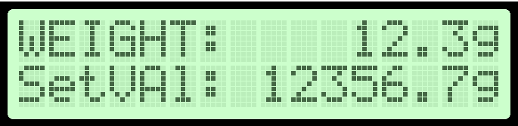

Figure : Example View of Home Screen

#### Valid Commands

Press ‘A’ (FN1) to switch to the Preset Screen with the previous value of Preset A loaded

Press ‘B’ (FN2) to switch to the Preset Screen with the previous value of Preset B loaded

Press ‘C’ (FN3) to switch to the Preset Screen with the previous value of Preset C loaded

Press ‘D’ (Tare) to tare/zero the scale i.e., sets the current WEIGHT = 0

Pressing any other key will result in error (red LED will flash and no change will occur to system)

### Preset Screen

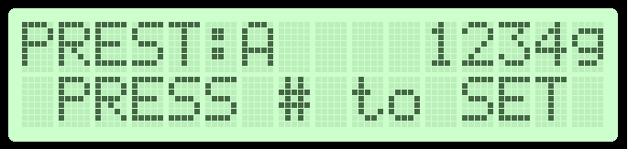

Figure : Example View of Preset Screen

#### Valid Commands

Press ‘A’ (FN1) to switch to the Program Screen with the previous value of Program A loaded**

Press ‘B’ (FN2) to switch to the Program Screen with the previous value of Program B loaded**

Press ‘C’ (FN3) to switch to the Program Screen with the previous value of Program C loaded**

Press ‘#’ (Enter) to load the currently selected preset value

**NOTE: Pressing two consistent values for the function buttons (ex: pressing A twice in a row) will move to the program state for the button that was pressed twice in a row. If a different button is pressed after entering the Preset screen, the screen will switch to the corresponding preset letter (ex: pressing A will change to the Preset A screen, then if you press B the screen will change to the **Preset** B screen, not the Program screen).

Pressing any other key will result in error (red LED will flash and no change will occur to system)

### Program Screen

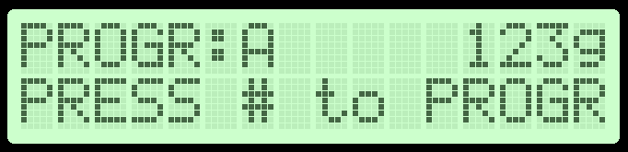

Figure : Example View of Program Screen

#### Valid Commands

Press ‘A’ (FN1) to switch to the Home Screen and cancel the Program**

Press ‘B’ (FN2) to switch to the Home Screen and cancel the Program **

Press ‘C’ (FN3) to switch to the Home Screen and cancel the Program **

Press ‘0’ – ‘9’ to enter in the newly programmed preset for the current selected program letter

Press ‘#’ (Enter) to confirm the newly programmed preset

**NOTE: Pressing two different values for the function buttons (ex: pressing A then B) will switch to the programming page for the second value pressed instead of canceling the program mode (ex: pressing A will bring you to the programming screen for A, pressing B after this will bring you to the programming screen for B, not cancel the program).

Pressing any other key will result in error (red LED will flash and no change will occur to system)