**Introduction to Computers**

**Definition of Computer:**

an electronic device which can receive information (data) in a form and of performing a sequence of operations in accordance with a predetermined but variable set of procedural instructions (program) to produce a result in the form of information or signals.

**OR**

computer. An electronic device that stores and manipulates information. Unlike a calculator, it can store a program and retrieve information from its memory. Most computers today are digital, which means they perform operations with quantities represented electronically as digits

**Basic components of a computer:**

**Input Devices**

 Any information or data that is sent to a computer for processing is considered input. An input device for a computer allows you to enter information. The most fundamental pieces of information are keystrokes on a keyboard and clicks with a mouse. These two input devices are essential for you to interact with your computer.

**Output Devices**

An output device is any peripheral that receives data from a computer, usually for display, projection, or physical reproduction. For example, the image shows an inkjet printer, an output device that can make a hard copy of any information shown on your monitor, which is another example of an output device.

**Memory Unit**

Memory unit is the amount of data that can be stored in the storage unit. This storage capacity is expressed in terms of Bytes.

**Processor**

The most important component of a computer is the central processing unit, or CPU, also called the processor. The processor acts as the computer's brain, running programs and sending and receiving signals to attached devices to keep the computer running

**Storage Devices**

A storage device is any computing hardware that is used for storing, porting and extracting data files and objects. It can hold and store information both temporarily and permanently, and can be internal or external to a computer, server or any similar computing device.

**Communications Devices**

A communication device is a hardware device capable of transmitting an analog or digital signal over the telephone, other communication wire, or wirelessly. The best example of a communication device is a computer Modem, which can send and receiving a signal to allow computers to talk to other computers over the telephone. Other examples of communication devices include a network interface card (NIC), Wi-Fi devices, and an access point.

**Types of Computers**:

**Super Computer:**

A Supercomputer is focused on performing tasks involving intense numerical calculations such as weather forecasting, fluid dynamics, nuclear simulations, theoretical astrophysics, and complex scientific computations. A supercomputer is a computer that is at the front-line of current processing capacity, particularly speed of calculation. The term supercomputer itself is rather fluid, and the speed of today's supercomputers tends to become typical of tomorrow's ordinary computer. Supercomputer processing speeds are measured in floating point operations per second, or FLOPS. An example of a floating-point operation is the calculation of mathematical equations in real numbers. In terms of computational capability, memory size and speed, I/O technology, and topological issues such as bandwidth and latency, supercomputers are the most powerful, are very expensive, and not cost-effective just to perform batch or transaction processing. Transaction processing is handled by less powerful computers such as server computers or mainframes. They are mainly kept in a cool environment for proper functions.

**Micro Computers** (personal computers)

Microcomputers became the most common type of computer in the late 20th century. The term “microcomputer” was introduced with the advent of systems based on single chip microprocessors. The best-known early system was the Altair 8800, introduced in 1975. The term "microcomputer" has practically become an anachronism.

**Mini Computers** (midrange computers)

Minicomputers (colloquially, minis) are a class of multi-user computers that lie in the middle range of the computing spectrum, in between the smallest mainframe computers and the largest single-user systems (microcomputers or personal computers). The contemporary term for minicomputer is midrange computer, such as the higher-end SPARC, POWER and Itanium-based systems from Oracle Corporation, IBM and Hewlett-Packard, and the size is now typically smaller, such as a tower case.

**Mainframe Computers**

The term mainframe computer was created to distinguish the traditional, large, institutional computer intended to service multiple users from the smaller, single user machines. These computers are capable of handling and processing very large amounts of data quickly. Mainframe computers are used in large institutions such as government, banks and large corporations. They are measured in MIPS (million instructions per second) and can respond to hundreds of millions of users at a time.

**Components of Information:**

**BIT**

The bit is represented by 0 for OFF or 1 for ON. It is a binary digit. It is the smallest unit of data the

computer can store in a database.

**BYTE**

A byte is a collection of bits. Each byte consists of eight bits. Each byte represents a character.

**FIELD**

A field is a unit of data consisting of one or more characters (bytes). A field is the smallest unit of meaningful information in the database. Each field has a field name. The field name describes the data that should be entered the field.

**RECORD**

A record is a collection of related fields. Example: Each record stores data about a student.

For example, a student record is a collection of fields about a student.

**FILE**

A file is a collection of related records. For example, a student file is a collection of students’ records.

**Database**

A database is a collection of information that is organized so that it can be easily accessed, managed and updated. Databases process workloads to create and update themselves, querying the data they contain and running applications against it.

**Definition of “Computer Network**

A computer network is a set of connected computers. Computers on a network are called nodes. The connection between computers can be done via cabling, most commonly the Ethernet cable, or wirelessly through radio waves. Connected computers can share resources, like access to the Internet, printers, file servers, and others. A network is a multipurpose connection, which allows a single computer to do more.

**TYPES OF COMPUTER NETWORK:**

**LAN**

A LAN (local area network) is a group of computers and network devices connected, usually within the same building. By definition, the connections must be high speed and relatively inexpensive

**MAN**

A MAN (metropolitan area network) is a larger network that usually spans several buildings in the same city or town

**WAN**

A WAN (wide area network), in comparison to a MAN, is not restricted to a geographical location, although it might be confined within the bounds of a state or country. A WAN connects several LANs, and may be limited to an enterprise (a corporation or an organization) or accessible to the public. The technology is high speed and relatively expensive.

**Internet**

The Internet is a massive network of networks, a networking infrastructure. It connects millions of computers together globally, forming a network in which any computer can communicate with any other computer if they are both connected to the Internet.

**Servers**

any computerized process that can be used or called by another process (particularly remotely, particularly to share a resource) is a server, and the calling process or processes is a client. Thus, any general-purpose computer connected to a network can host servers.

**Benefits of sharing resources on a network**

Fast and easy, access for multiple devices, possible to share internet connection, scalability and reduced costs.

**TYPES OF NETWORK CONNECTION**

**Bus Topology**

A bus topology is another type of design where a single cable connects all computers and the information intended for the last node on the network must run through each connected computer. If a cable is broken, all computers connected down the line cannot reach the network. The benefit of a bus topology is a minimal use of cabling.

**Ring Topology**

A similar topology is called a ring. In this design, computers are connected via a single cable, but the end nodes also are connected to each other. In this design, the signal circulates through the network until it finds the intended recipient. If a network node is not configured properly, or it is down temporarily for another reason, the signal will make several attempts to find its destination.

**Star Topology**

A star topology is a design of a network where a central node extends a cable to

each computer on the network. On a star network, computers are connected

independently to the center of the network. If a cable is broken, the other

computers can operate without problems. A star topology requires a lot of

cabling.

**Mesh Topology**

A network setup where each computer and network device is interconnected

with one another, allowing for most transmissions to be distributed even if one of

the connections go down. It is a topology commonly used for wireless networks.

**Hybrid Topology**

A hybrid topology is a type of network topology that uses two or more differing network topologies. These topologies include a mix of bus topology, mesh topology, ring topology, star topology

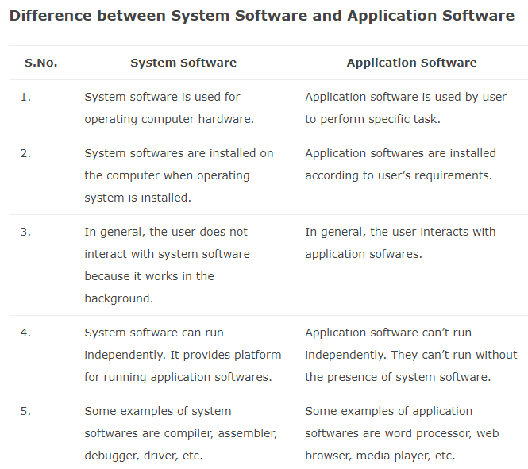

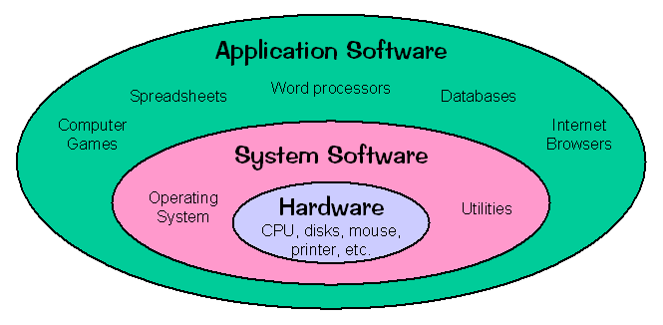

**Difference between Source and Object Programs**

Source program and Object program are two types of programs found in computer programming. The difference between Source program & Object program is given by below.  
  
**Source program:**

* Source program is typically a program which is human readable instructions written by a programmer.
* Source program is written in higher level languages such as Java or C.
* Source program are easily readable by humans.
* **Object program:**Object program is typically a machine executable program created by compiling a source program.
* Object programs usually contain lower level languages such as Assembly language or machine code.
* Object programs aren't easily readable by humans.

**COMPILER**

A compiler is a special program that processes statements written in a programming language and turns them into machine language or "code" that a computer's processor uses. Typically, a programmer writes language statements in a language such as C or C++ one line at a time using an editor. The file that is created contains what are called the source statements. The programmer then runs the appropriate language compiler, specifying the name of the file that contains the source statements.

When executing (running), the compiler first analyzes all the language statements syntactically one after the other and then, in one or more successive stages or "passes", builds the output code, making sure that statements that refer to other statements are referred to correctly in the final code. Traditionally, the output of the compilation has been called object code or sometimes an object module. (Note that the term "object" here is not related to object-oriented programming.) The object code is machine code that the processor can execute one instruction at a time.

**OPERATING SYSTEM**

An operating system is system software that manages computer hardware and software resources and provides common services for computer programs.

**APPLICATION PROGRAMS**

An application is any program, or group of programs, that is designed for the end user. Applications software (also called end-user programs) include such things as database programs, word processors, Web browsers and spreadsheets.

**Examples**: Microsoft suite of products, Internet browsers like Firefox and Chrome.

**Computer Languages**

An alternative term of programming language. It is a set of commands, instructions, and other syntax use to create a software program. ... For example, reserved words like function, while, if, and else are used in most major programming languages. Symbols like <, >, ==, and! = are common operators.