Assignment

CODING:

#include<iostream>

#include<conio.h>

#include<string>

using namespace std;

void loginfb(string username, string uname, string pass, string password);

int main()

{

char pass[32], password[32];

char a;

string uname, username;

cout << "Enter the UserName to sign up : ";

getline(cin, uname);

cout << "Enter the Password to sign up : ";

for (int i = 0;;)

{

a = _getch();

if ((a >= 'a' && a <= 'z') || (a >= 'A' && a <= 'Z') || (a >= '0' && a <= '9')) {

pass[i] = a;

++i;

cout << "*";

}

if (a == '\b' && i > 0) {

cout << "\b \b";

--i;

}

if (a == '\r') {

pass[i] = '\0';

break;

}

}

system("CLS");

cout << "\nEnter the username to sign in : ";

cin >> username;

cout << "\nEnter the password to sign in : ";

for (int j = 0;;) {

a = _getch();

if ((a >= 'a' && a <= 'z') || (a >= 'A' && a <= 'Z') || (a >= '0' && a <= '9')){

password[j] = a;

++j;

cout << "*";

}

if (a == '\b' && j > 0) {

cout << "\b \b";

--j;

}

if (a == '\r') {

password[j] = '\0';

break;

}

}

cout<<endl;

loginfb(username, uname, pass, password);

_getch();

return 0;

}

void loginfb(string username, string uname, string pass, string password){

if (uname == username && password == pass) {

cout << "Login Successfull";

}

else

cout << "The userName or password invalid";

}

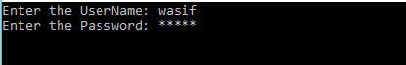

Results:

Login Successful!

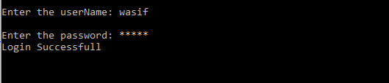

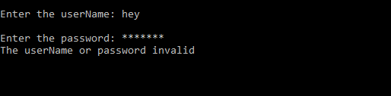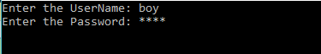Login Unsuccessful!