Assignment

CODING:

#include<iostream>
#include<stdio.h>
#include<conio.h>
using namespace std;
long power(int num, int power);

int main()
{
int n,p;
cout << "Enter the no: ";
cin >> n;
cout << "Enter the power: ";
cin >> p;
cout << power(n, p);
_getch();
return 0;
}
long power(int num, int pow)
{
long prod=1;
if (pow > 0) {
prod = num*power(num, pow-1);
}
return prod;
}

Results:

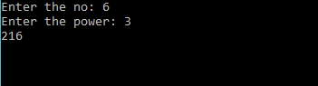

Assignment

CODING:
#include<iostream>
#include <stdio.h>
#include <conio.h>
#include <string>

using namespace std;
int fib(int n)
{
if (n <= 1)
return n;
return fib(n - 1) + fib(n - 2);
}
int main()
{
int n = 10, i;
for (i = 0; i < n; i++)
cout << fib(i) << " ";
system("pause");
return 0;
}
Results:
0 1 1 2 3 5 8 13 21 34 Press any key to continue . . .

