1. Home page -> <http://localhost:8080/RaboAssignment/>

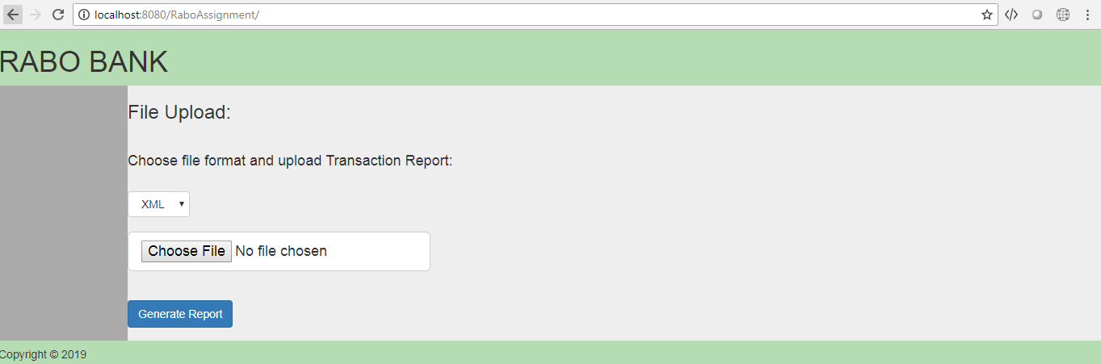

1. Choose File Format[XML/CSV] and upload the transaction report.

* Selected XML as file type and uploaded the report
* Click Generate Report Button

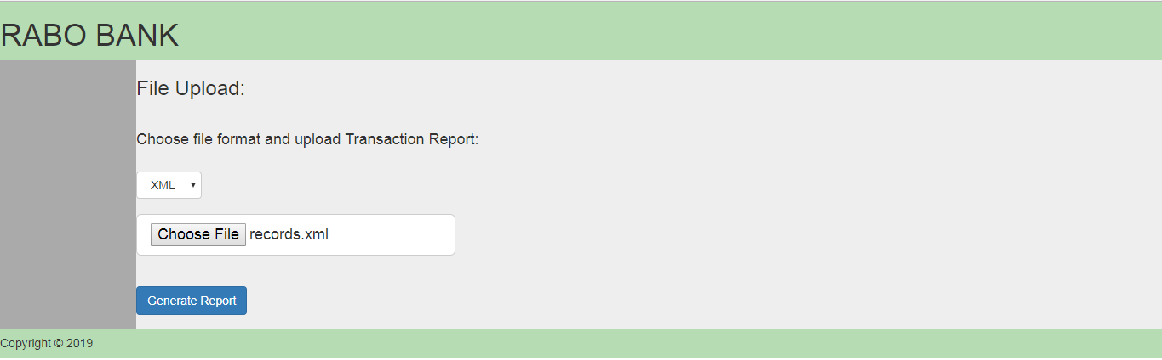

1. Failed Transaction report gets downloaded.

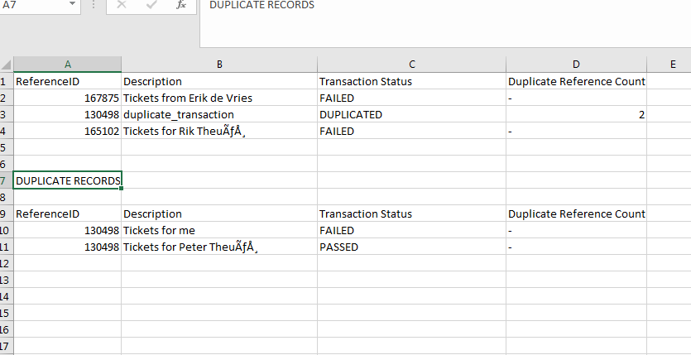

1. Empty File Scenario.

* In Home page, Without Uploading a report – Click Generate Report Button.
* Or upload XML file and select CSV format in Dropdown - Click Generate Report Button.
* Able to see **ERROR** page.

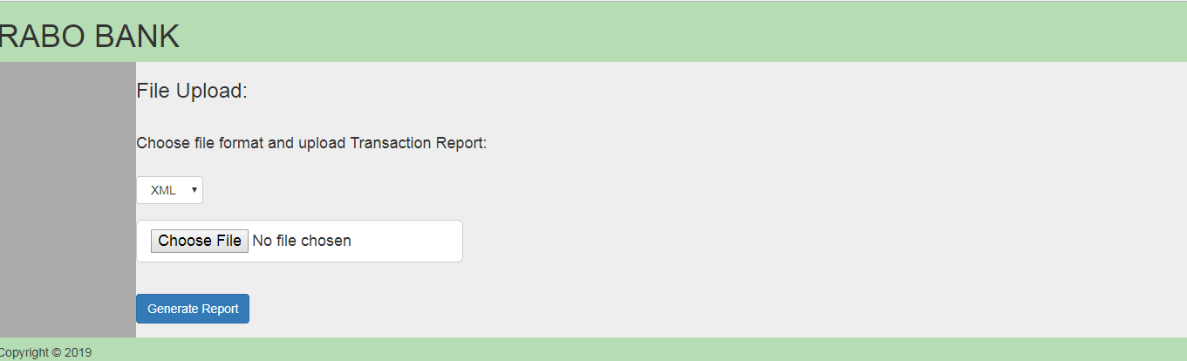

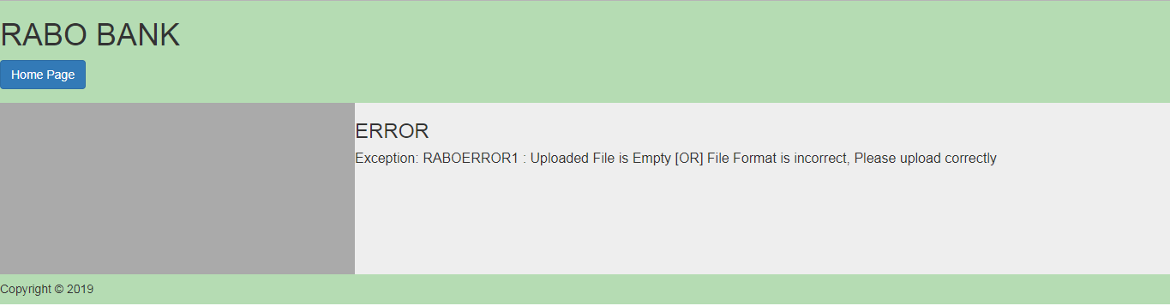

* Use **Home page** button to move back.

1. Empty Failed Transaction Report Generated Scenario.

* Upload CSV/XML Transaction Report Without Duplication Reference and Failed records,

Failed Transaction Report will generate with message “NO FAILED RECORDS TO SHOW”.

