层次分析法做事故预防

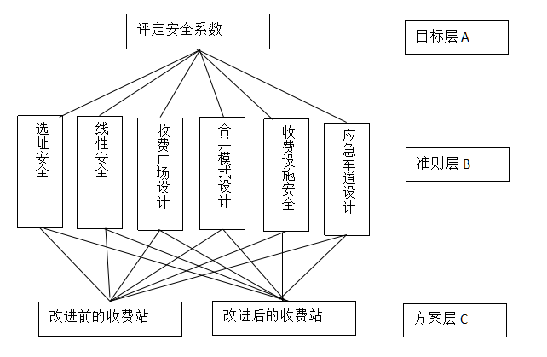

|  |  |  |  |  |  |  |
| --- | --- | --- | --- | --- | --- | --- |
| A | B1 | B2 | B3 | B4 | B5 | B6 |
| B1 | 1 | 1 | 1 | 4 | 1 | 1/2 |
| B2 | 1 | 1 | 2 | 4 | 1 | 1/2 |
| B3 | 1 | 1/2 | 1 | 5 | 3 | 1/2 |
| B4 | 1/4 | 1/4 | 1/5 | 1 | 1/3 | 1/3 |
| B5 | 1 | 1 | 1/3 | 3 | 1 | 1 |
| B6 | 2 | 2 | 2 | 3 | 3 | 1 |

改进后，收费广场和合并模式得到了改善

方案层的判断矩阵如下图所示

|  |  |  |  |  |  |  |  |  |
| --- | --- | --- | --- | --- | --- | --- | --- | --- |
| B1 | C1 | C2 | B2 | C1 | C2 | B3 | C1 | C2 |
| C1 | 1 | 1 | C1 | 1 | 1 | C1 | 1 | 1/4 |
| C2 | 1 | 1 | C2 | 1 | 1 | C2 | 4 | 1 |
| B4 | C1 | C2 | B5 | C1 | C2 | B6 | C1 | C2 |
| C1 | 1 | 1/5 | C1 | 1 | 1 | C1 | 1 | 1 |
| C2 | 5 | 1 | C2 | 1 | 1 | C2 | 1 | 1 |

层次总排序

|  |  |  |  |  |  |  |  |  |
| --- | --- | --- | --- | --- | --- | --- | --- | --- |
| 准则 | | 选址安全 | 线性安全 | 收费广场 | 合并模式 | 收费设施 | 应急车道 | 总排序权值 |
|
| 准则层权值 | | 0.1507 | 0.1792 | 0.1886 | 0.0472 | 0.1464 | 0.2879 |
| 方案层单 | 改进前 | 0.5 | 0.5 | 0.2 | 0.17 | 0.5 | 0.5 | 0.427844 |
| 排序权值 | 改进后 | 0.5 | 0.5 | 0.8 | 0.83 | 0.5 | 0.5 | 0.572156 |

经过层次分析法可以看出，改进后的广场安全系数得到了提高

参考文献：层次分析法

高速公路收费站处交通安全研究 尹小亭