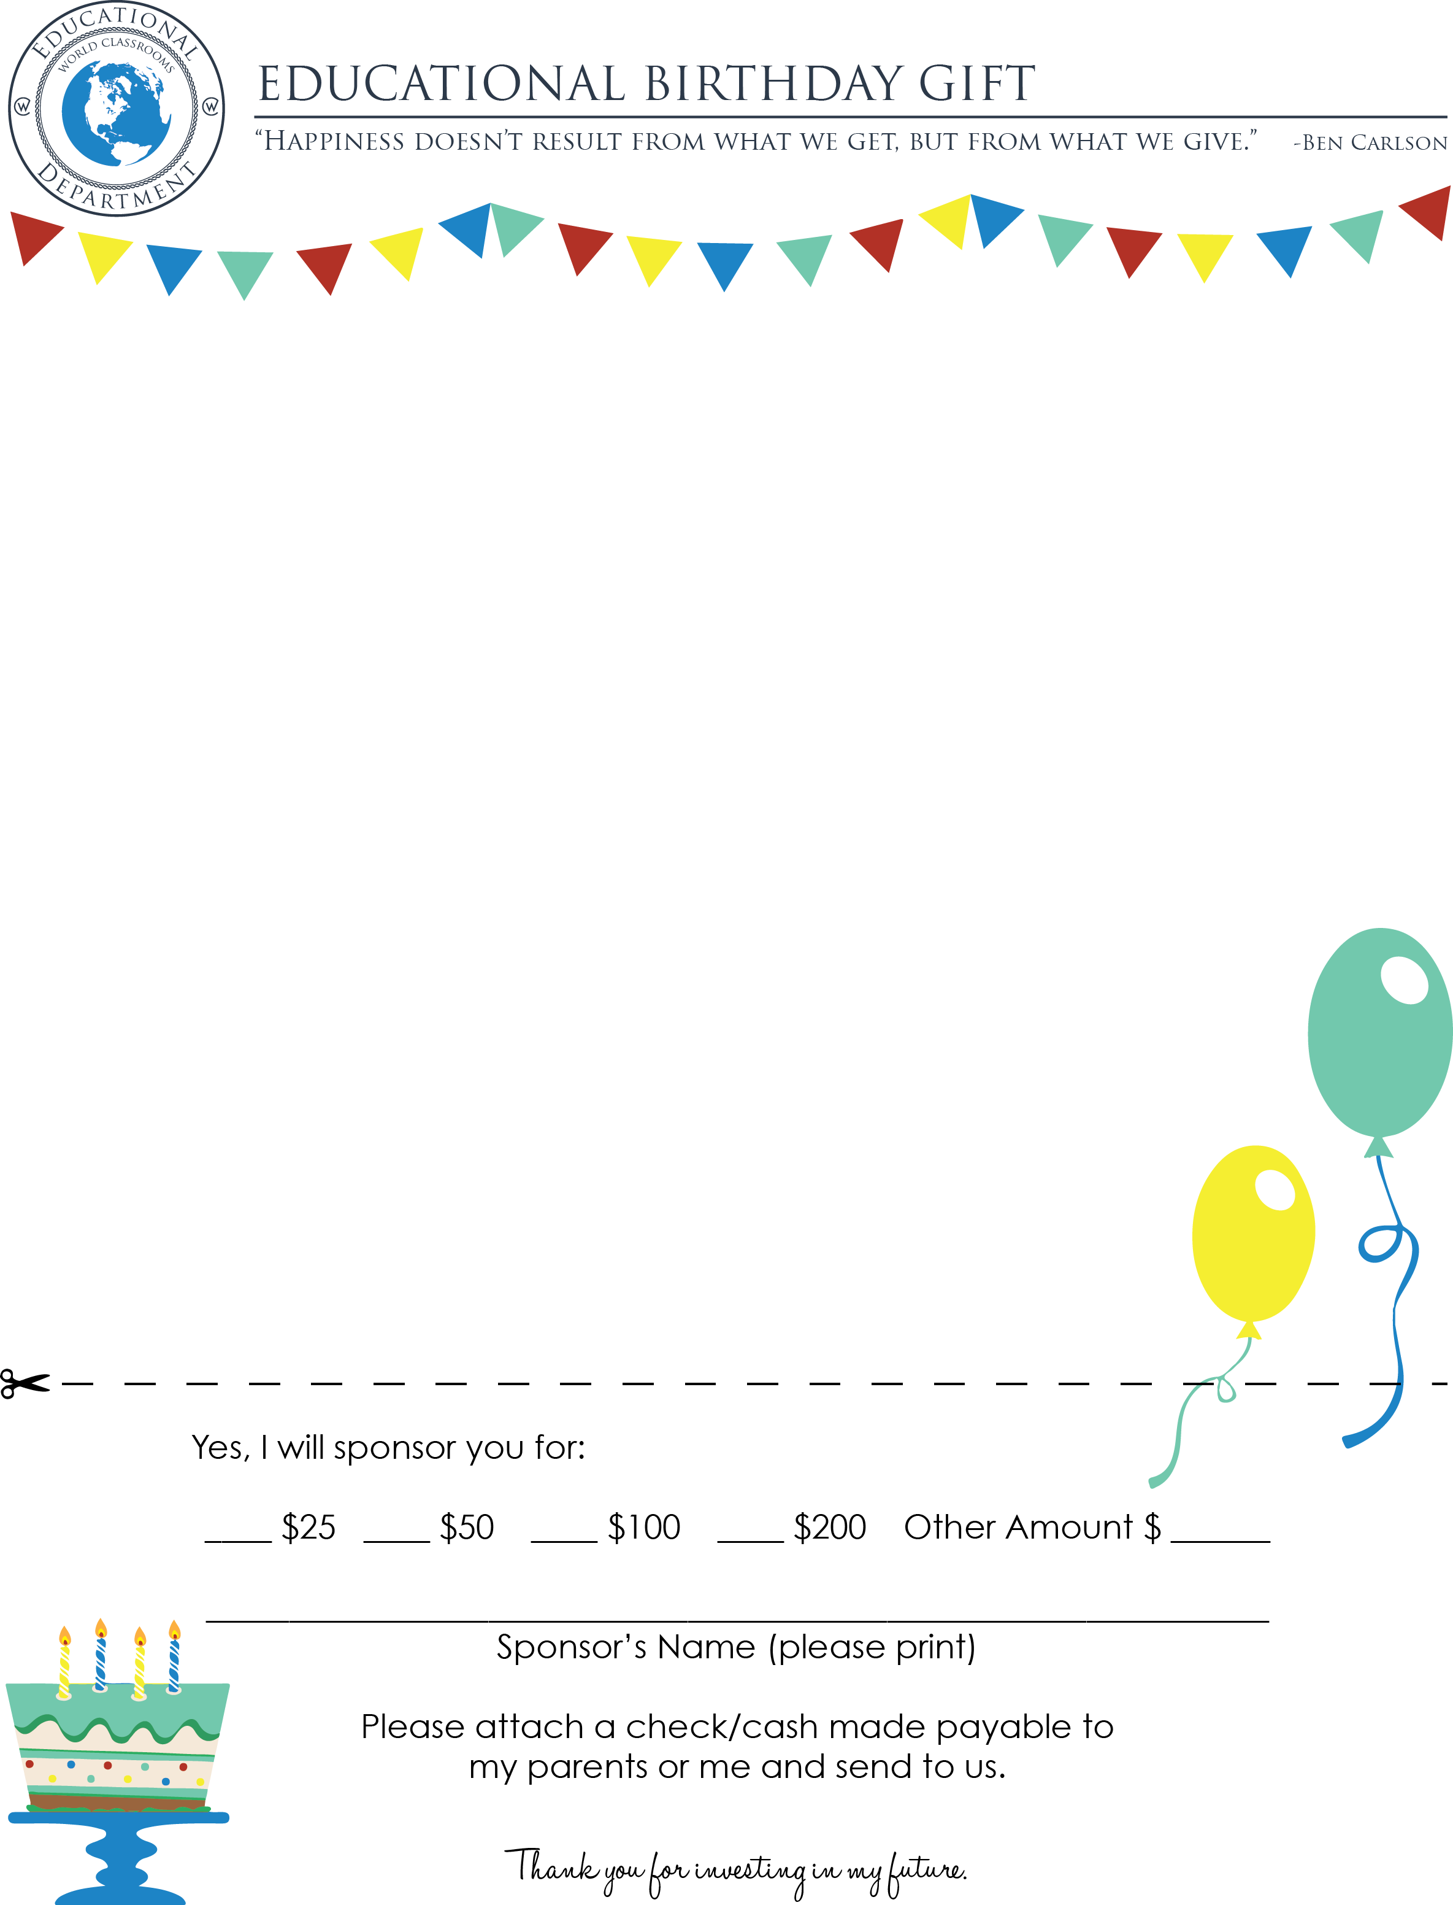

Dear (Friend or Relative's Name),

I have the opportunity to do something which I am very excited about. This coming summer I am planning to go on an Educational Field trip with my teacher and classmates! I cannot think of a better way to spend part of my summer.

While we are there we will be visiting many famous landmarks and other exciting educational sites. I am so excited to have the opportunity to actually go, see, and explore.

During the next few months I will be working very hard to raise the funds to go on this journey. I am asking that you consider assisting me to make this educational goal a reality by sponsoring a portion of my trip.

My goal is to have $1,000 raised before my trip. For my birthday this year, I am asking that instead of presents you will consider donating funds toward my academic adventure. Any contribution you give would bring me that much closer to being part of this once-in-a-lifetime opportunity.

Thank you so much for your consideration. You will really help me by making this educational investment in me.

If you have any questions, please give me a call.

Sincerely,

(Your Name)

(Your Address)