SECURE SOFTWARE ENGINEERING CAPSTONE REPORT

AWS DevSecOps
  - Secure Container Delivery and Runtime Monitoring
GitHub Actions AWS ECR and ECS Falco Local Docker
Document Control | Details
Author | Marisetti Avinash
Student ID | CH.SC.U4CYS23024
Institution | Amrita Vishwa Vidyapeetham Chennai
Supervisor | S.Udhaya Kumar
Subject | Secure Software Engineering
Project | AWS DevSecOps secure delivery demonstration
Repository | https://github.com/MAvinash24/aws
Region | Mumbai ap-south-1
Report date | 6 October 2026
Verified release | 37443610115

The implemented pipeline has completed a real signed deployment to AWS. The application is healthy in ECS and in the independent local Docker demonstration. This report records the engineering design, final changes, verification evidence and remaining production limits.

Table of Contents
1 Introduction 4
1.1 Background and Motivation 4
1.2 Purpose and Scope 4
1.3 Executive Summary 4
1.4 Engineering Lifecycle 4
1.5 Technology and Toolchain 5
2 Requirement Engineering 6
2.1 Problem Statement 6
2.2 Stakeholders 6
2.3 Functional Requirements 6
2.4 Non Functional Requirements 7
2.5 Security Requirements 7
3 Requirement Analysis 8
3.1 Actors and Use Cases 8
3.2 Verified Release Use Case 8
3.3 Trusted Deployment Use Case 9
3.4 Local Demonstration Use Case 9
4 Data Modeling 10
4.1 Release Artifact Model 10
4.2 Entities and Integrity Rules 10
4.3 Data Stores and Retention 11
4.4 Manifest Example 11
5 Data Flow Modeling 12
5.1 Context and Decomposition 12
5.2 Trust Boundary Matrix 12
6 Threat Modeling 13
6.1 Assets and CIA Analysis 13
6.2 STRIDE Analysis 13
6.3 Attack Surface and Limits 13
6.4 Qualitative Risk Register 14
6.5 Control Verification 14
7 Attack Tree Analysis 15
7.1 Attacker Goal and Paths 15
7.2 Path Analysis 15
7.3 Security Interpretation 15
8 Interfaces and Operations 16
8.1 Local Application Interface 16
8.2 AWS Runtime Interface 17
8.3 Operating Commands 17
9 Product Backlog 18
9.1 Completed Backlog 18
9.2 Future Work 18
10 Implementation Changes 19
10.1 Architecture Migration 19
10.2 File Changes 19
10.3 Action Runtime Update 20
10.4 Repository and Workflow Evidence 21
11 DevSecOps Testing and Deployment 22
11.1 Container Hardening 22
11.2 Preventive Gate Sequence 22
11.3 Unit and Negative Tests 23
11.4 Scanner Results 23
11.5 Live GitHub and AWS Results 24
11.6 Runtime Detection and Audit 24
11.7 Deployment Readiness 25
12 Traceability and Conclusion 26
12.1 Requirement Traceability 26
12.2 Submission Artifact Set 26
12.3 Conclusion 27
12.4 Primary References 27

List of Figures
Figure 1 Implemented architecture with independent local Docker runtime and separate build and deployment authority 5
Figure 2 Release use cases and actor responsibilities 8
Figure 3 Logical relationships among source commit, workflow, manifest, digest, signature, task and evidence 10
Figure 4 Release data flow with untrusted manifest transfer and separate AWS identity boundaries 12
Figure 5 Design attack tree with preventive controls and the residual administrator bypass path 15
Figure 6 Supplied local root endpoint showing AWS DevSecOps project metadata 16
Figure 7 Supplied local health endpoint returning healthy 16
Figure 8 Supplied AWS Console evidence of the devsecops-demo t3.micro host in Mumbai 17
Figure 9 Supplied CodeBuild project list showing retained build and deploy projects rather than successful active builds 19
Figure 10 Supplied repository screenshot showing source layout and the documented migration commit 21
Figure 11 Supplied workflow history showing successful runs and one cancelled run 21
Figure 12 Supplied test output showing the 11 successful application and deployment logic tests 23
Figure 13 Supplied earlier successful GitHub run 37438900114 before the Node 24 update 24

1 Introduction
This capstone implements secure container delivery from GitHub to AWS and keeps an independent local Docker demonstration available. The completed release passes preventive security gates, cryptographic verification and ECS health checks. Evidence is recorded against a specific source commit and image digest, rather than inferred from the presence of cloud resources.

1.1 Background and Motivation
A container can be deployable while its source, dependencies or delivery credentials remain unsafe. A reproducible security engineering workflow must examine the source, infrastructure, image and deployment decision together. This project demonstrates those checks with a deliberately small application so the delivery controls can be reviewed clearly.
The original AWS CodePipeline design reached its source stage, but CodeBuild could not start because applied account and regional concurrency was zero. AdministratorAccess did not override the service quota. The final architecture moves CI computation to GitHub Actions while ECR, ECS, Falco and AWS monitoring remain on AWS. The exact account restriction was observed; its underlying account-policy reason was not established.

1.2 Purpose and Scope
The report covers requirements, use cases, artifact modeling, data flows, threats, attack paths, operational interfaces, implementation changes, tests and verified deployment. It documents a single-account educational deployment in Mumbai and a localhost-only Docker app in D:\aws.
The application exposes JSON at / and /health. It has no authentication system, database, user-upload feature or interactive command execution. The engineering scope is the secure delivery and runtime observation of this service. Production availability, multi-account governance and a full enterprise security audit are outside this baseline.

1.3 Executive Summary
Table 1 Verified project baseline
Area | Final implementation | Evidence
CI/CD | Two GitHub Actions jobs with separate AWS OIDC roles | Successful run 37443610115
Preventive controls | 11 tests, IaC lint, selected Checkov, Guard, Semgrep and Trivy | Downloaded run evidence
Artifact integrity | Cosign keyed signature on the exact ECR digest | Verified deployment manifest
AWS runtime | One healthy ECS task on one t3.micro EC2 host | Current CLI/SDK snapshot
Runtime detection | Falco modern eBPF with CloudWatch delivery | Actual Warning events
Local demonstration | Docker app on 127.0.0.1:8080 | Healthy local response

1.4 Engineering Lifecycle
The lifecycle proceeds from requirements to architecture and threat analysis, then infrastructure validation, implementation, negative testing and deployment evidence. Security is checked before publishing and again before deployment. Runtime monitoring observes behavior after release; it does not replace preventive controls.
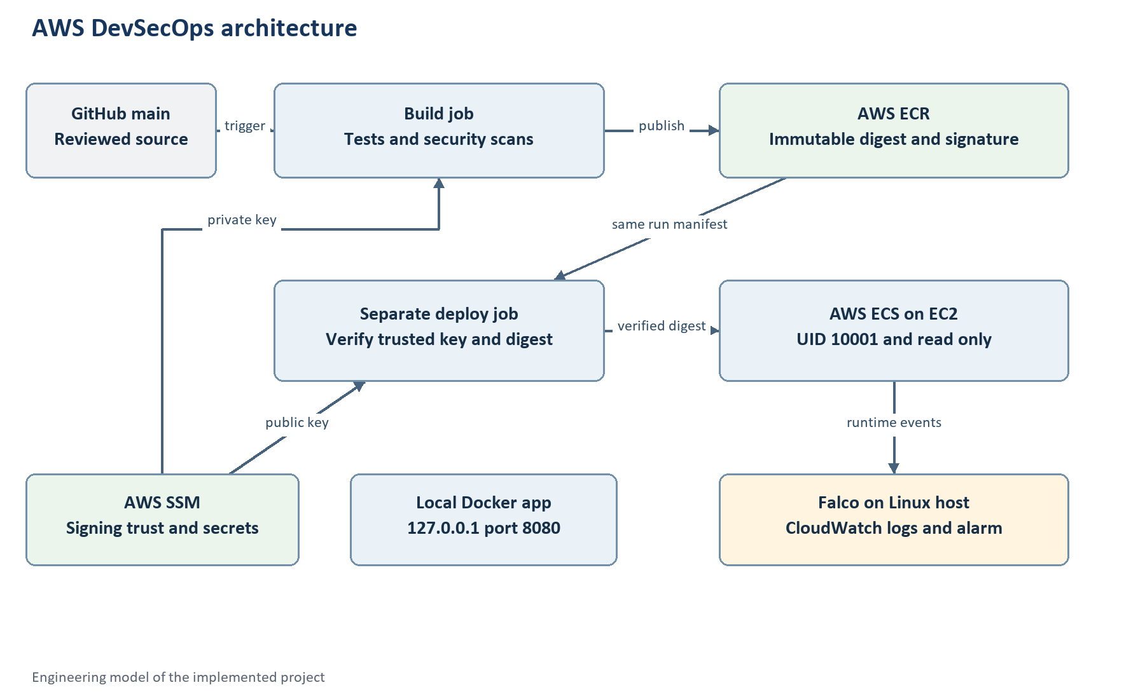
Figure 1 Implemented architecture with independent local Docker runtime and separate build and deployment authority

1.5 Technology and Toolchain
Table 2 Tools and their actual roles
Tool | Purpose | Scope or limitation
Python 3.12 container | Dependency-free JSON HTTP application | Standard library service
Docker | Local and CI image build; hardened execution | Local app stays separate from ECS
GitHub Actions | Tests, scans, build, signing and deployment | Standard hosted Ubuntu runners
CloudFormation and cfn-lint | Four generated infrastructure templates | Schema checks and reviewed changes
Checkov and Guard | Selected IaC controls and explicit invariants | Not every AWS benchmark
Semgrep CE | Checked-in rules and unsafe-pattern fixtures | Small rule set, not exhaustive SAST
Trivy | Filesystem/image CVE and secret gates; SBOM | Database-dependent findings
Cosign | Keyed ECR digest signing and verification | No public Rekor transparency requirement
AWS IAM and SSM | Scoped roles, boundary and signing trust | Administrator remains trusted
Falco and CloudWatch | Host/container behavior detection and alerting | Sensor requires host privileges

2 Requirement Engineering
Requirements separate what the service does from the safeguards required to release it. Each identifier is used again in the traceability matrix. Status is based on observed configuration or tests, with future work kept separate.

2.1 Problem Statement
Build an auditable DevSecOps demonstration that rejects unsafe source, infrastructure and images; authenticates CI without stored AWS access keys; signs immutable artifacts; verifies trust before modifying ECS; and observes suspicious container behavior. The local service must remain usable while the cloud pipeline executes.

2.2 Stakeholders
Table 3 Stakeholders and responsibilities
Stakeholder | Responsibility | Security consideration
Developer | Review and push application/security changes | Trusted main-branch code can alter the delivery process
AWS administrator | Provision account-scoped resources and signing trust | Can bypass pipeline controls if directly authorized
CI build job | Scan, build, publish and sign | Cannot register tasks, update ECS or pass roles
CI deployment job | Validate trust and deploy exact digest | Cannot push images or read private signing material
Evaluator or operator | Inspect report, workflow and runtime evidence | Must distinguish test doubles from live observations

2.3 Functional Requirements
Table 4 Functional requirements
ID | Requirement | Acceptance evidence
FR01 | Serve project metadata and HTTP health JSON | 200 for / and /health
FR02 | Reject unknown and traversal-shaped paths | 404 results in test_app
FR03 | Run source and infrastructure gates before AWS build access | Workflow step ordering and successful jobs
FR04 | Build, scan and publish a uniquely tagged immutable image | ECR digest and Trivy report
FR05 | Sign the exact digest using protected SSM trust | Cosign signature accepted by verifier
FR06 | Transfer release identity to a separate deployment job | Same-run release artifact
FR07 | Verify source, repository, digest, key and hardening before ECS mutation | Negative tests and real verified deployment
FR08 | Reach one healthy ECS task and reject rollback as success | Current service/task evidence
FR09 | Detect a harmless unexpected container shell event | Falco Warning delivered to CloudWatch
FR10 | Keep a hardened local app running independently | Docker inspect and localhost health

2.4 Non Functional Requirements
Table 5 Non functional requirements
ID | Requirement | Implemented baseline
NF01 | Reproducible inputs | Digest-pinned base and sensor; pinned action commits; checksummed native tools
NF02 | Limited attack surface | No public application ingress; localhost local port; dependency-free app
NF03 | Controlled resource use | One EC2 host, one ECS app task and bounded workflow timeouts
NF04 | Auditability | Source SHA, digest, scan evidence, task revision and dated runtime snapshot
NF05 | Safe failures | Failing gates stop deployment; ECS rollback is reported as failure
NF06 | Maintainability | Editable generator, reusable scripts and PowerShell operating guide

2.5 Security Requirements
Table 6 Security requirements
ID | Control | Verification
SR01 | Exact OIDC audience and immutable repository/environment subjects | Trust policies and real role assumption
SR02 | Main-only environments and scoped separate roles | GitHub settings, IAM validation and deny simulation
SR03 | No signing private key or AWS access key in GitHub artifacts | SSM storage and workflow handling
SR04 | Block HIGH/CRITICAL CVEs and secrets without ignoring unfixed issues | Trivy strict exit gate
SR05 | Trusted-key signature verification before any ECS registration/update | Verifier tests and real deployment
SR06 | UID 10001, read-only rootfs, unprivileged app and ALL capabilities dropped | Task validation and runtime inspection
SR07 | No application IAM permissions and metadata isolation | Task role configuration and earlier live rejection probe
SR08 | Encrypted/private storage and immutable ECR tags | Guard, Checkov and AWS configuration
SR09 | Runtime sensor and verifiable alert delivery | Falco event and CloudWatch evidence

3 Requirement Analysis
Use cases model the actors and the conditions that permit a release. Deployment success requires the correct source and signed artifact; a completed build alone is insufficient.

3.1 Actors and Use Cases
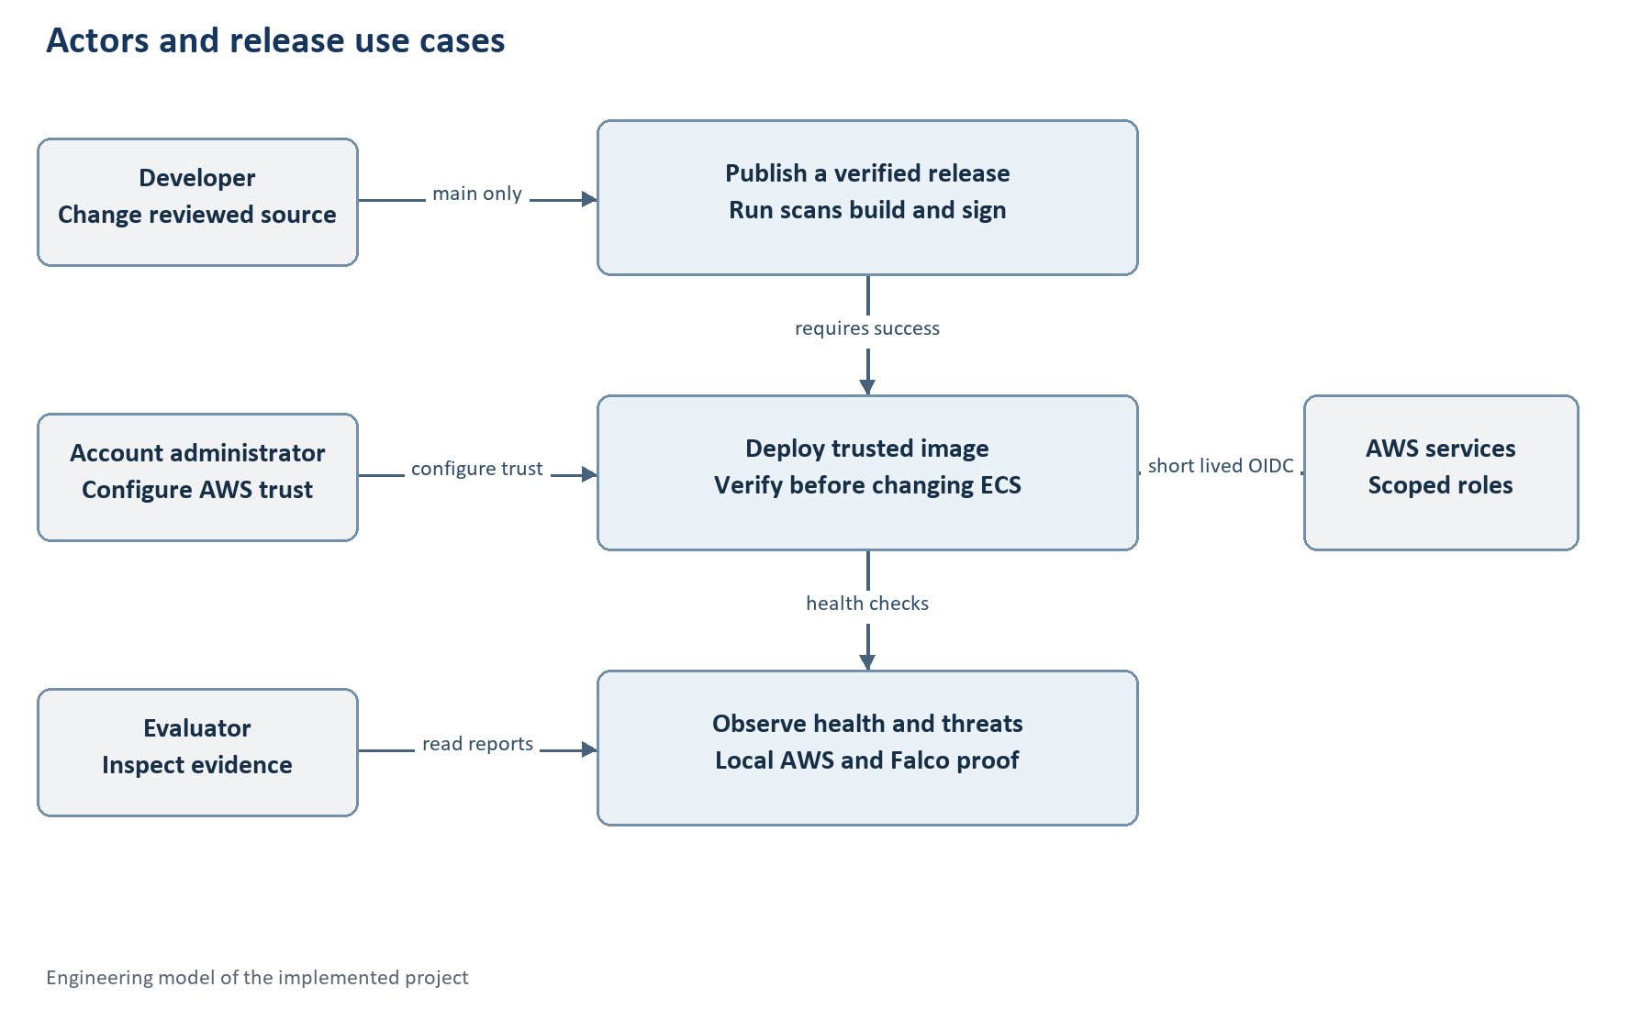
Figure 2 Release use cases and actor responsibilities
The developer starts a release by pushing to main or manually running the workflow. GitHub environments constrain AWS identity. The administrator establishes the initial infrastructure and trusted public key. An evaluator consumes evidence without needing signing permissions.

3.2 Verified Release Use Case
Table 7 UC01 Publish a verified release
Field | Specification
Primary actor | Developer using approved main-branch source
Preconditions | Configured repository variables, main-only environments, AWS roles, ECR and SSM trust
Trigger | Source push or workflow_dispatch on main
Normal flow | Checkout exact SHA; install pinned tools; run tests/scans; assume build role; validate IAM; build and scan; push image; sign exact digest; publish release manifest
Exception flow | Any tool/install/scan/identity/signing failure terminates the release; evidence upload still runs where available
Postcondition | A signed digest and same-run source manifest exist; AWS runtime has not yet been changed

3.3 Trusted Deployment Use Case
Table 8 UC02 Verify and deploy
Field | Specification
Primary actor | Separate GitHub deployment job
Preconditions | Build job succeeded and this run contains its release manifest
Normal flow | Read manifest; enforce source SHA and expected ECR repository/digest; obtain trusted SSM public key; validate current task hardening; verify signature; register revision; update this service; wait for stable healthy deployment
Exception flow | Signature or hardening rejection occurs before registration/update; stability timeout or rollback fails the job
Postcondition | One healthy ECS task references the verified digest and the deployment report records its source and revision
Test linkage | Invalid signature, invalid commit, wrong repository, privileged/host-mounted task and rollback tests

3.4 Local Demonstration Use Case
The operator checks the existing devsecops-local container and sends requests to localhost. This path needs Docker Desktop but does not consume CodeBuild capacity or use signing parameters. Building a newer local image does not automatically replace an existing container; the container remains running until deliberately restarted.
Table 9 UC03 Observe runtime behavior
Step | Expected outcome
Check local health | JSON status healthy
Inspect Docker hardening | UID 10001, read-only root and dropped capabilities
Inspect AWS service separately | One current healthy digest-based task
Generate harmless shell probe on AWS app | An actual Falco event for that container is found in CloudWatch
Save observations | Dated JSON or screenshot evidence, with environment identified

4 Data Modeling
This service has no business database. Its relevant data model consists of source revisions, immutable container artifacts, signing trust, ECS definitions and evidence records. The diagram is a logical artifact model rather than a relational schema.

4.1 Release Artifact Model
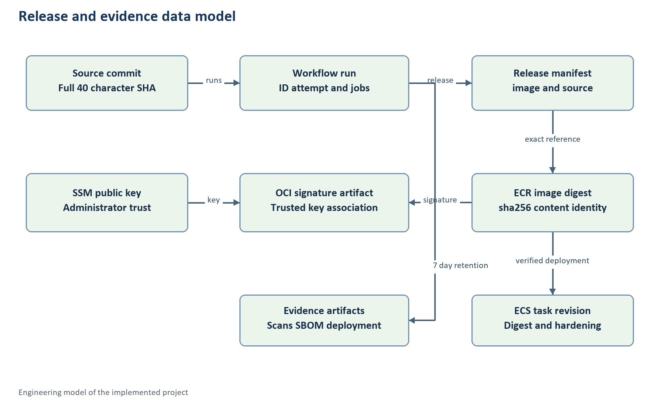
Figure 3 Logical relationships among source commit, workflow, manifest, digest, signature, task and evidence

4.2 Entities and Integrity Rules
Table 10 Release entities
Entity | Identifier or fields | Integrity rule
Source revision | 40 lowercase hexadecimal Git SHA | Build and deployment source must match
Workflow run | Run ID and attempt | Artifact identity is confined to the same run
Release manifest | image and source | Untrusted input until validated
ECR image | Repository plus sha256 digest | Expected repository and exact content address
Signature | OCI reference artifact | Verified against SSM public key
Signing trust | SSM private-key/password/public-key paths | Public trust comes from administrator, not artifact
Task definition | Family, revision, image, roles and hardening | Only permitted hardened task parameters accepted
Evidence | Tests, scanners, SBOM, deployment JSON | Dated result for the specific checked inputs

4.3 Data Stores and Retention
Table 11 Project data stores
Store | Stored data | Retention or handling
GitHub repository | Source, workflow, configuration and report | Git history; secret/local folders excluded
GitHub Actions artifacts | Release, scan reports, SBOM and deployment proof | Seven-day configured retention; downloaded local copies
ECR | Application images and signature reference artifacts | Immutable tags; no automatic lifecycle deletion in baseline
SSM Parameter Store | Protected signing key/password and trusted public key | Existing trust is not overwritten automatically
CloudWatch Logs | Runtime application/Falco and legacy event logs | Seven-day configured log retention
Retained S3 artifact bucket | Legacy CodePipeline artifacts | Versioned, encrypted, private; expiry policy in template
Local reports directory | Machine-specific and downloaded evidence | Ignored by Git and packaged separately

4.4 Manifest Example
{
"image": "<expected-ECR-repository>@sha256:<64-hex-digest>",
"source": "<full-40-character-Git-SHA>"
}
A manifest is not proof of trust by itself. The verifier rejects malformed identities, a different repository, a different source commit or a signature that does not match the trusted key. ECS receives the digest, avoiding tag-resolution ambiguity.

5 Data Flow Modeling
The release flow crosses GitHub, AWS identity, protected signing storage, registry and runtime boundaries. Each crossing has an explicit authority or validation step.

5.1 Context and Decomposition
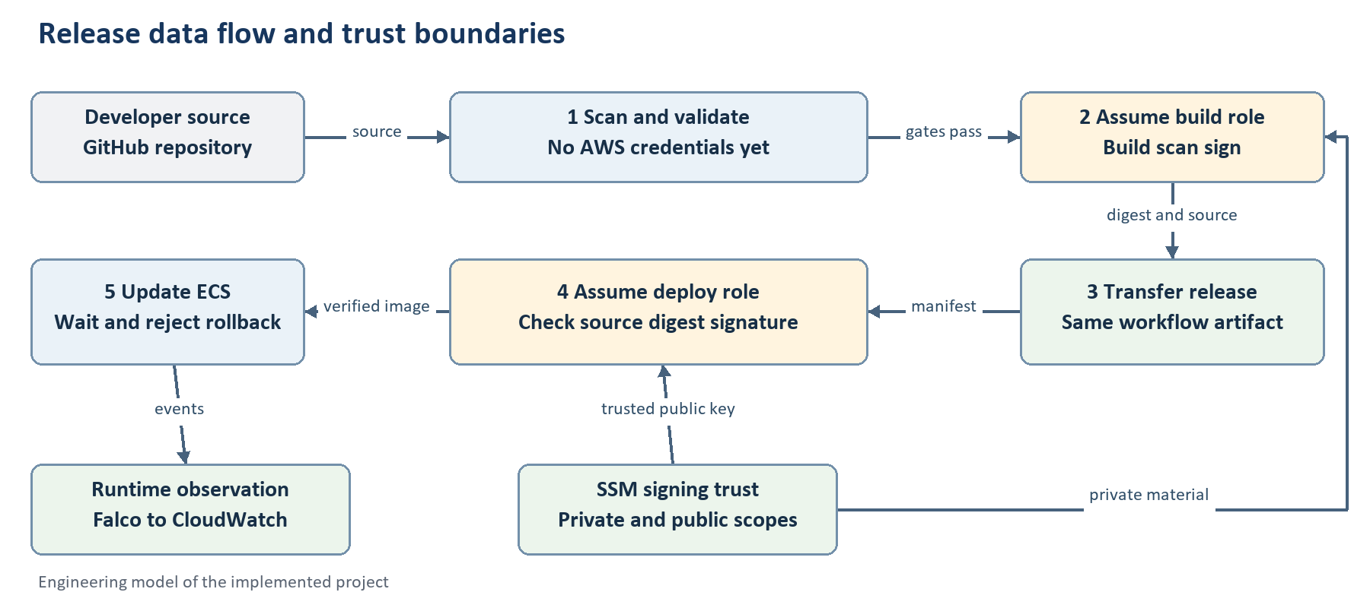
Figure 4 Release data flow with untrusted manifest transfer and separate AWS identity boundaries
Source enters a hosted runner, where preventive checks execute before AWS build credentials are configured. After those gates, the build role publishes and signs. A second runner receives only a release identity and assumes a different role. The trusted public key is retrieved from SSM rather than supplied by the artifact.

5.2 Trust Boundary Matrix
Table 12 Trust boundaries
Boundary | Data or authority | Required control
Developer to GitHub main | Source and workflow definitions | Authorized change review and restricted collaborators
GitHub to AWS STS | OIDC token | Exact repository/environment subject and audience
Build to SSM | Signing secrets | Read scope limited to private-key/password for this project
Build to ECR | Image layers, digest and signature | Strict scan gate and repository-scoped publish
Artifact to deploy job | Manifest from current run | Validate source, repository and SHA256 identity
Deploy to SSM | Trusted public key | Only configured public-key parameter
Deploy to ECS | Task registration and service update | Verify first; exact roles and hardened definition
App to host | Kernel/container interaction | Non-root/read-only/capability restrictions; metadata block
Falco to CloudWatch | Behavior events | Actual delivery and sensor-health validation

6 Threat Modeling
The threat model is a design analysis of this implementation. It distinguishes controls verified in tests from residual trust in administrators and reviewed main-branch code. A threat scenario is not a claim that the account was compromised.

6.1 Assets and CIA Analysis
Table 13 Assets and security priorities
Asset | Confidentiality | Integrity | Availability | Reason
Signing private key/password | High | High | Medium | Possession enables trusted signatures
Trusted public key | Low | High | Medium | Replacement changes release trust
Source and workflow | Low in public repo | High | Medium | Controls what code is scanned and released
Image and manifest | Low for this demo | High | Medium | Defines executable content
AWS deployment authority | High | High | High | Can change the running workload
Runtime host/sensor | Medium | High | High | Host compromise affects app and observation
Evidence and logs | Medium | High | Medium | Supports review and incident interpretation

6.2 STRIDE Analysis
Table 14 STRIDE scenarios
Category | Threat scenario | Implemented response | Residual risk
Spoofing | Another repository requests AWS authority | Exact OIDC subject and audience; main-only environments | Repository administrators remain trusted
Tampering | Manifest digest or source changed | Repository/SHA checks and trusted-key signature | Trusted workflow changes can alter checks
Repudiation | Release cannot be tied to source | Run IDs, source SHA, digest and deployment evidence | Artifact/log retention must be managed
Information disclosure | Signing key or credentials leak in logs | SSM SecureStrings, temporary files and no tracing | Compromised build code can access its authorized secrets
Denial of service | Build stalls, host overload or bad release | Timeouts, one-job concurrency, health checks and rollback rejection | One small host is a single failure domain
Elevation of privilege | App or build gains deployment/host privileges | Bounded separate roles, non-root/read-only app, no mounts | Falco necessarily has powerful host access

6.3 Attack Surface and Limits
The app uses a whitelist of two GET paths and never maps request paths to filesystem reads or commands. JSON log encoding reduces the risk of forged plain-text log entries. Runtime application privileges are minimized independently from the Falco sensor. These controls reduce the relevant surface; they do not establish the absence of every vulnerability in Python, Docker, the kernel or CI tools.
The Checkov control set is selected, Semgrep uses three project rules, and scanner results depend on supported formats and database state. Tool transitive dependencies are not fully hash-locked. A future HIGH/CRITICAL finding can legitimately fail a release even when this dated run passed.

6.4 Qualitative Risk Register
Table 15 Residual risk assessment
Risk | Initial exposure | Current controls | Residual judgment
Main workflow compromise | High | Review changes, pin actions, main-only role access | High impact remains; trusted source authority
Private signing-key misuse | High | SSM scope, isolated role, temporary handling | Medium; authorized build compromise remains relevant
Untrusted image deployment | High | Digest signature and verification-before-mutation | Low through normal workflow; admin bypass remains
Host failure or resource pressure | High | Health checks, bounded app/sensor, monitoring | Medium; no high availability
Evidence expiry | Medium | Downloaded reports and report evidence archive | Medium unless retained outside short-lived stores
Unexpected AWS cost growth | Medium | One host, no NAT/LB, explicit stop/resume | Medium; credits and storage remain finite

6.5 Control Verification
Table 16 Control verification and evidence strength
Control | Evidence class | Observed result
OIDC authentication | Live GitHub/AWS integration | Both jobs successfully assumed intended roles
Build/deploy separation | Actual IAM simulator and policy analysis | Build ECS update denied; deploy private-key read denied
Signature-before-mutation | Negative unit tests and real positive release | Rejected signature makes no ECS mutation; signed release deploys
Non-root/read-only app | Actual runtime inspection | UID 10001; readonly true; privileged false; drop ALL
Falco detection | Live host probe and CloudWatch event | Warning associated with application container
Wrong key rejection | Earlier real ECR verifier probe | Rejected before ECS mutation in bootstrap evidence

7 Attack Tree Analysis
The attacker goal is to make AWS execute an untrusted container. Alternative paths target source authority, artifact transfer or direct administrator deployment. The model explains where the normal workflow blocks tampering and where organizational trust remains necessary.

7.1 Attacker Goal and Paths
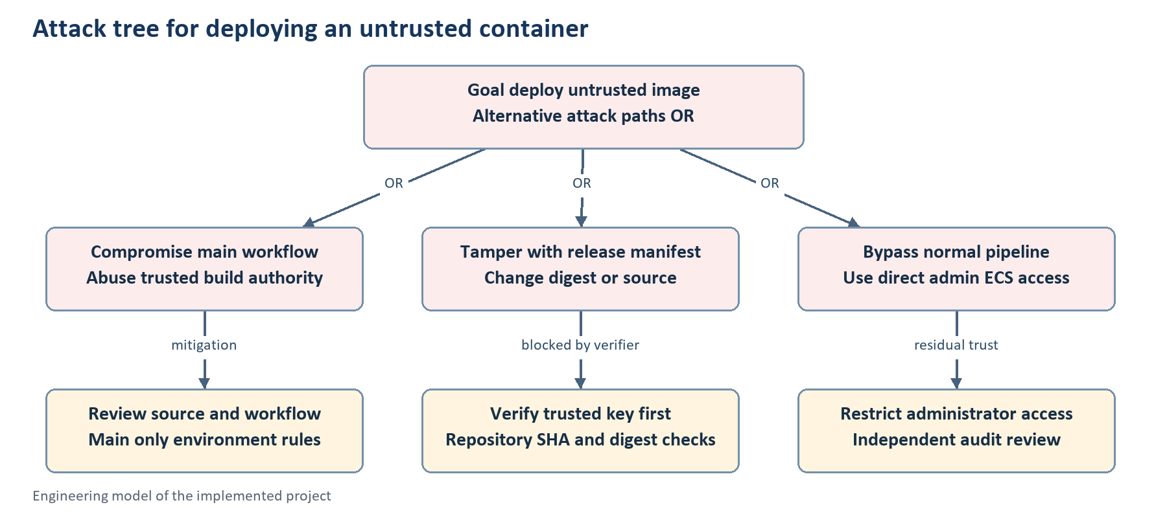
Figure 5 Design attack tree with preventive controls and the residual administrator bypass path

7.2 Path Analysis
Table 17 Attack paths and controls
Path | Required capability | Normal workflow response
Alter manifest | Modify current-run release data | Source/repository/digest checks and signature reject tampering
Substitute verification key | Change an artifact field | Verifier does not accept a key from the artifact
Use another repository identity | Obtain an unrelated GitHub OIDC token | Exact immutable subject fails AWS trust
Deploy from build job | Use build role credentials | IAM denies ECS update/register and role passing
Sign from deployment job | Use deployment role credentials | IAM denies private-key reads and ECR image push
Change trusted main workflow | Authorized source control or administrator compromise | Requires protected organizational change process
Use direct AWS administrator access | Administrator credentials | Outside the project-role boundary; audit and access review required

7.3 Security Interpretation
An accepted Cosign signature establishes integrity relative to the trusted signing key. It does not prove independent build provenance, source safety or that every reviewer approved the change. Keyed private signing deliberately omits public transparency-log verification. Future hardening should strengthen reviewer controls and provenance without weakening the current digest verifier.

8 Interfaces and Operations
The implemented interface is a small JSON API, GitHub workflow status, AWS Console/CLI observations and PowerShell operating commands. The screenshots below are actual supplied evidence. They do not imply a graphical business dashboard or a public AWS application endpoint.

8.1 Local Application Interface
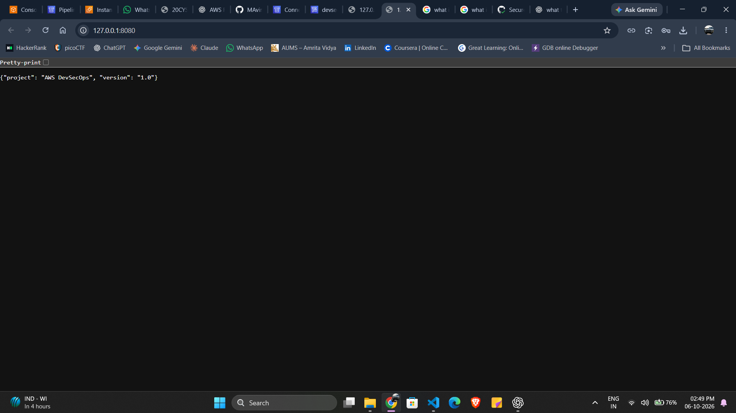
Figure 6 Supplied local root endpoint showing AWS DevSecOps project metadata
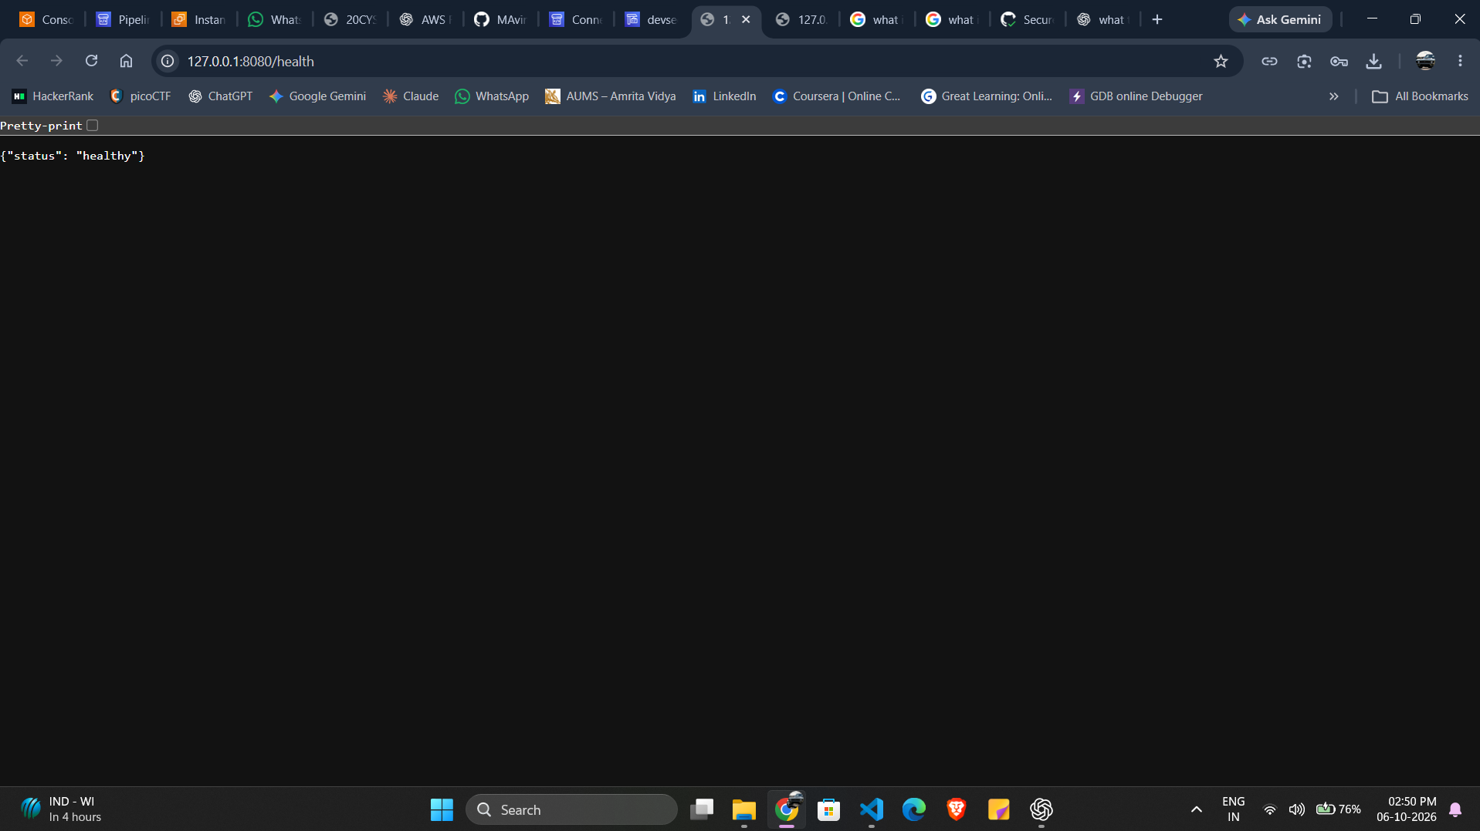
Figure 7 Supplied local health endpoint returning healthy
These browser addresses are localhost. They show the local service, not a public URL for the EC2 host. The same response contract is tested and used for container health. The local Docker publish address binds to 127.0.0.1 only.

8.2 AWS Runtime Interface
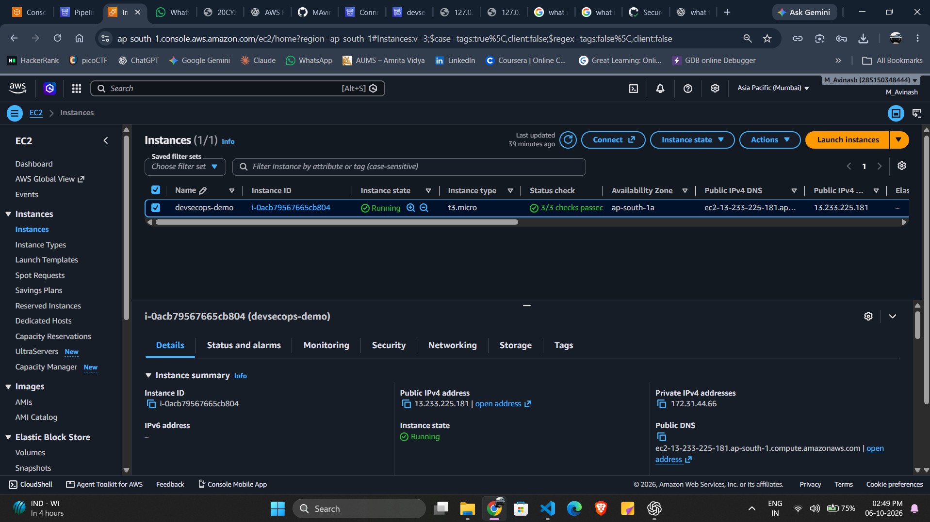
Figure 8 Supplied AWS Console evidence of the devsecops-demo t3.micro host in Mumbai
The screenshot shows the observed EC2 host. Current SDK/CLI evidence separately verifies ECS task health and the deployed image. The host has no public application ingress rule; use Systems Manager for controlled inspection or forwarding. The displayed public IPv4 address is not a promise that port 8080 is reachable from the internet.

8.3 Operating Commands
Set-Location D:\aws
Invoke-RestMethod http://127.0.0.1:8080/health
.\.venv\Scripts\python.exe -m unittest discover -s tests -v
.\.venv\Scripts\python.exe scripts/check-project.py
The complete Python, Docker, scan, signing-test and stop/resume sequences are in docs/LOCAL-RUN-POWERSHELL.md. A later intentional AWS shutdown disables/cancels the GitHub workflow before scaling compute down; the current implementation is left running.

9 Product Backlog
The backlog maps requirements to completed capabilities and clearly identified future work. It is an engineering record derived from this repository and its evidence; it does not claim an external Jira board or measured sprint velocity.

9.1 Completed Backlog
Table 18 Implemented work items
Item | Requirement | Outcome | Status
BL01 Small JSON service | FR01 FR02 | Root/health endpoints and rejection tests | Done
BL02 IaC validation | FR03 SR08 | Four templates, Guard fixtures and selected Checkov | Done
BL03 Source/image scans | FR03 FR04 SR04 | Semgrep rules and strict Trivy gates | Done
BL04 Protected digest signing | FR05 SR03 | SSM trust and real ECR signature | Done
BL05 Separate trusted deploy | FR06 FR07 SR05 | Same-run manifest and verification before mutation | Done
BL06 Hardened runtime | FR08 SR06 SR07 | Non-root read-only ECS and local container | Done
BL07 Falco observation | FR09 SR09 | Actual host warning delivered to CloudWatch | Done
BL08 CodeBuild alternative | SR01 SR02 | GitHub Actions with bounded OIDC roles | Done
BL09 Local guide and evidence | FR10 NF04 NF06 | PowerShell guide, snapshots and final report | Done

9.2 Future Work
Table 19 Proposed future improvements
Priority | Work item | Acceptance criterion
High | Strengthen source approval and workflow review | Required review rules appropriate to repository plan
High | Rotate and govern signing trust | Documented rotation/revocation with negative verification tests
Medium | Retain independent durable audit trail | Reviewed cost/scope and verified ongoing audit delivery
Medium | Expand IaC and SAST coverage | New controls/rules with rejection fixtures and reviewed findings
Medium | Improve host availability and capacity | Measured resource/availability need and agreed cloud costs
Medium | Hash-lock tool transitive dependencies | Reproducible install verified in fresh hosted runner
Low | Add stronger build provenance | Bound provenance accepted by a reviewed deployment policy

10 Implementation Changes
The final changes make GitHub Actions the active release system and preserve AWS runtime services and the local demonstration. File-level changes are mapped to the behavior they introduced so the repository can be reviewed without reconstructing the conversation.

10.1 Architecture Migration
The original retained pipeline uses CodePipeline and two CodeBuild projects. CodeBuild returned AccountLimitExceededException because concurrency was zero. The migration retains those resources as inactive reference, disables automatic source detection and the inbound build transition, and makes GitHub Actions the only active automatic deployment path.
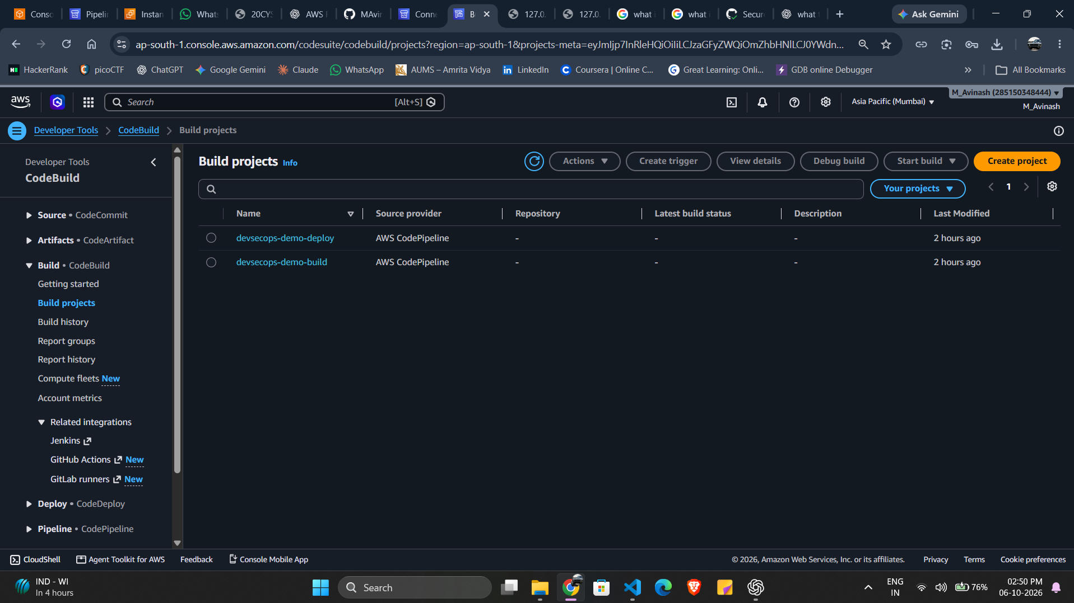
Figure 9 Supplied CodeBuild project list showing retained build and deploy projects rather than successful active builds

10.2 File Changes
Table 20 Changed files and resulting behavior
File | Final change | Reason
.github/workflows/deploy.yml | Two jobs, main-only environments, OIDC, exact source artifacts, concurrency and current Node 24 action pins | Active CI without CodeBuild quota; remove deprecation warnings
infra/generate.py and github.json | Generated OIDC provider and separate bounded GitHub roles | Explicit build/deploy trust and permission split
infra/pipeline.json | DetectChanges false | Avoid legacy automatic builds alongside GitHub
scripts/provision.py | GitHub stage and exact OIDC prefix configuration | Reviewable role-stack provisioning
scripts/build-publish.sh | CI-neutral source/run identifiers and unique tags | Same signing path works from GitHub and retained legacy builds
scripts/deploy.py | Release directory/source context for GitHub | Keep the original verifier before ECS mutations
scripts/validate-iam.py | Configurable role suffixes including both GitHub roles | Validate actual eight-role policies and boundary
scripts/security-gates.sh | Validate all four generated templates | Cover the added trust infrastructure
scripts/install-tools.sh | Configurable tool output directory | Install tools without requiring system-path writes
scripts/github_api.py | Credential Manager GitHub workflow control | Safe stop/resume coordinates active CI
scripts/stop-demo.py and resume-demo.py | Disable/cancel/wait or enable/dispatch GitHub workflow | Prevent CI from restoring compute after intentional shutdown
docs and deploy.example.json | Active CI/local commands and configuration fields | Repeatable operations and accurate scope
docs/report-build and report-assets | Editable report content, diagrams and supplied screenshots | Maintainable academic deliverable

10.3 Action Runtime Update
The supplied successful run showed Node.js 20 deprecation annotations on older pinned actions. Those warnings were not failed security gates. The workflow now pins verified official releases using Node 24 directly. The updated workflow completed a fresh signed AWS deployment; report-only files are excluded from automatic deployment triggers.
Table 21 Verified action release pins
Action | Official release | Runtime
checkout | v7.0.1 | Node 24
setup-python | v7.0.0 | Node 24
upload-artifact | v7.0.1 | Node 24
download-artifact | v8.0.1 | Node 24
configure-aws-credentials | v6.3.0 | Node 24

10.4 Repository and Workflow Evidence
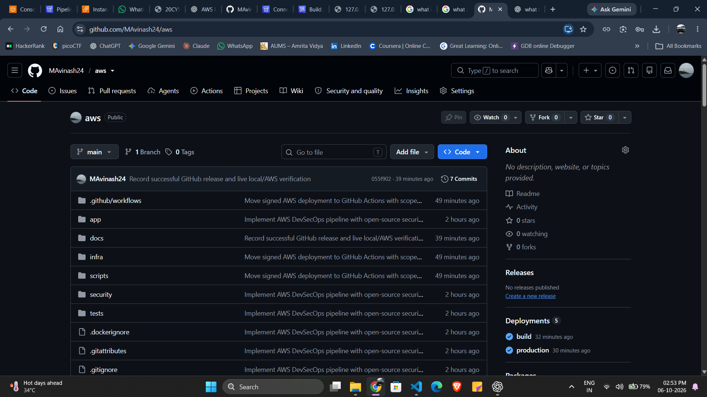
Figure 10 Supplied repository screenshot showing source layout and the documented migration commit
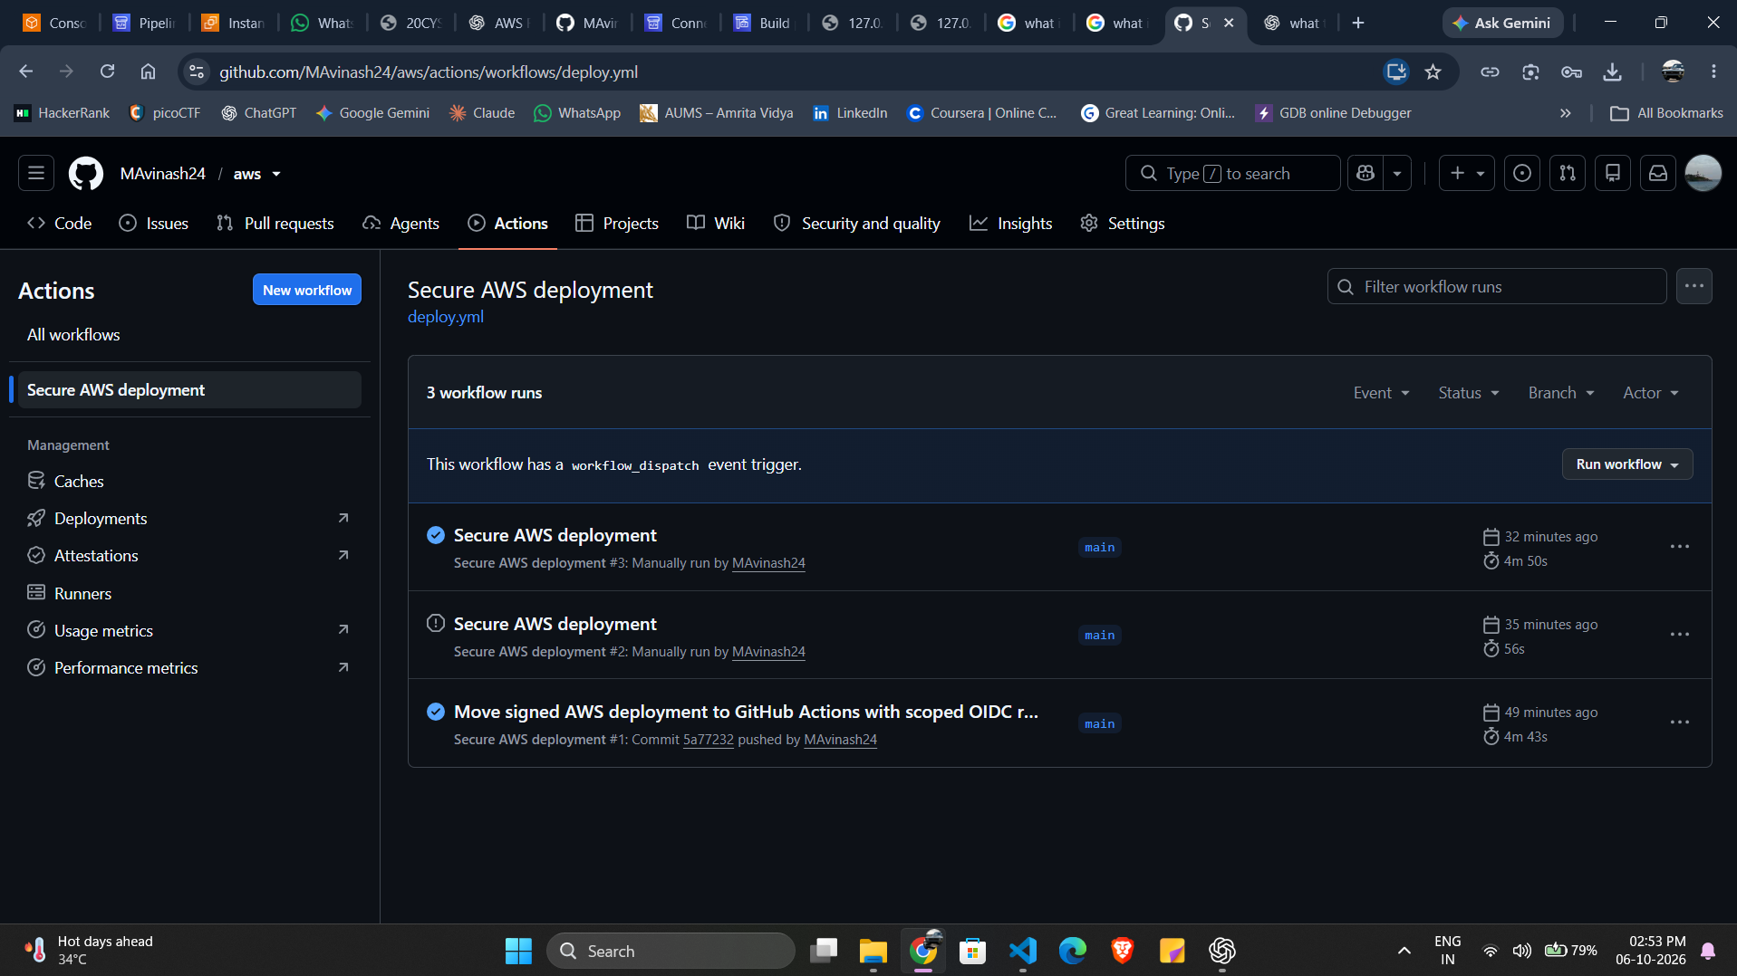
Figure 11 Supplied workflow history showing successful runs and one cancelled run
A cancelled run is not counted as a successful release. The supplied history predates the action-runtime update. The latest verified workflow is 37443610115, sourced from commit 611b9ffc42a6671ff8778489f1ca8aa37f793823. Its result and downloaded artifacts are the authoritative final release evidence.

11 DevSecOps Testing and Deployment
Testing spans application behavior, infrastructure rules, source patterns, image findings, signature ordering and actual AWS deployment. Unit tests and live observations answer different questions and are presented separately.

11.1 Container Hardening
Table 22 Application container controls
Control | Implemented value | Verification
User | 10001:10001 | Task and local Docker inspection
Root filesystem | Read-only | Configuration and write-rejection baseline test
Linux capabilities | Drop ALL; no added app capabilities | Task verifier and runtime inspection
Privileged mode | False | Guard, verifier and inspection
Host mounts/namespaces | Prohibited for application | Verifier rejection tests
AWS permissions | Application task role grants no AWS API permissions | Role inspection and IAM evidence
Health check | HTTP /health with bounded timeout | Docker/ECS healthy status
Application base | Pinned Python Alpine image digest | Dockerfile and Trivy report

11.2 Preventive Gate Sequence
Table 23 Active workflow gates
Order | Gate | Required result
1 | Checkout exact source and install pinned tools | No floating action references or unchecked native downloads
2 | Unit tests and generated-template consistency | All 11 tests and consistency checks pass
3 | cfn-lint, selected Checkov and Guard fixtures | No schema/control failures; unsafe fixtures rejected
4 | Semgrep rules and annotated fixtures | No findings/errors in covered code
5 | Trivy filesystem scan | No detected HIGH/CRITICAL findings
6 | Assume build role and validate actual IAM | No ERROR or SECURITY_WARNING findings
7 | Build and scan image; generate SBOM | Strict CVE/secret gate passes
8 | ECR publish and exact-digest signing | Signed release manifest produced
9 | Separate-role verification and ECS stability | Trust/hardening/source pass; no rollback

11.3 Unit and Negative Tests
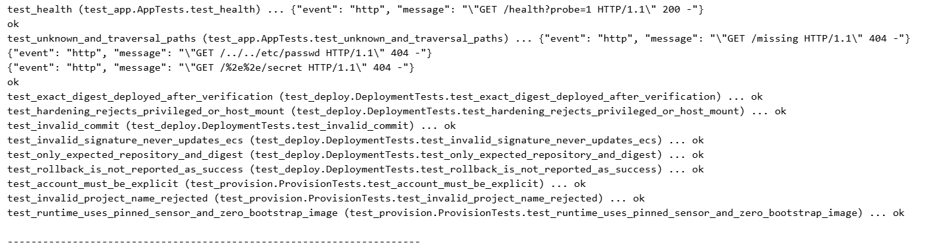
Figure 12 Supplied test output showing the 11 successful application and deployment logic tests
Table 24 Tests and the property each establishes
Test group | Cases | Evidence interpretation
HTTP behavior | Health; unknown/traversal-shaped paths | Application integration tests against local test server
Release identity | Invalid commit; wrong repository or malformed digest | Verifier input rejection
Hardening | Privileged task or host mount | Task constraints rejected
Signature ordering | Invalid signature never updates ECS | Mocked call-order test; no mutation before verification
Positive deployment | Exact digest deployed after verification | Mocked deployment logic test
Rollback detection | Service rollback is not success | Mocked ECS final-state rejection
Provisioning | Explicit account/project; pinned sensor/zero bootstrap | Configuration and generated-template tests

The supplied terminal run reports 11 tests in 0.537 seconds with OK. Current hosted-run tests also passed. Mocked AWS tests validate the code path and ordering, while the successful live workflow validates real identity, registry signing and ECS integration. Neither is substituted for the other.

11.4 Scanner Results
Table 25 Dated scanner results
Check | Observed outcome | Scope
cfn-lint 1.57.1 | All four templates pass | CloudFormation schema/lint
Checkov 3.3.23 | 72 pass; 0 fail/skip/parsing errors | Explicitly selected controls
Guard 3.2.1 | Applicable rules pass; five unsafe fixtures rejected | Project infrastructure invariants
Semgrep 1.179.0 | 0 findings and 0 errors; fixtures pass | Three checked-in Python rules
Trivy 0.75.0 | 0 detected HIGH/CRITICAL image CVEs or secrets | Pinned image with current run database
Access Analyzer | No errors or security warnings | Actual role identity policies and boundary

The first Debian base image had failed the strict CVE gate and was replaced with the pinned Alpine base. Rejected evidence was retained; the gate was not weakened. The current passing result is a dated observation, not a guarantee that future databases will remain clear.

11.5 Live GitHub and AWS Results
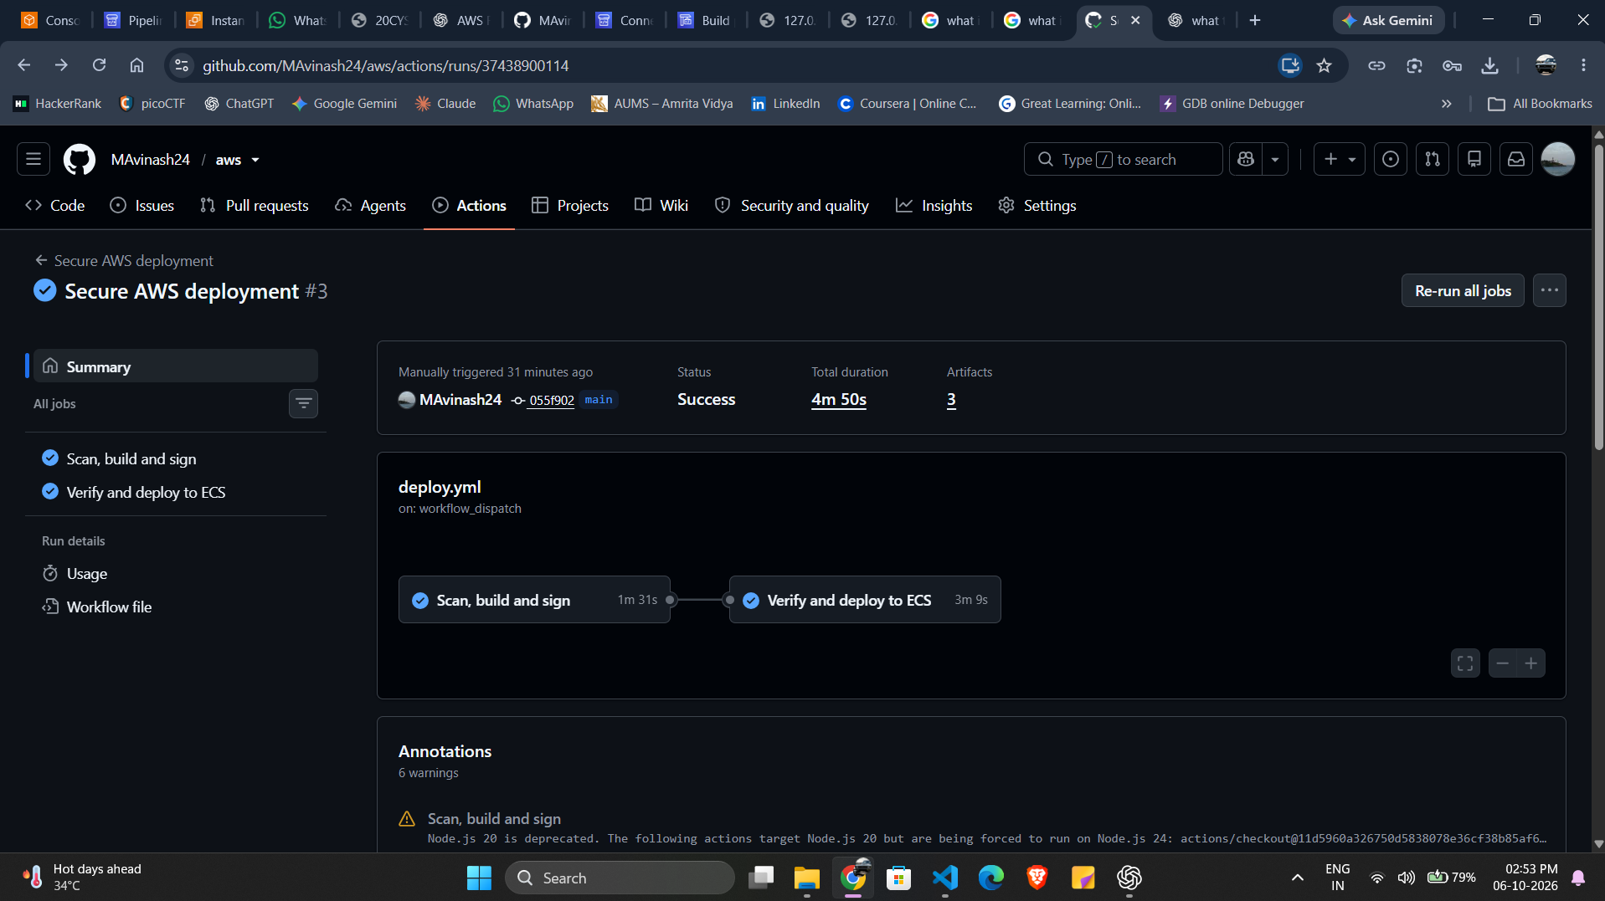
Figure 13 Supplied earlier successful GitHub run 37438900114 before the Node 24 update
Table 26 Latest verified cloud release
Field | Observed value
Workflow | 37443610115 completed successfully
Source | 611b9ffc42a6671ff8778489f1ca8aa37f793823
Task definition | devsecops-demo:5
Image digest | sha256:6892e992a1ed76adc04b4783f1ac1248b1aa4e388bae4dac026b27c64b2cc58b
ECS state | One running HEALTHY app task, zero pending and completed rollout
AWS region | ap-south-1 Mumbai
Local runtime | devsecops-local remains healthy on localhost:8080
Legacy CI | Automatic source detection and build transition disabled

The supplied screenshot contains runtime deprecation warnings from older action versions. The final release uses the updated Node 24 pins. Exact source and digest come from the downloaded final release/deployment artifacts and are checked against current ECS configuration.

11.6 Runtime Detection and Audit
A harmless shell execution inside the AWS application produced an actual Falco Warning event. The event includes the application container identity and is stored in CloudWatch. Sensor inspection confirms active status, no OOM and zero restarts at the check. This establishes demonstrated detection for the chosen probe, not comprehensive coverage of all runtime attacks.
Falco detection differs from application isolation. The sensor needs host capabilities and Docker-socket access; the app does not receive them. CloudTrail Event History provides management API audit lookup, while a durable trail is future work. GitHub CI logs are retained in GitHub and are not described as native CodePipeline events.

11.7 Deployment Readiness
Table 27 Readiness checklist
Item | State | Evidence
Source and generated templates | Verified | Commit and consistency gate
Scoped short-lived build/deploy access | Verified | Real OIDC assumptions and IAM checks
Exact digest signed and verified | Verified | Release/deployment artifacts
Negative verifier behavior | Verified | 11 tests plus earlier wrong-key live probe
AWS app health and hardening | Verified | Current ECS/host evidence
Local app independence | Verified | Docker and HTTP health
Runtime alert delivery | Verified | CloudWatch Falco events
High availability and durable audit | Future work | Explicit baseline limitation

12 Traceability and Conclusion
The final implementation is tied to requirements through source files, specific test cases and actual release evidence. The report closes with operating guidance and a bounded statement of what this demonstration establishes.

12.1 Requirement Traceability
Table 28 Requirements mapped to artifacts
Requirement | Implementation | Evidence
FR01 FR02 | app/server.py and tests/test_app.py | 200 health and 404 rejection tests
FR03 NF01 SR08 | security gates and infra/*.json | Lint, Checkov, Guard, Semgrep and Trivy outputs
FR04 FR05 SR03 SR04 | build-publish.sh; Dockerfile; SSM/ECR | Trivy image report, SBOM and signed digest
FR06 FR07 SR05 | deploy.yml and deploy.py | Same-run manifest, signature-order tests and actual release
FR08 SR06 SR07 | runtime.json and task validation | HEALTHY ECS task and hardened runtime inspection
FR09 SR09 | Falco host rule and CloudWatch | Actual Warning event evidence
FR10 NF06 | Local Docker and PowerShell guide | Independent localhost response
SR01 SR02 | github.json and environment rules | Exact OIDC assumptions, policy validation and deny simulator
NF04 NF05 | Reports and release checks | Source/digest/task linkage and rollback rejection

12.2 Submission Artifact Set
Table 29 Submission artifacts
Artifact | Location | Purpose
Final academic report | deliverables/AWS_DevSecOps_Capstone_Report_Final.docx | Requirements, models, changes and evidence
Editable report content | docs/report-build/ | Maintain and rebuild subject-specific report
Screenshots and diagrams | docs/report-assets/ | Supplied observations and engineering models
Source repository | github.com/MAvinash24/aws | Active workflow and implementation
Local command guide | docs/LOCAL-RUN-POWERSHELL.md | Copyable local operating commands
Change summary | docs/FINAL-IMPLEMENTATION-CHANGES.md | GitHub, AWS CLI and Docker changes
Live evidence | reports/ and dist/aws-live-evidence.zip | Machine-specific verified observations
Source package | dist/aws-devsecops-source.zip | Source without local credentials/secrets

12.3 Conclusion
The project demonstrates a complete scan, build, sign, verify and deploy chain using GitHub Actions and AWS runtime services. CodeBuild capacity no longer blocks this active path. The verified AWS task runs a content-addressed image under constrained application permissions, Falco produces an observed runtime warning, and the local hardened service remains available independently.
The evidence supports this educational baseline. Selected scanner coverage, private keyed signing, short retention, trusted administrators and a single small host remain explicit limits. Further production work should strengthen governance, provenance, retained audit and availability while preserving the existing fail-closed deployment checks.

12.4 Primary References
Implementation evidence is the repository, the linked workflow, downloaded artifacts and current runtime snapshots. The following primary documentation supports the service and control semantics; it does not substitute for project-specific proof.
GitHub OIDC with AWS: https://docs.github.com/en/actions/how-tos/secure-your-work/security-harden-deployments/oidc-in-aws
AWS CodeBuild quotas: https://docs.aws.amazon.com/codebuild/latest/userguide/limits.html
Amazon ECS task and container security: https://docs.aws.amazon.com/AmazonECS/latest/developerguide/security-tasks-containers.html
Cosign signature verification: https://docs.sigstore.dev/cosign/verifying/verify/
Latest verified project workflow: https://github.com/MAvinash24/aws/actions/runs/37443610115

