Makeel Bhikshu

ITPNA2-12 Project 2


Individual Assessment Coversheet
To be attached to the front of the assessment.
Campus: Midrand
Faculty: Information Technology
Module Code: ITPNA2-12
Group: 1
Lecturer’s Name: Mr S. Rametse
Student Full Name: Makeel Bhikshu
Student Number: EDUV4961561

Indicate | Yes | No
Plagiarism report attached |  | x

Declaration:
I declare that this assessment is my own original work except for source material explicitly acknowledged. I also declare that this assessment or any other of my original work related to it has not been previously, or is not being simultaneously, submitted for this or any other course. I am aware of the AI policy and acknowledge that I have not used any AI technology to generate or manipulate data, other than as permitted by the assessment instructions. I also declare that I am aware of the Institution’s policy and regulations on honesty in academic work as set out in the Conditions of Enrolment, and of the disciplinary guidelines applicable to breaches of such policy and regulations.

Signature | Date
Lecturer’s Comments:

Marks Awarded: |  | %
Signature | Date

Eduvos (Pty) Ltd. (formerly Pearson Institute of Higher Education) is registered with the Department of Higher Education and Training as a private higher education institution under the Higher Education Act, 101, of 1997. Registration Certificate number: 2001/HE07/008

This is a declaration that AI tools such as Grammarly, Microsoft CoPilot for Word and Bing CoPilot has been used to aid me in correct grammar and spelling as well as conciseness of the text provided. The Bing Copilot was used to help me understand some context of questions I did not understand and needed explaining of requirements for the questions I found vague. The use of AI was not used for any content generation other than grammar, spellchecks and conciseness. I have also used the AI for finding relevant websites to assist me in finding appropriate information to answer the questions.

Table of Contents
Question 1: 4
Question 1.1 answer: 6
Question 1.2 answer: 10
Question 1.3 answer: 12
Question 1.4 answer: 28
Question 1.5 answer: 43
Question 2.1: 47
Question 2.1 answer: 47
Question 2.2: 48
Question 2.2a) answer: 48
Question 2.2b) answer: 51
Question 2.2c) answer: 54
Question 2.3: 57
Question 2.3 answer: 57
Question 3: 58
Question 3 answer: 58
References 65

Question 1:
Aircraft activities
You are working for Aero Airlines, an airline operating in South Africa and linking different cities. You are in charges of monitoring the airplane system focusing on Air traffic control and airline operations center using ADS-B, radar, and satellite systems.
The ground tracked activities include:
Tracked Activities on the Ground:
1. Pre-Departure (at the Gate):
o Aircraft status: Ground crew updates the maintenance log via electronic systems.
o Passenger boarding: Count and verification logged into the airline’s database.
o Fueling and catering: Automated IoT systems on refueling trucks log the amount delivered.
o Door closure and pushback time: Timestamped and tracked in real-time.
2. In-Flight Events:
o Autopilot status: Logged internally by the airline’s onboard flight data monitoring (FDM).
o Cabin pressure: Monitored and transmitted periodically to ground-based maintenance platforms.
o Wi-Fi usage: Logged for service quality tracking.

Source: Nawej, C (2025)

1.1 Create HTTP server system that reads a file containing Pre-Departure information and sends them as JSON response to any HTTP client.
A file can have the following information :

Aircraft Status: Ready for departure
Passenger Boarding Number: 128
Fuelling: Completed
Door State: Closed
Push Back Time: 13:45
(10 Marks)

1.2 Create a client application that connects to the server and reads the Pre-Departure information.
(10 Marks)
1.3 Create an application for staff at the gate to update different Pre-Departure information using the HTTP request between the Application and the Server.
(10 Marks)
1.4 Create a client application that connects to the server and reads the In-Flight Events information.
(10 Marks)
1.5 Create an application to update the In-Flight Events every 5 seconds.
(10 Marks)

Question 1.1 answer:
The code for this question is below:
#First we need to import some modules and classes for our HTTP server to work
from http.server import BaseHTTPRequestHandler,HTTPServer
import json

#This is our HTTP class that will retrieve information from our file and send it to any http client as a json response
class HTTP_System(BaseHTTPRequestHandler):
def do_GET(self):
if self.path=="/predepartureInfo":
self.send_response(200)
self.send_header("content-type","application/json")
self.end_headers()

try:
#This portion retrives the information from the file and collects it in a list of dictionaries
with open(r"predeparture_info.txt",'r') as fileData:
singleData = fileData.readlines()

dataUser = []

for line in singleData:
Aircraft_status,Passenger_boardingNo,Fuelling,DoorState,Push_back_time = line.strip().split(';')
dataUser.append({"Aircraft status" :Aircraft_status.split(':')[1],
"Passenger boarding number":Passenger_boardingNo.split(':')[1],
"Fuelling":Fuelling.split(':')[1],
"Door state":DoorState.split(':')[1],
"Push back time": Push_back_time.split(":")[1] +":"+Push_back_time.split(":")[2]})

print(dataUser)
self.wfile.write(json.dumps(dataUser).encode())

except FileNotFoundError:
self.wfile.write(json.dumps("ERROR file not found").encode())

#This is our display function which runs our client HTTP server to view the json information
def display(serverClass=HTTPServer, handler_class=HTTP_System, port = 1227):#It is important to note that everytime you run you might have to change the port number
server_address=('',port)
httpValue = serverClass(server_address,handler_class)
print(f"Server is running on port: {port}")
httpValue.serve_forever()

display()
output looks as follows:
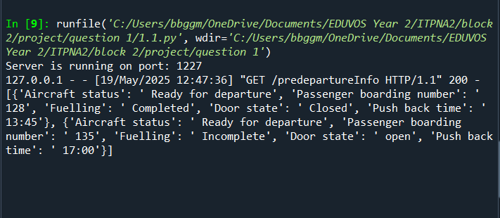

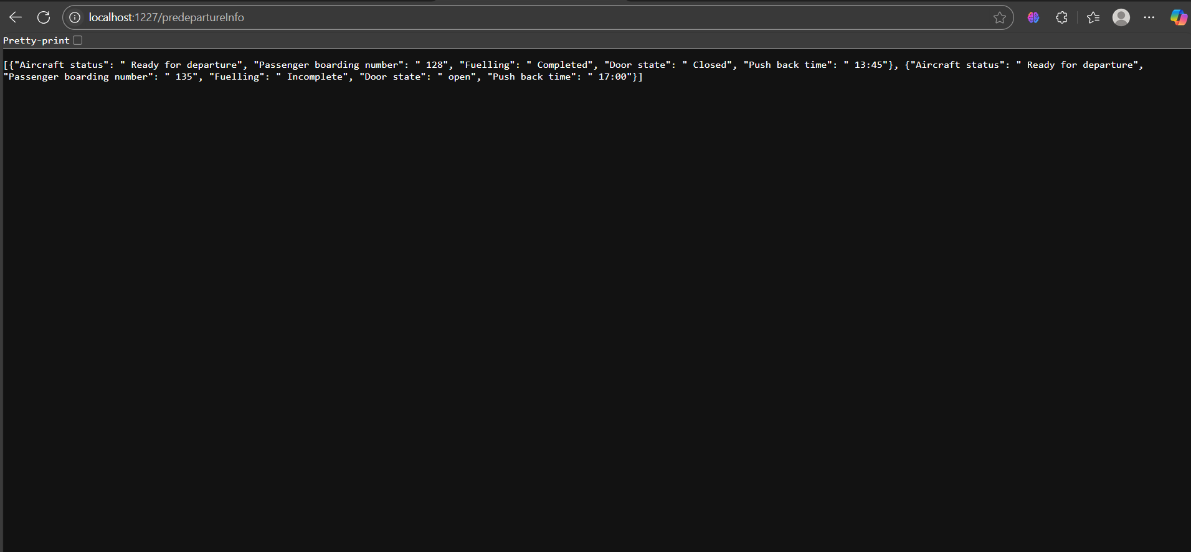
Text file looks as follows:
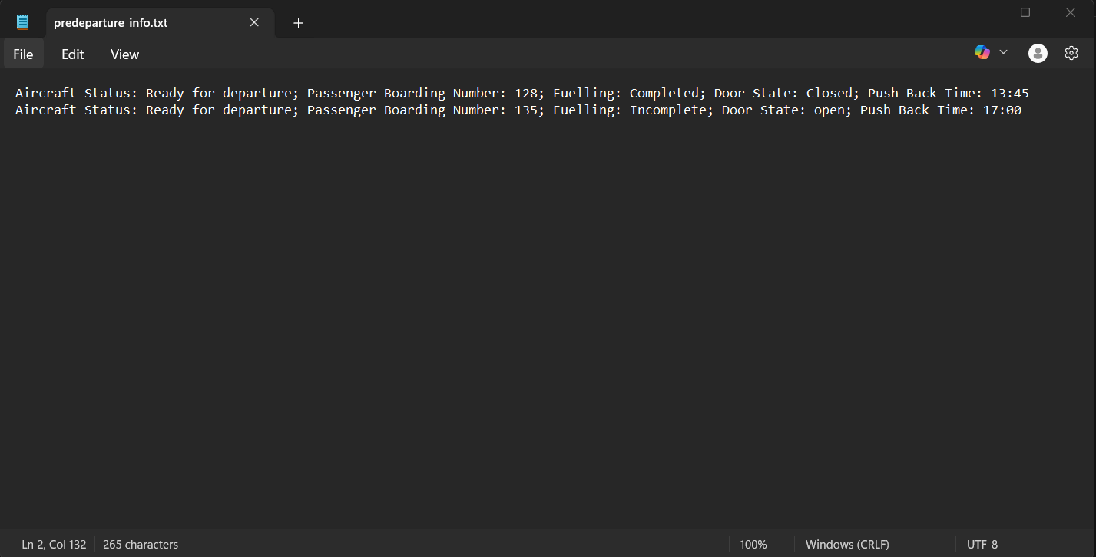

Question 1.2 answer:
The code for the question is below:
#For 1.2 we will create an application that gets info from our 1.1 server:
import requests

#Take note that the port number must match the one in question 1.1
response = requests.get("http://localhost:1228/predepartureInfo") #this is the address of the server made in 1.1
if response.status_code == 200:
data = response.json()
print("Pre-Departure Information:")
print("*"*45)
count = 1
for item in data:
print(f"Predeparture No: {count}")
count +=1
for key, value in item.items():
print(f"{key}: {value}")
print("="*45)
else:
print("Failed to retrieve Pre-Departure information from server")

The output is as follows:
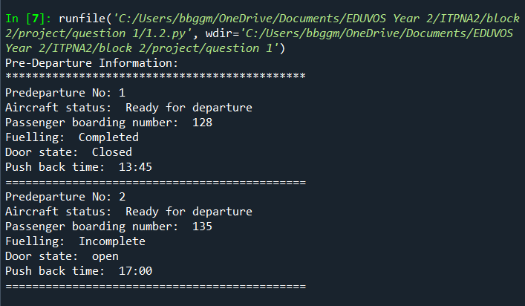
Server output:
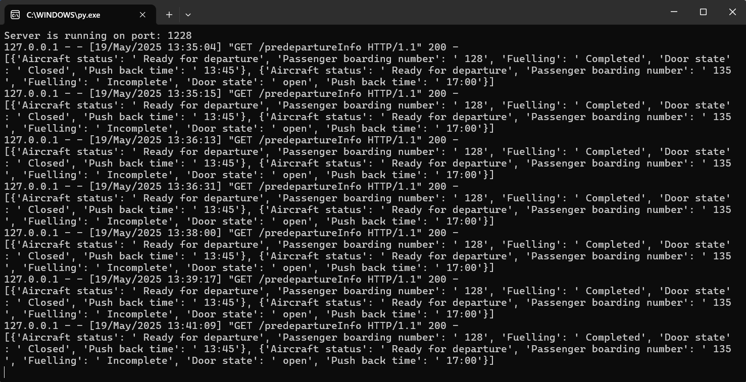

Question 1.3 answer:
1.3_server.py code a modification of my HTTP server in 1.1:
#First we need to import some modules and classes for our HTTP server to work
from http.server import BaseHTTPRequestHandler, HTTPServer
import json

#This is our HTTP class that will retrieve information from our file and send it to any http client as a json response

class HTTP_System(BaseHTTPRequestHandler):
#This function has remained unchanged from 1.1
def do_GET(self):
if self.path == "/predepartureInfo":
self.send_response(200)
self.send_header("content-type", "application/json")
self.end_headers()

try:
with open(r"predeparture_info.txt", 'r') as fileData:
singleData = fileData.readlines()
dataUser = []

for line in singleData:
Aircraft_status, Passenger_boardingNo, Fuelling, DoorState, Push_back_time = line.strip().split(',')
dataUser.append({
"Aircraft status": Aircraft_status.split(';')[1],
"Passenger boarding number": Passenger_boardingNo.split(';')[1],
"Fuelling": Fuelling.split(';')[1],
"Door state": DoorState.split(';')[1],
"Push back time": Push_back_time.split(";")[1]
})

self.wfile.write(json.dumps(dataUser).encode())

except FileNotFoundError:
self.wfile.write(json.dumps("ERROR: File not found").encode())

#This is our new function that implements the updated information
def do_POST(self):
if self.path == "/predepartureInfo":
content_length = int(self.headers["Content-Length"])
post_data = self.rfile.read(content_length)
new_info = json.loads(post_data)
print(new_info)

#Create a condition statement to check if the new_info action equals add
if new_info.get("Action") == "add":

try:

# Read existing data
with open(r"predeparture_info.txt", 'r') as fileData:
singleData = fileData.readlines()

updated_lines = []
for line in singleData:
#This maintains current information
updated_lines.append(line)

#This uses an existing entry to add new information while retaining the existing information
Aircraft_status, Passenger_boardingNo, Fuelling, DoorState, Push_back_time = line.strip().split(',')

updated_entry = {
"Aircraft status": new_info.get("Aircraft status", Aircraft_status.split(';')[1]),
"Passenger boarding number": new_info.get("Passenger boarding number", Passenger_boardingNo.split(';')[1]),
"Fuelling": new_info.get("Fuelling", Fuelling.split(';')[1]),
"Door state": new_info.get("Door state", DoorState.split(';')[1]),
"Push back time": new_info.get("Push back time", Push_back_time.split(";")[0])
}

updated_lines.append(f"Aircraft status;{updated_entry['Aircraft status']},"+
f"Passenger boarding number;{updated_entry['Passenger boarding number']},"+
f"Fuelling;{updated_entry['Fuelling']},"+
f"Door state;{updated_entry['Door state']},"+
f"Push back time;{updated_entry['Push back time']}\n")

# Write updated data back to file
with open(r"predeparture_info.txt", 'w') as fileData:

fileData.writelines(updated_lines)

self.send_response(200)
self.send_header("content-type", "application/json")
self.end_headers()
self.wfile.write(json.dumps({"message": "Pre-Departure information updated successfully!"}).encode())

except FileNotFoundError:
self.send_response(500)
self.end_headers()
self.wfile.write(json.dumps({"error": "File not found"}).encode())

#next add the elif to check if a record needs to be updated:
elif new_info.get("Action") == "update":
try:

# Read existing data
with open(r"predeparture_info.txt", 'r') as fileData:
singleData = fileData.readlines()

updated_lines = []

for line in singleData:
dic = {key.strip():value.strip() for key, value in (item.split(";")for item in line.split(","))}

#This uses an existing entry to add new information while retaining the existing information
Aircraft_status, Passenger_boardingNo, Fuelling, DoorState, Push_back_time = line.strip().split(',')
updated_entry = {
"Aircraft status": new_info.get("Aircraft status", Aircraft_status.split(';')[1]),
"Passenger boarding number": new_info.get("Passenger boarding number", Passenger_boardingNo.split(';')[1]),
"Fuelling": new_info.get("Fuelling", Fuelling.split(';')[1]),
"Door state": new_info.get("Door state", DoorState.split(';')[1]),
"Push back time": new_info.get("Push back time", Push_back_time.split(";")[1])
}

new_line = str(f"Aircraft status;{updated_entry['Aircraft status']},"+
f"Passenger boarding number;{updated_entry['Passenger boarding number']},"+
f"Fuelling;{updated_entry['Fuelling']},"+
f"Door state;{updated_entry['Door state']},"+
f"Push back time;{updated_entry['Push back time']}\n")

if dic["Passenger boarding number"] != updated_entry["Passenger boarding number"]:

updated_lines.append(line)

updated_lines.append(new_line)

# Write updated data back to file
with open(r"predeparture_info.txt", 'w') as fileData:

fileData.writelines(updated_lines)

self.send_response(200)
self.send_header("content-type", "application/json")
self.end_headers()
self.wfile.write(json.dumps({"message": "Pre-Departure information updated successfully!"}).encode())

except FileNotFoundError:
self.send_response(500)
self.end_headers()
self.wfile.write(json.dumps({"error": "File not found"}).encode())

def display(serverClass=HTTPServer, handler_class=HTTP_System, port=1231):
server_address = ('', port)
httpValue = serverClass(server_address, handler_class)
print(f"Server is running on port: {port}")
httpValue.serve_forever()

display()

1.3_staff.py application code that adds and updates the information:
#This is our staff application that updates our information
import requests

URL = "http://localhost:1231/predepartureInfo"

status = True

while status == True:
menu = input("Would you like to Add,Update or Exit \n Type add or exit: ")

#Check if the user wants to add a record
if menu.lower() == "add":
status2 = True
while status2 == True:
command= input("Would you like to add a new record? Type Y or N: ")

if command.lower()== "y":

#Create a user interface to allow staff to specify the new info to be updated
new_info = {"Action": "add",
"Aircraft status": input("Enter Aircraft status: "),
"Passenger boarding number": input("Enter Passenger boarding number: "),
"Fuelling": input("Enter Fuelling status: "),
"Door state": input("Enter Door state: "),
"Push back time": input("Enter Push back time: ")
}

response = requests.post(URL, json=new_info)

if response.status_code == 200:
print(response.json()["message"])

else:
print("Failed to read Command.")

status2 = False

elif command.lower()=="n":
status2 = False
print("Goodbye")

else:
print("!Incorrect command!\n")

elif menu.lower() == "update":

status3 = True
while status3 == True:
#Print menu to see which record user wants to update
#Take note that the port number must match the one in question 1.3_server
response = requests.get(URL) #this is the address of the server made in 1.1
if response.status_code == 200:
data = response.json()
print("Pre-Departure Information:")
print("*"*45)
count = 1
for item in data:
print(f"Predeparture No: {count}")
count +=1
for key, value in item.items():
print(f"{key}: {value}")
print("="*45)

#Get the users choice of which record they wish to update
selected_record = int(input("Type the record number you want to select: "))-1

if selected_record >= 0 and selected_record < len(data): #checks the length of the data set::
print(f"You selected record No: {selected_record+1} to update")
#Now we need to access the dictionary record and update information the only information that won't change is the boarding number
key_list=["Action","Aircraft status","Passenger boarding number","Fuelling","Door state","Push back time"]
for key in key_list:
if key == "Action":
data[selected_record][key] = "update"

if key != "Passenger boarding number" and key != "Action":
data[selected_record][key] = input(f"Please input the new {key}: ")

if key == "Passenger boarding number":
print(f"The {key} is {data[selected_record][key]}")

#next is to send the updated data to the server
respond = requests.post(URL, json=data[selected_record])

if respond.status_code == 200:
print(respond.json()["message"])

else:
print("Failed to read Command.")

status3 = False
else:
print("Invalid record selected try again")
else:
status3 = False
print("Failed to retrieve Pre-Departure information from server")

elif menu.lower() == "exit":
print("Goodbye")
status = False

else:
print("**Incorrect Menu Option**\n")

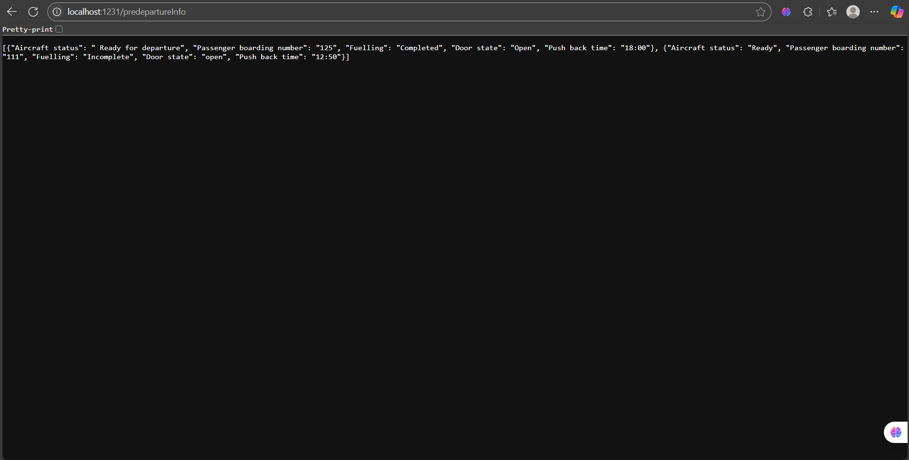
Output before changes:

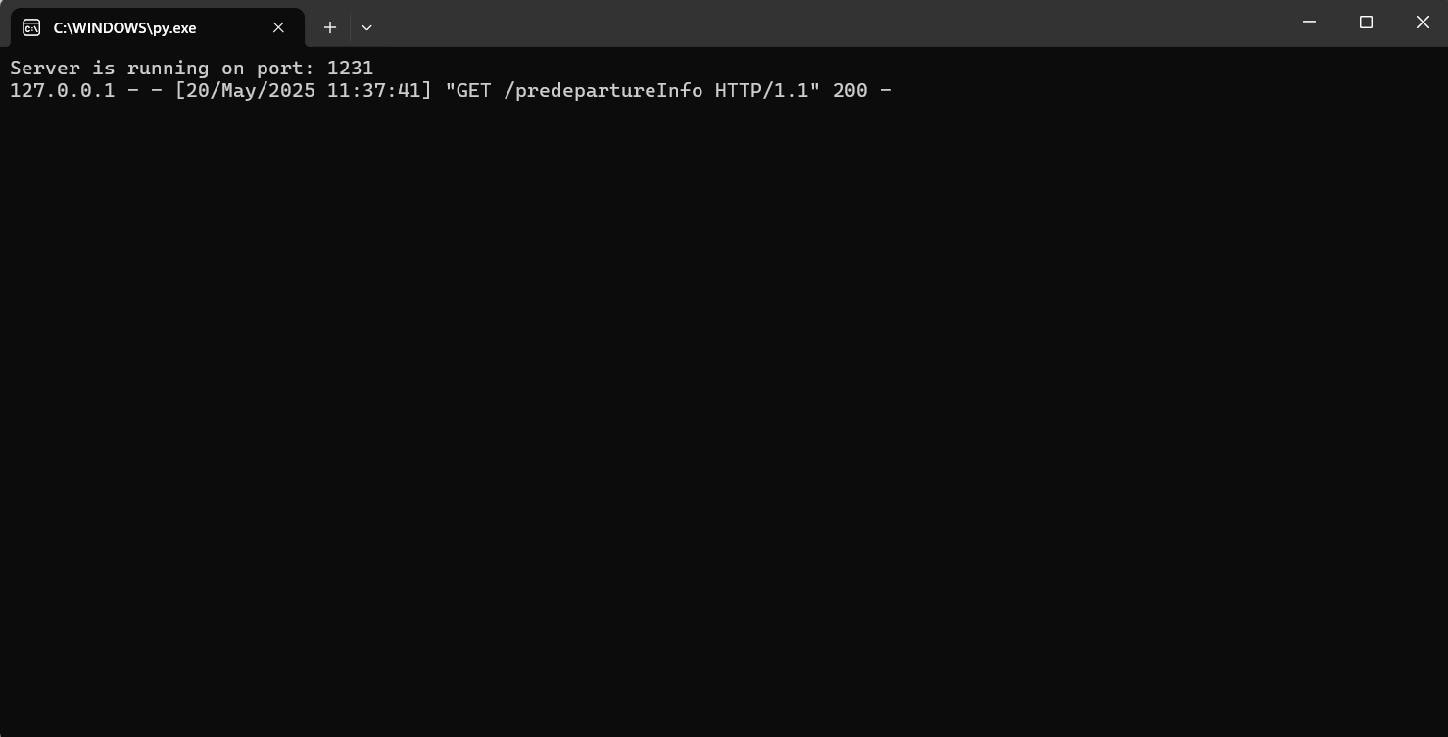

Output after changes:
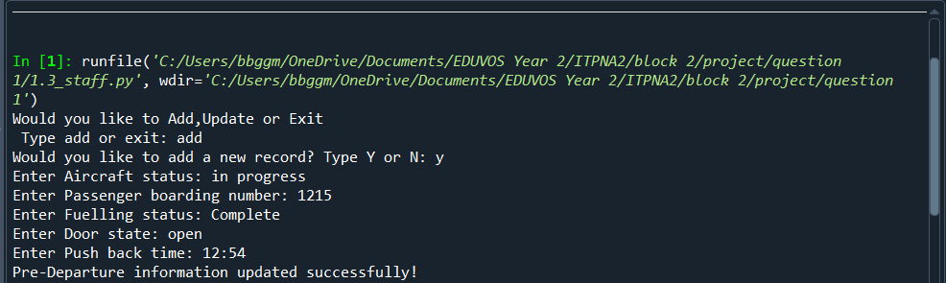
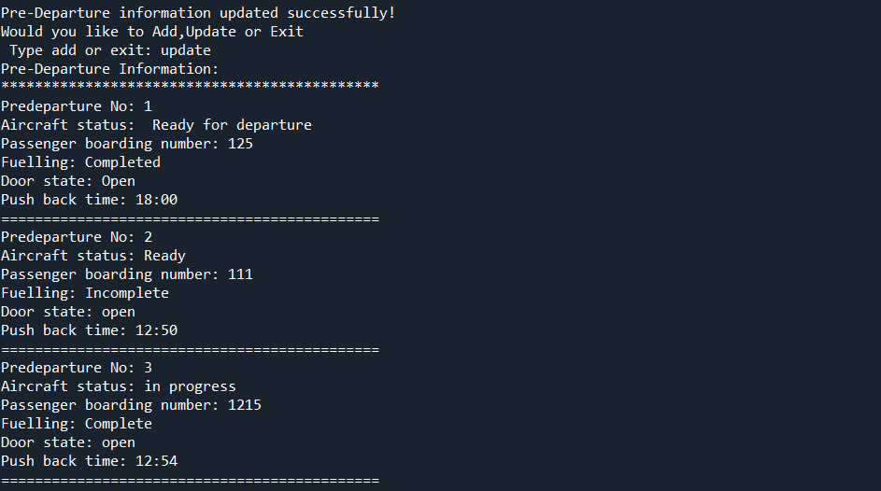
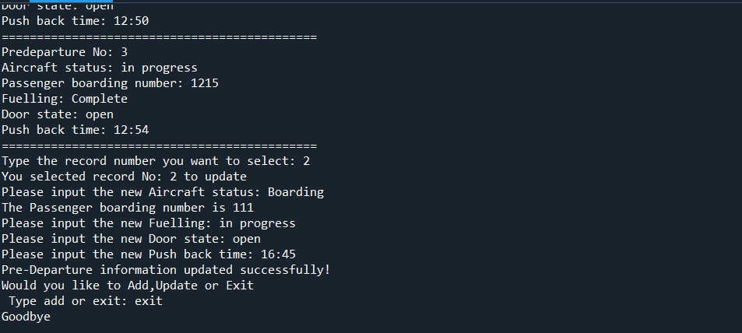

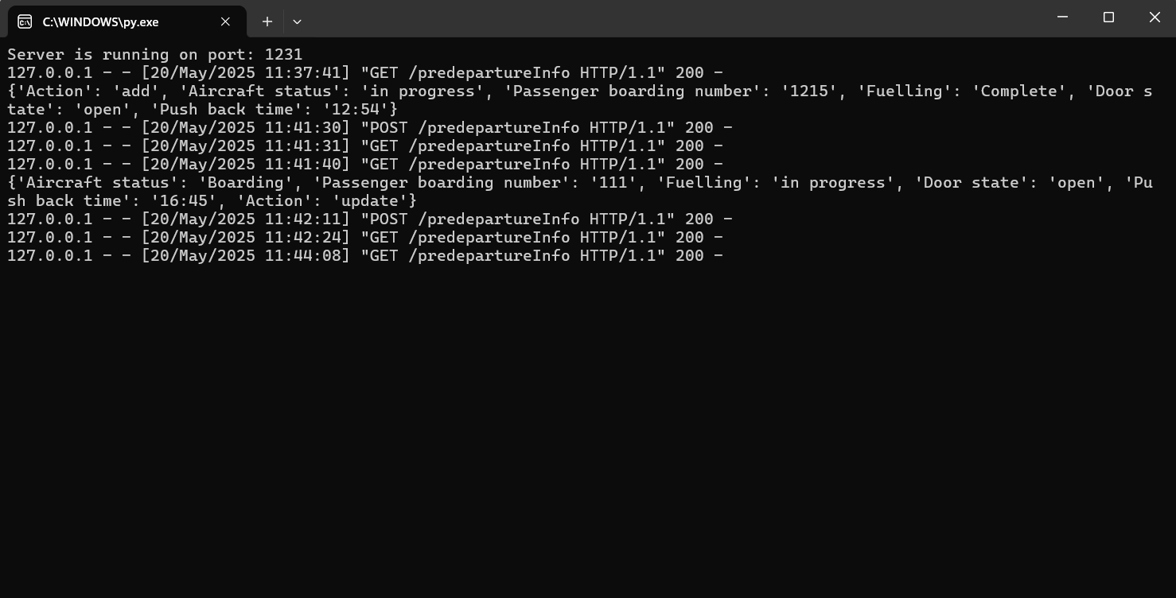
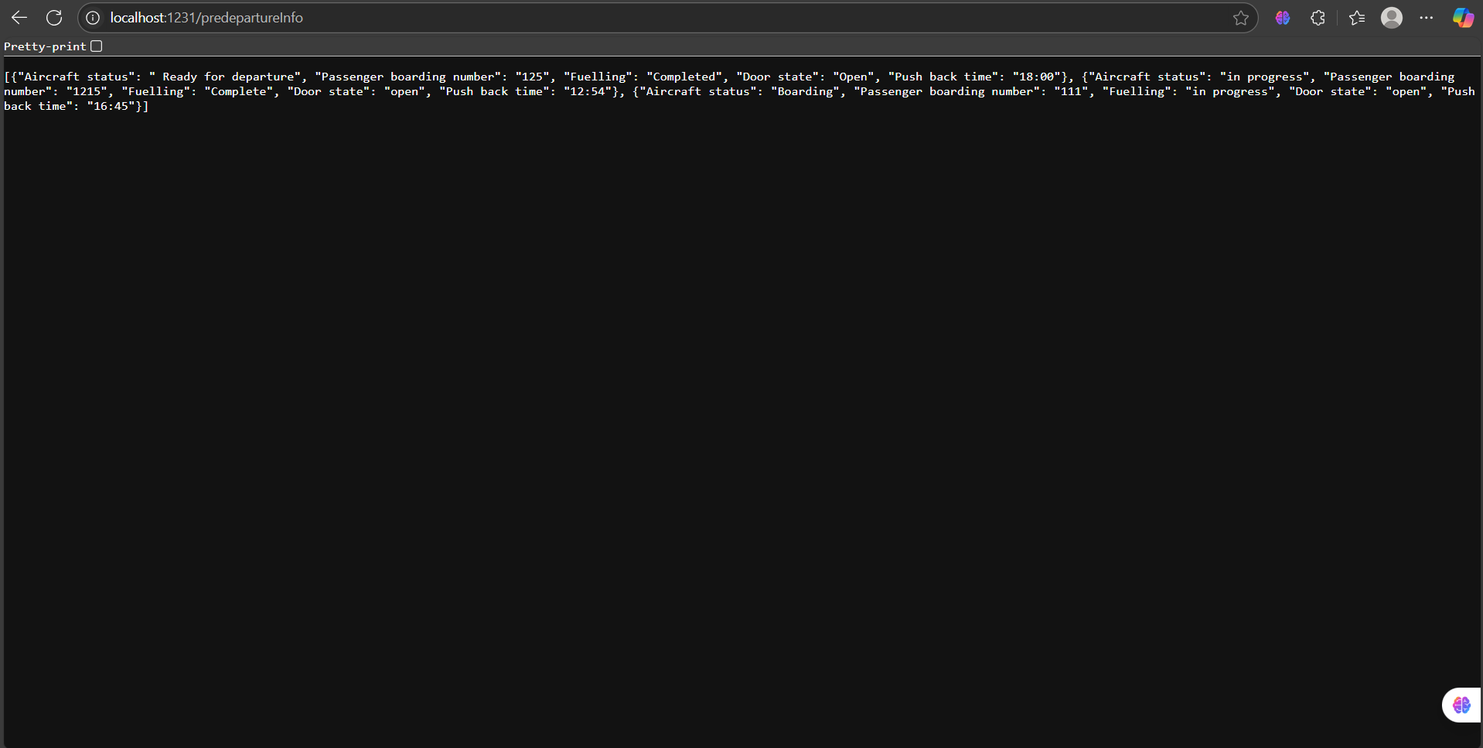
Updates to the text file:
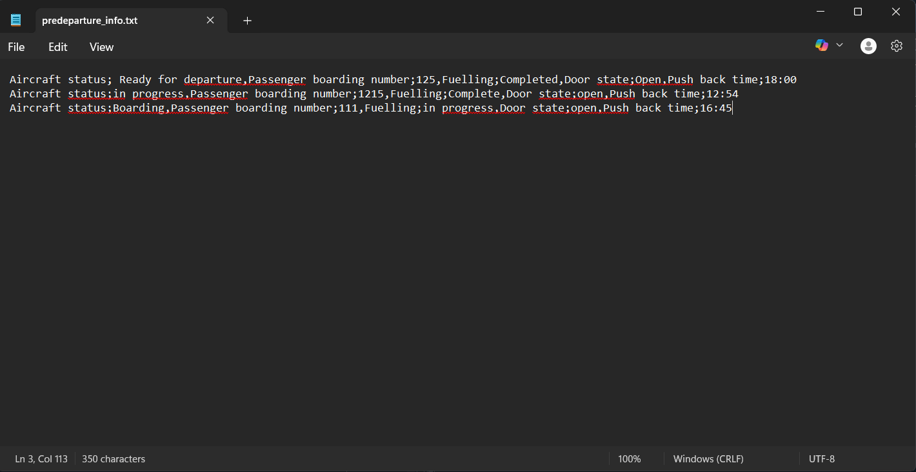

Question 1.4 answer:
So I created a new server file for this question here is the 1.4_server.py file code:
#First we need to import some modules and classes for our HTTP server to work
from http.server import BaseHTTPRequestHandler,HTTPServer
import json

#This is our HTTP class that will retrieve information from our file and send it to any http client as a json response
class HTTP_System(BaseHTTPRequestHandler):
def do_GET(self):
if self.path=="/InFlightInfo":
self.send_response(200)
self.send_header("content-type","application/json")
self.end_headers()

try:
#This portion retrives the information from the file and collects it in a list of dictionaries
with open(r"InFlight_info.txt",'r') as fileData:
singleData = fileData.readlines()

dataUser = []

for line in singleData:
Autopilot_status,Cabin_pressure,WiFi_usage = line.strip().split(';')
dataUser.append({"Auto-Pilot Status" :Autopilot_status.split(':')[1],
"Cabin pressure":Cabin_pressure.split(':')[1],
"WiFi usage":WiFi_usage.split(':')[1]
})

print(dataUser)
self.wfile.write(json.dumps(dataUser).encode())

except FileNotFoundError:
self.wfile.write(json.dumps("ERROR file not found").encode())

#This is our display function which runs our client HTTP server to view the json information
def display(serverClass=HTTPServer, handler_class=HTTP_System, port = 1229):#It is important to note that everytime you run you might have to change the port number
server_address=('',port)
httpValue = serverClass(server_address,handler_class)
print(f"Server is running on port: {port}")
httpValue.serve_forever()

display()

Note that I can modify the existing 1.3_server file to contain this code:
#First we need to import some modules and classes for our HTTP server to work
from http.server import BaseHTTPRequestHandler, HTTPServer
import json

#This is our HTTP class that will retrieve information from our file and send it to any http client as a json response

class HTTP_System(BaseHTTPRequestHandler):
#This function has remained unchanged from 1.1
def do_GET(self):
if self.path == "/predepartureInfo":
self.send_response(200)
self.send_header("content-type", "application/json")
self.end_headers()

try:
with open(r"predeparture_info.txt", 'r') as fileData:
singleData = fileData.readlines()
dataUser = []

for line in singleData:
Aircraft_status, Passenger_boardingNo, Fuelling, DoorState, Push_back_time = line.strip().split(',')
dataUser.append({
"Aircraft status": Aircraft_status.split(';')[1],
"Passenger boarding number": Passenger_boardingNo.split(';')[1],
"Fuelling": Fuelling.split(';')[1],
"Door state": DoorState.split(';')[1],
"Push back time": Push_back_time.split(";")[1]
})

self.wfile.write(json.dumps(dataUser).encode())

except FileNotFoundError:
self.wfile.write(json.dumps("ERROR: File not found").encode())
#1.4 section:
if self.path=="/InFlightInfo":
self.send_response(200)
self.send_header("content-type","application/json")
self.end_headers()

try:
#This portion retrives the information from the file and collects it in a list of dictionaries
with open(r"InFlight_info.txt",'r') as fileData:
singleData = fileData.readlines()

dataUser = []

for line in singleData:
Autopilot_status,Cabin_pressure,WiFi_usage = line.strip().split(';')
dataUser.append({"Auto-Pilot Status" :Autopilot_status.split(':')[1],
"Cabin pressure":Cabin_pressure.split(':')[1],
"WiFi usage":WiFi_usage.split(':')[1]
})

print(dataUser)
self.wfile.write(json.dumps(dataUser).encode())

except FileNotFoundError:
self.wfile.write(json.dumps("ERROR file not found").encode())

#This is our new function that implements the updated information
def do_POST(self):
if self.path == "/predepartureInfo":
content_length = int(self.headers["Content-Length"])
post_data = self.rfile.read(content_length)
new_info = json.loads(post_data)
print(new_info)

#Create a condition statement to check if the new_info action equals add
if new_info.get("Action") == "add":

try:

# Read existing data
with open(r"predeparture_info.txt", 'r') as fileData:
singleData = fileData.readlines()

updated_lines = []
for line in singleData:
#This maintains current information
updated_lines.append(line)

#This uses an existing entry to add new information while retaining the existing information
Aircraft_status, Passenger_boardingNo, Fuelling, DoorState, Push_back_time = line.strip().split(',')

updated_entry = {
"Aircraft status": new_info.get("Aircraft status", Aircraft_status.split(';')[1]),
"Passenger boarding number": new_info.get("Passenger boarding number", Passenger_boardingNo.split(';')[1]),
"Fuelling": new_info.get("Fuelling", Fuelling.split(';')[1]),
"Door state": new_info.get("Door state", DoorState.split(';')[1]),
"Push back time": new_info.get("Push back time", Push_back_time.split(";")[0])
}

updated_lines.append(f"Aircraft status;{updated_entry['Aircraft status']},"+
f"Passenger boarding number;{updated_entry['Passenger boarding number']},"+
f"Fuelling;{updated_entry['Fuelling']},"+
f"Door state;{updated_entry['Door state']},"+
f"Push back time;{updated_entry['Push back time']}\n")

# Write updated data back to file
with open(r"predeparture_info.txt", 'w') as fileData:

fileData.writelines(updated_lines)

self.send_response(200)
self.send_header("content-type", "application/json")
self.end_headers()
self.wfile.write(json.dumps({"message": "Pre-Departure information updated successfully!"}).encode())

except FileNotFoundError:
self.send_response(500)
self.end_headers()
self.wfile.write(json.dumps({"error": "File not found"}).encode())

#next add the elif to check if a record needs to be updated:
elif new_info.get("Action") == "update":
try:

# Read existing data
with open(r"predeparture_info.txt", 'r') as fileData:
singleData = fileData.readlines()

updated_lines = []

for line in singleData:
dic = {key.strip():value.strip() for key, value in (item.split(";")for item in line.split(","))}

#This uses an existing entry to add new information while retaining the existing information
Aircraft_status, Passenger_boardingNo, Fuelling, DoorState, Push_back_time = line.strip().split(',')
updated_entry = {
"Aircraft status": new_info.get("Aircraft status", Aircraft_status.split(';')[1]),
"Passenger boarding number": new_info.get("Passenger boarding number", Passenger_boardingNo.split(';')[1]),
"Fuelling": new_info.get("Fuelling", Fuelling.split(';')[1]),
"Door state": new_info.get("Door state", DoorState.split(';')[1]),
"Push back time": new_info.get("Push back time", Push_back_time.split(";")[1])
}

new_line = str(f"Aircraft status;{updated_entry['Aircraft status']},"+
f"Passenger boarding number;{updated_entry['Passenger boarding number']},"+
f"Fuelling;{updated_entry['Fuelling']},"+
f"Door state;{updated_entry['Door state']},"+
f"Push back time;{updated_entry['Push back time']}\n")

if dic["Passenger boarding number"] != updated_entry["Passenger boarding number"]:

updated_lines.append(line)

updated_lines.append(new_line)

# Write updated data back to file
with open(r"predeparture_info.txt", 'w') as fileData:

fileData.writelines(updated_lines)

self.send_response(200)
self.send_header("content-type", "application/json")
self.end_headers()
self.wfile.write(json.dumps({"message": "Pre-Departure information updated successfully!"}).encode())

except FileNotFoundError:
self.send_response(500)
self.end_headers()
self.wfile.write(json.dumps({"error": "File not found"}).encode())

def display(serverClass=HTTPServer, handler_class=HTTP_System, port=1231):
server_address = ('', port)
httpValue = serverClass(server_address, handler_class)
print(f"Server is running on port: {port}")
httpValue.serve_forever()

display()

here is the code for the 1.4_client.py file:
#For 1.4 we will create an application that gets info from our 1.4 server:
import requests

#Take note that the port number must match the one in 1.4 server
response = requests.get("http://localhost:1229/InFlightInfo") #this is the address of the server made in 1.1
if response.status_code == 200:
data = response.json()
print("In-Flight Information:")
print("*"*45)
count = 1
for item in data:
print(f"In-Flight No: {count}")
count +=1
for key, value in item.items():
print(f"{key}: {value}")
print("="*45)
else:
print("Failed to retrieve In-Flight information from server")

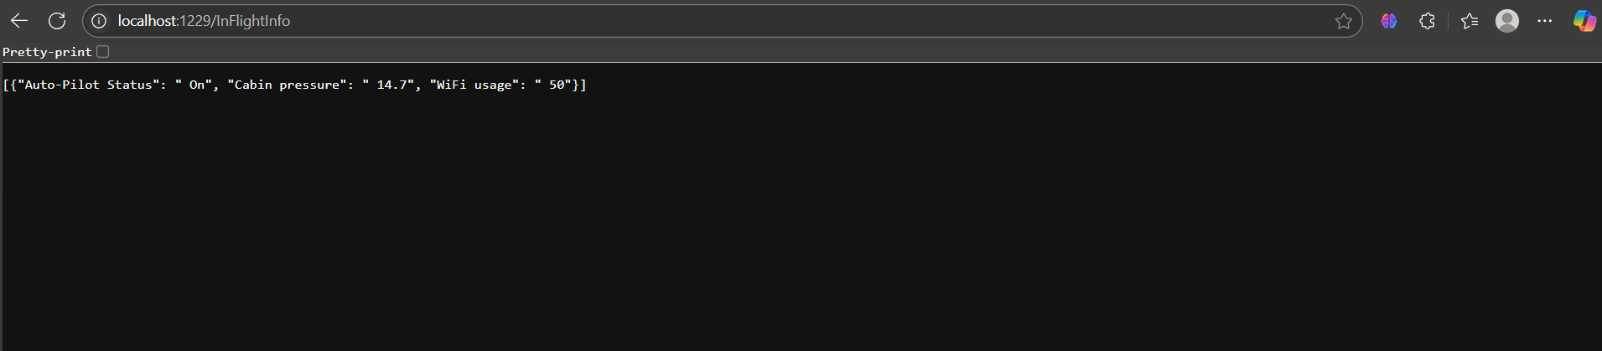
here is the output:

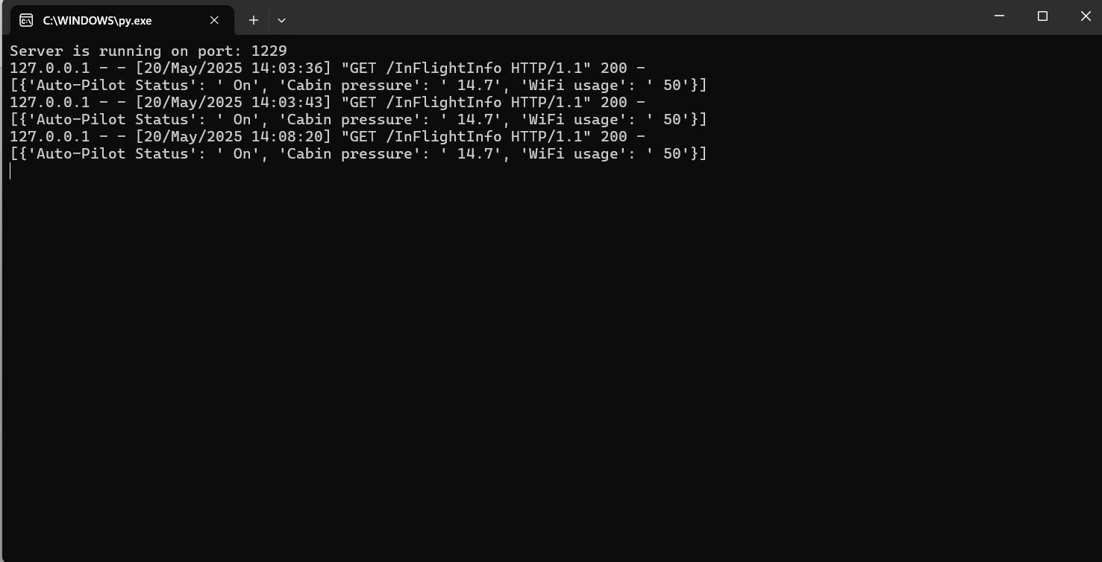
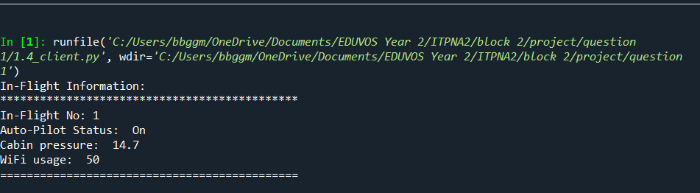

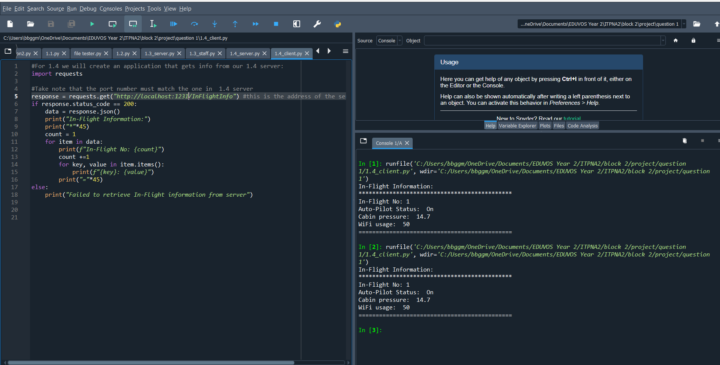
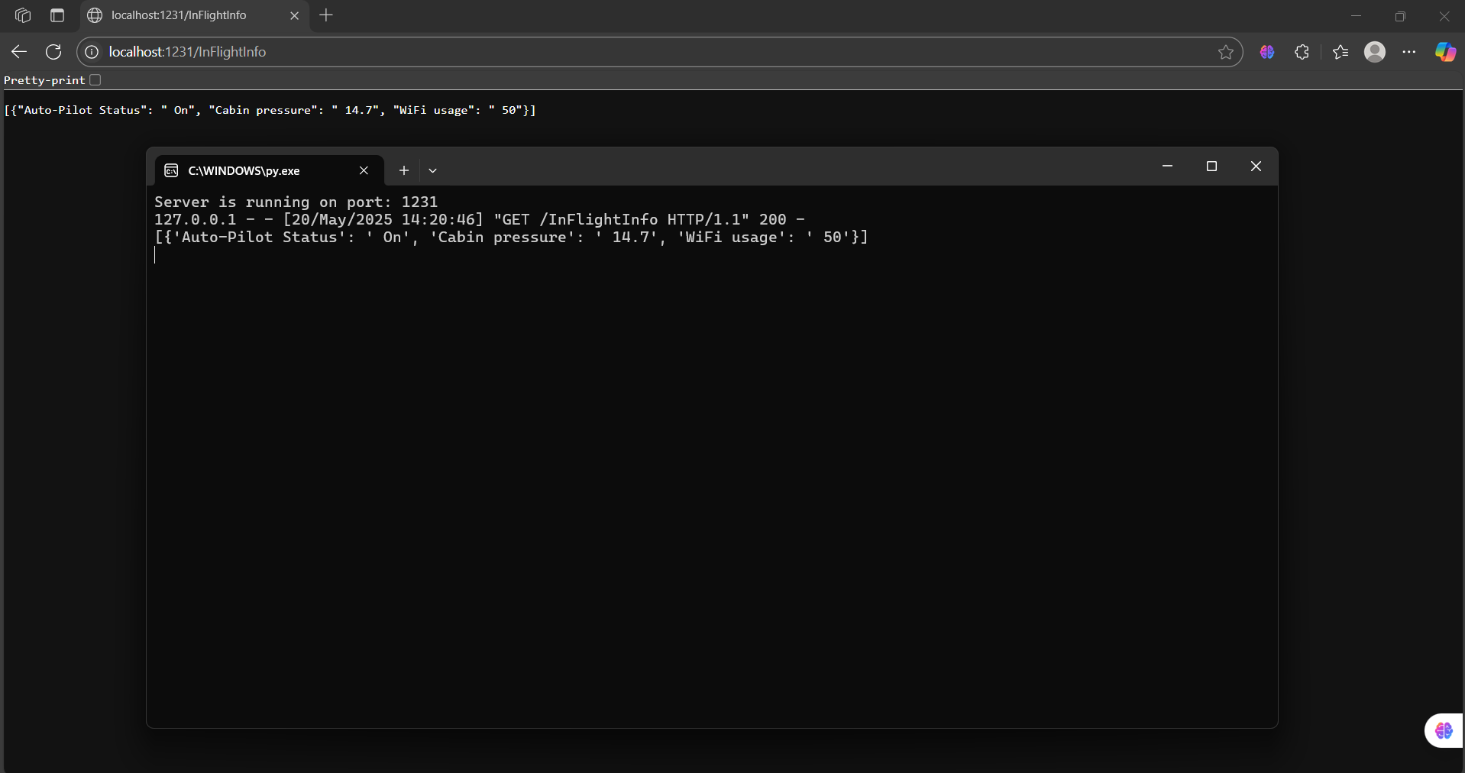
1.3 modified server output:

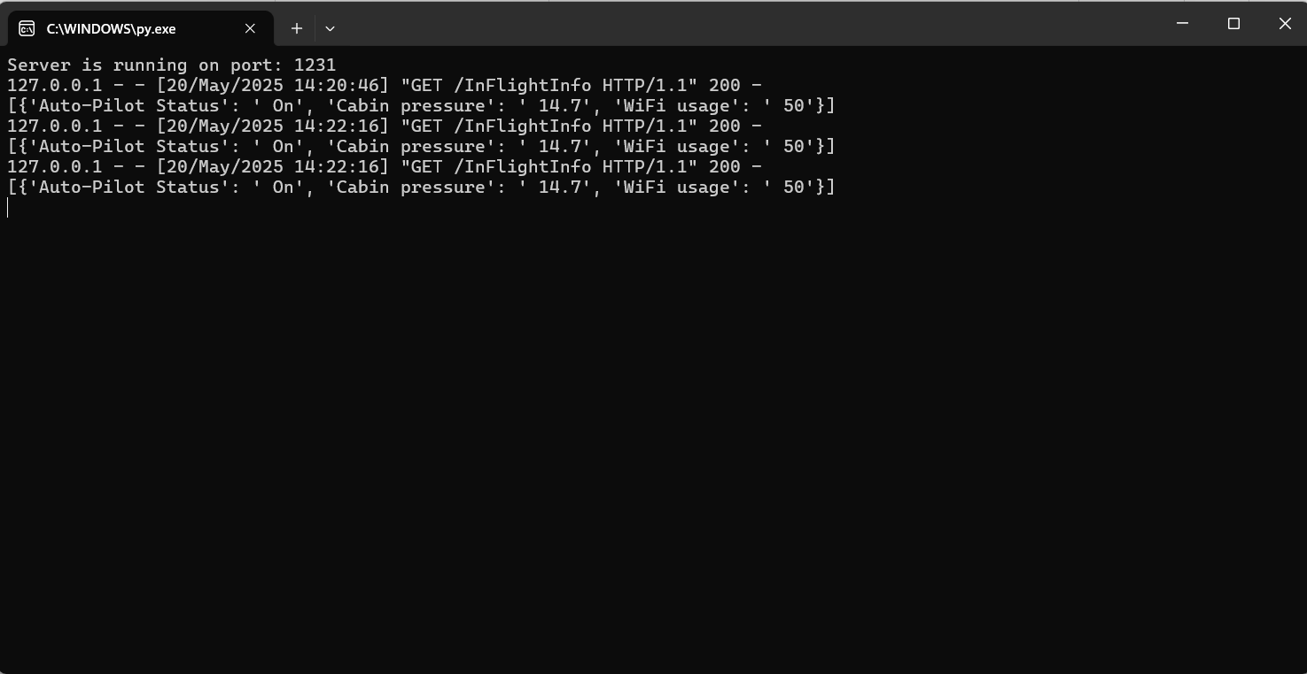
Text file contents:
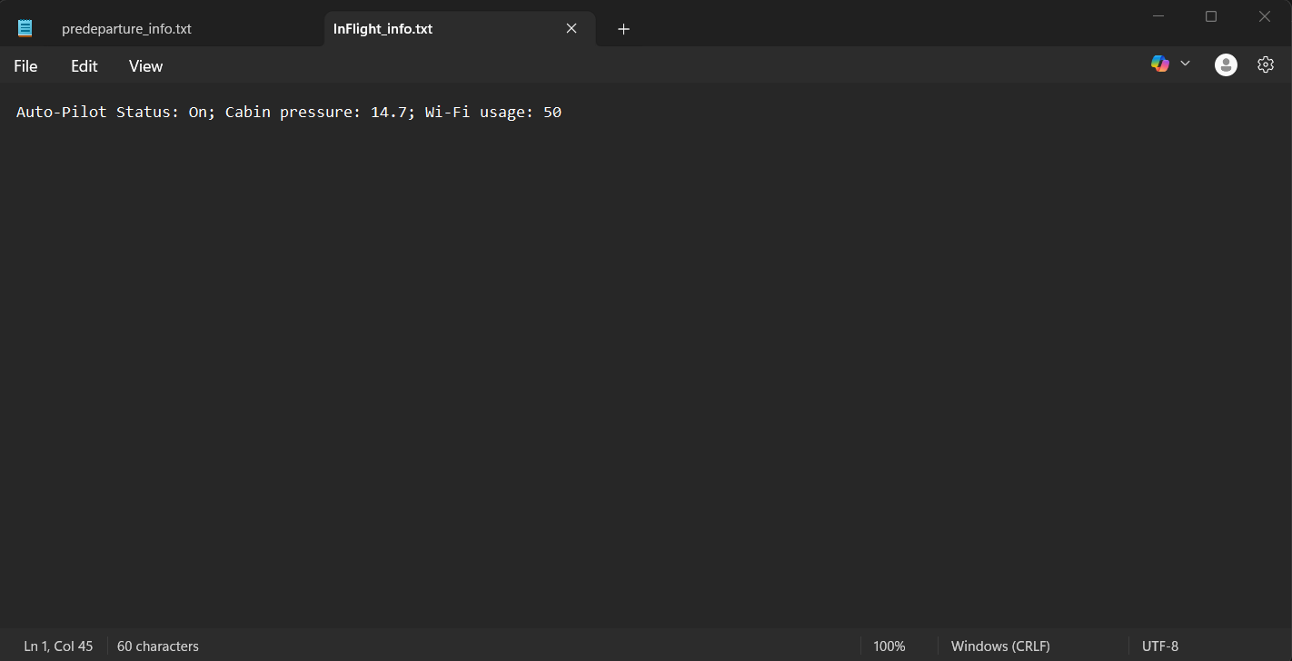

Question 1.5 answer:
For this question we will use the server from 1.4 and a separate file from 1.5_client.py, here is the code for this application:
#First we need to import some modules and classes for our HTTP server to work
from http.server import BaseHTTPRequestHandler,HTTPServer
import json
import time
import threading
#This is our HTTP class that will retrieve information from our file and send it to any http client as a json response
class HTTP_System(BaseHTTPRequestHandler):
def do_GET(self):
if self.path=="/InFlightInfo":
self.send_response(200)
self.send_header("content-type","application/json")
self.end_headers()

try:
#This portion retrives the information from the file and collects it in a list of dictionaries
with open(r"InFlight_info.txt",'r') as fileData:
singleData = fileData.readlines()

dataUser = []

for line in singleData:
Autopilot_status,Cabin_pressure,WiFi_usage = line.strip().split(';')
dataUser.append({"Auto-Pilot Status" :Autopilot_status.split(':')[1],
"Cabin pressure":Cabin_pressure.split(':')[1],
"WiFi usage":WiFi_usage.split(':')[1]
})

print(dataUser)
self.wfile.write(json.dumps(dataUser).encode())

except FileNotFoundError:
self.wfile.write(json.dumps("ERROR file not found").encode())
def update_inflight_info():
"""Update the in-flight information a fixed number of times before stopping."""
#This allows the program to stop so the loop doesn't run in the background
max_updates = 5 # Number of times to update before stopping
count = 0

while count < max_updates:
with open("InFlight_info.txt", 'w') as fileData:
fileData.write("Auto-Pilot Status:Off;Cabin pressure:14.7;WiFi usage:ACTIVE for first class\n")
print(f"Updated In-Flight Events! ({count + 1}/{max_updates})")
time.sleep(5) # Wait for 5 seconds
count += 1

print("Completed all updates. Stopping now.")

#This is our display function which runs our client HTTP server to view the json information
def display(serverClass=HTTPServer, handler_class=HTTP_System, port=1233):
server_address = ('', port)
httpValue = serverClass(server_address, handler_class)
print(f"Server is running on port: {port}")

# Start the file update task in a separate thread
updater_thread = threading.Thread(target=update_inflight_info, daemon=True)
updater_thread.start()
#This allows the program to stop so the loop doesn't run in the background

# Run the HTTP server
httpValue.serve_forever()
display()

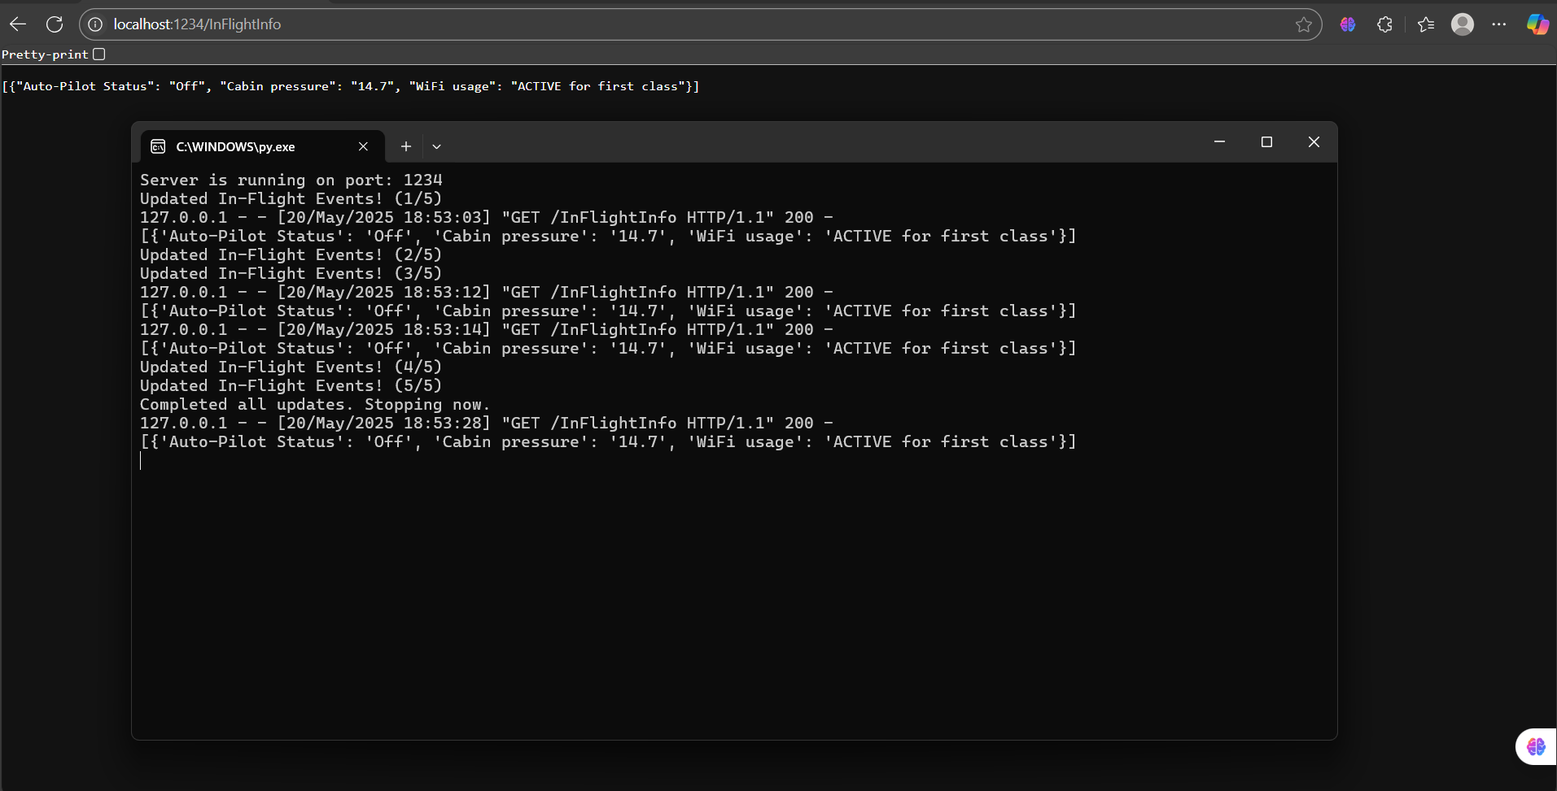
Now for the output:

Question 2.1:
Describe the differences between SMTP, POP3, and IMAP, including which protocols are used for sending and receiving, and how they handle mail storage.

Question 2.1 answer:
Let’s start with SMTP or simple mail transfer protocol. This protocol is used for sending emails from a client to a mail server or between servers. It works by pushing outgoing emails to the recipient’s mail server. It is important to note that SMTP does not store these emails it just sends the emails. Next is POP3 or post office protocol 3. This is used for receiving emails from a server to a client. It does so by downloading emails from the mail server to a local device and typically removes them from the server. Once these emails are downloaded, they are stored on the client and no longer remain on the server unless the administrator configures it to do so. The last protocol is IMAP or internet message access protocol. This is an alternative to protocol for receiving emails, however this protocol allows users to manage messages directly on the server. Emails remain on the server and are synced on multiple devices and messages are stored on the server making them accessible from different locations. (GeeksForGeeks_1, 2025) (Aleksic, 2022) (SiteGround_1, 2025) (Rhodes & Goerzen, 2024). So to summarize SMTP is strictly for sending and not storing or receiving, IMAP stores, receives on both client and servers, and POP3 stores and receives on the client side.

Question 2.2:
Write Python code snippets to:
a) Connect to an SMTP server using smtplib and send an email.
(7 marks)
b) Connect to a POP3 server using poplib, list and retrieve email subjects, and delete an email.
(7 marks)
c) Connect to an IMAP server using imaplib, list the subjects of unread emails, and mark them as read.
(7 marks)

Question 2.2a) answer:
import smtplib
from email.mime.text import MIMEText

# SMTP Server Details
smtp_server = "smtp.gmail.com"
smtp_port = 587
username = "bbggmbab2002@gmail.com"
password = "crnm yedj bgby sjqn"

# Create Email Message
msg = MIMEText("Hello, this is a test email.")
msg["Subject"] = "Test Email"
msg["From"] = username
msg["To"] = "mak.bhik@gmail.com"

# Send Email
server = smtplib.SMTP(smtp_server, smtp_port)
server.starttls()
server.login(username, password)
server.sendmail(username, ["mak.bhik@gmail.com"], msg.as_string())
server.quit()

output looks as follows:
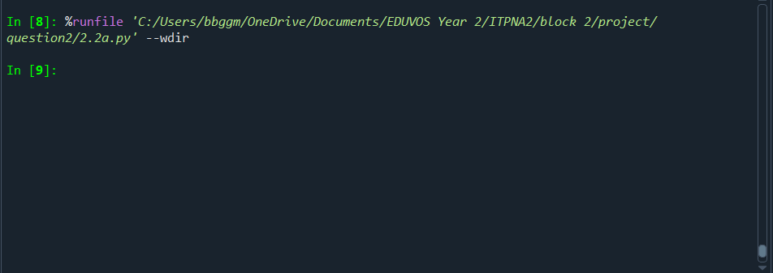
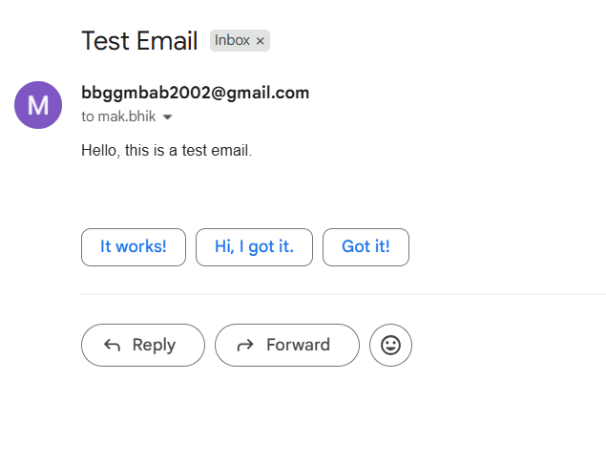

Question 2.2b) answer:
import poplib
from email.parser import BytesParser

try:
# POP3 Server Details
pop3_server = "pop.gmail.com"
username = "bbggmbab2002@gmail.com"
password = "crnm yedj bgby sjqn"

# Connect to POP3 Server
server = poplib.POP3_SSL(pop3_server)
server.user(username)
server.pass_(password)

# List Messages
num_messages = len(server.list()[1])
print(f"Total messages: {num_messages}")

# Retrieve and Print Email Subjects
for i in range(num_messages):
raw_email = b"\n".join(server.retr(i + 1)[1])
msg = BytesParser().parsebytes(raw_email)
print(f"Email {i+1} Subject: {msg['subject']}")

# Delete First Email (example)

server.dele(1)
print("message deleted")

except Exception as e:
print(e)

finally:
server.quit()
output looks as follows:

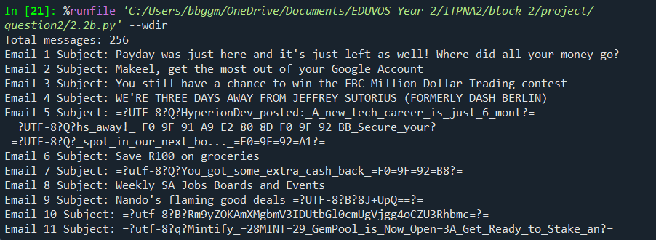
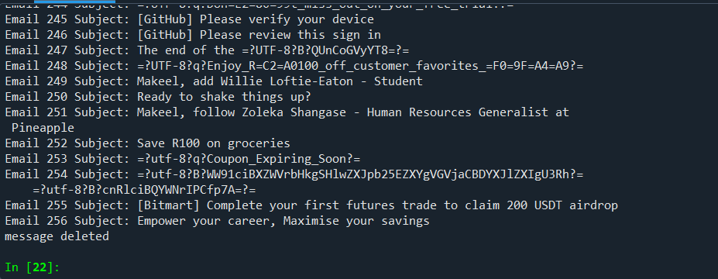

Question 2.2c) answer:
import imaplib
import email

# IMAP Server Details
imap_server = "imap.gmail.com"
username = "bbggmbab2002@gmail.com"
password = "crnm yedj bgby sjqn"

# Connect to IMAP Server
mail = imaplib.IMAP4_SSL(imap_server)
mail.login(username, password)
mail.select("INBOX")

# Search Unread Emails
status, messages = mail.search(None, 'UNSEEN')
email_ids = messages[0].split()

# Retrieve and Print Email Subjects of the first 20
count = 0
for email_id in email_ids:
count+=1
status, msg_data = mail.fetch(email_id, "(RFC822)")
msg = email.message_from_bytes(msg_data[0][1])
print(f"Unread Email Subject: {msg['subject']}")
if count == 20:
break

# Mark All Unread Emails as Read for the first 20 emails
count = 0
for email_id in email_ids:
count+=1
mail.store(email_id, '+FLAGS', '\\Seen')
print(f"{email_id}: Marked as read")
if count==20:
break
mail.logout()
output looks as follows:

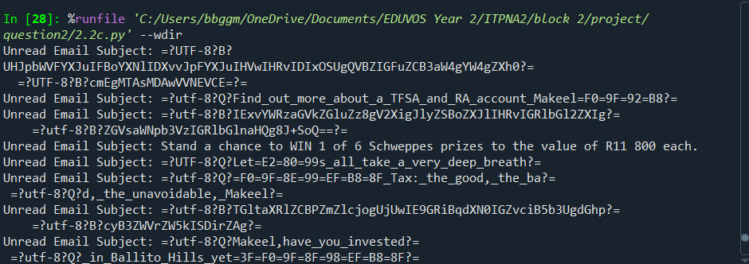
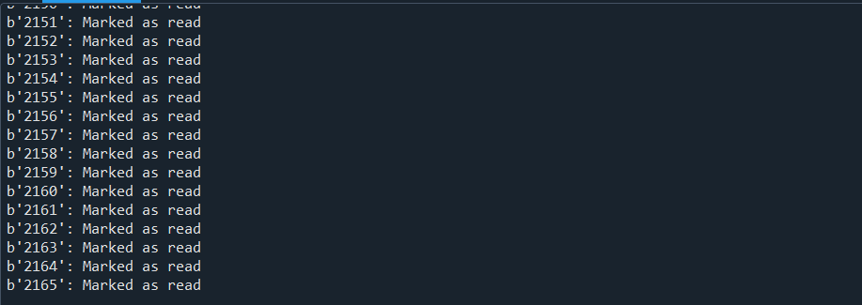

Question 2.3:
Explain which protocol (POP3 or IMAP) would be better suited for a mobile user who checks emails from multiple devices, and justify your answer.

Question 2.3 answer:
In my opinion IMAP is the better protocol for a mobile user. Firstly, IMAP keeps emails stored on the server rather than downloading and deleting them which allows users to access their messages from different devices and ensures all changes sync across these devices. Secondly, since the emails remain on the server, users can check their messages anywhere without worrying about lost emails or device-specific storage issues. Lastly, if a device is lost or damaged, emails remain safe on the server whereas POP3 often removes emails from the server after downloading, making recovery harder. Additionally, IMAP allows simultaneous access to mailbox, meaning users can switch between devices without creating duplicate changes or losing changes (Microsoft_1, 2025) (Malek, 2024) (123media_1, 2025) (MEFMobile_1, 2025).

Question 3:
Network communication in aviation
Effective communication in aviation ensures safe and efficient flight operations by facilitating real-time information exchange between pilots, air traffic controllers, and other personnel. This exchange includes sharing crucial details about weather, flight paths, clearances, and potential hazards, leading to reduced risks and improved operational efficiency.
Write a program that checks the information of the in-Flight events and if the information are not in the specified safety margin, the server must send an email to alert the monitoring service that about the specs of the modem.

Question 3 answer:
Code is as follows for email part:
import requests
import smtplib
from email.mime.text import MIMEText

# Server Configuration
DATA_SOURCE_URL = "http://localhost:1235/InFlightInfo" # Replace with actual API URL
SAFETY_LIMITS = {
"Altitude": (30000, 40000), # Min and max safe altitude in feet
"Speed": (200, 600), # Min and max safe speed in knots
"Temperature": (0, 50), # Safe temperature range in Celsius
}

# Email Configuration
SMTP_SERVER = "smtp.gmail.com"
SMTP_PORT = 587
EMAIL_SENDER = "bbggmbab2002@gmail.com"
EMAIL_PASSWORD = "crnm yedj bgby sjqn"
EMAIL_RECEIVER = "mak.bhik@gmail.com"

def fetch_flight_data():
"""Retrieve in-flight event data from the server."""
try:
response = requests.get(DATA_SOURCE_URL, timeout=10)
response.raise_for_status()
return response.json() # Assuming the API returns JSON data
except requests.RequestException as e:
print(f"Error fetching data: {e}")
return None

def check_safety_margins(data):
"""Check if flight parameters are within safety margins."""
violations = []
for param, (min_val, max_val) in SAFETY_LIMITS.items():
data1 = dict(data[0])

if param in data1:
value = int(data1[param])

if value < min_val or value > max_val:
violations.append(f"{param} ({value}) is outside safe range ({min_val}-{max_val})")

return violations

def send_alert(violations):
"""Send an email alert if safety margins are violated."""
message = MIMEText(f"Safety Alert!\n\nThe following flight parameters are out of range:\n\n" + "\n".join(violations))
message["Subject"] = "In-Flight Safety Alert"
message["From"] = EMAIL_SENDER
message["To"] = EMAIL_RECEIVER

try:
server = smtplib.SMTP(SMTP_SERVER, SMTP_PORT)
server.starttls()
server.login(EMAIL_SENDER, EMAIL_PASSWORD)
server.sendmail(EMAIL_SENDER, EMAIL_RECEIVER, message.as_string())
server.quit()
print("Alert email sent successfully!")
except smtplib.SMTPException as e:
print(f"Error sending email: {e}")

def main():
"""Main function to monitor flight data and trigger alerts."""
data = fetch_flight_data()
if data:
violations = check_safety_margins(data)

if violations:
print(violations)
send_alert(violations)
else:
print("All flight parameters are within safe margins.")

main()

code is as follows for server side:
#First we need to import some modules and classes for our HTTP server to work
from http.server import BaseHTTPRequestHandler,HTTPServer
import json

#This is our HTTP class that will retrieve information from our file and send it to any http client as a json response
class HTTP_System(BaseHTTPRequestHandler):
def do_GET(self):
if self.path=="/InFlightInfo":
self.send_response(200)
self.send_header("content-type","application/json")
self.end_headers()

try:
#This portion retrives the information from the file and collects it in a list of dictionaries
with open(r"InFlight_info.txt",'r') as fileData:
singleData = fileData.readlines()

dataUser = []

for line in singleData:
Autopilot_status,Cabin_pressure,WiFi_usage = line.strip().split(';')
dataUser.append({"Altitude" :Autopilot_status.split(':')[1],
"Speed":Cabin_pressure.split(':')[1],
"Temperature":WiFi_usage.split(':')[1]
})

print(dataUser)
self.wfile.write(json.dumps(dataUser).encode())

except FileNotFoundError:
self.wfile.write(json.dumps("ERROR file not found").encode())

#This is our display function which runs our client HTTP server to view the json information
def display(serverClass=HTTPServer, handler_class=HTTP_System, port = 1235):#It is important to note that everytime you run you might have to change the port number
server_address=('',port)
httpValue = serverClass(server_address,handler_class)
print(f"Server is running on port: {port}")
httpValue.serve_forever()

display()
output looks as follows with text file contents:
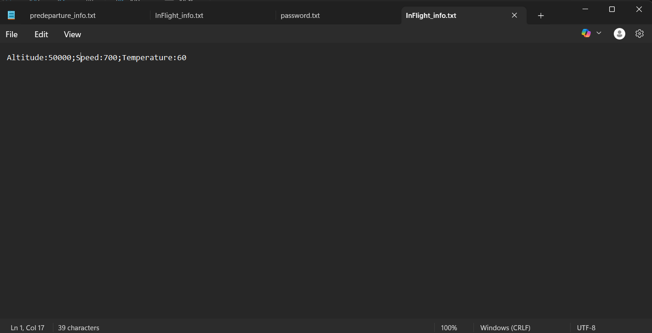
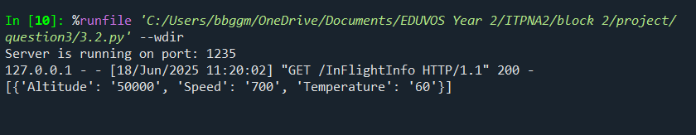
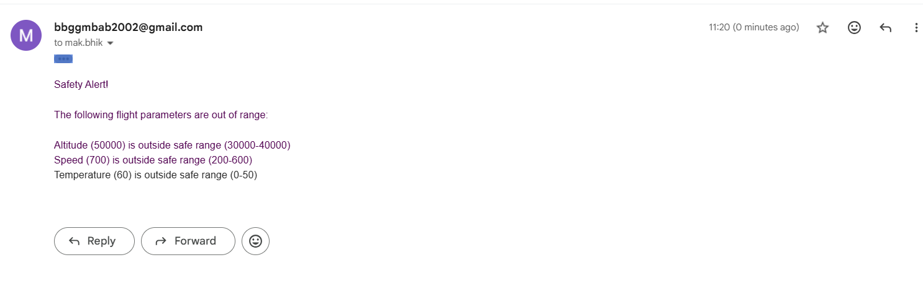

References
123media_1, 2025. 123Media. [Online]
Available at: https://123media.co.za/kb-articles/imap-vs-pop3/
[Accessed 17 June 2025].
Aleksic, M., 2022. PhoenixNap. [Online]
Available at: https://phoenixnap.com/kb/imap-vs-pop3-vs-smtp
[Accessed 17 June 2025].
Distributors, D., 2024. ReadDocs.io. [Online]
Available at: https://dnspython.readthedocs.io/en/latest/resolver-functions.html
[Accessed 13 March 2025].
GeeksForGeeks_1, 2025. GeeksForGeeks. [Online]
Available at: https://www.geeksforgeeks.org/computer-networks/imap-vs-pop3-vs-smtp/
[Accessed 17 June 2025].
Malek, P., 2024. Mailtrap. [Online]
Available at: https://mailtrap.io/blog/pop3-vs-imap/
[Accessed 17 June 2025].
MEFMobile_1, 2025. MEFMobile. [Online]
Available at: https://mefmobile.org/imap-vs-pop3-whats-the-difference-which-one-should-you-use/
[Accessed 17 June 2025].
Microsoft_1, 2025. Microsoft support. [Online]
Available at: https://support.microsoft.com/en-us/office/what-is-the-difference-between-pop-and-imap-85c0e47f-931d-4035-b409-af3318b194a8
[Accessed 17 June 2025].
Rhodes, B. & Goerzen, J., 2024. Foundations of python Network programming. 3rd ed. Unknown: Friends of.
SiteGround_1, 2025. SiteGround. [Online]
Available at: https://www.siteground.com/tutorials/email/protocols-pop3-smtp-imap/
[Accessed 17 June 2025].

