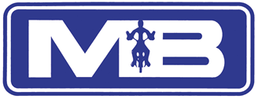
(MOBILE): 07768 340340 TEL: 01246 201993 or 01246 411777 (ANSWERPHONE)
email: mike@mbmotorcycletraining.co.uk - website: www.mbmotorcycletraining.co.uk

Prices
We now offer two payment options:
PAY-AS-YOU-GO or ALL-IN TRAINING PACKAGE:
PAY-AS-YOU-GO
CBT
1. CBT TRAINING WITH INSURED BIKE ON A 50 CC OR 125 CC BIKE - £120.00
2. CBT TRAINING WITH INSURED BIKE ON A 600 CC BIKE - £150.00
PLEASE NOTE - TWO-PART THEORY TEST TO BE BOOKED BY CUSTOMER - TEL: 0300 200 1122 - OR GO TO WEBSITE WWW.DSA.GOV.UK - TEST MUST BE PASSED BEFORE MODULE ONE TEST CAN BE TAKEN
MODULE ONE TRAINING
3. MODULE ONE TRAINING ON A 125 CC OR 600 CC BIKE INCLUDING MODULE 1 TEST - £200
PLEASE NOTE - GOVERNMENT TEST FEE OF £70 IS PAYABLE AFTER MODULE 1
MODULE TWO TRAINING
4. 2 HOUR LESSON MODULE 2 TRAINING - ON A 125 CC BIKE, HIRE & INSURANCE- £80
5. 2 HOUR LESSON MODULE 2 TRAINING - ON A 600 CC BIKE, HIRE & INSURANCE - £90.00
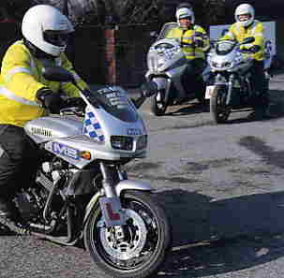

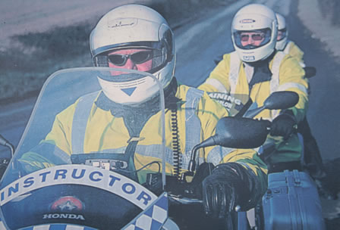
ALL-IN TRAINING PACKAGES - MASSIVE SAVINGS
6. CBT - FULL RESTRICTED LICENCE INCLUDING MODULE ONE TRAINING AND TEST - £750 + £5 petrol for each road session.
Individually tailored course from CBT to DSA restricted licence - 20 hours. With 125cc insured bike hire during day/evenings including one test fee and C.B.T. If a person requires more than 20 hours training, each additional 2 hours will be charged at half the normal rate at a cost of £40 (includes £5 fuel fee.) Can be arranged in 2,4,6 or 8 hour blocks. Restricted Licence limits rider to 33 bhp for 2 years. THIS IS A HUGE SAVING - COST OF ABOVE WOULD BE £1190 ON PAY-AS-YOU-GO (BASED ON CBT ON A 125 CC BIKE = £120 + MODULE 1 TRAINING & TEST = £200 + GOVERNMENT TEST FEE £70 + 20 HOURS MODULE 2 TRAINING =£800 COMPRISING 10 X 2 HOUR SESSIONS AT £80 PER SESSION)
DIRECT ACCESS TRAINING - AGE 21 YEARS AND OVER
THE BIKE REQUIRED FOR THIS TRAINING MUST BE MORE THAN 46 BHP TO ENABLE THE RIDER TO RIDE ANY CAPACITY BIKE.
7. DIRECT ACCESS COURSE INCLUDING MODULE ONE TRAINING AND TEST - £800
Individually tailored course from CBT to DSA unrestricted licence, 20 hours, with 47bhp insured bike hire during day/evenings including one test fee and CBT. If a person requires more than 20 hours training, each addtitional 2 hours will be charged at half the normal rate at a cost of £45. Can be arranged in 2, 4, 6 or 8 hour blocks. Unrestricted licence allows the rider to ride any machine. THIS IS A HUGE SAVING - COST OF ABOVE WOULD BE £1320 ON PAY-AS-YOU-GO (BASED ON CBT ON A 600 CC BIKE = £150 + MODULE 1 TRAINING & TEST = £200 + GOVERNMENT TEST FEE £70 + 20 HOURS MODULE 2 TRAINING =£900 COMPRISING 10 X 2 HOUR SESSIONS AT £90 PER SESSION)
8. ACCELERATED ACCESS COURSE
Please contact us for further information.
REFRESHER LESSON FOR FULL LICENCE HOLDER ONLY
9. 2 HOUR REFRESHER WITH OR WITHOUT BIKE HIRE - £90.00
WE WELCOME CASH - CHEQUE WITH BANKERS CARD

