What training do I need to take?

The starting point for learner is Compulsory Basic Training (CBT). This is a course run by training bodies approved by the Driving Standards Agency (DSA). Most DSA approved training bodies can hire or loan both bikes and safety equipment e.g. helmets.  Compulsory Basic Training  - All learner rider must complete CBT before riding on the roads.  - CBT pass certificates issued before 1st February 2001 will be valid for three years from the date of issue. Those certificates issued from 1st February 2001, will be valid for 2 years.  - CBT will have to be re-taken if both theory and practical tests are not passed within the certificate life.  CBT must be completed before riding on the road by all learners who are resident on mainland Great Britain, islands that are connected to the mainland by a road, and the following islands:-Wight, North Uist, Lewis, South Uist, Harris, Benbecula, mainland Orkney and mainland Shetland, Residents of all other islands will be exempt from the need to tale CBT, but only if riding on roads which are on an exempted island. | 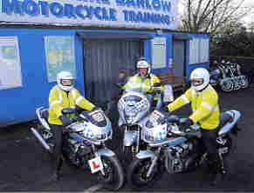  A CBT certificate issued in respect of a course completed on a motorcycle and sidecar combination or a moped with more than 2 wheels will restrict the provisional riding entitlement (or full moped entitlement on full car licence) to such vehicles.  Once you have your certificate (DL 196), you can carry on to take additional training to pass your tests and qualify for a full motorcycle or moped licence.

What test do I need to take?
There are 3 categories of full licence to aim for:  - Category P - Moped  - Sub-Category A1 - Light motorcycle licence, which restrictsriders to any bike up to 125cc and a power output of 11KW.  - Category A - A standard motorcycle licence. Moped and Motorcycle tests normally consist of 2 seperate parts- a theory test and a practical test.  Theory Test  You will probably need to pass a theory test before taking a practical test for a moped or a motorcycle.  You do not need to take a theory test if you already hold a full licence for another category of motorcycle or have passed a moped test since 1st July 1996.  The Theory Test Pass Certificate is valid for 2 years. The practical test must be passed within this period otherwise the Theory Test will have to be taken again.  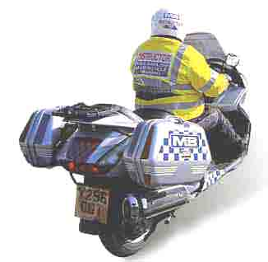  Accelerated Access  Riders who already hold a full licence and reach the age of 21 while still within the 2 year restricted period and wish to ride bikes larger than 25KW (33bhp), may practice and take a further test on a large bike.  The same test and practice conditions for Direct Access riders will apply.  Although you revert to learner status while practising, test failure will not affect your existing motorcycle licence entitlement. | 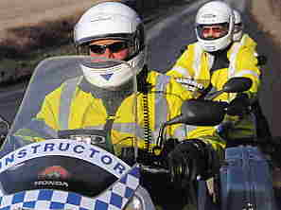  Practical Test  Category P, the practical test can be taken on any moped.  Sub-Category A1, the practical test is taken on a bike of between 75cc and 125cc.  Category A, the practical test is taken on a bike of between 121cc and 125cc and capable of at least 100Kph (62mph). After passing the standard motorcycle practical test you will be restricted for 2 years to riding a bike of up to 25 KW (33 bhp) and a power/weight ratio not exceeding 0.16KW/Kg. After this you may ride any size of bike.  Riders over the age of 21, or those who reach 21 before their 2 year restriction ends, have further test options.  Direct Access  Those who do not already hold a full motorcycle licence may, after taking CBT and the Theory Test, if necessary, take the practical test on a motorcycle with a power output of at least 35KW (46.6 bhp). A pass will allow you to ride any size of bike.  All or part of the CBT course may be taken on either a learner bike or a large bike.  You may practice for the practical test on bikes larger than the learner bike specification provided:  - You are accompanied at all times by a qualified instructor on another bike and in radio contact.  - You wear flourescent/reflective clothing and follow all other provisional licence restrictions.

Sidecars
Learners who wish to ride with a sidecar can practise on a combination with a power/weight ratio not exceeding 0.16KW/kg. On obtaining a standard licence ( category A), you will be restricted to a combination with the above power/weight ratio for two years. At age 21 learners may, only within Direct or Acceleratd Access provisions, practice on a larger combination. But the test must be taken on a solo bike (physically disabled riders may take a test on a sidecar combination, but their licence will limit them to riding combinations).

