***Basic Front-end design for HarmonIQ***

**Frontend Developer:**

*Michael Savon*

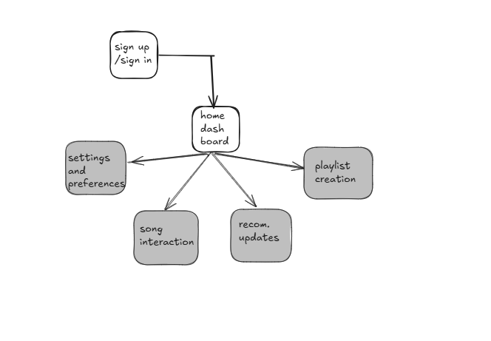

**Home Dashboard**

* Display of personalized song recommendations, recent listening history, and user profile.

**Song Interaction**

* **Input**: User likes, dislikes, or saves a song.
* **Output**: Update of user preferences and recalculation of recommendations.

**Recommendation Update**

* **Input**: User interaction data (likes, listening hours, most played{optional}).
* **Output**: Updated list of recommended songs.

**Playlist Creation**

* **Input**: User selects songs to add to a playlist.
* **Output**: Playlist creation and saving in Spotify account.

**Settings and Preferences**

* **Input**: User adjusts recommendation settings (genres, artists, mood).
* **Output**: Tailored recommendation algorithms and UI adjustments.