[Skip to content](https://tunecomp.net/google-dns-8-8-8-8/#content)

[TuneComp](https://tunecomp.net/)

Top of Form

Bottom of Form

* [iPhone & iPad](https://tunecomp.net/category/iphone-ipad/)
* [Android](https://tunecomp.net/category/android/)
* [Galaxy S21](https://tunecomp.net/tag/galaxy-s21/)
* [Windows 10](https://tunecomp.net/category/windows-10/)
* [Networking](https://tunecomp.net/category/networking/)
* [Google Photos](https://tunecomp.net/tag/google-photos/)
* [Call Blocking](https://tunecomp.net/tag/call-blocking/)
* [Remove Malware](https://tunecomp.net/malware-removal/)

Top of Form

Bottom of Form

[Home](https://tunecomp.net/) » [Networking](https://tunecomp.net/category/networking/) » Google DNS Servers 8.8.8.8, 8.8.4.4. Benefits & How to Use

Google DNS Servers 8.8.8.8, 8.8.4.4. Benefits & How to Use

2020-06-09 by [Adam Swift](https://tunecomp.net/author/tune/)

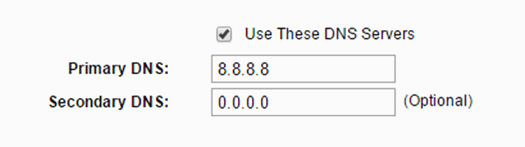

What is Google DNS

**Google Public DNS** represents two servers with IP addresses for IPv4 – 8.8.8.8 and 8.8.4.4. 8.8.8.8 is the primary DNS, 8.8.4.4 is the secondary one.

Google DNS service is free to use and can be used by anyone who has access to the Internet. You can use Google servers IP addresses as alternate DNS instead of such provided by your ISP with the purpose to resolve Internet names faster and improve your security.

Quick Navigation:

* [Benefits](https://tunecomp.net/google-dns-8-8-8-8/#Benefits)
* [How to use 8.8.8.8 on Router](https://tunecomp.net/google-dns-8-8-8-8/#Router)
* [on Windows PC](https://tunecomp.net/google-dns-8-8-8-8/#Windows)
* [on Android](https://tunecomp.net/google-dns-8-8-8-8/#Android)
* [IPv6](https://tunecomp.net/google-dns-8-8-8-8/#IPv6)
* [on Cellular Data](https://tunecomp.net/google-dns-8-8-8-8/#Cellular-data)

Benefits of Using Google DNS Servers – 8.8.8.8 and 8.8.4.4

1. **Ensures the DNS is being resolved correctly**  
   As you probably know, the default DNS on router is your ISP’s DNS. Often ISPs block access to certain resources be resolving their site names to a “wrong” IP-address.  
   For instance if ISP wants to block access to *example.com* their DNS would resolve example.com to *127.0.0.1* or another fake IP. To avoid such blocking it would be enough to set 8.8.8.8 or 8.8.4.4 on router or PC and use them to resolve the correct domain names.
2. **Faster resolve speed**  
   Google DNS resolves hostnames faster that many DNS servers that belong to ISPs.

How to Set Up and Use 8.8.8.8 Server on a Wi-Fi Router

Login to the web interface:

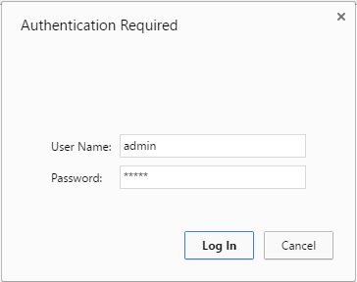

Go to Network → WAN Setup.  
Check the flag Use these DNS Servers.  
Type 8.8.8.8 into the Primary DNS field.  
Press Save.

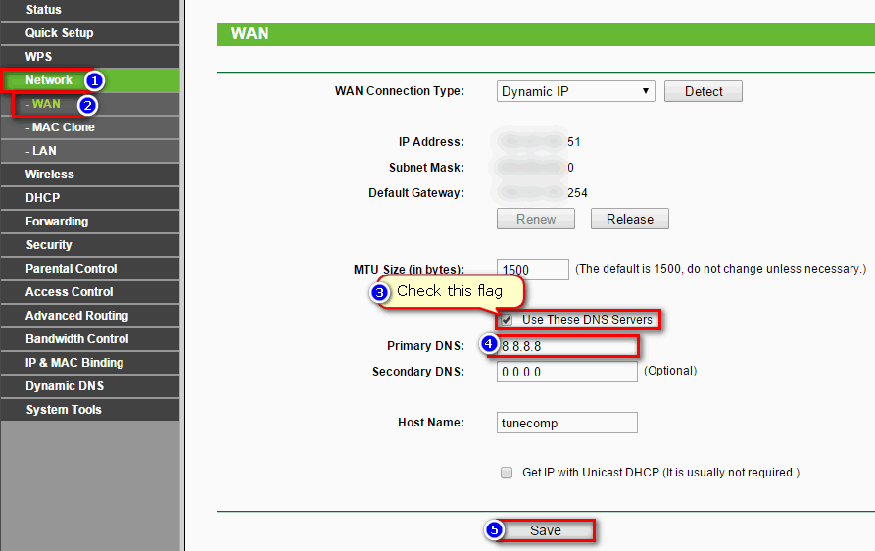TP-Link Router DNS settings for WAN interface

How to Switch to Google DNS on a Windows PC (Laptop)

(We took Windows 10 to illustrate Google DNS Setup)

Right click on the network icon in the taskbar and click on Open Network and Sharing Center:

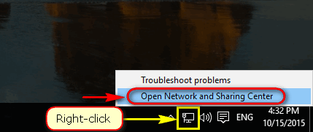

Click on your connection (or go to Change adapter settings and call for the connection properties):

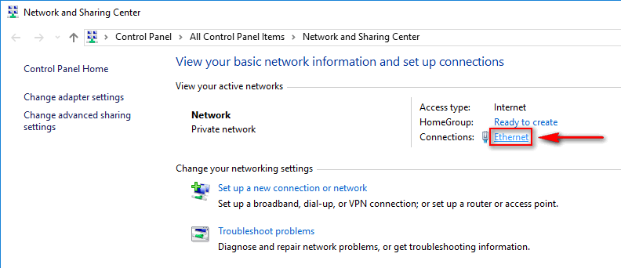

Click on Properties:

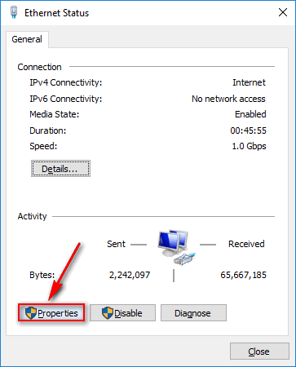

Select Internet Protocol Version 4 (TCP/IPv4) in the list and click the Properties button:

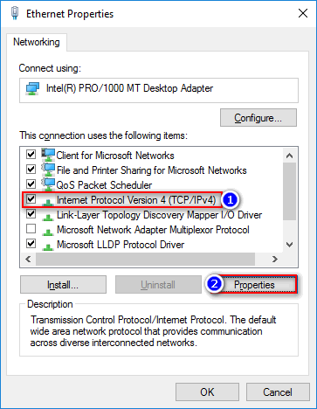

Switch the lower selector to Use the following DNS server addresses.  
Specify 8.8.8.8 as the Preferred DNS server.  
Optionally specify 8.8.4.4 as the Alternate DNS server (or just leave the field blank).  
Click OK to save settings:

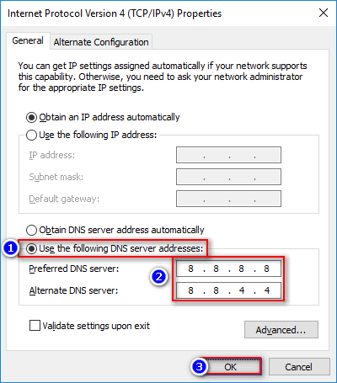

Then press Close → Close in the previous Windows.

How to set up 8.8.8.8 for WiFi on Android phone (tablet)

*Note! It is much more easier to set up Google DNS on a router rather then an Android device.*

*It makes sense to set up 8.8.8.8 on Android only in case if you do not have access to the router’s admin page (for example, if the router does not belong to you).*

Go to Settings:

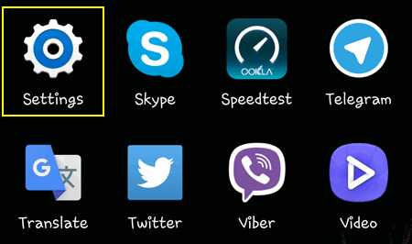

Press and hold on your network name (it doesn’t matter whether you are currently connecnted to it or not):

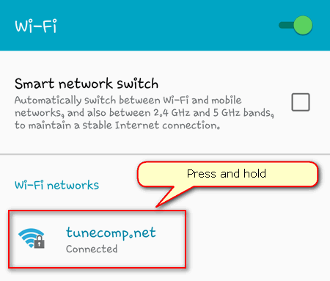

Tap on Modify network config:

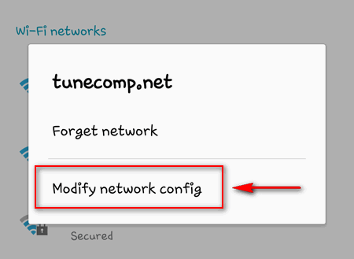

Check the flag Show advanced options:

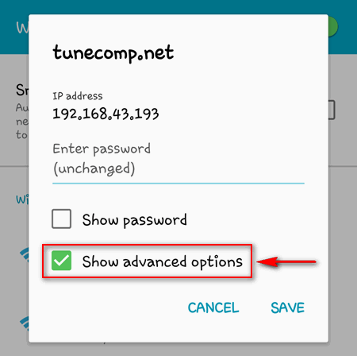

In IP settings select Static:

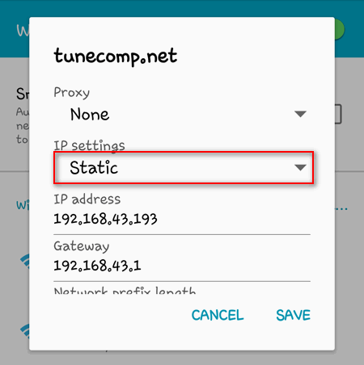

Specify Google’s servers 8.8.8.8 and 8.8.4.4 as DNS1 and DNS2 respectively (you can fill only the DNS1 field and leave the second blank).  
Tap on Save to apply changes to the network interface of your Android device:

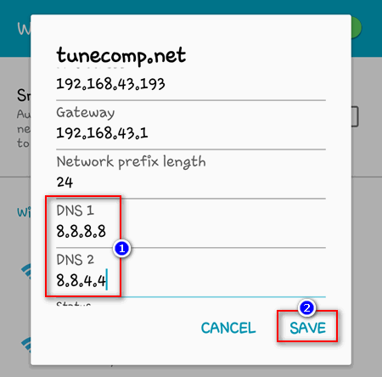

Google DNS IPv6 Address

You may also use Google DNS IPv6 address on your PC:

Primary: **2001:4860:4860::8888**  
Secondary: **2001:4860:4860::8844**

How to Use Google DNS Servers on Cellular Data

For the concluding part of our guide we left one more curious and rather difficult task to talk about — how to use Google DNS when your iPhone or Android is connected to the Internet via mobile data.

The thing is that you cannot manually change DNS servers for your cellular data connection the way we showed this in the previous paragraph concerning Wi-Fi. Because there is simply no field to manually enter at least the primary IP address – 8.8.8.8.

The answer is **use a third-party app**. Unfortunately, there is no such app by Google (we hope that they will release one in the future), so you are to choose between several third-party apps on Google Play Store.

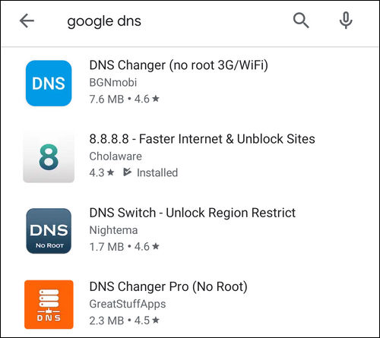

As a rule, they show you annoying ads until you pay money but nevertheless you can use them to actually switch your mobile data connection to Google DNS. Try some of them and choose the one you like.

Note that such apps work exactly as any VPN app. You can manually connect and disconnect VPN to start or stop using 8.8.8.8 DNS server respectively, or make it connect automatically on startup or reboot.

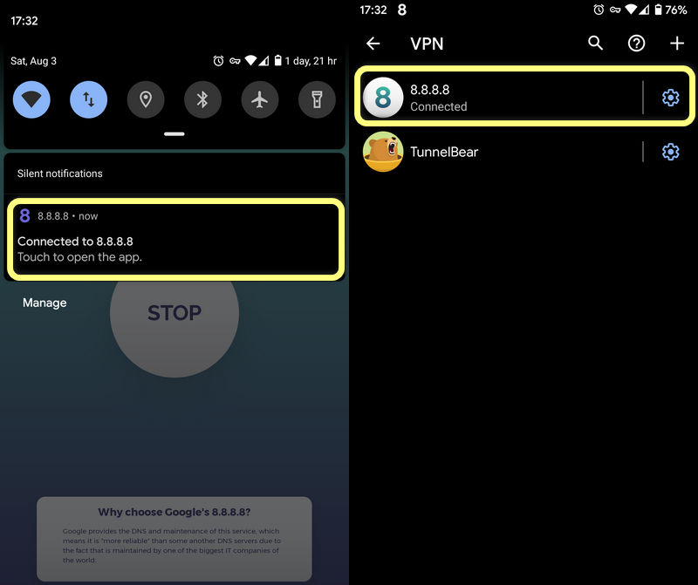

Wrapping Up

Firstly, if you found the topic interesting we encourage you to read [Google’s guide](https://developers.google.com/speed/public-dns/docs/using) for more details.

Secondly, we’d love to hear some feedback from you on the following questions:

1. on what devices do you prefer to use Google Public DNS?
2. what kind of connection do you use 8.8.8.8 with (Wi-Fi or cellular data)?
3. what are the reasons behind it (what is the purpose and what problems do you actually solve by using Google DNS)?

Thank you in advance and good luck!

Categories[Android](https://tunecomp.net/category/android/), [iPhone & iPad](https://tunecomp.net/category/iphone-ipad/), [Networking](https://tunecomp.net/category/networking/), [Windows 10](https://tunecomp.net/category/windows-10/)Post navigation

[Fix ERR_CONNECTION_REFUSED in Chrome on Android or Windows 10](https://tunecomp.net/err_connection_refused-chrome-android-windows-10/)

[Add High Performance/Ultimate Performance Plan on Windows 10 if It is Missing in Power Options](https://tunecomp.net/add-high-performance-plan-windows-10-power-options/)

9 thoughts on “Google DNS Servers 8.8.8.8, 8.8.4.4. Benefits & How to Use”

1. **Alice87**

[2016-10-17 at 07:25](https://tunecomp.net/google-dns-8-8-8-8/#comment-324)

I had a problem with accessing a few websites from my home PC. Setting 8.8.8.8 DNS on my router fixed the issue! Thanks a lot!

[Reply](https://tunecomp.net/google-dns-8-8-8-8/#comment-324)

1. **Adera**

[2016-11-25 at 07:33](https://tunecomp.net/google-dns-8-8-8-8/#comment-336)

Thx

[Reply](https://tunecomp.net/google-dns-8-8-8-8/#comment-336)

1. **replica**

[2017-01-24 at 15:16](https://tunecomp.net/google-dns-8-8-8-8/#comment-386)

OMG YOU SAVED MY LIFE – didn’t know waht to do and this problems for me on twitch appeard from nowhere, now that i add 8888 and 8844 work like before, god bless you xD

[Reply](https://tunecomp.net/google-dns-8-8-8-8/#comment-386)

1. **ddggmm**

[2018-08-24 at 04:10](https://tunecomp.net/google-dns-8-8-8-8/#comment-779)

YES! YOU SAVED ONE MORE LIFE!!

[Reply](https://tunecomp.net/google-dns-8-8-8-8/#comment-779)

1. **sarahJane**

[2018-12-04 at 02:05](https://tunecomp.net/google-dns-8-8-8-8/#comment-848)

Fixed my LG SmartTV internet connection issues.  
Thanks.

[Reply](https://tunecomp.net/google-dns-8-8-8-8/#comment-848)

1. **Dorian**

[2019-11-21 at 10:02](https://tunecomp.net/google-dns-8-8-8-8/#comment-2097)

Thanks for the guide about using Google DNS on mobile! Have never read about it elsewhere.

[Reply](https://tunecomp.net/google-dns-8-8-8-8/#comment-2097)

1. **a**

[2020-03-25 at 11:44](https://tunecomp.net/google-dns-8-8-8-8/#comment-2300)

I was having issues accessing any service from the NCBI. This worked perfectly! Thanks a lot!

[Reply](https://tunecomp.net/google-dns-8-8-8-8/#comment-2300)

1. **Marnie**

[2020-04-10 at 07:54](https://tunecomp.net/google-dns-8-8-8-8/#comment-2334)

It worked for a day, but it seems the next morning the site I love using the most is blocked again even with the DNS set, nobody else is having issues with this site but me..

[Reply](https://tunecomp.net/google-dns-8-8-8-8/#comment-2334)

1. **Scott**

[2020-05-27 at 14:33](https://tunecomp.net/google-dns-8-8-8-8/#comment-2420)

While it might fix blocked websites. In web programming, you can’t afford a slow DNS. I was timing out over 40% of the time connecting to MongoDB. Meaning it was running over 30000, milliseconds, or 30 seconds. It wasn’t my code it was the DNS was too slow. Now it connects in about 1/3 of a second on average and no failures. That is a big difference.

[Reply](https://tunecomp.net/google-dns-8-8-8-8/#comment-2420)

Leave a Comment

Top of Form

Comment

NameEmailWebsite



Bottom of Form

* [[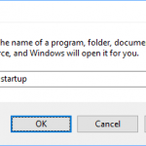](https://tunecomp.net/add-program-to-startup-windows-10/)How to Add an App or Program to Startup in Windows 10: Startup Folder, Registry, Scheduler](https://tunecomp.net/add-program-to-startup-windows-10/)
* [[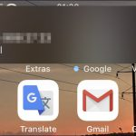](https://tunecomp.net/silence-unknown-callers-block-calls-from-unknown-numbers-iphone/)Silence Unknown Callers Option to Block Calls from Unknown Numbers on iPhone (iOS 13, 14)](https://tunecomp.net/silence-unknown-callers-block-calls-from-unknown-numbers-iphone/)
* [[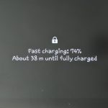](https://tunecomp.net/enable-disable-fast-charging-samsung-galaxy/)How to Enable or Disable the Fast Charging on Galaxy S21, S20, S10, S9, Note](https://tunecomp.net/enable-disable-fast-charging-samsung-galaxy/)
* [[](https://tunecomp.net/put-app-to-sleep-samsung-galaxy/)How to Put an App to Sleep on Galaxy S21, S20, S10, Note 20](https://tunecomp.net/put-app-to-sleep-samsung-galaxy/)
* [[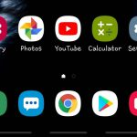](https://tunecomp.net/hide-navigation-bar-enable-full-screen-gestures-mode-galaxy-s9-s10/)Enable Full Screen Gestures Mode (Hide Navigation Bar) on Galaxy S21, S20, S10, S9](https://tunecomp.net/hide-navigation-bar-enable-full-screen-gestures-mode-galaxy-s9-s10/)
* [[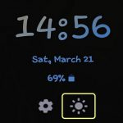](https://tunecomp.net/adjust-brightness-always-on-display-galaxy-oneui/)How to Adjust Brightness of Always On Display on Galaxy S21, S20](https://tunecomp.net/adjust-brightness-always-on-display-galaxy-oneui/)
* [Privacy Policy](https://tunecomp.net/privacy-policy/)
* [About Us](https://tunecomp.net/about/)

© 2014-2020 TuneComp

We use cookies to ensure that we give you the best experience on our website. If you continue to use this site we will assume that you are happy with it.[Ok](https://tunecomp.net/google-dns-8-8-8-8/)[Privacy policy](https://tunecomp.net/privacy-policy/)