**Important Excel functions**

***Formula to count the number of digits in a text string:***

=COUNT (--MID (B2, SEQUENCE(LEN(B2)),1))

To count numbers that appear in a text string, you can use a formula based on the COUNT function, with help from the MID, SEQUENCE, and LEN functions. In the example shown, the formula in cell D5 is:

=COUNT (--MID (B5, SEQUENCE(LEN(B5)),1))

***Formula to split digits from a string once you have the number of digits in a string from the previous formula:***

=IFS(C2=1,LEFT(B2,1)& " " & RIGHT(B2,LEN(B2)-C2),C2=2,LEFT(B2,2)& " " & RIGHT(B2,LEN(B2)-C2),C2=3,LEFT(B2,3)& " " & RIGHT(B2,LEN(B2)-C2),C2=4,LEFT(B2,4)& " " & RIGHT(B2,LEN(B2)-C2))

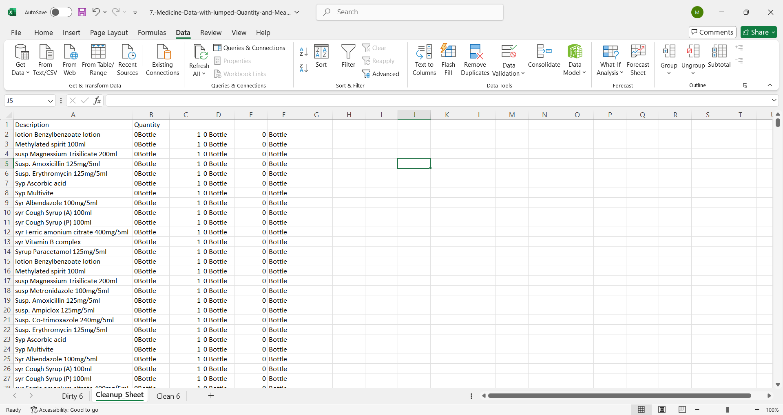

***Mailing sales Excel files:***

I used this formula to calculate the Ship Mode:

=IFS(OR(NOT(ISBLANK(D4)),NOT(ISBLANK(E4)),NOT(ISBLANK(F4))),"First Class",OR(NOT(ISBLANK(G4)),NOT(ISBLANK(H4)),NOT(ISBLANK(I4))),"Same Day",OR(NOT(ISBLANK(J4)),NOT(ISBLANK(K4)),NOT(ISBLANK(L4))),"Second Class",OR(NOT(ISBLANK(M4)),NOT(ISBLANK(N4)),NOT(ISBLANK(O4))),"Standard Class")

***Formula I used to calculate the Segment (subcategories of the Ship Mode):***

=IFS(AND(NOT(ISBLANK(E4)),C4="First Class"),"Consumer",AND(NOT(ISBLANK(F4)),C4="First Class"),"Corporate",AND(NOT(ISBLANK(G4)),C4="First Class"),"Home Office",AND(NOT(ISBLANK(H4)),C4="Same Day"),"Consumer",AND(NOT(ISBLANK(I4)),C4="Same Day"),"Corporate",AND(NOT(ISBLANK(J4)),C4="Same Day"),"Home Office",AND(NOT(ISBLANK(K4)),C4="Second Class"),"Consumer",AND(NOT(ISBLANK(L4)),C4="Second Class"),"Corporate",AND(NOT(ISBLANK(M4)),C4="Second Class"),"Home Office",AND(NOT(ISBLANK(N4)),C4="Standard Class"),"Consumer",AND(NOT(ISBLANK(O4)),C4="Standard Class"),"Corporate",AND(NOT(ISBLANK(P4)),C4="Standard Class"),"Home Office")