Installing Linux on HP210-2000 Netbooks
with the Live Install USB thumbdrive of 1/11
brent@mbari.org 1/19/11

This live install thumbdrive will boot into a fully functional Linux graphical environment without modifying the contents of the netbook's harddrive. The distribution is the Debian edition of Mint Linux. It was chosen over Ubuntu largely because it is a “rolling release”. As such, there should be no “new” versions requiring re-installation of all the customizations we've made to this one. More information about LDME at: http://www.linuxmint.com/download_lmde.php

To boot the netbook into Linux via the thumbdrive:

- Cycle the netbook's power or reboot it.
- Press the ESC key immediately when BIOS prompts for it.
- Press F9 to select boot options
- Chose to boot from the USB thumbdrive (usually identified as Lexar)
- If the system hangs with a single “SYSLINUX” line at the top of the console, return to step 1 (try again)
- After about 2 minutes, you will see a graphical login screen.
- Log in as user esp. The password is also esp
- After another couple minutes, you will see the background change to a floral outdoor image. You are up and running at this point.

Take care when booting off the USB thumbdrive not to alter the root filesystem on it. The USB filesystems are “live” and writable.

There are four user accounts preconfigured:

esp: The main ESP application user. Can also administer the netbook.

espdev: The ESP Developer user has access to the tools to regenerate MSP430 firmware for dwarves and rebuild flash images for the ESP's embedded Linux host. This user can also administer the netbook.

guest: Unprivileged user. Cannot administer the netbook.

root: Superuser. Password is HPMini210-2000

Password for non-root users are same as user name. Feel free to change them. You may want to leave the root passwd as is so I can administer the machines as a last resort.

There are two hidden control panels, at the bottom and top of the screen, respectively. Move the mouse pointer up or down to see them. The bottom panel contains the standard menu, which is very windows-like in its functions. This is one of the features of the Mint Linux distro. The top panel contains icons to launch commonly used ESP applications.

Repartioning the Hard Disk

Your first, and probably most difficult, task is to repartition the harddrive to make room for Linux there. You should do this after Windows has at least been started once and allowed to configure itself. By the numbers:

- Click (once) on the terminal icon in the top panel to launch a terminal window.
- To get a root shell, in the terminal window:

$ sudo bash #enter the user's account password when prompted

- To start the disk partition manager GUI (in the background):

# gparted &

Unfortunately, these machines come with their disks partitioned such that there are no unused slots in the primary table. We will therefore replace the partition containing HP's diagnostic tools to with an extended partition for Linux. Then the WINDOWS partition will be shrunk and the RECOVERY partition moved to make room on the disk for the Linux partitions. You should allow at least 20 GB for the Linux ROOT partition and 30 GB for the HOME partition. I usually make ROOT 25GB and HOME 50-70GB, but this leave little room for WINDOWS.

Here's the display of gparted before repartitioning:

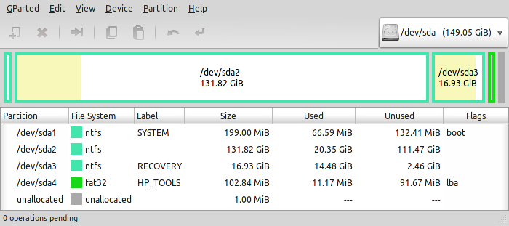

Here's the gparted display after repartitioning for Linux:

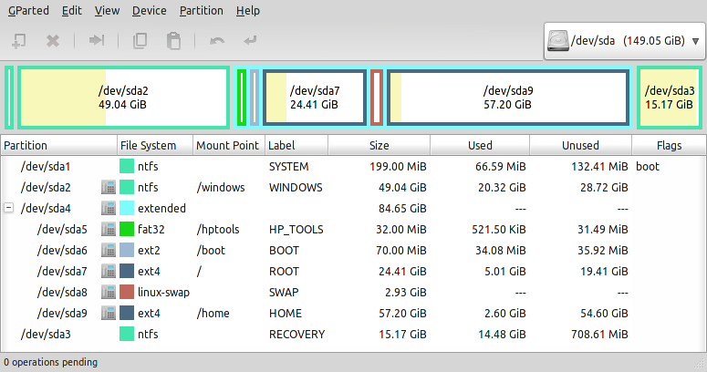
Note that the “used” fields in the above screen shot reflect the amount after Linux has been installed – not just after repartitioning.

Here's a step-by-step procedure for repartitioning:

- Label the large main windows partition WINDOWS
- Shrink the WINDOWS partition to the new desired size (you should free up at least 50GB or so of disk space, per notes above)
- delete the HPTOOLS partition
- Shrink and move the RECOVERY partition so it is nearly full at the end of the disk
- Create an extended partition in the resulting contiguous block of free space
- Create a 32Mb fat32 logical partition at the start labeled HP_TOOLS
- Create a 70Mb ext2 logical partition following that labeled BOOT
- Next comes a 20+GB ext4 logical partition labeled ROOT
- Next comes a 2 to 3 GB linux-swap logical partition labeled SWAP
- The remainder of the disk is devoted to an ext4 logical partition called HOME

Notes:

- Do not move the WINDOWS or SYSTEM partitions (resizing is OK).
- The RECOVERY partition may be shrunk and moved as recommended above.
- Take care to chose the correct filesystem type for each new partition.
- Compare the gparted display with that desired after all config steps are completed before applying them.
- If you make an error, use the “undo” function to wind back and until you can correct it.
- Do not try to edit the partition to fix the error. Gparted will do more disk operations if you try this.

Repartitioning will take about 40 minutes and should not be interrupted.

Installing Linux
to the prepared Hard Disk Partitions

Now the easy part. To load Linux onto the prepared partitions:

- Run this script with the new hostname for the machine as its only argument

# /home/archive/installLinuxToPreppedDisk {new hostname}

The {new hostname} should be unique on your network
If you omit it the, the machine will be named ESPhpMini

- Shutdown the netbook
- Remove the USB thumbdrive
- Power on the netbook. It should show a LILO boot menu including various Linux kernel options and Windows. The default is to boot Linux normally.

Known Problems

RF Kill Switch (Function F12) DOES NOT WORK:

The RF Kill Switch is function F12 on the HP210-2000's keyboard.
Unfortunately, it is not supported under the latest (2.6.37) Linux kernel.
Further, the LED indicator on this key always glow RED, indicating that the radio is OFF, regardless of the actual state of the RF Kill Switch.

If you switch the WiFi Radio off using the function F12 keystroke while in Linux, the kernel will crash, freezing the system the next time it attempts to access the WiFi.

The state of the switch persists across power cycles, so, if you shut off the radio, causing the kernel to crash, it will immediately crash again when you reboot it next time.

There are three ways to recover from this:

- Boot into Windows, turn the radio back on (with Fn F12), then reboot Linux.
- Boot into Linux in Single user mode, login at the maintenance prompt, turn the radio back on with Fn F12, then type 'exit' to continue booting Linux normally.
- Boot into Linux in Single user mode, at the maintenance login prompt, turn the radio back on with Fn F12, then hold the power switch for 5 seconds to shut down.

Method 3 is a last resort if you've forgotten (or never knew) the root password.

Newer kernel versions should address this issue. The only driver that supports the WiFi chip in this netbook is current flagged as “experimental” for this reason.

For now, as a general rule, don't touch Fn-F12 once the radio has been turned on successfully.

Power management in Linux

On the Graphical screens (X-windows):
Closing the netbook while it is on battery power will cause it to suspend to RAM.
Closing the netbook while on AC power will just power off the display.

After suspend, it may be necessary to press the SHIFT or CTRL keys to restore the display.

Sliding the Power switch while will prompt for what to do:
Suspend, Reboot, Shutdown

On text screens:
Closing the netbook does nothing
Sliding the power button shuts down gracefully, but does not prompt.

Obviously, this little guide is incomplete. More info about ESP specific tools can be found in the various slide sets I've presented over the past year.

Some debian software packages you probably would like to install are:

Open Office
Skype
gnumeric

Enjoy,

Brent

P.S. You may want to update the BIOS if it is older than v .14. The v.14 BIOS handles the keyboard combo FN-arrow properly. FN-up arrow is page up, FN-down arrow is page down, etc. This BIOS is probably up on the HP website by now. If not, you can find a copy in the thumbdrive in the directory /home/archive/bios

You'll have to copy it to the /windows partition under Linux then reboot into windows to run the BIOS installer there.

