Procedure for Programming the Lattice FPGA
of Low-Power ESP PC/104 carrier boards

Revised: 10/10/17 brent@mbari.org

Background:
The Lattice FPGA on the PC/104 carrier board implements almost all its digital “glue” logic.
This FPGA must be programmed before the board is first used.

Required Equipment:
1) Linux laptop preloaded with Lattice development tools.
2) A USB Host power supply that is not connected to the above laptop
3) Lattice model HW-USBN-2B programming dongle.
4) Two MiniUSB to standard USB cables
One for powering the PC/104 board, the other for the HW-USBN-2B programmer

Note that the USB Host socket used for powering the board may not be on the laptop being used to program the FPGA. Unfortunately, this situation causes Lattice's FPGA programming software to become confused. The USB power socket may be from a cell phone charger or another computer
(as pictured)
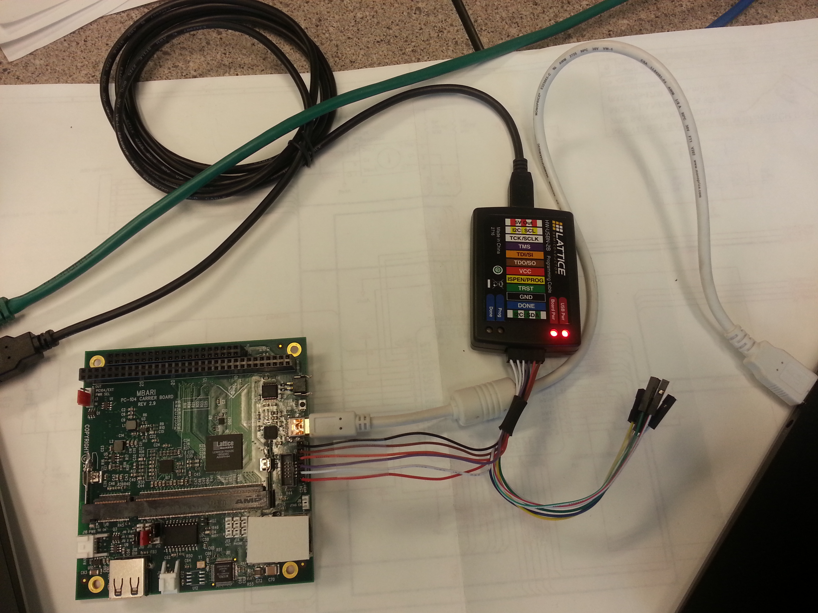
The HW-USBN-2B programming dongle connects to the PC/104 carrier board via a 6 pin header labeled J7 (FPGA). The six pins are to be connected as follows:

[nearest the Ethernet connector]
Pin 1: Vcc
Pin 2: Tclk
Pin 3: TMS
Pin 4: TDI/SI
Pin 5: TDO/SO
Pin 6: GND
[nearest the PC/104 bus connectors]

Programming procedure:

1) Log in (graphically) to the laptop's espdev account
2) Find the graphical Lattice FPGA Programmer launcher icon
This icon is located near the center of the extreme top of the screen. When you hover the mouse over it, the tooltip will display: “FPGA Programmer”

3) Connect the cabling as depicted above:
a) Laptop USB to the FPGA programming dongle
b) Six programming pins between the PC/104 carrier and other side of the programming dongle
c) USB power to the PC/104 carrier

4) Start the FPGA Programmer by clicking ONCE on its launcher icon
The programmer takes about 20 seconds to display anything. Be patient.
You will see a blue light blink a few times on the programming dongle as the programmer starts.

5) Just under the programming application's menu bar, you should see a row of icons.
Hover over each icon until you find the one called “Program”
Press this “Program” icon once.
Programming takes about 1 minute. The blue light will blink rapidly after 30 seconds.

6) Remove the USB and FPGA cables from the PC/104 carrier.

7) Install a new EA3141 SOC module in the DIMM socket
→ proceed to load system software

8) Go to step 3 to program another carrier board, if desired.

