**Programming for Problem Solving**

**Lab Assignments Plan**

|  |  |  |  |
| --- | --- | --- | --- |
| **S.No.** | **Topic** | **No. of Labs** | **Lab Assignment** |
| 1 | Data Type, Expression, Operators: Relational, Logical | 1 | 1. An employee is getting Rs. “B” as basic of salary. Dearness allowance (DA) is 31% of the basic salary. House rent allowance (HRA) is 8% or 16% depends on living city type is non-metro or metro respectively. The employee is also eligible to get 3% of basic as medical insurance premium. Compute the net salary of the employee.  2. The house wall of length “l” and width “w” is need to be tile up with the tiles. There are two types of tiles available; Type 1 having dimension m1 and n1, and Type 2 having dimension “m2” and “n2” as length and width respectively. The cost of one tile of type 1 is Rs. “r1” and type 2 is Rs. “r2”. If the total cost of the tiles is greater than Rs. 30000.00 and less than Rs. 50000.00, a discount of 5% is given. If it’s greater than Rs. 50000.00, 5% more discount is given of the exceeded amount. Compute the total cost of the wall to be tiled up.  3. Four vertices are given as (x1,y1), (x2,y2), (x3,y3) and (x4,y4). Determine whether it is a square or rectangle. Also compute the area of given shape.  4. At the beginning of a journey the reading on a car’s odometer is “S” km and the fuel tank is full. After the reading is “F” km and it takes “L” liters to fill the tank. Write a program to compute the milage of the car. |
| 2 | If else, Loop, Nested loop | 2 | 1.Write a program to generate electricity bill as per following details  i.Unit <=100 charge 0.5 Rs per unit  ii.Unit>100 and <=200 charge 50 + 0.65Rs per unit for more than 100 unit  iii.Unit >200 and <=300 charge 115 Rs + 0.75 Rs per unit for more than 200 unit  iv.Unit >300 and <=500 charge 190 Rs + 0.85 Rs per unit for more than 300 unit  2. Write a program to evaluate following series  S1 = 2+ 4+ 6 + 8 +10………………………..n  S2 = 2 + 4 +8 + 16+ ……………………..n  S3 = n* ( n-1) * (n-2)*…………….1.  3. Write a program to draw following patterns |
| 3 | 1-D, 2-D Array, String | 3 | 1. Write a program to search an element in a given array using linear search and binary search.  2. Write a program to find maximum and minimum value exist in a two dimensional array of size NxN.  3. Write a program to compare the number of vowels and number of consonants occurring in a sentence.  4. Design a program to count the number of words occurring in a sentence and to find the average number of characters in each word. |
| 4 | Function, Recursion, Pointers | 2 | 1. Write a recursive function to generate Fibonacci series up to n terms.  2. Write a recursive procedure to calculate the factorial of given number.  3. Ackermann’s function is defined by :  A(m. n) = n+1 if(m=0)  =A(m-1, 1) if( m!=0 and n=0)  = A(m-1,A(m,n-1)) if ( m!=0 and n!=0)  Write a function that take m and n as input and returns A(m,n). Tabulates the value of A(m,n) for all m in the range 1 to 4 and all n range 1 to 10. |
| 5 | Structure and Class  Constructor | 4 | 1. Define a structure called cricket that will describe following data - player name, country name, number of matches played and batting average. Develop a program the information of 10 cricket players and also display names of player having batting average greater than 50. 2. Define a class to represent bank account including following data members    1. Name of depositor    2. Account number    3. Type of account    4. Balance amount in the account   Member function   1. To assign initial value 2. To deposit an amount 3. To withdraw an amount after checking the balance 4. To display name and balance   Write a main program to test the program.   1. A book shop maintains the inventory of books that are being sold at shop. The list include details such as author title, price, publisher and stock position. Whenever a customer wants a book, the sales person inputs the title and author and the system search the list and display whether it is available or not. If it is not an appropriate message is displayed. If it is then the system displays the book details and request for number of copies required. If the requested copies are available, the total cost of requested copies is displayed, otherwise the message ‘Required copies not in stock” is displayed. Design a system using a class called book with suitable member function and constructor. Use new operator in constructor to allocate memory space required. |
| 6 | Inheritance, Polymorphism | 1 | 1. An educational institutions wishes to maintain a data base of its employee the data bases divided into a number of classes whose hierarchical relationship are shown in figure A. The figure also shows the minimum information required for each class. Specify all the classes and define function to store and retrieve individual information from database as and when required. 2. Consider a class network of Fig. B. The class master derives information from both account and admin classes which in turn derive information from the class person. Define all the four classes and write a program to create, update and display the information contained in master objects. |

Figure A

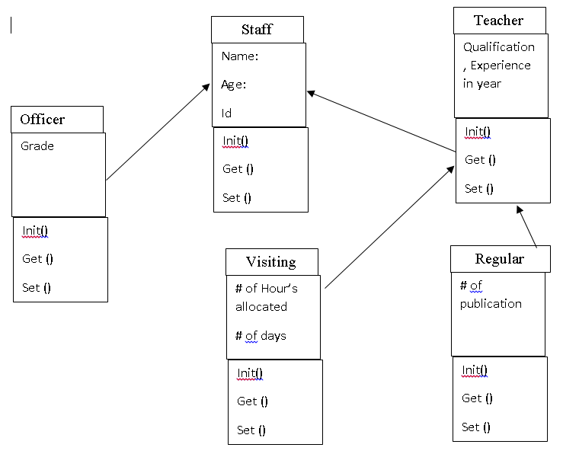

Figure B

Person

:Name

:ID

: ID

Accountant

Admin

:Code

: ID

:Experience

Teacher

:Name

:ID

:Pay

: ID