My process began with choosing a dataset. Once I found one I felt suited the criteria I went about creating pivot tables in Excel and playing around with the data and different fields. My reasoning for this was to see if I could formulate some questions by moving things around and doing some calculations. I came up with a few questions but decided on a final question. I decided to create a bar graph to answer the question. The dataset I chose looked at the math, writing and reading scores of students while also taking into consideration other factors (gender, the type of lunch they receive, etc.). After playing around with the dataset in Excel I decided to use Tableu to create some rough drafts to answer the question I came up with. The question I wanted to answer was to see if there was a difference in the average scores of students who completed the test preparation course and students who did not. I wanted to do this for all 3 test scores. So after calculating the average scores for each test based on whether the students completed the test prep course or not, I decided to move to Tableu. The rough draft I came up with looked like this:

After calculating the scores in excel, I included the average test scores with the category they represented and separated by whether the student took the test prep course or not. I chose a bar chart because I thought it was the best method to visualize the data. My reasoning is since I am measuring the values and wanting to see if there is a difference between them, a bar chart would be most helpful. I thought a good way to show the differences between test scores for students who took the test prep course and those who did not would be by putting the scores of the tests for each group next to each other. What I mean by this is I put the average math scores for both groups next to each other, the average writing scores for the groups next to each other, and so on. I thought this would be a good way to show there is a difference between the two. I used the red fill for bars that have been already scrolled over so the user knows which one they have already looked at, and I used a blue hover for the bar that a person was on currently. This visualization helped me answer the question I had, which was is there a difference in the average scores between students who took the test preparation course and students who did not.

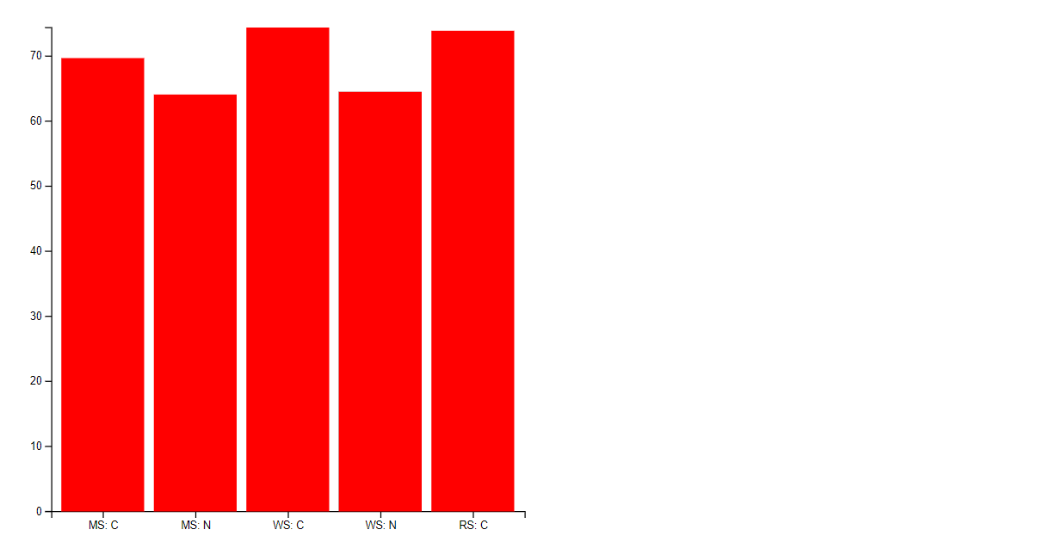

YouTube video link: <https://youtu.be/foUSpQf7bzs>