Masar — Design Note
Backend technical case study — Java / Spring Boot — Maryam D.

ER Diagram
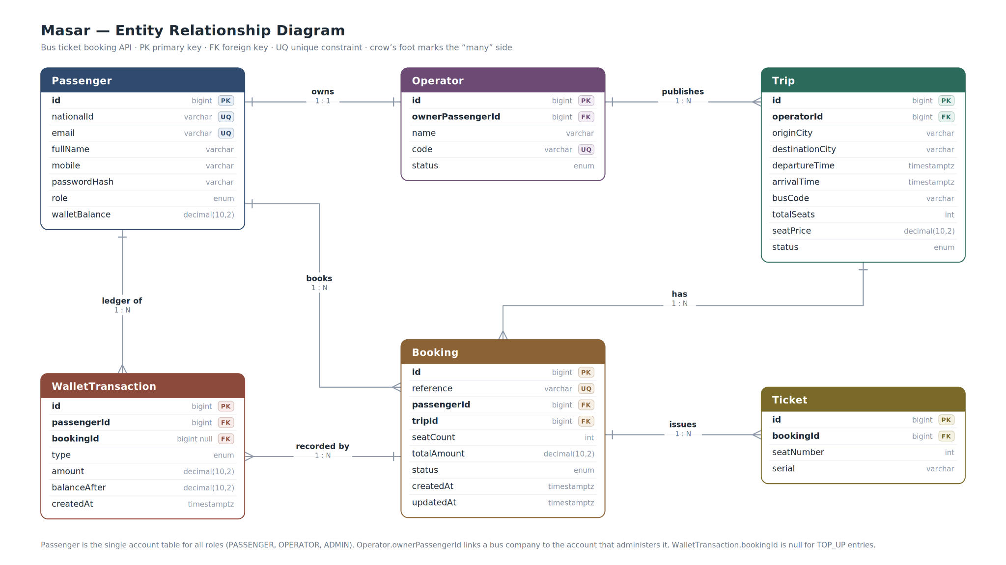
The data model centers on six entities. A Passenger row represents any account — passenger, operator, or admin — distinguished by its role field, and holds the wallet balance used for bookings. An Operator (bus company) is owned by exactly one Passenger account in a 1:1 relationship, enforced by a unique, non-null foreign key, so each operator login manages exactly one company. Each Operator publishes many Trip records (1:N), and each Trip can have many Booking records (1:N), one per passenger reservation. A Booking in turn owns one Ticket per seat reserved (1:N), and every wallet movement — top-ups, debits, and refunds — is recorded as an immutable WalletTransaction tied to a Passenger and, where relevant, to the Booking that caused it (1:N). This structure keeps money movement fully auditable while letting seat availability be computed live from confirmed bookings rather than stored as a separate, driftable counter.

Overbooking Prevention (R1)
Trip does not store an availableSeats column. Instead, available seats are computed live on every read: totalSeats − SUM(seatCount) across all bookings on that trip with status = CONFIRMED. This avoids the classic race between two independent counters (a stored seat count and the actual booking rows) drifting out of sync.
At booking time, the seat check and the booking insert happen inside the same @Transactional method (BookingService.createBooking), and the whole method runs under the JPA/Hibernate connection's transaction isolation. Concurrent requests against the same trip serialize at the database row level through normal transactional locking on the affected rows, so two simultaneous bookings cannot both succeed past the seat check when only one seat remains.

Transaction Boundaries
Booking creation: one @Transactional method covers the seat check, wallet debit, booking insert, one ticket insert per seat, and the wallet ledger entry. If any step fails (including insufficient balance), the entire method rolls back — no partial booking, no orphaned ticket, no wallet change. This directly satisfies R4's "reject and persist nothing" requirement.
Cancellation: one @Transactional method covers the booking status flip, refund calculation, wallet credit, and ledger entry — same all-or-nothing guarantee.
Operator trip cancellation (R7): one @Transactional method iterates every CONFIRMED booking on the trip and cancels + refunds each at 100%, then flips the trip to CANCELLED. All of it commits together or none of it does.

Security Model
- Stateless JWT authentication (jjwt). Token subject is the account's email; passenger/operator/admin id and role are carried as claims.
- Passwords hashed with BCrypt via Spring Security's PasswordEncoder.
- Roles (PASSENGER, OPERATOR, ADMIN) enforced with @PreAuthorize at the controller method level.
- 401 vs 403 are distinguished deliberately: a custom AuthenticationEntryPoint returns 401 when no valid authentication is present at all, while a custom AccessDeniedHandler returns 403 when authentication succeeded but the role or ownership check fails — both wired into Spring Security's exception handling rather than left to the framework default (which returns 403 for both cases).
- Ownership (R8) is enforced separately from role — e.g. a PASSENGER role check alone doesn't prove the booking is theirs, so the service layer additionally compares the resource's owner id to the current authenticated user's id.
- Per R8, a denied ownership check and a genuinely missing resource return the identical 404 response, so a non-owner cannot distinguish "not yours" from "doesn't exist."
- ADMIN cannot be self-assigned through registration; the service layer rejects it explicitly (R10). Admin accounts exist only via the startup DataSeeder.
- A global @RestControllerAdvice maps every exception type (validation, not-found, conflict, unprocessable, access-denied, and an unhandled catch-all) to a single consistent error body — no stack trace, SQL fragment, or internal class name ever reaches the client.

Configuration & REST Compliance
- Refund tiers (24h/2h thresholds and their percentages), the booking cutoff (30 minutes before departure), and seat limits are externalized to application.properties rather than hardcoded in BookingService, injected via @Value.
- Config is split into dev and prod profiles. dev enables the H2 console; prod disables it and requires the JWT_SECRET environment variable with no fallback, so the app refuses to start in prod with an insecure default secret.
- Every @ManyToOne/@OneToOne relationship (Booking→Passenger, Booking→Trip, Ticket→Booking, Trip→Operator, WalletTransaction→Passenger/Booking, Operator→Passenger) uses a deliberate FetchType.LAZY rather than Hibernate's EAGER default for @ManyToOne, avoiding unnecessary eager loading of parent object graphs.
- All 201 Created responses (register, publish trip, create booking, wallet top-up) include a Location header pointing to the created resource.

Assumptions
- One Operator account maps to exactly one bus company (modeled as a unique 1:1 relationship between Operator and its owning Passenger row).
- Seat numbering is assigned sequentially based on how many seats are already confirmed on a trip; it does not track which specific numbered seats were released by a cancellation and re-issue them first.
- The minimum-available-seats trip search filter is applied in the application layer after the paged database query returns, since availableSeats is computed rather than stored — see "What I'd change" below for the trade-off this introduces.
- H2 in-memory database is used for development per the case study's brief; the schema (Flyway migrations) is written in standard SQL and would need only a dialect check to run against a persistent database such as PostgreSQL.

What I'd Change With Two More Weeks
- Make the minSeats trip search filter part of the database query itself (e.g. a derived/native query with a HAVING clause on booked-seat counts) instead of filtering the page's contents in Java, so pagination counts stay exact when the filter is applied.
- Track individual seat numbers as an inventory (e.g. a seat-map table) rather than a running count, so a cancelled seat is precisely released and re-offered, and two passengers are never implicitly assigned the same seat number.
- Add refresh tokens and token revocation, since the current JWT setup has no logout/invalidation path before natural expiry.
- Expand automated test coverage to the controller layer for every endpoint (currently: full unit coverage of the R5/R1 business rules plus two integration tests covering auth rejection and R8), and add tests for R7's cascade cancellation.
- Add rate limiting on the auth endpoints and a password complexity policy beyond the current minimum-length check.

Documented Deviation: Spring Boot Version
The case study specifies Spring Boot 3.x. At the time of this project, Spring Boot 3.x was no longer offered on Spring Initializr, so Spring Boot 4.1.0 was used instead. This surfaced several real migration issues along the way — Spring Boot 4's modular auto-configuration split single-purpose starters like Flyway, Jackson, and MockMvc test support into separate artifacts that had to be identified and added individually — all resolved and documented in the commit history.

AI Assistance Disclosure
This case study was completed as part of a confidential assessment for my new role. No confidential, sensitive, or proprietary information from the case study was shared with Claude (Anthropic).
Claude was used as an AI assistance tool during the development of the solution. Its use was mainly to support coding and debugging, discuss implementation approaches, and assist with resolving technical issues, including Spring Boot dependency and migration issues. Any code suggested or generated through this assistance was reviewed, adapted, and tested by me.
The solution's requirements, architecture, business logic, entity design, transaction boundaries, exception hierarchy, and placement of the R1–R10 business rules were determined by me. I was responsible for understanding the case study, translating its requirements into the implementation, making the design decisions, and verifying that the resulting solution behaved as required.
Claude was also used to assist with writing the README and design note, as my primary focus during the task was implementing and validating the code and business logic. The content of these documents was based on my own implementation, decisions, and understanding of the solution.
For routine development tasks such as generating getters and setters and suggesting/importing libraries, I used IntelliJ IDEA's built-in automation features rather than Claude.
Overall, Claude was used as an assistance and productivity tool, not as the source of the solution. The requirements, logic, design decisions, implementation, and final verification were my responsibility.

