**Exercise 1**

In 250 words or less: In your own words - describe the concept and mechanisms used in inheritance

Inheritance is a mechanism that makes an object acquire all the properties and behaviors of a parent object. This mechanism makes it so that once you instantiate a new object that has a parent class you have to input the same variables as the parent class. On top of that,all of the methods in the parent class are also available in the instantiation.

**Exercise 2**

Write a small program that exemplifies the concept of inheritance. Comment the program accordingly to describe your example. You should use real-life concepts as classes in the program.

**Exercise 3**

Write a program that reads a file with *n* number of strings separated by linebreaks.

The program prints how many words are in the file

**Exercise 4**

The U.S. Census Bureau projects population based on the following assumption:

* One birth happens every 7 seconds
* One death happens every 13 seconds
* The population of the USA is currently: 331,002,651.

Write a program that calculates how the US population are projected to be in 5 years.

Print the growth & sum

**Exercise 5**

In your own words - explain the following program in 250 words or less.

This program is a program that prints 10 random numbers between 0 and 9. The main method of the program has a for loop in it that loops 10 times. Inside the for loop is an integer variable that goes into the generateRandomInteger() method.

This method makes use of the Random class and creates a new random generator. It then returns a random integer between 0 and 9.

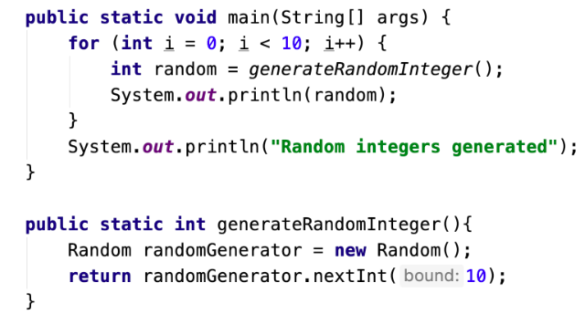

**Exercise 6**

Write a program that constructs an arraylist containing the numbers 1 to 100, and prints them out.

The program ask the user for a number and remove all multiples of that number (except for the number itself) from the list.

* Print the list again.

For example, if the user selects 5, it will remove 10, 15, 20, 25, 30, etc from the list.

**Exercise 7**

In 250 words or less: explain the concept of the "static" keyword. You can use a code example.

The static function is a function you can apply to a variable, method or object. Whatever the static function is applied to can then be accessed by all methods in the given class without using arguments. If you have a static variable in a class, that variable cannot be instantialized in an object. It can instead be used to keep track of how many objects from that class have been instantialized. Once the static keyword is used, exactly one copy is instancialized and shared among all instances of that class.