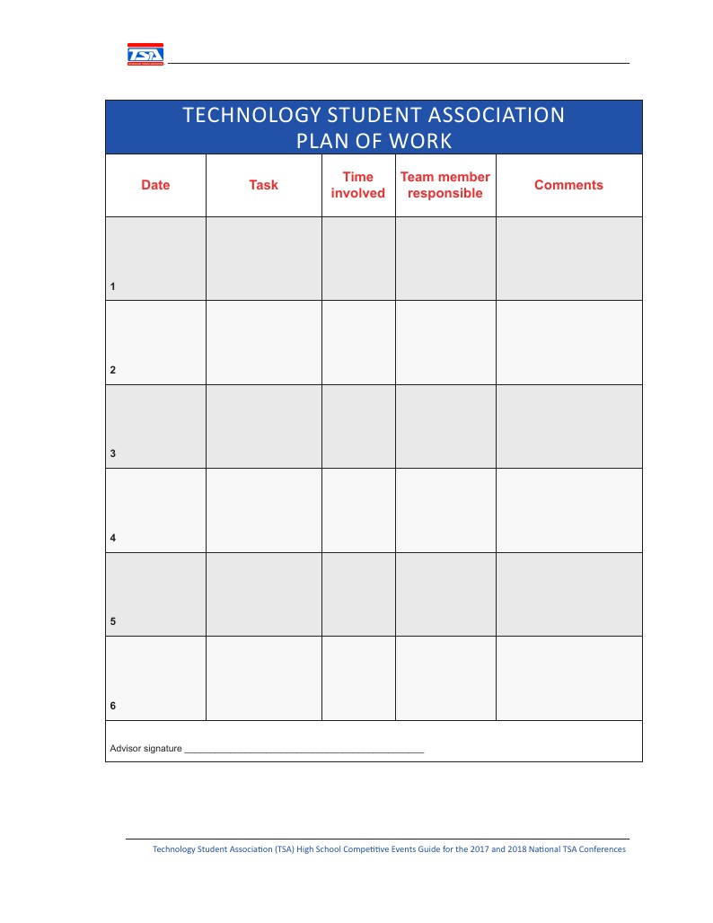

|  |  |  |  |  |
| --- | --- | --- | --- | --- |
| January 2, 2017 | Brainstorming | 1.5 hours | Christian Duffee  Joshua Kim  Thai Nguyen  Jarod Norwood  Nicholas Roth  Sammy Shin | General brainstorming |
| January 9, 2017 | Brainstorming | 1.5 hours | Christian Duffee  Joshua Kim  Thai Nguyen  Jarod Norwood  Nicholas Roth  Sammy Shin | Created a shortlist of project ideas |
| January 16, 2017 | Brainstorming | 1.5 hours | Christian Duffee  Joshua Kim  Thai Nguyen  Jarod Norwood  Nicholas Roth  Sammy Shin | Decided on project idea |
| January 17, 2017 | Brainstorming | 1.5 hours | Christian Duffee  Joshua Kim  Thai Nguyen  Jarod Norwood  Nicholas Roth  Sammy Shin | Developed project idea |
| January 18, 2017 | Brainstorming | 7 hours | Christian Duffee  Joshua Kim  Thai Nguyen  Jarod Norwood  Sammy Shin | Divided up roles and decided specifics of project idea |
| January 23, 2017 | Development | 1.5 hours | Christian Duffee  Joshua Kim  Thai Nguyen  Jarod Norwood  Sammy Shin | Design team shared their progress |
| January 24, 2017 | Development | 1.5 hours | Christian Duffee  Joshua Kim  Thai Nguyen  Jarod Norwood  Sammy Shin | Debated on specifics of database solution |
| January 25, 2017 | Development | 1.5 hours | Christian Duffee  Joshua Kim  Thai Nguyen  Jarod Norwood  Nicholas Roth  Sammy Shin | Design team shared their progress |