Criterion B: Design Overview
Flowchart of a Battle
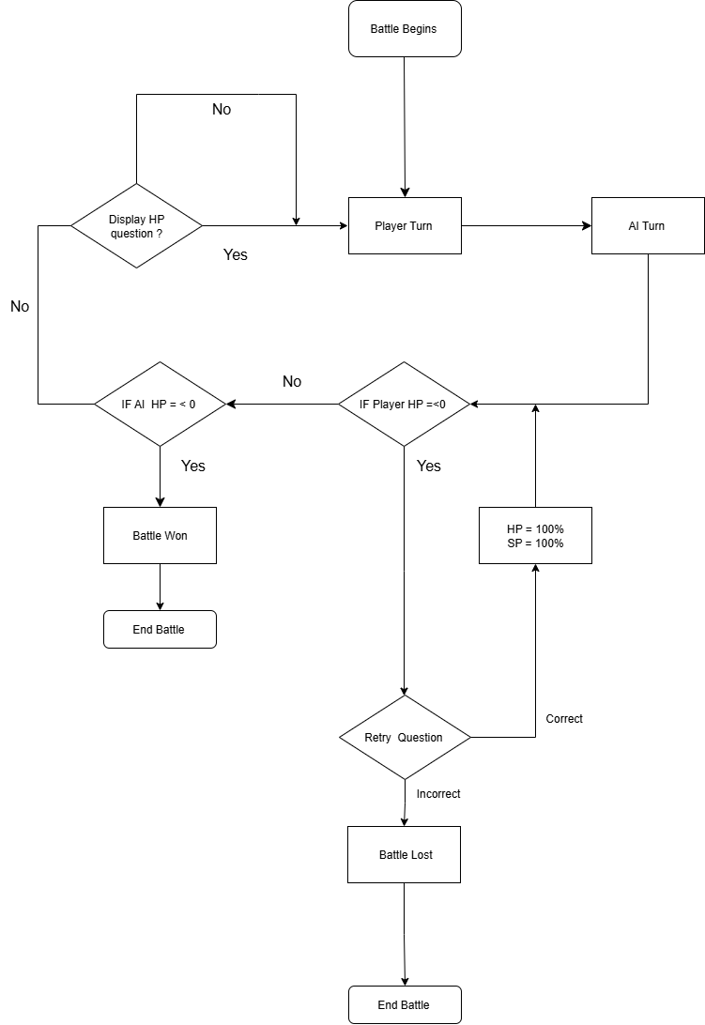
Flowchart of whole game
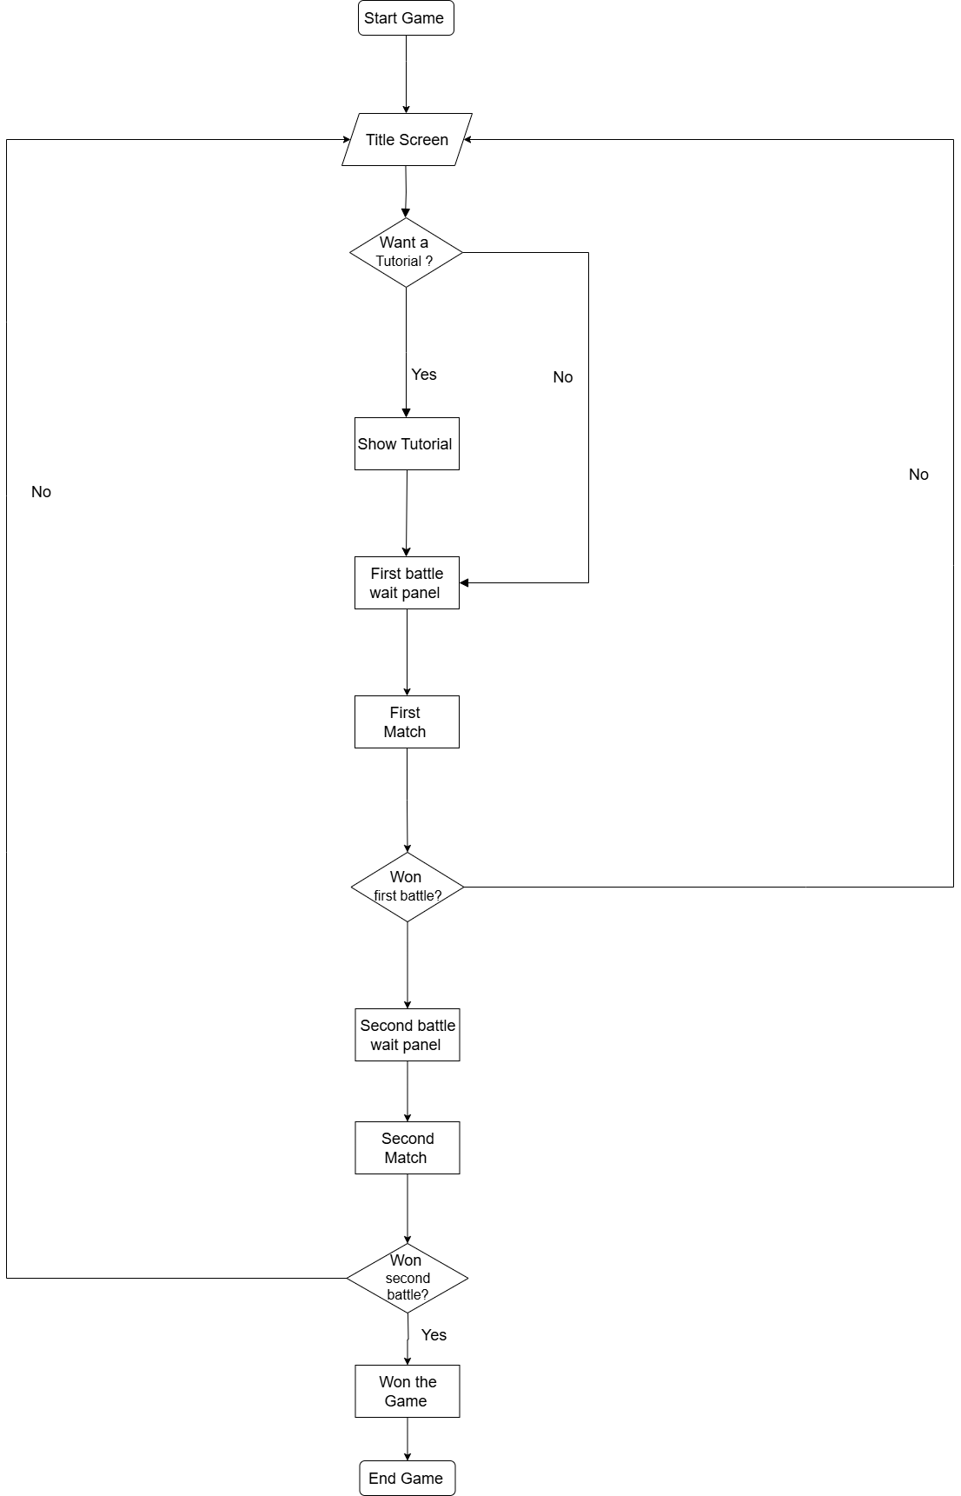

User Interface during a battle
Main UI Panel
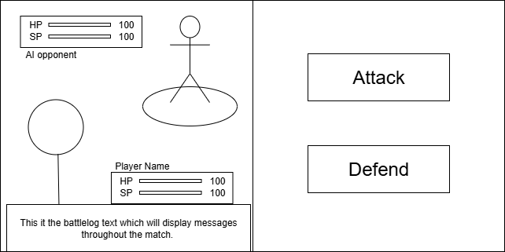

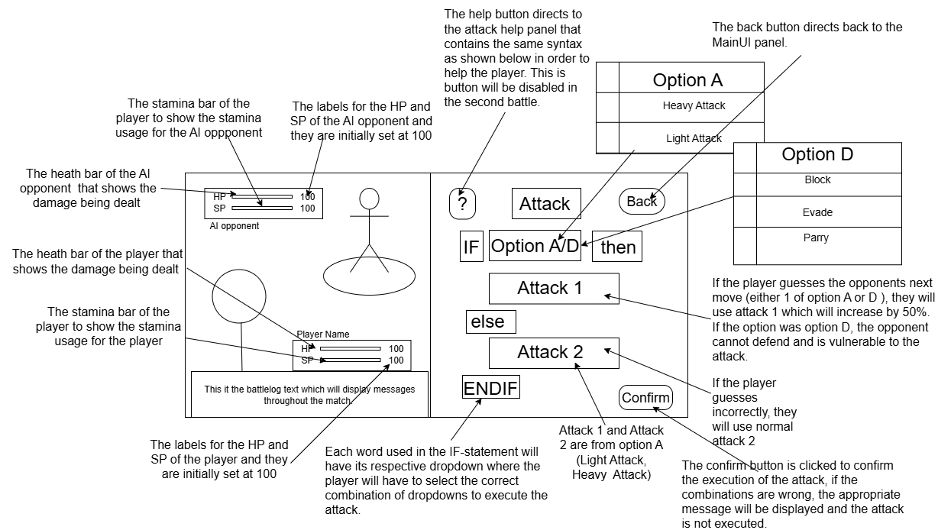
Attack Panel
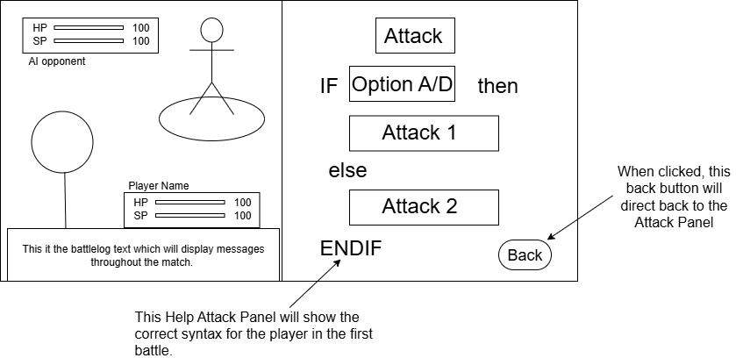
Attack Help Panel
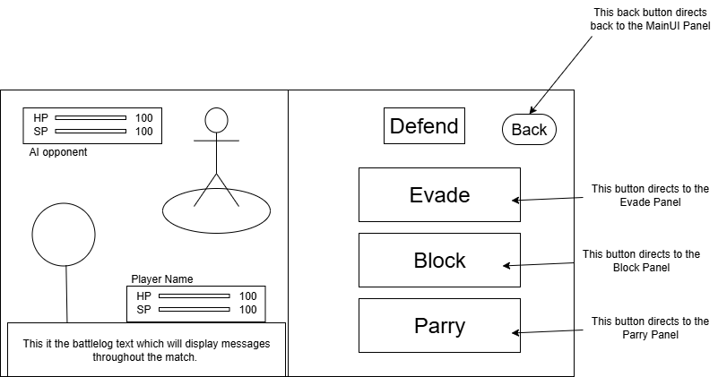
Defend Panel
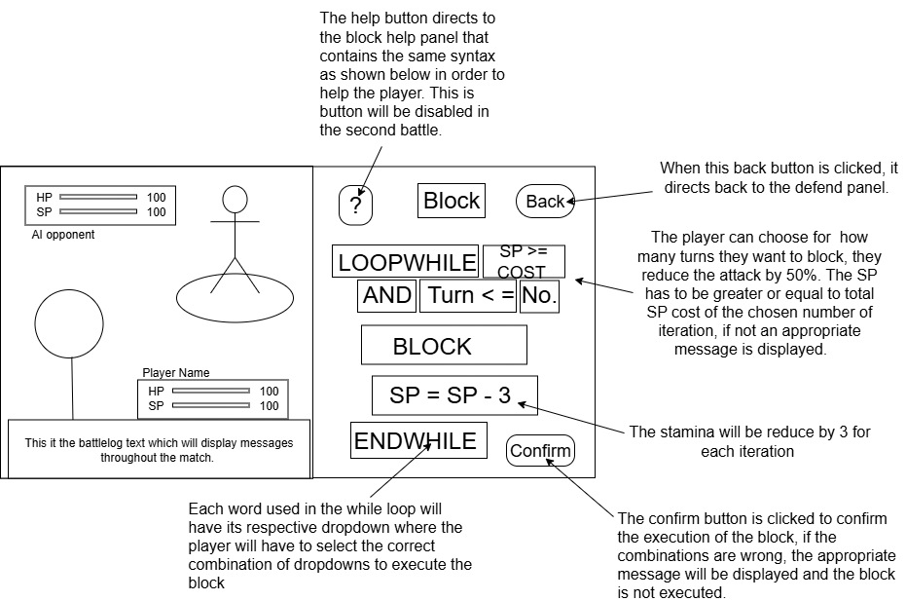
Block Panel
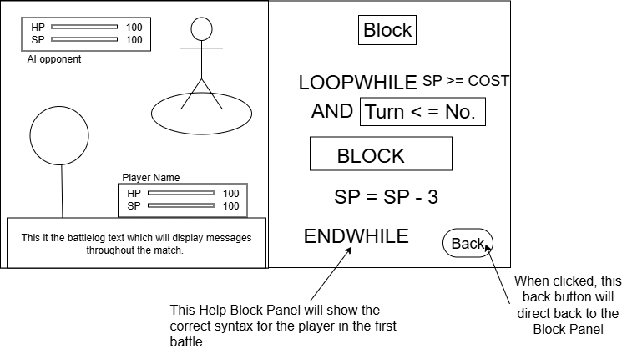
Block Help Panel
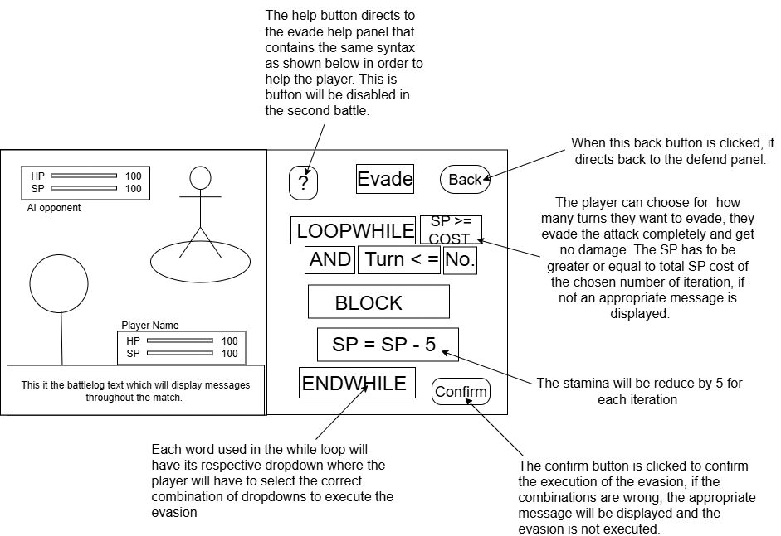
Evade Panel

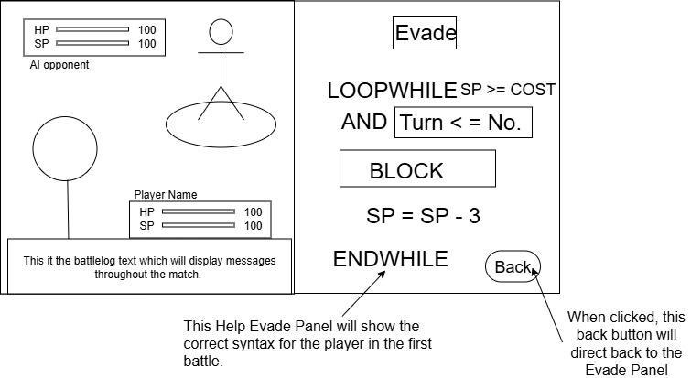
Evade Help Panel
Parry Panel
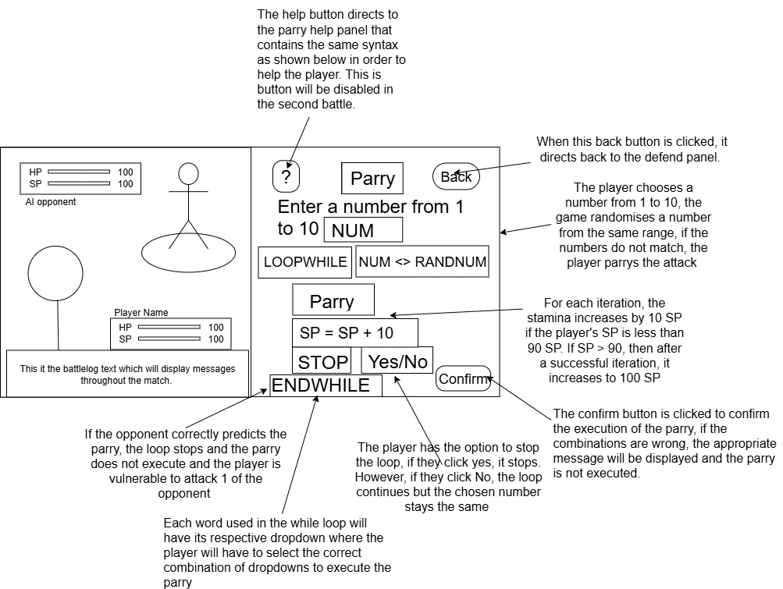
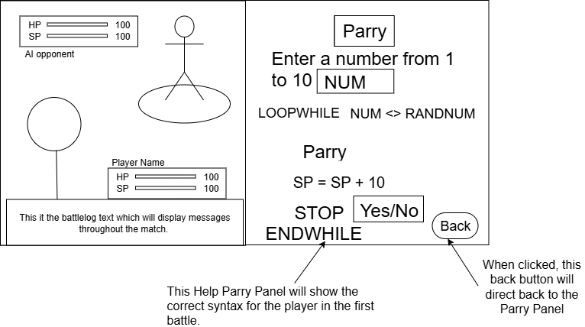
Help Parry Panel

Data Dictionary
The information provided below would be used in the development of these tables in SQLite.
Move
This table is used in the battle for the HP and SP deductions and additions during a battle.
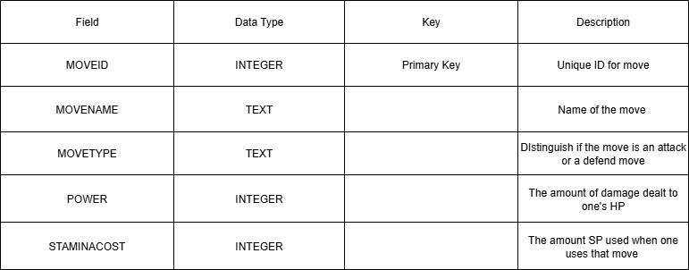
HP Questions
This table would be used for the HP Questions that will randomly appear in between turns.
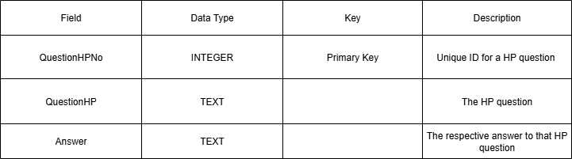

Sample Data Tables
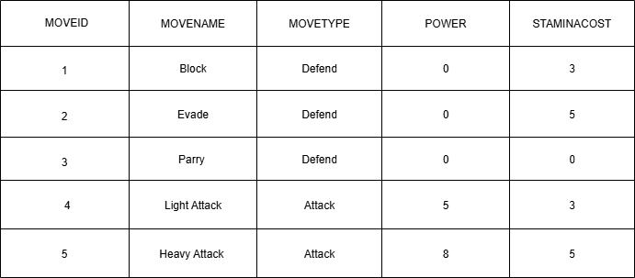
Move
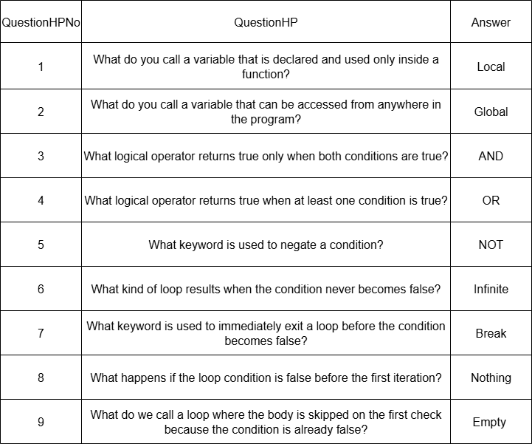
HP Questions
Pseudocode Design
Attack Logic
procedure ConfirmAttack
// Reset flags
set hpQuestionShownThisCycle to false
set AIDefendedThisTurn to false

if gameOver then
return
endif

call LockAttackPanelButtons
call RemoveAttackPanelListeners

// Check if dropdowns form correct logic structure
logicOk = (IFDropdown = "IF" and ENDIFDropdown = "ENDIF" and thenDropdown = "then" and elseDropdown = "else")

if not logicOk then
output "The combinations are wrong, check again."
call UnlockAttackPanelButtons
call AddAttackPanelListeners
return
endif

// Disable attack options
disable HelpAttackButton
disable IFDropdown, ENDIFDropdown, thenDropdown, elseDropdown
disable PlayerChoice, Attack1, Attack2

// Get player choices
prediction = PlayerChoice
atk1 = Attack1
atk2 = Attack2

lastPlayerAttackPrediction = prediction

call UpdateAIMoveAndPrediction

if prediction = currentAIMoveName then
move = atk1
damage = Power of atk1
else
move = atk2
damage = Power of atk2
endif
if playerSP < StaminaCost of move then
output "Not enough SP"
call UnlockAttackPanelButtons
call AddAttackPanelListeners
return
endif
playerSP = playerSP - StaminaCost of move

// AI move resolution
if currentAIMoveName = "Block" then
opponentSP = opponentSP - StaminaCost of Block
if prediction = currentAIMoveName then
bonus =1.5 * damage
opponentHP = opponentHP - bonus
output "AI used Block. Prediction correct! You dealt bonus damage."
else
reduced = 0.5 * damage
opponentHP = opponentHP - reduced
output "AI used Block. You dealt reduced damage."
endif

elseif currentAIMoveName = "Evade" then
opponentSP = opponentSP - StaminaCost of Evade
if prediction = currentAIMoveName then
bonus =1.5 * damage
opponentHP = opponentHP - bonus
output "AI used Evade. Prediction correct! You dealt bonus damage."
else
output "AI used Evade. Attack missed."
endif
elseif currentAIMoveName = "Parry" then
if prediction = currentAIMoveName then
bonus =1.5 * damage
opponentHP = opponentHP - bonus
output "AI used Parry. Prediction correct! You dealt bonus damage."
else
output "AI used Parry. Attack missed."
endif
elseif currentAIMoveName = "Light Attack" or currentAIMoveName = "Heavy Attack" then
opponentHP = opponentHP - damage
output PlayAIAnimation("AI Damage")
AIMove = currentAIMoveName
playerHP = playerHP - Power of AIMove
output PlayPlayerAnimation("Damage Player")
opponentSP = opponentSP - StaminaCost of AIMove
output "Both attacked. Damage exchanged. Prediction outcome shown."
else
opponentHP = opponentHP - damage
output PlayAIAnimation("AI Damage")
output "AI used move. You dealt damage. Prediction outcome shown."
endif
if currentAIMoveName = "Block" or currentAIMoveName = "Evade" then
AIDefendedThisTurn = true
end if

output PlayPlayerAnimation("Attack Player")

// Show AI animations based on move
if currentAIMoveName = "Block" then
output PlayAIAnimation("AI Block")
elseif currentAIMoveName = "Evade" then
output PlayAIAnimation("AI Evade")
elseif currentAIMoveName = "Parry" then
output PlayAIAnimation("AI Parry")
elseif currentAIMoveName = "Light Attack" or currentAIMoveName = "Heavy Attack" then
output PlayAIAnimation("AI Attack")
output PlayPlayerAnimation("Damage Player")
else
output PlayAIAnimation("AI Damage")
endif
call UpdateBars
call CheckWinOrLose
if not gameOver then
output (MainUI Panel or HP Panel)
endif
endprocedure
procedure OpenHelpAttackPanel
if HelpAttackPanel <> null then
HelpAttackPanel.Active = true
AttackPanel.Active = false
endif
endprocedure
procedure CloseHelpAttackPanel
if HelpAttackPanel <>null then
HelpAttackPanel.Active = false
endif
AttackPanel.Active = true
endprocedure
Block Logic
Evade Logic would follow the exact same logic except that the player gets no damage when successfully evading.
procedure ConfirmBlock
// Reset values at the start of a new turn
hpQuestionShownThisCycle = false
AIDEFENDEDTHISTURN = false

if gameOver then
return
endif

call LockBlockPanelButtons
call RemoveBlockPanelListeners

// Check if block syntax dropdowns are selected correctly
logicOk =
LOOPWHILEBLOCKDropdown <> null and LOOPWHILEBLOCKDropdown = "LOOPWHILE" and
ENDWHILEBLOCKDropdown <> null and ENDWHILEBLOCKDropdown = "ENDWHILE" and
SPBLOCKDropDown <> null and SPBLOCKDropDown = "SP >= COST" and
ANDBLOCKDropDown <> null and ANDBLOCKDropDown = "AND" and
TurnDropBLOCKDown <> null and TurnDropBLOCKDown = "Turn <=" and
BlockDropDown <> null and BlockDropDown = "BLOCK" and
SPDeductionBLOCKDropDown <> null and SPDeductionBLOCKDropDown = "SP = SP - 3"

if not logicOk then
output "The combinations are wrong, check again."
call UnlockBlockPanelButtons
call AddBlockPanelListeners
return
endif

// Disable buttons and dropdowns after valid syntax
disable HelpBlockButton, LOOPWHILEBLOCKDropdown, ENDWHILEBLOCKDropdown
disable SPBLOCKDropDown, ANDBLOCKDropDown, TurnDropBLOCKDown
disable BlockDropDown, SPDeductionBLOCKDropDown, blockTurnDropdown

lastPlayerAttackPrediction = ""

// Get number of turns selected by player
turns = blockTurnDropdown

blockMove = GetMove("Block")
totalSPNeeded = blockMove.StaminaCost × turns

if playerSP < totalSPNeeded then
output "Not enough SP to block!"
call UnlockBlockPanelButtons
call AddBlockPanelListeners
return
endif

// Start block cycle for the given number of turns
if defenseCoroutine <> null then
stop defenseCoroutine
endif

defenseCoroutine = start BlockTurnCycleCoroutine(turns, blockMove)
endprocedure

procedure BlockTurnCycleCoroutine(turns, blockMove)
loop currentTurn from 1 to turns do
if gameOver then
exit procedure
endif

playerSP = playerSP - blockMove.StaminaCost

call UpdateAIMoveAndPrediction

if currentAIMoveName = "Block" or currentAIMoveName = "Evade" then
AIDEFENDEDTHISTURN = true
endif

if currentAIMoveName = "Block" or currentAIMoveName = "Evade" or
currentAIMoveName = "Light Attack" or currentAIMoveName = "Heavy Attack" then
AIMove = GetMove(currentAIMoveName)
opponentSP = opponentSP - AIMove.StaminaCost
opponentSP = clamp(opponentSP, 0, MaxSP)
endif

call UpdateBars
output PlayPlayerAnimation("Block Player")

if currentAIMoveName = "Light Attack" or currentAIMoveName = "Heavy Attack" then
output PlayAIAnimation("AI Attack")
aiPredicted = (currentAIPrediction = "Block")

if aiPredicted then
output PlayPlayerAnimation("Damage Player")
endif

elseif currentAIMoveName = "Block" then
output PlayAIAnimation("AI Block")

elseif currentAIMoveName = "Evade" then
output PlayAIAnimation("AI Evade")

else
output PlayAIAnimation("AI Breathing")
endif

if currentAIMoveName = "Light Attack" or currentAIMoveName = "Heavy Attack" then
AIMove = GetMove(currentAIMoveName)
aiPredicted = (currentAIPrediction = "Block")

if aiPredicted then
damage = roundUp(AIMove.Power × 1.5)
playerHP = playerHP - damage
output PlayPlayerAnimation("Damage Player")
call UpdateBars
output "Block " + currentTurn + ": AI used " + AIMove.Name + " (predicted block). You took " + damage + " damage. Block failed."
exit procedure
else
reducedDamage = roundUp(AIMove.Power × 0.5)
playerHP = playerHP - reducedDamage
output PlayPlayerAnimation("Block Player")
output "Block " + currentTurn + ": AI used " + AIMove.Name + ". You blocked, took " + reducedDamage + " damage. Success."
endif
else
output "Block " + currentTurn + ": AI used " + currentAIMoveName + ". No attack. Success."
endif

call UpdateBars
wait logDelay
endloop

output "Block cycle finished. Your turn."
wait logDelay
endprocedure
procedure OpenHelpBlockPanel
if HelpBlockPanel <> null then
HelpBlockPanel.Active = true
BlockPanel.Active = false
endif
endprocedure

procedure CloseHelpBlockPanel
if HelpBlockPanel <> null then
HelpBlockPanel.Active = false
endif
call ShowPanel(BlockPanel)
endprocedure

Parry Logic
procedure StartParry
hpQuestionShownThisCycle = false
AIDEFENDEDTHISTURN = false

if gameOver then
return
endif

call LockParryPanelButtons
call RemoveParryPanelListeners

// Check input is an integer between 1 and 10
if ParryInput is not a number or ParryInput < 1 or ParryInput > 10 then
output "Enter a number from 1 to 10"
call UnlockParryPanelButtons
call AddParryPanelListeners
ParryInput.Interactable = true
return
endif

AIDEFENDEDTHISTURN = false
if gameOver then
return
endif

call LockParryPanelButtons
call RemoveParryPanelListeners

// Validate dropdown syntax
logicOk =
LOOPWHILEPARRYDropdown <> null and LOOPWHILEPARRYDropdown = "LOOPWHILE" and
ENDWHILEPARRYDropdown <> null and ENDWHILEPARRYDropdown = "ENDWHILE" and
PARRYDropDown <> null and PARRYDropDown = "PARRY" and
COMPARISON1DropDown <> null and COMPARISON1DropDown = "NUM" and
COMPARISON2DropDown <> null and COMPARISON2DropDown = "<> RANDNUM" and
SPIncreaseDropDown <> null and SPIncreaseDropDown = "SP = SP + 10" and
STOPDropDown <> null and STOPDropDown = "STOP"

if not logicOk then
output "The combinations are wrong, check again."
call UnlockParryPanelButtons
call AddParryPanelListeners
return
endif

// Lock UI
disable HelpParryButton, LOOPWHILEPARRYDropdown, ENDWHILEPARRYDropdown
disable PARRYDropDown, COMPARISON1DropDown, COMPARISON2DropDown
disable SPIncreaseDropDown, STOPDropDown

lastPlayerAttackPrediction = ""
remainingNumbers = [1, 2, ..., 10]
ParryInput.Interactable = false

remove all YesButton listeners
remove all NoButton listeners
add OnParryYes to YesButton
add OnParryNo to NoButton
YesButton.Interactable = false
NoButton.Interactable = false

if defenseCoroutine <> null then
stop defenseCoroutine
endif

defenseCoroutine = start ParryIteration
endprocedure

procedure OnParryYes
parryDecisionMade = true
parryContinue = false
endprocedure

procedure OnParryNo
parryDecisionMade = true
parryContinue = true
endprocedure

procedure ParryIteration
turn = 1
lastRandomValue = null

loop forever
if gameOver then
exit procedure
endif

call LockParryPanelButtons
call UpdateAIMoveAndPrediction

if currentAIMoveName = "Block" or currentAIMoveName = "Evade" then
AIDEFENDEDTHISTURN = true
endif

AIMove = GetMove(currentAIMoveName)

if AIMove.StaminaCost > 0 then
opponentSP = opponentSP - AIMove.StaminaCost
opponentSP = clamp(opponentSP, 0, MaxSP)
endif

aiMoveMsg = "Parry " + turn + ": AI used " + AIMove.Name
parryFailed = false
parrySuccess = false
resultMsg = ""

// Pick unique random number for this turn
if remainingNumbers.Count = 1 then
randomValue = remainingNumbers[0]
else
do
randomValue = random number from remainingNumbers
while randomValue = lastRandomValue and remainingNumbers.Count > 1
endif
lastRandomValue = randomValue

if AIMove.Type = "Attack" then
isParryFailure = (currentAIPrediction = "Parry") or (randomValue = parryGuess)

if isParryFailure then
parryFailed = true
damageMultiplier = 1.0
failureReason = "(Number matched: " + randomValue + ")"

if currentAIPrediction = "Parry" then
damageMultiplier = 1.5
failureReason = "(AI predicted parry)"
endif

damage = roundUp(AIMove.Power × damageMultiplier)
playerHP = playerHP - damage
output PlayPlayerAnimation("Damage Player")
resultMsg = "Parry failed! " + failureReason + " You took " + damage + " damage."

else
parrySuccess = true
resultMsg = "Parry successful!"

spGain = min(10, MaxSP - playerSP)
if spGain > 0 then
playerSP = playerSP + spGain
resultMsg = resultMsg + " (+" + spGain + " SP)"
else
resultMsg = resultMsg + " (SP full)"
endif

if AIMove.Name = "Parry" then
aispGain = min(10, MaxSP - opponentSP)
if aispGain > 0 then
opponentSP = opponentSP + spGain
resultMsg = resultMsg + " (AI gains " + spGain + " SP)"
endif
endif

remove randomValue from remainingNumbers
endif

else
parrySuccess = true
spGain = min(10, MaxSP - playerSP)
if spGain > 0 then
playerSP = playerSP + spGain
resultMsg = "Parry successful! (+" + spGain + " SP)"
else
resultMsg = "Parry successful! (SP full)"
endif
remove randomValue from remainingNumbers
endif

call UpdateBars
output PlayPlayerAnimation("Parry Player")

if AIMove.Type = "Attack" then
output PlayAIAnimation("AI Attack")
if currentAIPrediction = "Parry" or randomValue = parryGuess then
output PlayPlayerAnimation("Damage Player")
endif
elseif AIMove.Name = "Block" then
output PlayAIAnimation("AI Block")
elseif AIMove.Name = "Evade" then
output PlayAIAnimation("AI Evade")
elseif AIMove.Name = "Parry" then
output PlayAIAnimation("AI Parry")
else
output PlayAIAnimation("AI Breathing")
endif

output aiMoveMsg
wait logDelay

output resultMsg
wait logDelay

if parryFailed then
call EndParryCycle
exit procedure
endif

if parrySuccess then
if remainingNumbers.Count = 0 then
output "Parry cycle finished. All numbers used."
wait logDelay
call EndParryCycle
exit procedure
endif

output "Do you want to continue parrying? Yes = stop, No = continue"
YesButton.Interactable = true
NoButton.Interactable = true
parryDecisionMade = false

while parryDecisionMade = false
wait
endwhile

YesButton.Interactable = false
NoButton.Interactable = false

if not parryContinue then
output "Parry stopped. Your turn."
wait logDelay
call EndParryCycle
exit procedure
endif
endif

turn = turn + 1
endloop
endprocedure

procedure EndParryCycle
ParryInput.Interactable = true
remove all YesButton listeners
remove all NoButton listeners
YesButton.Interactable = true
NoButton.Interactable = true
call UnlockParryPanelButtons
call AddParryPanelListeners
endprocedure

procedure OpenHelpParryPanel
if HelpParryPanel <> null then
HelpParryPanel.Active = true
ParryPanel.Active = false
endif
endprocedure

procedure CloseHelpParryPanel
if HelpParryPanel <> null then
HelpParryPanel.Active = false
endif
call ShowPanel(ParryPanel)
endprocedure

AI Prediction and Selection Logic
procedure UpdateAIMoveAndPrediction
// Initialize list of possible moves AI can afford based on current SP
set possibleMoves to empty list
if opponentSP >= StaminaCost of "Light Attack" then
add "Light Attack" to possibleMoves
endif
if opponentSP >= StaminaCost of "Heavy Attack" then
add "Heavy Attack" to possibleMoves
endif

// Add defend moves only if AI hasn't defended this turn
if not aiDefendedThisTurn then
if opponentSP >= StaminaCost of "Block" then
add "Block" to possibleMoves
endif

if opponentSP >= StaminaCost of "Evade" then
add "Evade" to possibleMoves
endif

// Allow parry only if SP is not full
if opponentSP < MaxSP then
add "Parry" to possibleMoves
endif
endif

// If no moves available, default to "Parry" with no prediction
if Count(possibleMoves) = 0 then
set currentAIMoveName to "Parry"
set currentAIPrediction to ""
return
endif

// Create weighted list of moves to favor "Parry" when SP is low
set weightedMoves to copy of possibleMoves

if opponentSP < 20 and possibleMoves contains "Parry" and opponentSP < MaxSP then
// Add "Parry" once more to increase its chance
add "Parry" to weightedMoves
endif

// Randomly choose AI move from weightedMoves
set currentAIMoveName to random element from weightedMoves

// If AI move is an attack, randomly predict player's move
if currentAIMoveName = "Light Attack" or currentAIMoveName = "Heavy Attack" then
set playerMoves to ["Light Attack", "Heavy Attack", "Block", "Evade", "Parry"]
set currentAIPrediction to random element from playerMoves
else
// No prediction needed for defend moves
set currentAIPrediction to ""
endif
endprocedure
Turn order enforcement (ensuring strict turn-base combat):
procedure NextTurn
if isPlayerTurn then
set isPlayerTurn to false
call AITakeAction
else
set isPlayerTurn to true
call EnablePlayerControls
endif
endprocedure
HP/SP update with clamping:
procedure UpdateBars
// Clamp HP and SP values within valid ranges
set playerHP to Clamp(playerHP, 0, 100)
set playerSP to Clamp(playerSP, 0, MaxSP)
set opponentHP to Clamp(opponentHP, 0, 100)
set opponentSP to Clamp(opponentSP, 0, MaxSP)

// Normalize values (0 to 1) and update slider bars
set PlayerHPBar.value to playerHP / 100
set PlayerSPBar.value to playerSP / 100
set AIHPBar.value to opponentHP / 100
set AISPBar.value to opponentSP / 100

// Update text labels if they exist
if PlayerHPLabel is not null then
set PlayerHPLabel.text to playerHP converted to string
endif

if PlayerSPLabel is not null then
set PlayerSPLabel.text to playerSP converted to string
endif

if AIHPLabel is not null then
set AIHPLabel.text to opponentHP converted to string
endif

if AISPLabel is not null then
set AISPLabel.text to opponentSP converted to string
endif
endprocedure

Transitions between UIs Logic
procedure ResetBattleLogic
// reset state flags and variables
gameOver = false
AIDEFENDEDTHISTURN = false
lastPlayerAttackPrediction = ""
parryGuess = 0
parryDecisionMade = false
parryContinue = false
currentAIMoveName = ""
currentAIPrediction = ""
remainingNumbers = empty list
if defenseCoroutine <> null then
stop defenseCoroutine
endif
defenseCoroutine = null

// restore full HP/SP for both sides
playerHP = 100
playerSP = MaxSP
opponentHP = 100
opponentSP = MaxSP
call UpdateBars

// reset UI controls and listeners
call UnlockAllPanelButtons
call AddAttackPanelListeners
call AddBlockPanelListeners
call AddEvadePanelListeners
call AddParryPanelListeners

// show main UI and set idle visuals
call ShowPanel(MainUIPanel)
call SetBattleUIVisible(true)
call SetPlayerIdle
call SetAIIdle

// reset HP question bookkeeping
call ResetUnusedHPQuestions

// reset help panels' availability depending on battleStage
if HelpAttackButton <> null then HelpAttackButton.interactable = (battleStage = 1) endif
if HelpBlockButton <> null then HelpBlockButton.interactable = (battleStage = 1) endif
if HelpEvadeButton <> null then HelpEvadeButton.interactable = (battleStage = 1) endif
if HelpParryButton <> null then HelpParryButton.interactable = (battleStage = 1) endif
endprocedure

procedure OnFirstBattleNextClicked
battleStage = 1
call ShowPanel(MainUIPanel)
call SetBattleUIVisible(true)
enable and reset player and AI animators to idle
call SetPlayerIdle
call SetAIIdle
output "Battle has started. Fight!"
endprocedure

procedure OnSecondBattleNextClicked
battleStage = 2
call ShowPanel(MainUIPanel)
call ResetBattleLogic
call SetBattleUIVisible(true)
disable help buttons (since battleStage = 2)
call UnlockAllPanelButtons
output "Battle has started. Fight!"
endprocedure

procedure CheckWinOrLose
if gameOver then
return
endif

if opponentHP <= 0 then
opponentHP = 0
call UpdateBars
call HideAllPanels
call ShowPanel(WinPanel)
call SetBattleUIVisible(true)
output "You win!"
gameOver = true

if battleStage = 1 then
start transition to second battle after delay
elseif battleStage = 2 then
start transition to ending after delay
endif

elseif playerHP <= 0 then
playerHP = 0
call UpdateBars
if not gameOver then
hide MainUIPanel if present
call ShowRandomRetryPanel
gameOver = true
endif
endif
endprocedure

procedure TransitionToSecondBattle
wait 10 seconds
hide WinPanel
playerHP = 100
playerSP = MaxSP
opponentHP = 100
opponentSP = MaxSP
call UpdateBars
call ResetBattleLogic
call ShowPanel(SecondBattlePanel)
call SetBattleUIVisible(false)
endprocedure

procedure TransitionToEnding
wait 5 seconds
hide WinPanel
call ShowPanel(EndingPanel)
call SetBattleUIVisible(false)
wait 5 seconds
playerHP = 100
playerSP = MaxSP
opponentHP = 100
opponentSP = MaxSP
call UpdateBars
battleStage = 1
call ResetBattleLogic
call ShowPanel(MainTitlePanel)
call SetBattleUIVisible(false)
endprocedure

procedure RestartGameAfterDelay
wait 5 seconds
hide LosePanel
hide WinPanel
playerHP = 100
playerSP = MaxSP
opponentHP = 100
opponentSP = MaxSP
call UpdateBars
battleStage = 1
call ResetBattleLogic
call ShowPanel(MainTitlePanel)
call SetBattleUIVisible(false)
endprocedure
Retry Panel Logic
procedure ShowRandomRetryPanel
call HideAllPanels
if MainUIPanel <> null then
MainUIPanel.Active = false
endif

panelIndex = random integer from 1 to 6
currentRetryPanel = null

if panelIndex = 1 then currentRetryPanel = RetryQuestion1
elseif panelIndex = 2 then currentRetryPanel = RetryQuestion2
elseif panelIndex = 3 then currentRetryPanel = RetryQuestion3
elseif panelIndex = 4 then currentRetryPanel = RetryQuestion4
elseif panelIndex = 5 then currentRetryPanel = RetryQuestion5
elseif panelIndex = 6 then currentRetryPanel = RetryQuestion6
endif

if currentRetryPanel <> null then
currentRetryPanel.Active = true

trueBtn = find TrueButtonQ{panelIndex}Retry in currentRetryPanel
falseBtn = find FalseButtonQ{panelIndex}Retry in currentRetryPanel

remove all listeners from trueBtn
remove all listeners from falseBtn

add listener to trueBtn that calls OnRetryAnswer(panelIndex, true)
add listener to falseBtn that calls OnRetryAnswer(panelIndex, false)
endif

retryAnswered = false
endprocedure

procedure OnRetryAnswer(questionIndex, isTrueButton)
if retryAnswered then
return
endif
retryAnswered = true

isCorrect = false
if questionIndex = 1 then isCorrect = isTrueButton
elseif questionIndex = 2 then isCorrect = not isTrueButton
elseif questionIndex = 3 then isCorrect = isTrueButton
elseif questionIndex = 4 then isCorrect = not isTrueButton
elseif questionIndex = 5 then isCorrect = isTrueButton
elseif questionIndex = 6 then isCorrect = not isTrueButton
endif

if currentRetryPanel <> null then
currentRetryPanel.Active = false
endif

if isCorrect then
playerHP = 100
playerSP = MaxSP
call UpdateBars
output "Correct! HP and SP restored. Battle resumes."
gameOver = false
call ShowPanel(MainUIPanel)
else
LosePanel.Active = true
output "Incorrect! You lose!"
gameOver = true
start RestartGameAfterDelay
endif
Endprocedure

HP Panel Logic
function ShouldShowHPPanel returns boolean
return random value < 0.2
endfunction

procedure ShowHPPanel
if hpQuestions.Count = 0 then
return
endif

if unusedHPQuestionIndices.Count = 0 then
call ResetUnusedHPQuestions
endif

randIdx = random integer from 0 to unusedHPQuestionIndices.Count - 1
currentHPQuestionIndex = unusedHPQuestionIndices[randIdx]
remove unusedHPQuestionIndices[randIdx]

MainUIPanel.Active = false
HPPanel.Active = true

HPPanelText.text = hpQuestions[currentHPQuestionIndex].QuestionHP
HPPanelInput.text = ""
HPPanelInput.Interactable = true
HPPanelConfirmButton.Interactable = true
hpPanelActive = true

remove all listeners from HPPanelConfirmButton
add listener OnHPPanelConfirm to HPPanelConfirmButton
endprocedure

procedure OnHPPanelConfirm
if not hpPanelActive then
return
endif

hpPanelActive = false
entered = trim(HPPanelInput.text)
correct = trim(hpQuestions[currentHPQuestionIndex].Answer)

HPPanelInput.Interactable = false
HPPanelConfirmButton.Interactable = false

// restore previous HP/SP snapshot
playerHP = hpPanelPrevPlayerHP
playerSP = hpPanelPrevPlayerSP
opponentHP = hpPanelPrevOpponentHP
opponentSP = hpPanelPrevOpponentSP

if entered equals correct (case-insensitive) then
hpToAdd = 0
if playerHP < 100 then
if playerHP <= 90 then
hpToAdd = 10
else
hpToAdd = 100 - playerHP
endif
endif

playerHP = playerHP + hpToAdd
call UpdateBars

if hpToAdd > 0 then
output "Correct! +" + hpToAdd + " HP."
else
output "Correct! HP is already full."
endif

start HideHPPanelAndShowMainUIAfterDelay
else
call UpdateBars
output "Incorrect! The answer was: " + correct
start HideHPPanelAndShowMainUIAfterDelay
endif
endprocedure

procedure HideHPPanelAndShowMainUIAfterDelay
wait logDelay
HPPanel.Active = false
call ShowPanel(MainUIPanel)
endprocedure

procedure ShowMainUIPanelAndMaybeHPPanelAfterDelay
call LockAttackPanelButtons
call LockBlockPanelButtons
call LockEvadePanelButtons
call LockParryPanelButtons

wait logDelay
call ShowPanel(MainUIPanel)
wait one frame

if not hpQuestionShownThisCycle and ShouldShowHPPanel() then
hpQuestionShownThisCycle = true

// save current HP/SP snapshot
hpPanelPrevPlayerHP = playerHP
hpPanelPrevPlayerSP = playerSP
hpPanelPrevOpponentHP = opponentHP
hpPanelPrevOpponentSP = opponentSP

call ShowHPPanel
endif
endprocedure
Test Plan
The test plan below would be used to test the different parts of the system.
Test Case Number | Feature Tested | Test Method | Expected Outcome | Pass Criteria
1 & 2 | Conditional execution of attack or defensive move using correct syntax  (CFS 1 & 2) | Select correct syntax using the dropdowns then press the confirm button.  For Attack, the correct syntax is “IF”, “then” , “else”, “ENDIF”.  For Block, the correct syntax is “LOOPWHILE”, “SP >= COST”, “AND”, “Turn<=”, “BLOCK”, “SP= SP- 3”, “ENDWHILE”.  For Evade, the correct syntax is “LOOPWHILE”, “SP >= COST”, “AND”, “Turn<=”, “EVADE”, “SP= SP- 5”, “ENDWHILE”.  For Parry, the correct syntax is “LOOPWHILE”, “NUM<>RANDNUM”, “PARRY”, “SP= SP+ 10”, “STOP” “ENDWHILE”.  Select incorrect syntax using the dropdowns for each action logic then press the confirm button. | If the dropdown logic is correct, the move executes as intended.  If the dropdown logic is incorrect, the execution stops and the battle log text displays the appropriate message that the combinations are wrong. | The message appears and persists when the confirm button is pressed until the user selects correct syntax.  This feature should be persistent for the Attack, Block, Evade, Parry Panels.
3 | Verifying the HP Panel which appears randomly after AI’s turn. (CFS 3) | Press the keycode ‘Z’ at the beginning of a turn, the HP Panel should appear.  Type the correct and incorrect answers when player HP is full, player HP > 90 and player HP =< 90. | The battle log text displays ‘Correct! +10 HP’ when the answer is correct and the player HP =< 90; this increase should be shown in the player HP bar and its respective label.  The battle log text displays ‘Correct! + (Number< 10) HP’ when the answer is correct and the player HP > 90; this increase should be shown in the player HP bar and its respective label.  The battle log text displays ‘Incorrect! The answer was: (Answer)’ when the answer is incorrect and the player HP should remain the same and should be shown in the player HP bar and its respective label. | The HP Panel should be able to distinguish if the answer is correct or incorrect.  The increases in HP would only occur when the answer is correct and HP is not full.
4 | Guided tutorial video displays only upon player’s confirmation prior to the first battle beginning.  (CFS 4) | Start up the game, then click on “Yes” on the tutorial question.  Start up the game again then click on “No” on the same question. | When “Yes” is clicked, the tutorial video plays before the first battle wait panel.  If “No” is clicked, the tutorial is skipped and the player is directed to the first battle wait panel. | Only when "Yes" is chosen does the tutorial show; otherwise, the game continues without it.
5 | The retry panel appears when the player has 0 HP where the outcome is dependent on the latter’s response.  (CFS 5) | Press the keycode ‘Q’ to make the player HP decrease to 0 and answer the retry panel correctly.  Repeat the same steps and answer it incorrectly. | When answered correctly, the player's HP and SP are restored and the battle resumes.  If answered incorrectly, the lose panel should appear and after a few seconds, the game restarts. | The game resumes with the player's restored HP and SP if the response is correct; if not, it ends.
6 | When successful, the Parry iteration awards SP and only accepts integers within a predetermined range.  (CFS 6) | Enter valid/invalid number during parry.  After a successful iteration, press “Yes” to stop the parry cycle.  After another iteration, press “No” to move to the next iteration. | If input is invalid, the battle log text displays the message "Enter 1-10 to parry”.  If the input is valid, the parry would be executed given that the randomise number mismatches with the player’s input number and the AI opponent did not predict that the player would parry when the former is attacking.  A successful iteration would increase SP if SP is not full.  When “Yes” is pressed, the parry cycle should stop and direct back to the MainUI panel. When the “No” button is pressed, it should move to the next iteration. | Only inputs between 1 and 10 are used for iteration, and SP only rises when the parry conditions are met.
7 | Validating player’s moves based on whether their SP is sufficient.  (CFS 7) | Press the keycode ‘/’ and attempt to execute attack, evade, block or parry. | The move cannot be executed and the battle log text displays that the player’s SP is insufficient. | The game appropriately blocks movement and gives textual feedback.
8 | The player and AI use the same prediction-based attack logic including defensive interruptions and damage multipliers. (CFS 8) | Force scenario where both player and AI make correct or incorrect predictions to verify any successful defend moves interruptions. | If prediction is correct, the attack1 increases by 1.5 and if a defend move is used against, it does not work and the latter is prone to the increased attack.  If the prediction is incorrect, the attack2 is executed normally and if a defend move would be successful against the attack. | Depending on defensive conditions and predictions, the game appropriately assigns damage multiplier or cycle interruption.
9 | During the first combat, help buttons direct to the appropriate syntax guides of correspondent panels.  (CFS 9) | Start the first battle, and click on the help buttons for its respective panels.  Check if the buttons are disabled in the second battle. | The help buttons should be interactable and should direct to its respective syntax in the first battle only.  The help buttons should not be interactable in the second battle. | During the first battle, the attack, block, evade and parry panels have operational help buttons.
10 | The player takes action before the AI opponent, maintaining a turn-based structure.  (CFS 10) | Monitor a couple of turns in a battle. | AI responses are always handled after player action. | The combat system in the game follows a rigid player-first turn structure.
11 | Verifying the labels of the SP and HP for both the player and the AI opponent are correctly reflecting corresponding HP and SP bars.  (CFS 11) | Trigger changes in HP and SP for both AI and player using “Q”, “W”, “Z” keys or by playing the game normally | UI bars and labels dynamically change to show the updated HP and SP values and these changes are based on the Power and StaminaCost in the Move table. | The values of the underlying variables are consistently matched by all visible indications and the calculations are coherent with the database.

