Criterion C: Development
Introduction
This document describes the development process of this turn-based battle system game which enables the player and an AI opponent to engage in strategic combat using attack, block, evade and parry.
Language & Tools used
Language: C#
Environment: Unity (2021 +), Visual Studio 2022, DB Browser for SQLite
Justification: The interactive UI, animations, and database integration that are crucial to the requirements of this project are effectively supported by Unity and C#. Every feature was thoughtfully designed to demonstrate object-oriented programming and complex logic structures through Unity’s engine whilst meeting the required success criteria.
Libraries:
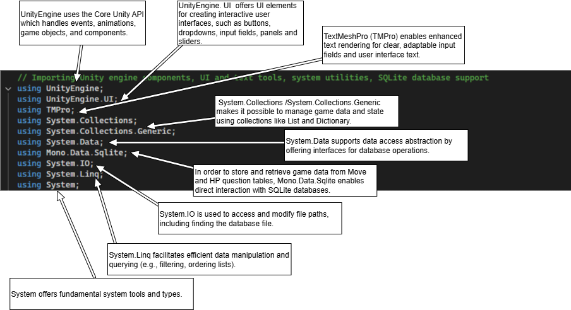

System Architecture
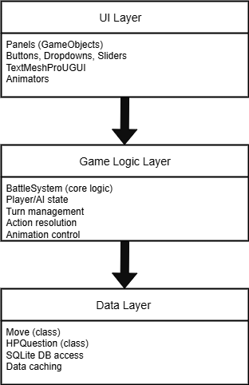

UI Layer: Manages all UI components, such as panels, buttons, dropdown menus, sliders, and character motions and gets input from the player and shows the state of the game.
Game Logic Layer: contains the main BattleSystem class, which controls the game's mechanisms, player/Al status, turn flow, and action consequences and serves as the intermediary between data and UI.
Data Layer: Handles persistent data that is loaded from the SQLite database and mapped to C# classes, such as move definitions and HP questions.

Key Features and Techniques used
Object-Oriented Programming (OOP): Classes and Objects
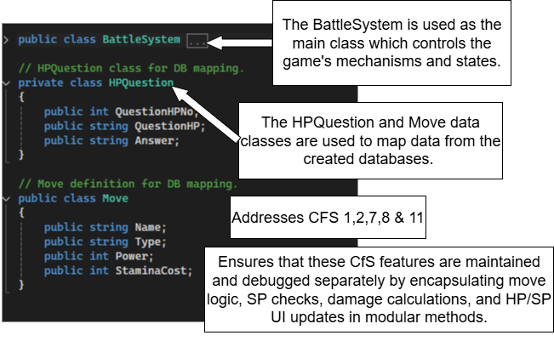
Classes (BattleSystem, Move, HPQuestion) and objects are used to maintain modularity by encapsulating related data and behaviors (C# OOP).

Each method (C# Methods) in the BattleSystem class carries out a single, well-defined task thus making it easier to maintain, expand and debug the code.

Unity Coroutines
In order to handle asynchronous turn-based flows, such attack, block, and parry cycles, Unity Coroutines enable sequential player and AI action execution without causing the main thread of the game to freeze (Write and run coroutines). E.g. The Block cycle uses this:
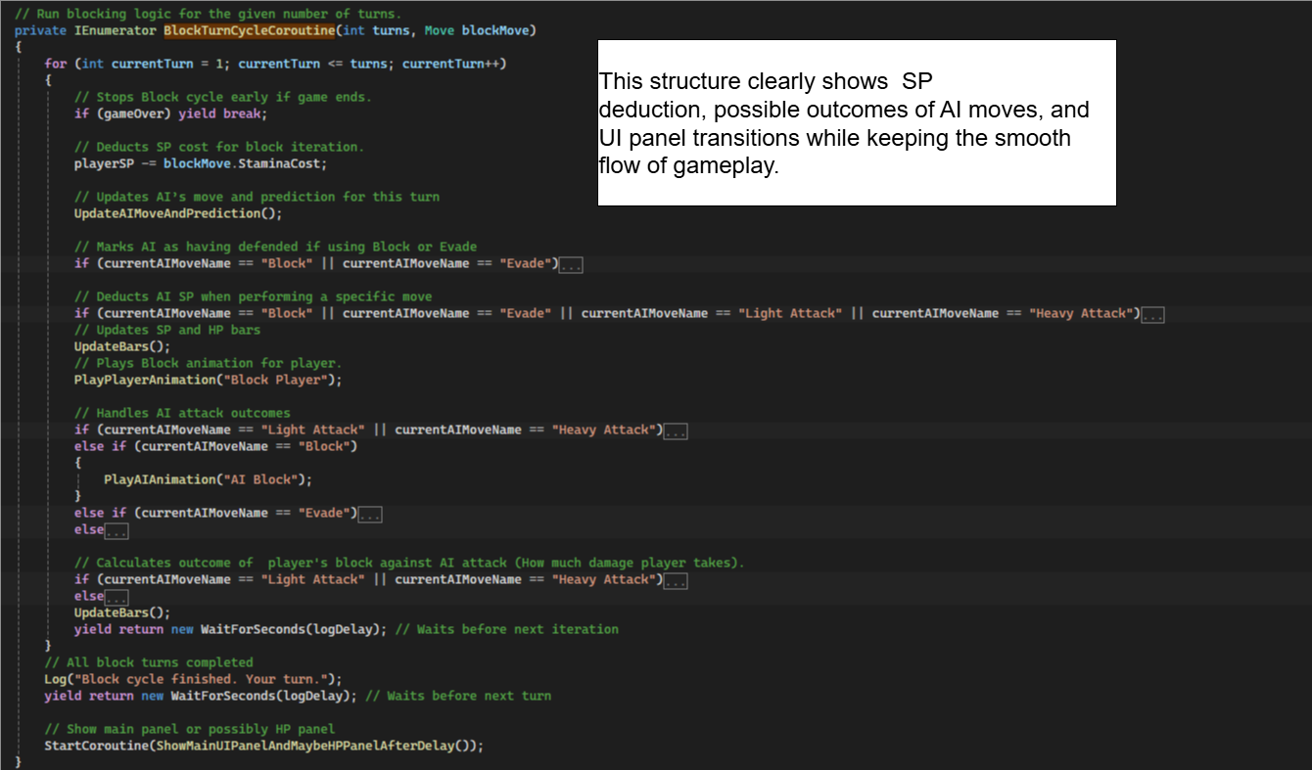
The main battle flows have a clear algorithmic structure by handling all possible move outcomes (Block, Evade, Parry, and Light/Heavy Attack) using for loops along with nested if-else statements (C# If Else); enabling branching.
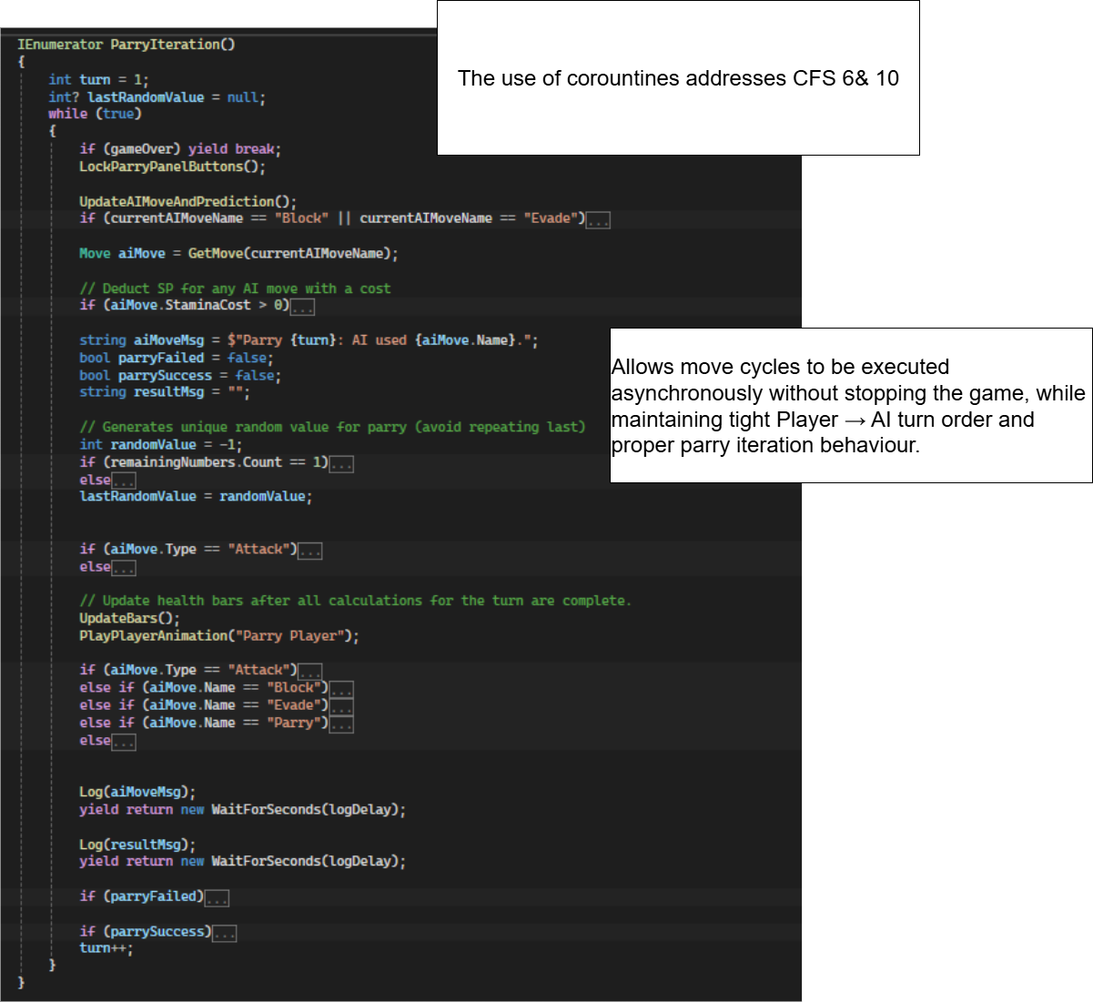
Coroutines for cycles control avoids the need of using inconsistent ad hoc delays, as the code intentionally designs asynchronous algorithms by iterating over a certain number of turns and yielding in between each iteration.
Event-driven UI state management & Input Validation
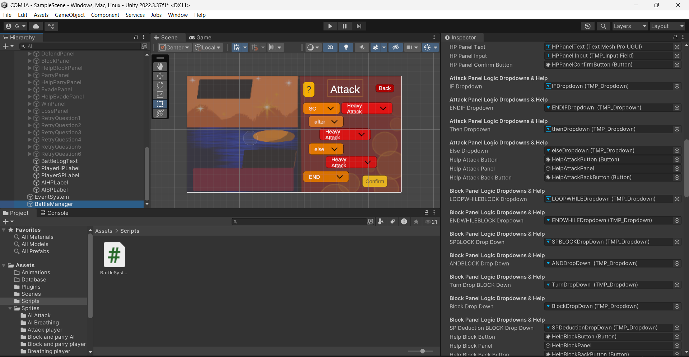
Includes locking and unlocking of dropdowns during a move execution which is based on syntax validation of the dropdowns. As shown below, buttons, input fields panels and dropdowns for the UI (Get started with UI Toolkit) were assigned to the BattleSystem script through the BattleManager (main controller object) as shown in the Inspector.

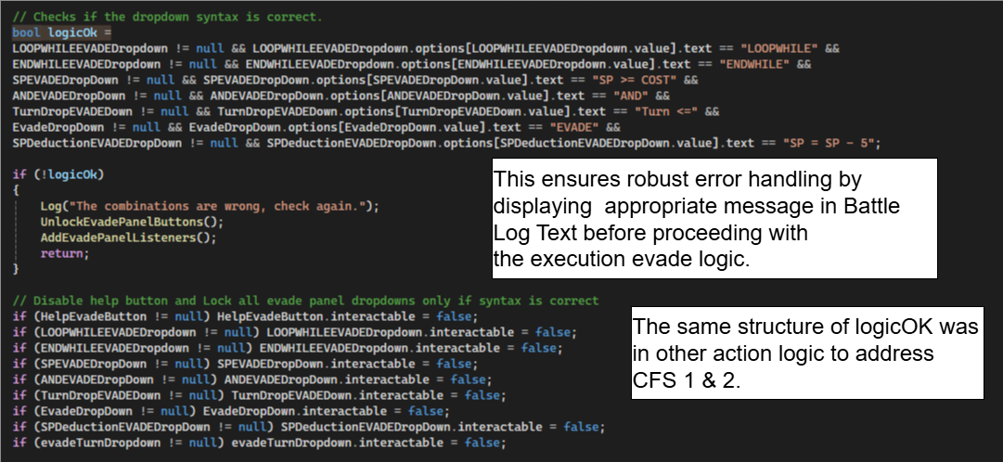
Once the player's syntax has been verified, the buttons and dropdowns on each move panel (Attack, Block, Evade, and Parry) are locked to prevent invalid interactions. An instance of the code for syntax checking for Evade is as follows:
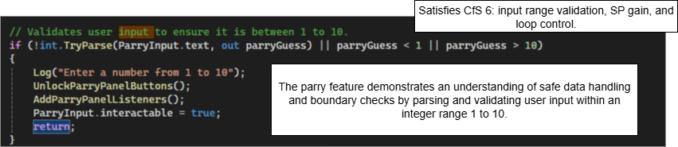
Another instance of input validation is used in the Parry Cycle when the player inputs a number from 1 to 10.
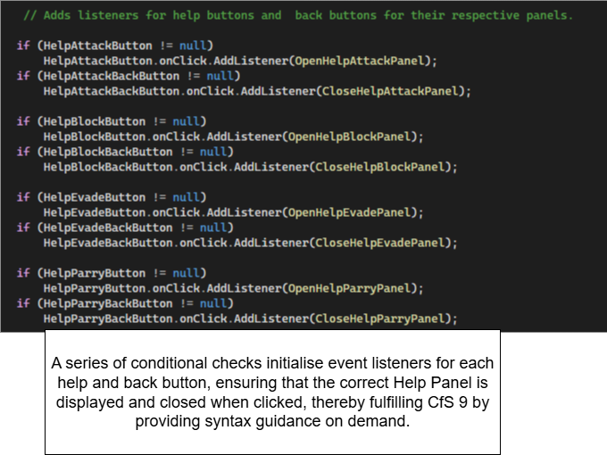
Other instances of event-driven UI state management can be seen for the help buttons and guided tutorial :

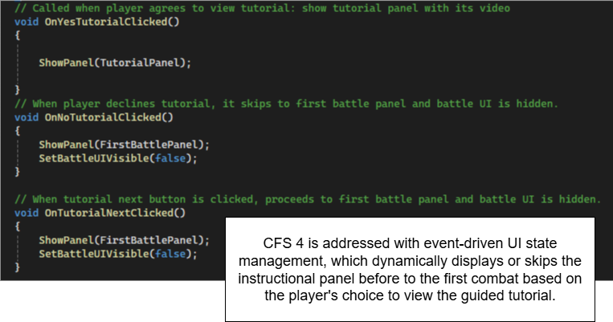
By guiding the player through valid combat logic , event-driven UI state management and input validation ensure that the UI reacts to player interactions in a dynamic and accurate manner, lowering the possibility of invalid inputs and avoiding logical errors during gameplay.
Data-driven design & decision- making
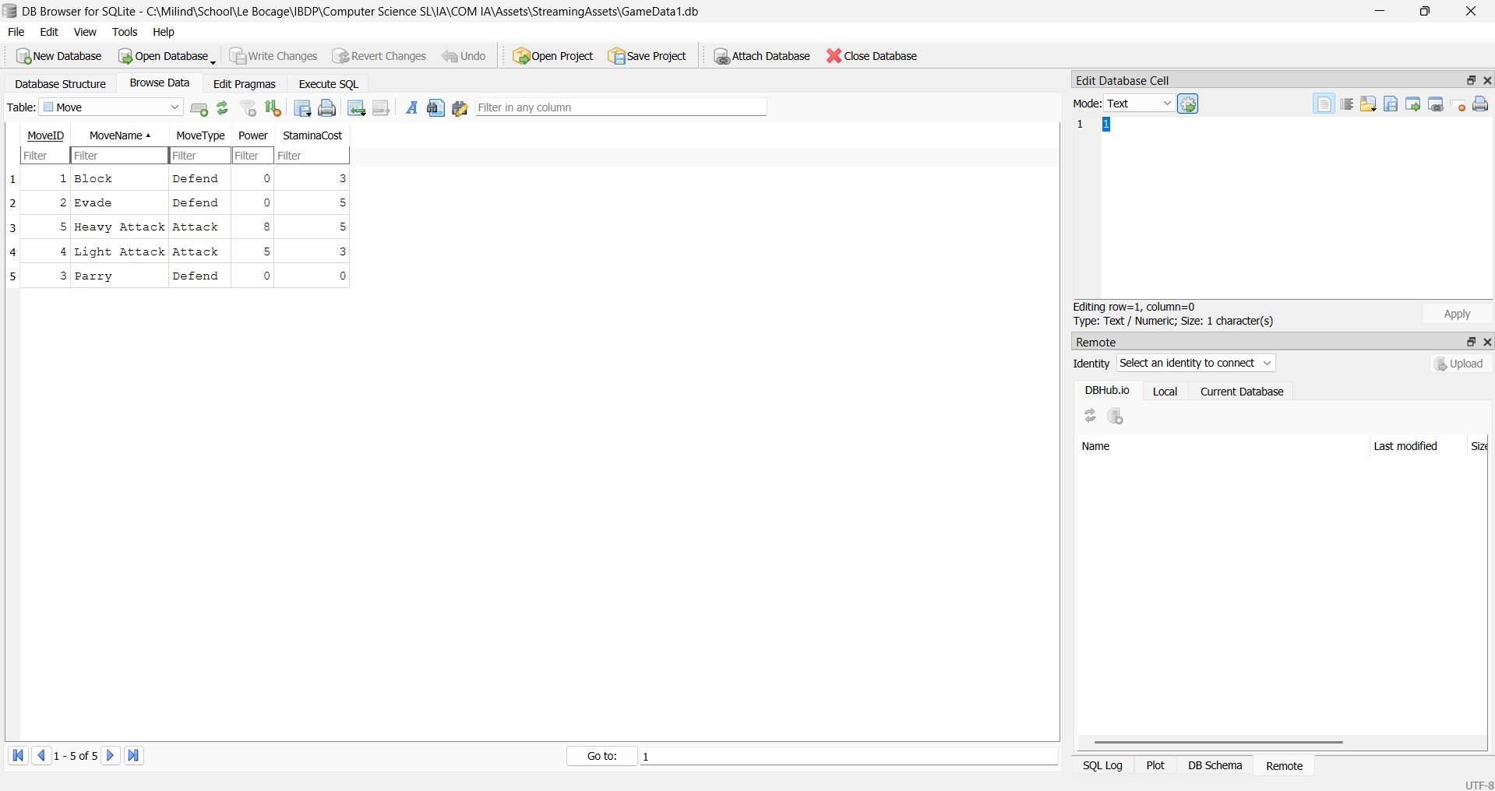
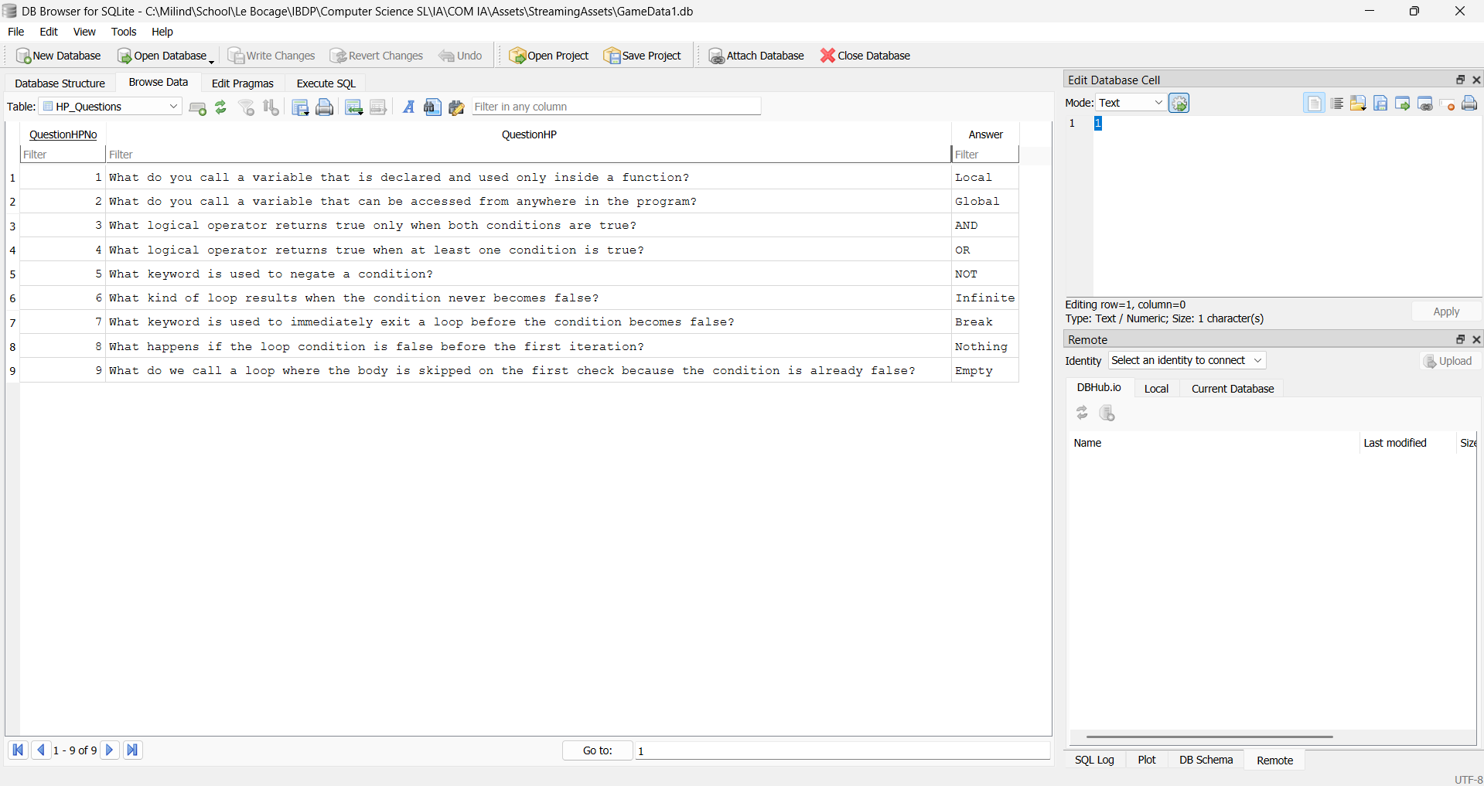
This is where external data controls game behaviour and content. The SQLite (SQLite) Move and HP Question Tables were created using the Unity plugin of DB Browser for SQLite as shown (Hayter):
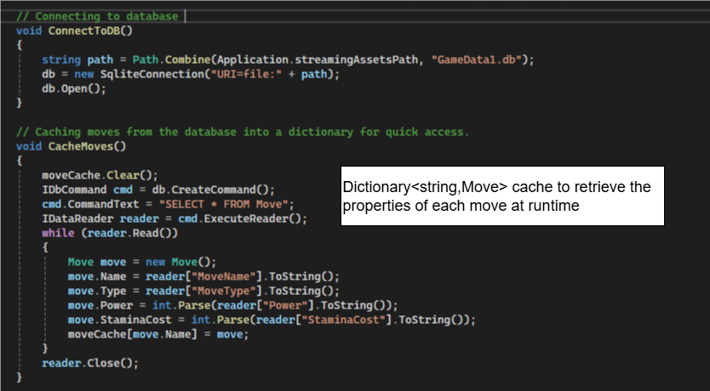
An instance of caching data into a dictionary can be seen below (C# Methods):

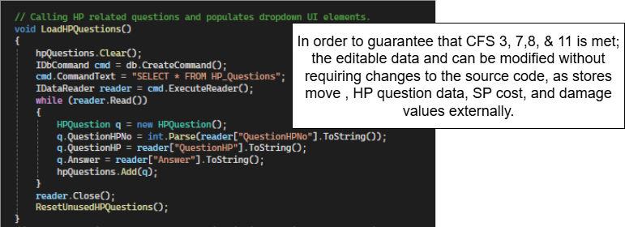
Hence allowing stamina cost and damage of moves to be driven entirely by external data. The same logic is used in HP Questions. Retrieving a move is as follows:
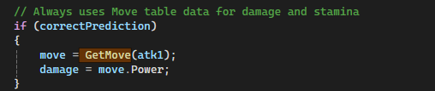
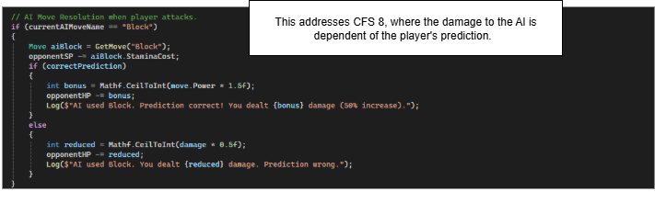
Pertaining to moves, branching logic driven by runtime data comparisons is demonstrated with conditional damage calculations (normal damage or bonus/reduced damage) based on prediction accuracy as shown in an instance of the Attack Logic :
Data-driven design & decision- making separates game balance from code, simplifying updates to move and HP Questions parameters via the database, and allowing easier modification and testing gameplay values without touching the source.
LINQ & Randomisation
LINQ manipulates collections in order to handle UI collections in a clear and effective manner. For example, it is used to shuffle dropdown choice lists using OrderBy with a random key (Language Integrated Query (LINQ)).
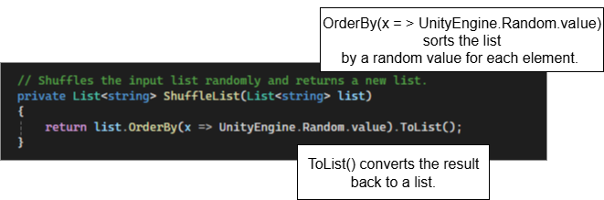
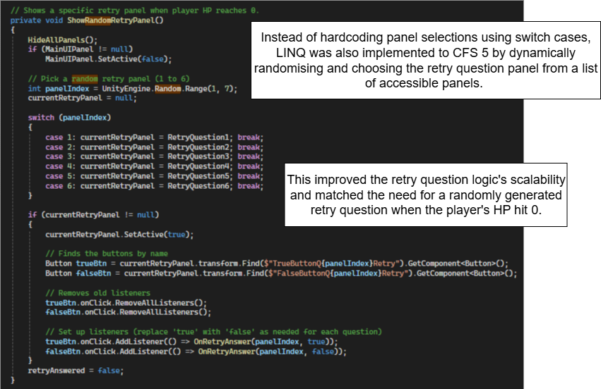
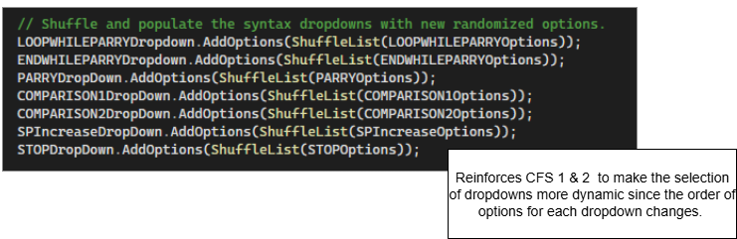
This is then called to shuffle the options of the syntax dropdowns for each action panel. An example for Parry is shown:

This makes use of built-in.NET features in order to provide effective randomisation without the need for manual index switching.

Animation Control
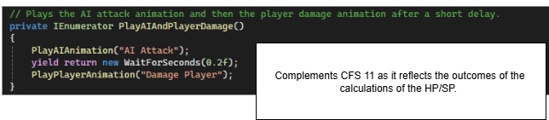
Following each turn resolution, animations are started based on the result of chosen moves (How to animate 2D characters in Unity 6):

These calls improve the user experience by coordinating visual feedback with game events.
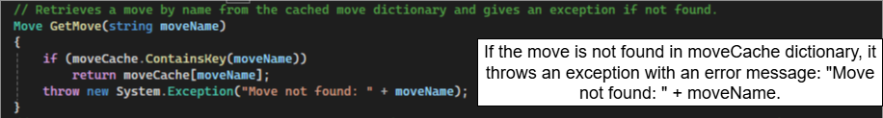
Error handling and logging
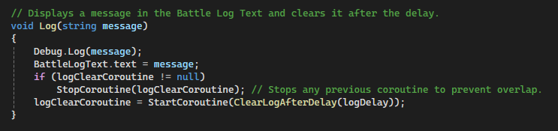
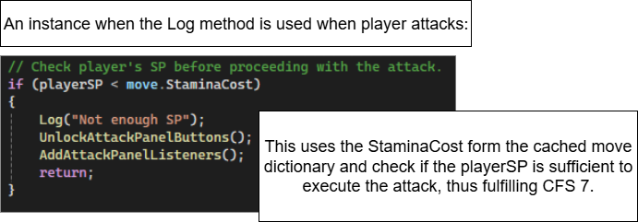
This is a type of error handling since it gives a clear description of what went wrong and stops the application from continuing with invalid data (C# Exceptions).
The Log method (C# Methods) outputs messages to both the Unity console and the in-game UI.
This technique creates code that is simpler to use, maintain, and debug by combining strong error handling with efficient logging. It gives players clear messages and helped me in the early detection of problems.

Iterative Testing and Debugging Process
The Game view (The Editor interface) was utilised for iterative testing of each panel and action logic separately to make sure the entire game worked as expected and that all interactions, transitions, and mechanisms behaved correctly.
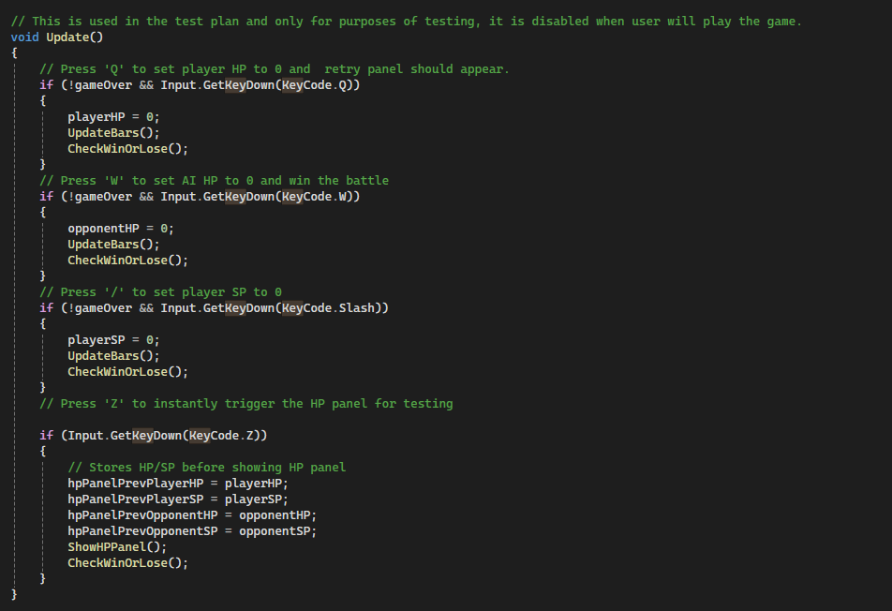
This was used to facilitate testing and debugging to ensure that all CFS were met and the game was working as intended.
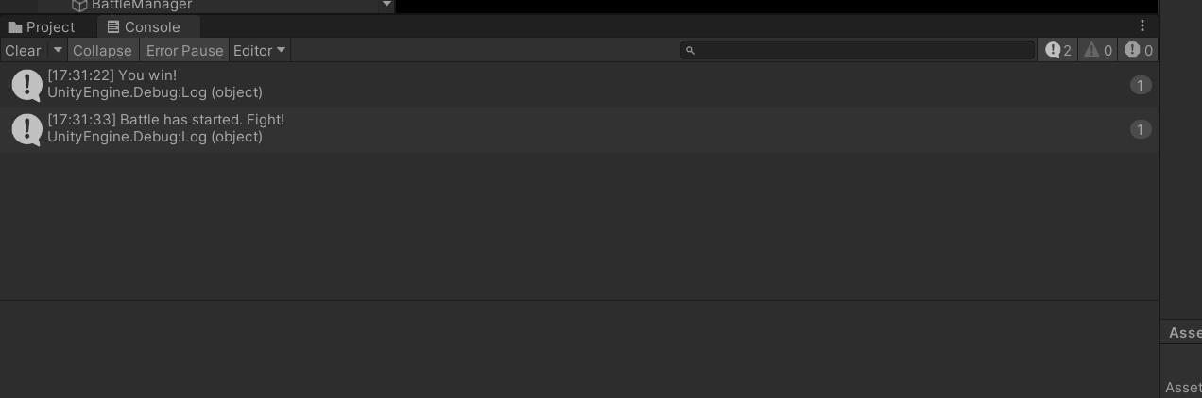
For debugging, the Debug.Log (message) used trace outputs. ChatGPT was used to understand error messages displayed in the Unity Console (The Editor interface) when the game contained bugs (ChatGPT).
Reflection
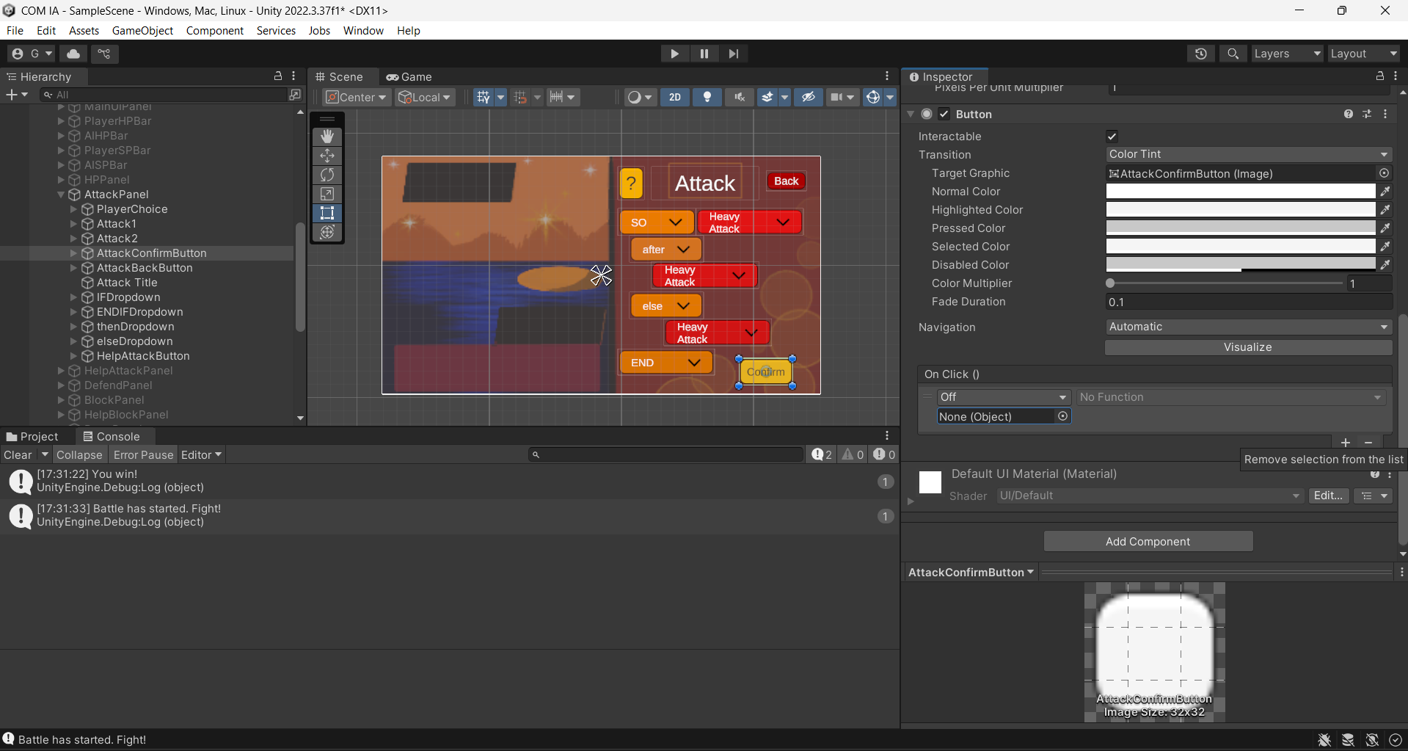
One major difficulty faced was that the HP and SP calculations were not coherent with the values of the StaminCost and Power in the Move Table. After some weeks of debugging, the solution was to simply remove an On Click function in the confirm buttons in Unity Editor (The Editor interface) which was doubling the execution of a move.
In conclusion, the process of coding was effective in allowing The game to implement database-driven moves & HP question data, a dynamic user interface, and algorithms for combat to produce an entertaining and instructive gaming experience.

References

"C# Exceptions - Try..Catch." W3Schools, www.w3schools.com/cs/cs_exceptions.php.
"ChatGPT." ChatGPT, chatgpt.com/?model=auto.
"C# If Else." W3Schools, www.w3schools.com/cs/cs_conditions.php.
"C# Methods." W3Schools, www.w3schools.com/cs/cs_methods.php.
"C# OOP." W3Schools, www.w3schools.com/cs/cs_oop.php.
"The Editor interface." Unity Documentation, docs.unity3d.com/Manual/unity-editor.html.
"Get started with UI Toolkit." Unity Documentation, docs.unity3d.com/Manual/UIE-simple-ui-toolkit-workflow.html.
Hayter, Michael. "Unity & SQLite: Quick Start Guide (Part-1)." Medium, Apr. 2021, michaelhayter.medium.com/unity-sqlite-quick-start-guide-part-1-8cba7ed22b9a.
"How to animate 2D characters in Unity 6." Unity Discussions, 14 May 2022, discussions.unity.com/t/how-to-animate-2d-characters-in-unity-6/1642950.
"Language Integrated Query (LINQ)." Microsoft, Dec. 2023, learn.microsoft.com/en-us/dotnet/csharp/linq/.
"SQLite." Mono, www.mono-project.com/docs/database-access/providers/sqlite/.
"Welcome to Unity Learn." Learn, learn.unity.com/.
"Write and run coroutines." Unity Documentation,docs.unity3d.com/Manual/Coroutines.html.

