Design and Development of an Automated IUPAC Nomenclature Generator Using Rule-Based Molecular Formula Validation

Authors
Mohan Bhatt
Department of Computer Science
FSCP-1 Semester 3 Project

Abstract
Chemical nomenclature plays a crucial role in chemistry education, research, and industrial documentation. Manual identification of International Union of Pure and Applied Chemistry (IUPAC) names from molecular formulas can be time-consuming and prone to human error, especially for students learning organic chemistry. This paper presents the design and implementation of an Automated IUPAC Nomenclature Generator developed in Python. The proposed system integrates molecular formula parsing, element validation, valency-based bond verification, and rule-based hydrocarbon classification to generate standardized IUPAC names automatically.
The architecture consists of three independent modules: Exception Management, Formula Validation, and Nomenclature Generation. The system currently supports alkanes, alkenes, and alkynes up to ten carbon atoms while providing extensibility for future support of functional groups and inorganic compounds. Experimental testing demonstrates accurate naming of valid hydrocarbons and reliable detection of invalid molecular formulas. The proposed solution offers a lightweight educational cheminformatics tool suitable for academic environments.
Keywords: IUPAC Nomenclature, Organic Chemistry, Formula Validation, Python Programming, Rule-Based Systems, Chemical Informatics.

1. Introduction
Chemical compounds are identified globally using standardized naming conventions established by the International Union of Pure and Applied Chemistry (IUPAC). Correct nomenclature ensures consistency in communication among scientists, educators, and students.
Despite established standards, determining an IUPAC name from a molecular formula often requires multiple steps, including element identification, bond analysis, structural interpretation, and nomenclature rule application. These processes can be challenging for beginners.
To address this issue, an automated software solution has been developed to validate molecular formulas and generate corresponding IUPAC names for hydrocarbon compounds. The system employs rule-based algorithms and modular software engineering principles to ensure scalability and maintainability.

2. Problem Statement
Existing chemistry learning approaches rely heavily on manual interpretation of molecular formulas. Students frequently encounter difficulties in:
• Verifying formula correctness
• Understanding valency constraints
• Identifying hydrocarbon categories
• Generating standardized IUPAC names
There is a need for an automated and educational tool capable of validating formulas and generating nomenclature results accurately.

3. Objectives
The primary objectives of this research are:
- To develop a molecular formula parser.
- To validate chemical formulas using valency rules.
- To identify hydrocarbon classes automatically.
- To generate corresponding IUPAC names.
- To design an extensible architecture for future compound support.

4. System Architecture
The proposed system consists of three major modules:
A. Exception Management Module
Handles all custom errors generated during processing.
B. Formula Validation Module
Validates elements and bonding constraints.
C. Nomenclature Engine
Determines hydrocarbon type and generates the final IUPAC name.

5. Methodology
The methodology follows six major stages:
Step 1: User enters molecular formula.
Step 2: Formula parser separates elements and counts.
Step 3: Element validation verifies supported elements.
Step 4: Valency verification checks molecular stability.
Step 5: Hydrocarbon classification identifies alkane, alkene, or alkyne.
Step 6: IUPAC name is generated and displayed.
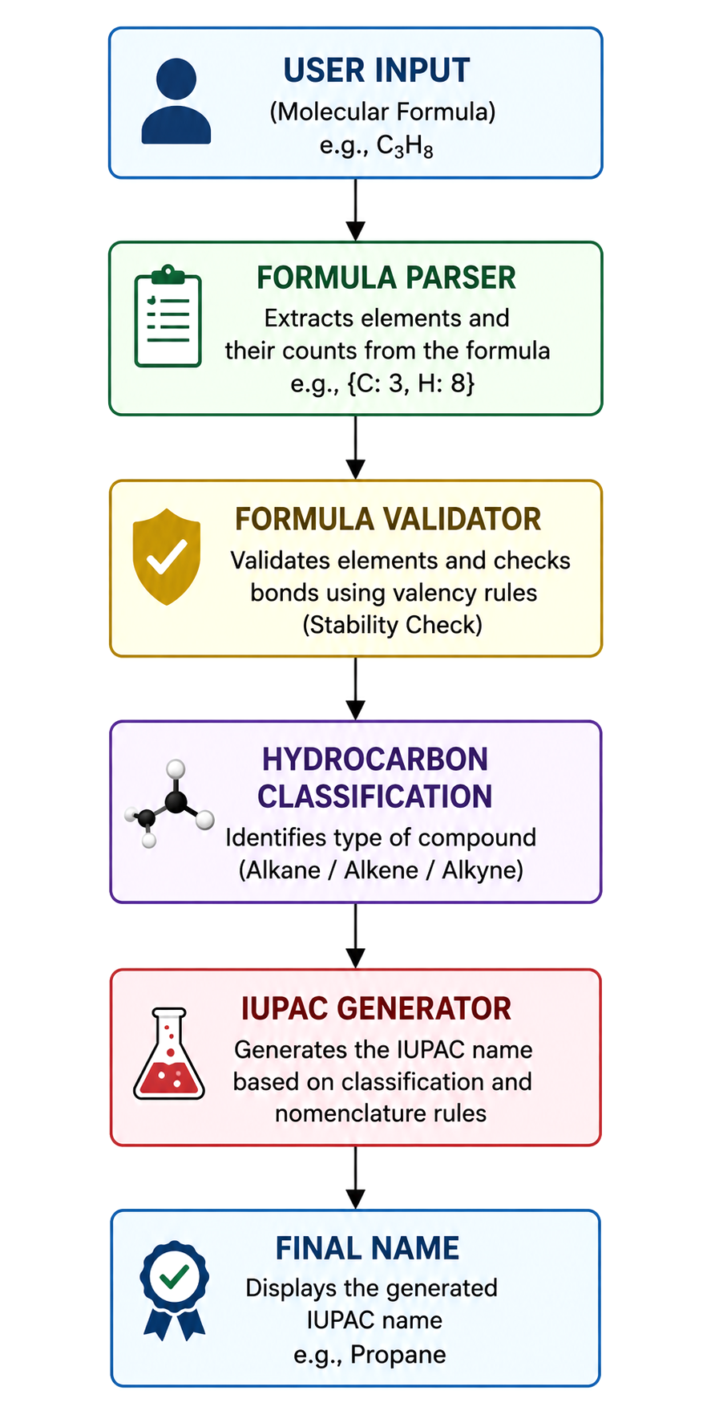

6. Algorithm
Algorithm 1: Formula Parsing
Input: Molecular Formula
Output: Element List and Element Dictionary
- Read formula string.
- Detect uppercase letters as new elements.
- Detect lowercase letters as element extensions.
- Detect digits as atom counts.
- Store element-count pairs.
- Return parsed structure.
Algorithm 2: Formula Validation
- Check whether each element exists in the valid element list.
- Retrieve element valency.
- Compute total bond count.
- Verify bond count satisfies stability conditions.
- Return validation result.
Algorithm 3: Name Generation
- Check whether formula contains only carbon and hydrogen.
- Extract carbon count n.
- Compare hydrogen count with:
  - 2n + 2 → Alkane
  - 2n → Alkene
  - 2n - 2 → Alkyne
- Retrieve root hydrocarbon name.
- Return generated IUPAC name.
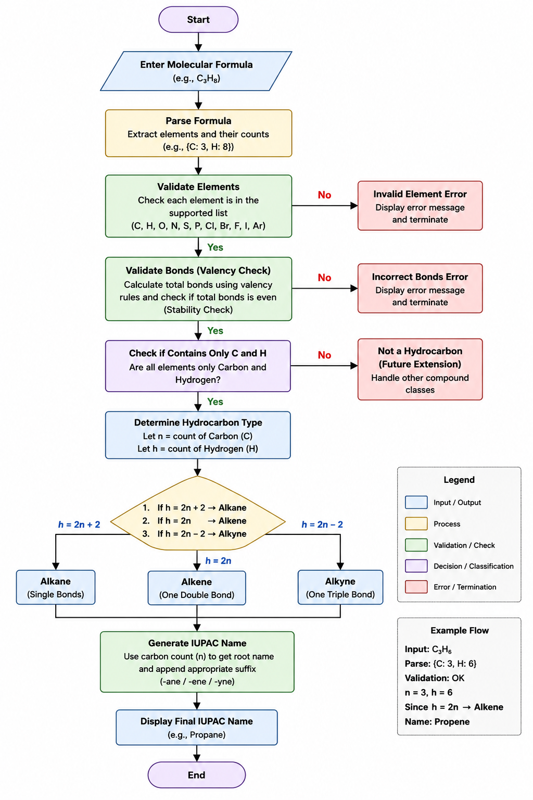7. Implementation
The software is implemented using Python and organized into the following modules:
- Exceptions_of_IUPAC.py
- FormulaValidator.py
- IUPAC_Namonator.py
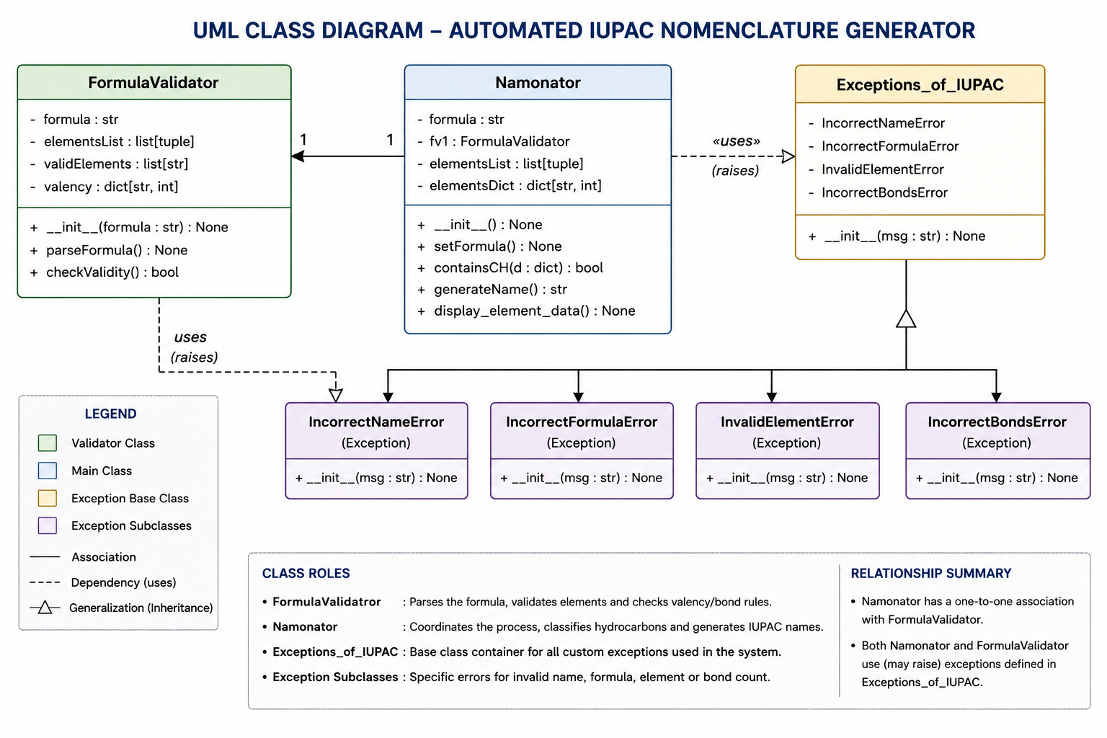

Object-oriented programming principles were used to improve modularity and maintainability.

8. Experimental Results
Table 1. Test Cases
Formula | Compound Type | Generated Name
CH4 | Alkane | Methane
C2H6 | Alkane | Ethane
C3H8 | Alkane | Propane
C4H10 | Alkane | Butane
C2H4 | Alkene | Ethene
C3H6 | Alkene | Propene
C2H2 | Alkyne | Ethyne
C4H6 | Alkyne | Butyne
C2H7 | Invalid | Error
The system correctly classified and generated names for all tested hydrocarbons within the supported range.

9. Discussion
The implementation demonstrates the feasibility of automating chemical nomenclature using rule-based methods. The modular architecture enables future expansion to include:
• Alcohols
• Ketones
• Aldehydes
• Carboxylic Acids
• Aromatic Compounds
• Inorganic Compounds
The current version serves as a foundational framework for advanced chemical naming systems.

10. Future Work
Future improvements may include:
- Graphical User Interface (GUI)
- Structural Formula Recognition
- Functional Group Detection
- AI-Assisted Compound Analysis
- Large Chemical Database Integration
- Web-Based Deployment
- Mobile Application Support

11. Conclusion
This research presented a Python-based Automated IUPAC Nomenclature Generator that combines formula validation, molecular parsing, and rule-based hydrocarbon classification. The proposed system successfully generates standardized IUPAC names for supported hydrocarbon compounds while maintaining modularity and extensibility. The results indicate that rule-based cheminformatics solutions can provide effective educational tools for chemistry students and researchers.

References
[1] IUPAC, "Nomenclature of Organic Chemistry," International Union of Pure and Applied Chemistry.
[2] David R. Klein, Organic Chemistry, Wiley Publications.
[3] John McMurry, Organic Chemistry, Cengage Learning.
[4] Python Software Foundation, Python Documentation.
[5] Khan Academy, Organic Chemistry Fundamentals.

