**Assignment**

**Case-1**

1. DimSalesTerritory and FactInternetSales inputs are joined with using SalesTerritoryKey.
2. Results of that join are joined with DimProduct input using ProductKey column. Since this column in tables are different data type, its type converted to double with select tool.
3. Data is filtered for the country value with France.
4. Summarize tool is used for grouping data by product name and their amount of sales.
5. Another summarize tool is used for summation of the total amount of sales by every product. Append tool is used for appending this field to the data.
6. Formula tool is used for ratio of total sales amount by product / total sales amount. Formula is: Round([TotalSalesAmount]/[TotalSalesAmountPercentile]*100, .01) This fromula also takes two decimal places.
7. Sort tool is used for sorting data according to total sales amount per product in descending order.
8. Used sample tool to take first 10 rows.

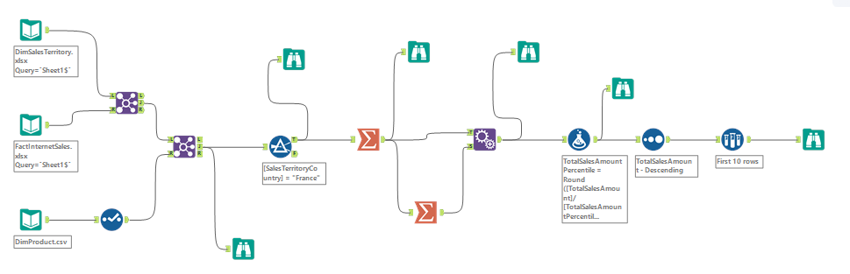

**Case-2**

1. DimSalesTerritory and FactInternetSales inputs are joined with using SalesTerritoryKey.
2. Results of that join are joined with DimProduct input using ProductKey column. Since this column in tables are different data type, its type converted to double with select tool.
3. Filter data for wanted time interval. Code: [OrderDate] >= "2007-01-01" AND [OrderDate] < "2008-01-01"
4. Written a formula for taking the month. When months are written with names, cross tab sort them alphabetically/mathematically. Inorder to prevent that formula is written. Formula’s format is like: 01-January. Code: DateTimeFormat([OrderDate],"%m") + "-" + DateTimeFormat([OrderDate],"%B")
5. Numbers are written inorder to fix sorting, they will be deleted after cross tab process.
6. Select tool is used for for removing unused columns.
7. Cross tab tool is used because we wanted to sales amount of product names by the months. Cross tab setting must be like:

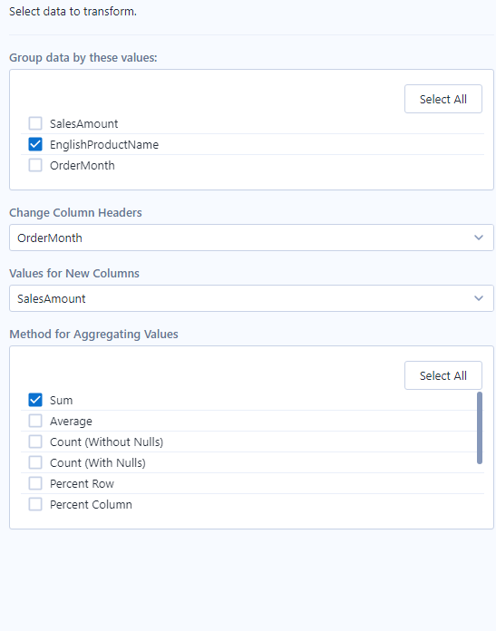

1. Field info tool is used. We wanted to dynamically change the name field of metadata.
2. After that, we connect formula tool to the field info to replace the name with only month name. Code: IF [Type] = "Double" THEN ReplaceChar(Substring([Name],3), "-" , "") ELSE [NAME] ENDIF
3. Dynamically rename tool is used. Cross tab is connected to left anchor, formula is connected to right anchor. Settings:

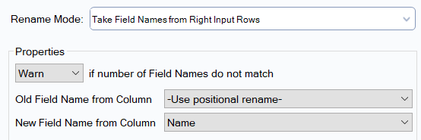

1. Sort tool is used. Sorts the data by product name ascending.

