**DOCUMENTATION OF FINAL ASSIGMENT**

**1SR EV.**

**Miguel Barruz**

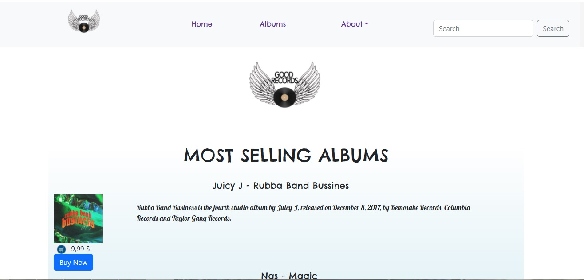

* **Short Description:**
  + These webpages were created to simulate a real website of a music label. The These web pages were created to simulate a real website of a music label.

the first page (Index) it has information about the label, rotated images, sell of the two more selling albums besides information too. down of these, we can found the news section, that includes new singles, tours of the best artist and sometimes any masterclass.

in the end of the page there are some links to main social networks.

* + the second page its about the location of the label and more top albums including the option of bullying
  + the third page its just a formulary that it has to complete to buy any product of the webpage.
* **Extras:**
  + Google Maps (Location).
  + Hover effect in some sections.
  + Top postion or “header” fixed on Index (css + bootstrap webpage).
* **Screenshots:**
  + Index:

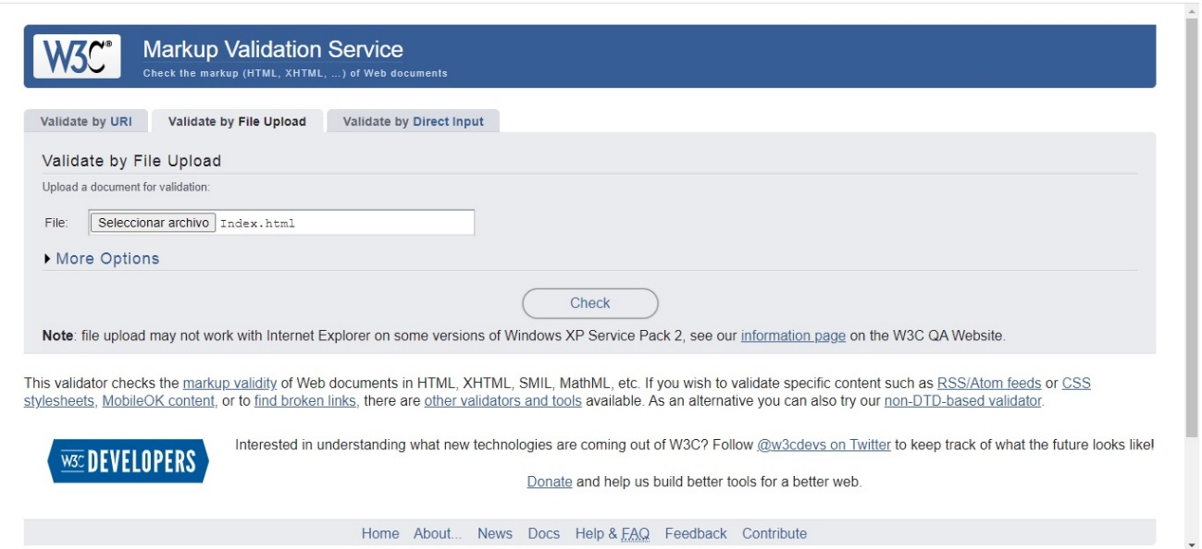

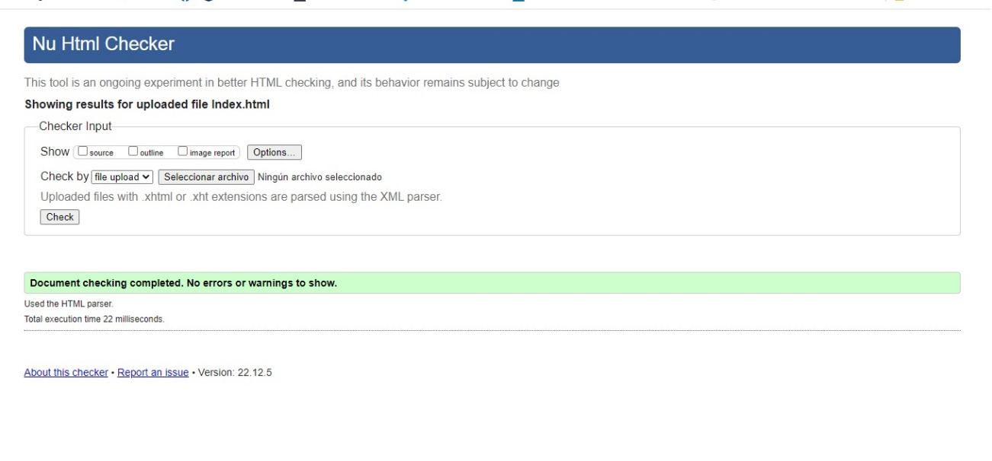

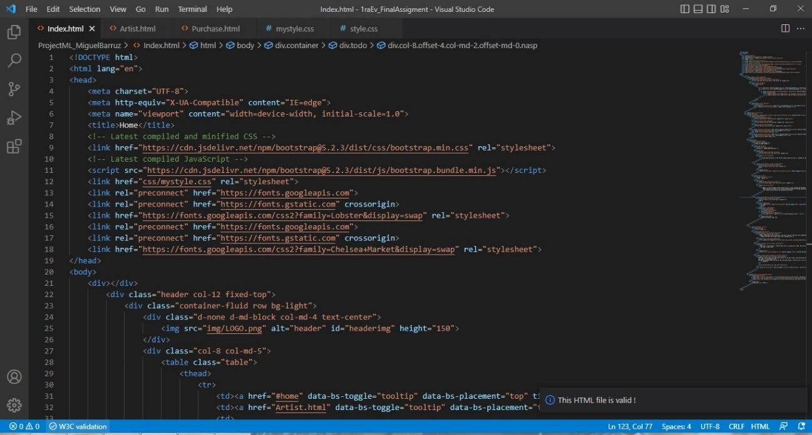

* + Artist:

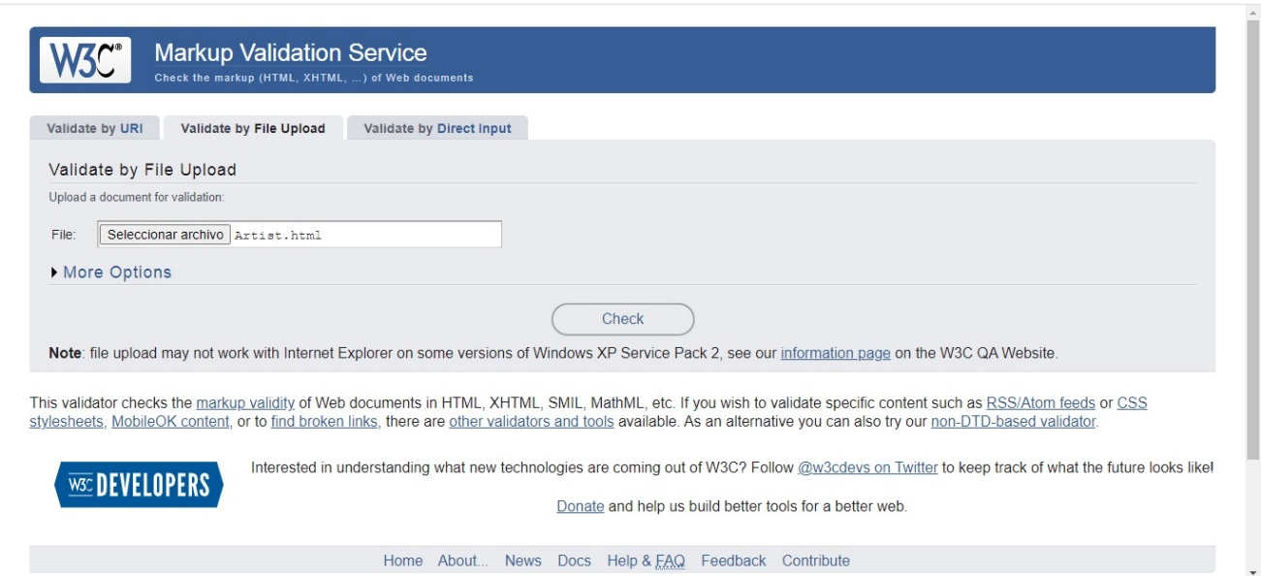



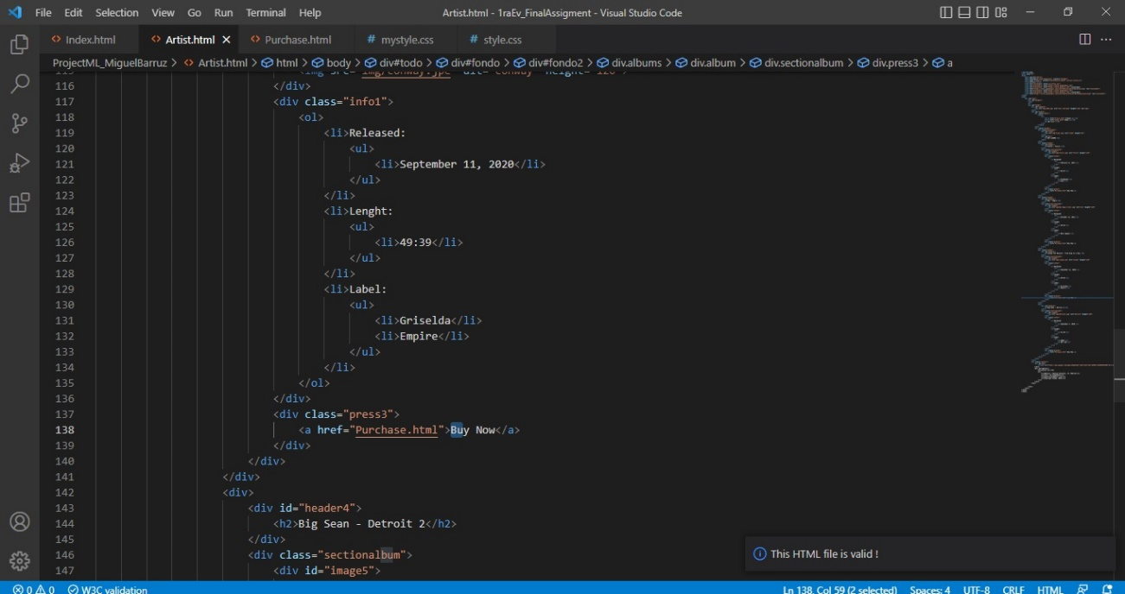

* + Purchase:

