**Version 0 Code Performance:**

2-Word Solutions:

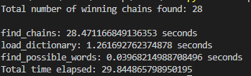

2-word and 3-Word Solutions:

5+ Minutes Allowed, no response, therefore terminated.

**V1: Early Termination**

# Base case: If all letters have been used, stop exploration, and add chain to valid_chain_solutions

if len(remaining_letters) <= 0:

valid_chain_solutions.append(start_chain)

return

# Find the last word and its last letter in the start_chain

last_word = start_chain[-1]

last_letter = last_word[-1]

# Select every word as a potential continuation of the chain

for word in possible_words:

if word[0] == last_letter:

new_start_chain = start_chain + [word]

if len(new_start_chain) > 2: # E

continue

new_remaining_letters = remaining_letters.copy()

for letter in word:

if letter in new_remaining_letters:

new_remaining_letters.remove(letter)

# Recursively call generate_chain with the updated start_chain and remaining_letters

generate_chain(new_start_chain, new_remaining_letters)

In the code above, the highlighted if statement determines if the chain has reached a length of 3 words (2-word solution) and terminates the search. Prior to this condition check, many assignments are made that prove to be unneeded. We can instead check the length of the chain upon entering the generate_chain function, as a second base case. (Change made below)

# Base case: If all letters have been used, stop exploration, and add chain to valid_chain_solutions

if len(remaining_letters) <= 0:

valid_chain_solutions.append(start_chain)

return

if len(start_chain) > 1:

return

Let’s see how the performance has changed.

2-Word Sols:

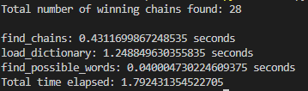

2-word and 3-Word Sols:

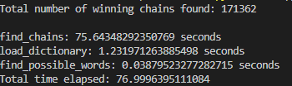

Wow. As we can see the early termination to avoid the many initializations significantly reduced the run time. Let’s see what else we can do.

**V2: Load Dictionary**

The load_dictionary function is used to insert all of the words from the dictionary.txt file for efficient searching.

def load_dictionary(file_path):

trie = Trie()

with open(file_path, 'r') as file:

for word in file:

trie.insert(word.strip().upper())

return trie

However, each time the dictionary is loaded with the entirety of the words provided, and this is simply not needed for this use case. Let’s adapt the load_dictionary function to create a trie of words consisting only of the provided game/puzzle letters.

def load_dictionary(file_path, gameData):

trie = Trie()

with open(file_path, 'r') as file:

for word in file:

word = word.strip().upper()

# Flatten the list of letters from gameData

puzzle_letters = [letter for letters in gameData.values() for letter in letters]

# Check if the word can be formed using the letters from gameData

if all(letter in puzzle_letters for letter in word):

trie.insert(word)

return trie

Since the number of puzzle letter remains the same, for testing we are only going to test 2-word solutions to determine the performance increase of the load dictionary function.

2-Word Sols.:

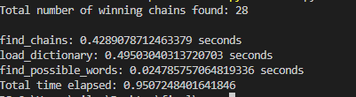

We do see a performance increase for both the load_dictionary function and find_possible_words. While not huge, it definitely helps.