Mohammed Baker

Project Documentation



# Executive Summary

The automation of tracking inventory saved time for organizations, which also reflected on the expenses by saving the cost of managing and tracking inventory. The market is filled with inventory management application, but the problem they’re not free, and small business are in need for an application that track their inventory and orders, without paying a fortune for a software.

MANAGE IT, is a web application that track the inventory, management, and track the orders of the business. It’s focuses on small business that are not willing to spend on implementing a paid inventory management software. The application will allow the user to add brands, add category, add product, and add order. Also, it allows the user to generate a report within a specific period that will display the orders and their cost.

The application has different tools that can help the user, such as displaying the total number of categories and total number of brands, the user will be able to update the status of the brand or the category, besides that the user will be able to update the orders and view the orders detail. The payment section allows the user to select the payment type, and the payment status.

The application is developed by using PHP, MYSQL, BOOTSTRAP, AND JQUERY AJAX.

# Scenario | Adding a Brand

The user will be able to add brand, delete brand and manage brands.

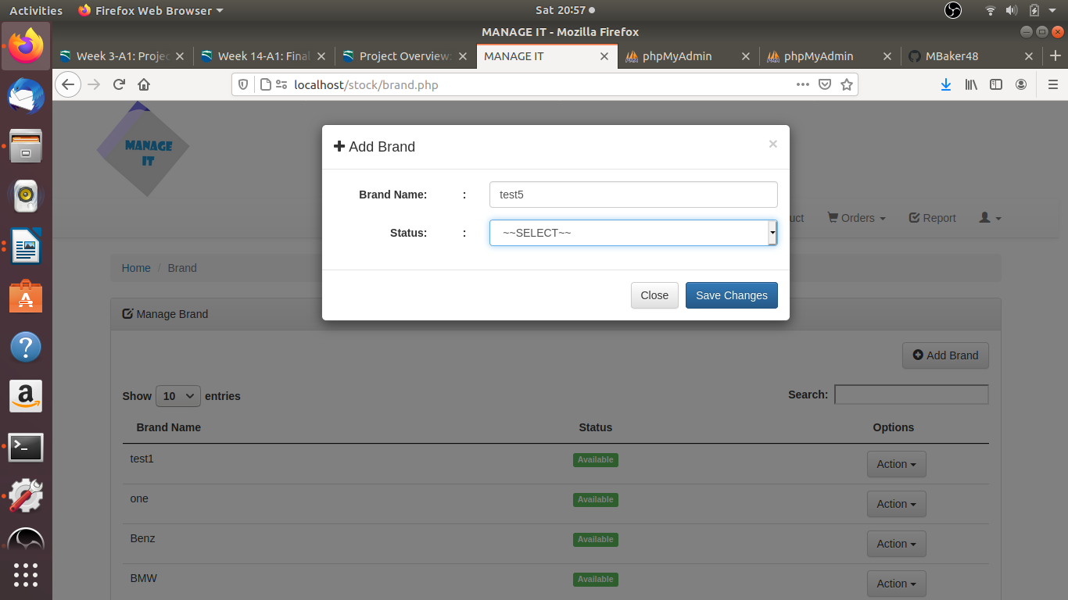

# Scenario | Add Categories

The user will be able to display the available categories, add a category, and manage category.

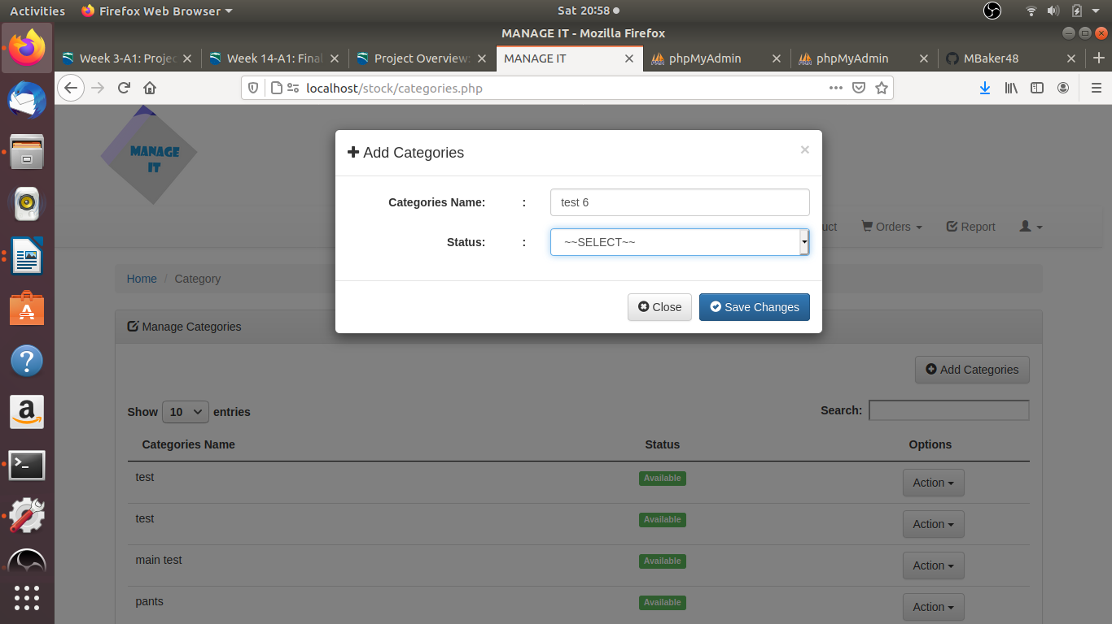

# Scenario | Add Products

The user will be able to display the available products, add products, and manage products.

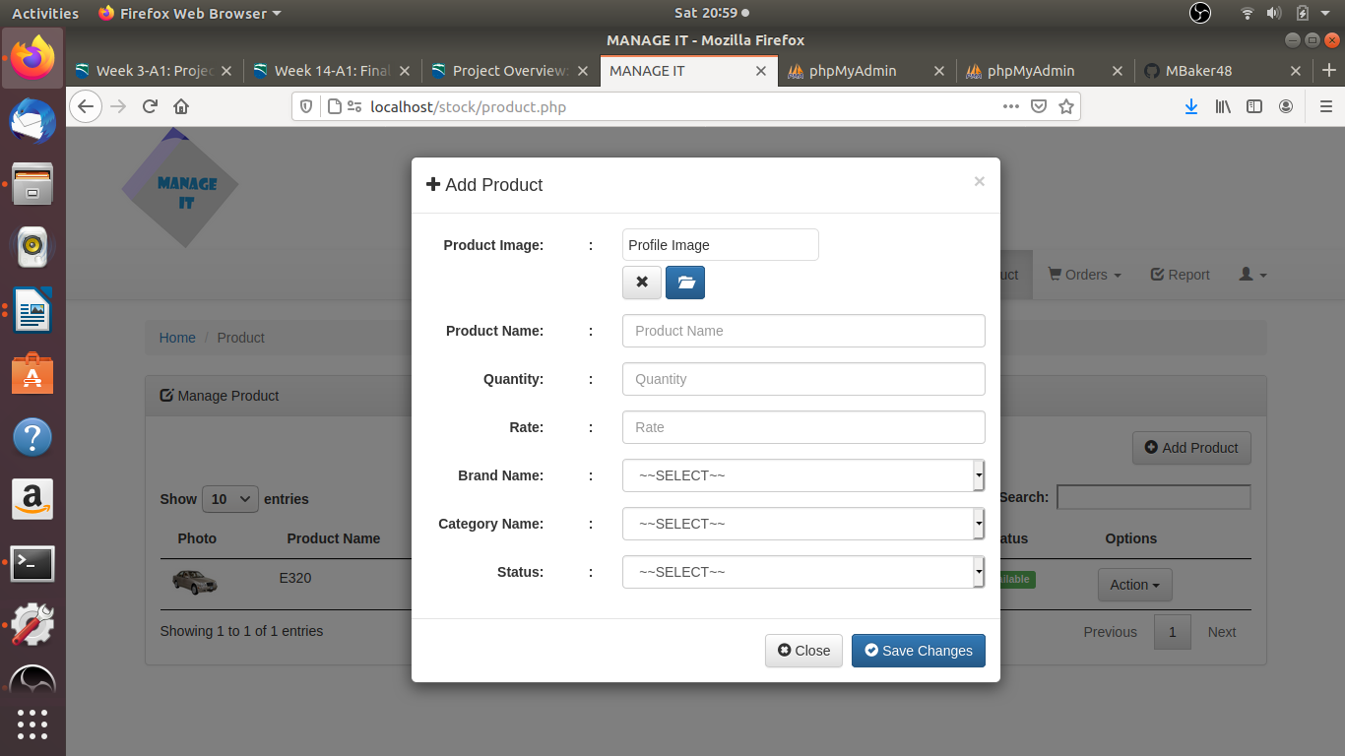

# Scenario | Program Usage Description

The user will be able to display the orders, create order, and manage orders, and payments.

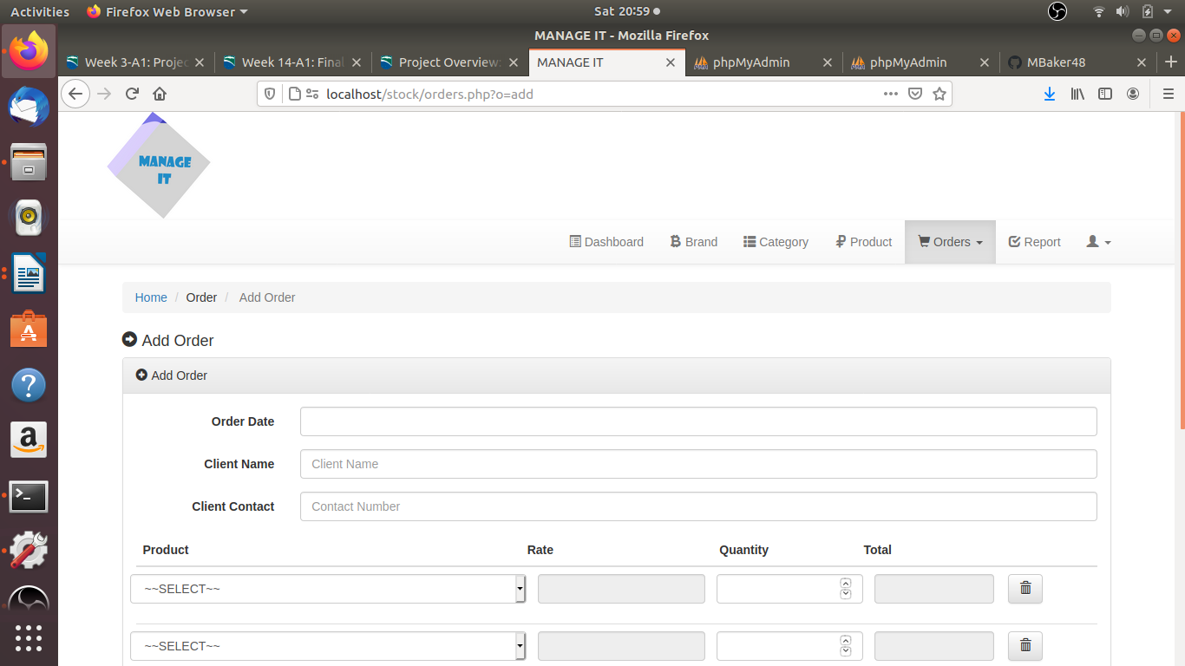

# Reports

The user will be able to generate a report within a specific period and print it.

# 

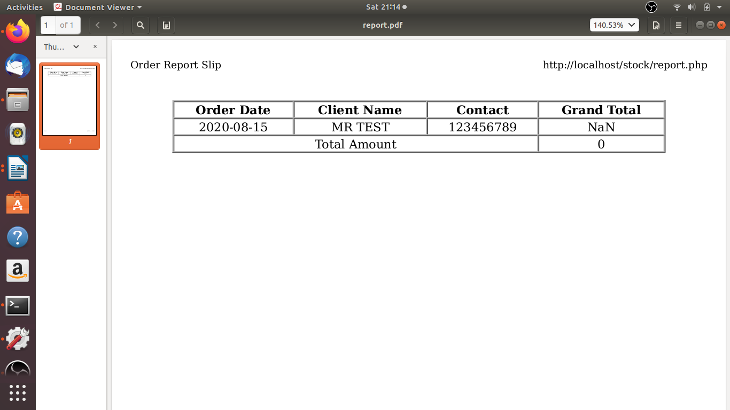

# System Architecture

ManageIt is a simple web application were data will be moving between the web-page and the database.

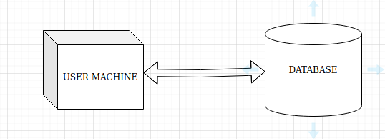

## Database or Data Store

Introduction to the database or data store.

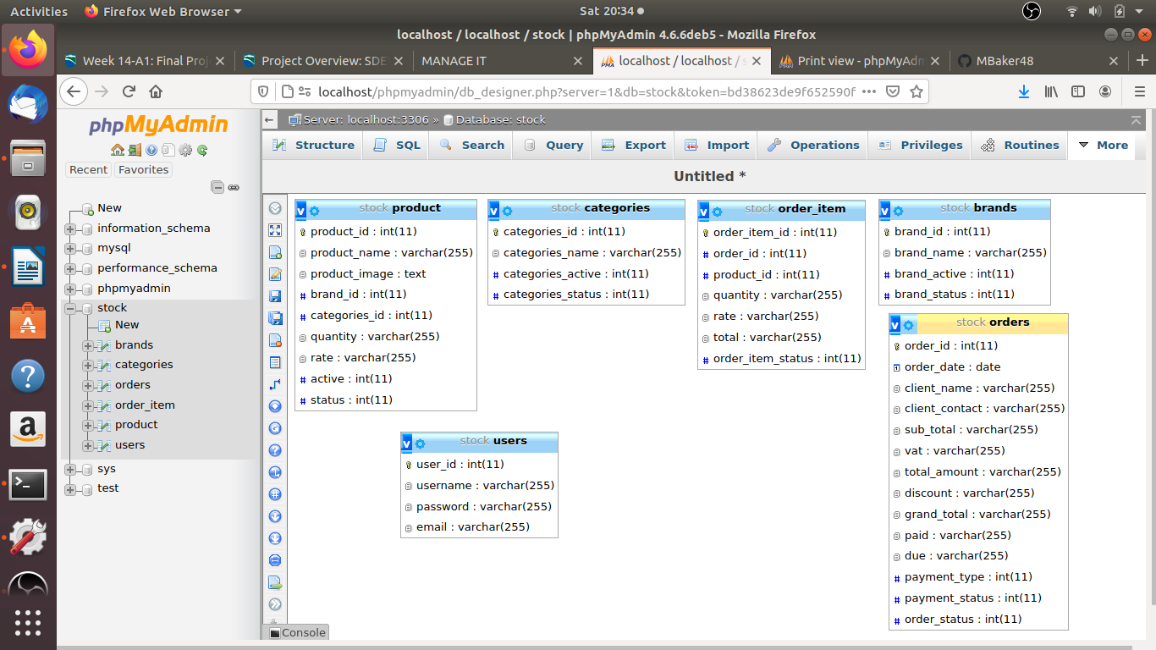

## Views, Stored Procedures and User Defined Functions

Some of the stored procedures to add data into tables.

**Adding data into Brands table**

INSERT INTO `brands` (`brand_id`, `brand_name`, `brand_active`, `brand_status`)

**Adding data into Categories table**

INSERT INTO `categories` (`categories_id`, `categories_name`, `categories_active`, `categories_status`)

**Adding data into Orders table**

INSERT INTO `orders` (`order_id`, `order_date`, `client_name`, `client_contact`, `sub_total`, `vat`, `total_amount`, `discount`, `grand_total`, `paid`, `due`, `payment_type`, `payment_status`, `order_status`)

**Adding data into Order_item table**

INSERT INTO `order_item` (`order_item_id`, `order_id`, `product_id`, `quantity`, `rate`, `total`, `order_item_status`)

**Adding data into Products table**

INSERT INTO `product` (`product_id`, `product_name`, `product_image`, `brand_id`, `categories_id`, `quantity`, `rate`, `active`, `status`)

**Adding data into Users table**

INSERT INTO `users` (`user_id`, `username`, `password`, `email`)

External Files & Data

Within this system different external were used such as bootstrap, font awesome and jquery.

Programming Language

HTML, java script, and PHP.

Program Start and End Flow

The diagram below explains the user flow when logging in to the application.

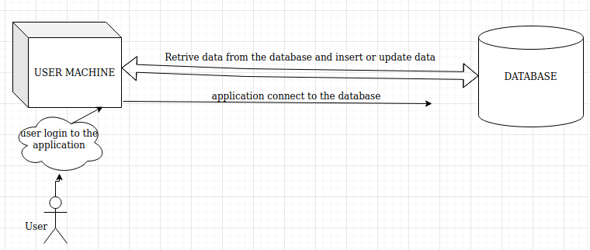

Summary

This document includes details about ManageIt such as stored procedures, Requirements, installation steps, user guide, External files and data, Programming language, System architecture ,Build and release process, and Developer instructions,

APPENDIX B (BUILD AND RELEASE PROCESS)

Inventory Management uses procedural php, jquery, and bootstrap

The database was created in PHPMyAdmin. The requirements are PHP, and Web server apache2 with php and mysqli.

# APPENDIX C (CLIENT INSTALLATION INSTRUCTIONS)

Download The source code and the database.

1. For Windows users Ensure you have PHP, Web server apache2 with php and mysqli and PhpMyAdmin on your operating system, if not download them.
2. In PhpMyAdmin create a database and name it stock, then import the database script there.
3. Copy the source code file into the html folder or the htdocs file.
4. Go to stock/index.php and change the localhost port number to your suitable port number. See the image below

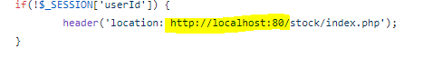

1. Go to stock/php_action/core.php and change the port number to your port number. See the image below.



1. From stock/php_action/db_connect.php ensure you have the right database name, username, and password. See the image below

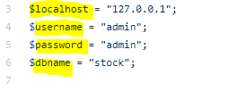

1. Open your favorite web browser and type in localhost:(Your port number), in my case it’s localhost:80
2. You will be directed to the login page and use the following credential username “admin”, password “admin” you will be able to change them after login from the setting tap.

Note: To change the TAX percentage; go to stock/orders.php and change the TAX percentage in line 151. In my case it was 6%



# APPENDIX D (DEVELOPER SETUP INSTRUCTIONS)

Requirements:

* PHP Version +5.4.4
* Web Server ( Recommended : Apache with PHP and Mysqli

Download the source code and the database, then import the database to phpmyadmin. Move the source code to the html folder. Ensure the port number are matching the port number for your connection.