Methodology for Premasters DSS

Group 17

Bart Kuipers - 2085029

Daniel Noumon - 2076640

Joël van Run - 2082698

Mehmet Bakirci – 208610

Lieke Buuron – 2082095

17-11-2021

KNMI_20200710 <- read.csv("KNMI_20200710.csv", header= TRUE)  
library(psych)  
install.packages("lubridate")

## Installing package into '/home/mehmet/R/x86_64-pc-linux-gnu-library/4.1'  
## (as 'lib' is unspecified)

library(lubridate)

##   
## Attaching package: 'lubridate'

## The following objects are masked from 'package:base':  
##   
## date, intersect, setdiff, union

head(KNMI_20200710)

## STN YYYYMMDD DDVEC FHVEC FG FHX FHXH FHN FHNH FXX FXXH TG TN TNH TX TXH  
## 1 260 19010101 NA NA NA NA NA NA NA NA NA -49 -65 NA -24 NA  
## 2 260 19010102 NA NA NA NA NA NA NA NA NA -18 -33 NA -14 NA  
## 3 260 19010103 NA NA NA NA NA NA NA NA NA -26 -76 NA -6 NA  
## 4 260 19010104 NA NA NA NA NA NA NA NA NA -65 -90 NA -11 NA  
## 5 260 19010105 NA NA NA NA NA NA NA NA NA -60 -82 NA -20 NA  
## 6 260 19010106 NA NA NA NA NA NA NA NA NA -100 -114 NA -80 NA  
## T10N T10NH SQ SP Q DR RH RHX RHXH PG PX PXH PN PNH VVN VVNH VVX VVXH NG UG  
## 1 NA NA 28 36 NA NA NA NA NA NA NA NA NA NA NA NA NA NA NA 66  
## 2 NA NA 0 0 NA NA NA NA NA NA NA NA NA NA NA NA NA NA NA 86  
## 3 NA NA 0 0 NA NA NA NA NA NA NA NA NA NA NA NA NA NA NA 89  
## 4 NA NA 0 0 NA NA NA NA NA NA NA NA NA NA NA NA NA NA NA 79  
## 5 NA NA 36 46 NA NA NA NA NA NA NA NA NA NA NA NA NA NA NA 65  
## 6 NA NA 61 77 NA NA NA NA NA NA NA NA NA NA NA NA NA NA NA 63  
## UX UXH UN UNH EV24  
## 1 NA NA NA NA NA  
## 2 NA NA NA NA NA  
## 3 NA NA NA NA NA  
## 4 NA NA NA NA NA  
## 5 NA NA NA NA NA  
## 6 NA NA NA NA NA

KNMI_20200710$daynumber <- c(1:43656)  
knmi <- KNMI_20200710  
set.seed(123)  
knmi$YYYYMMDD <-ymd(knmi$YYYYMMDD)  
  
  
knmi$STN <- NULL  
knmi$FHVEC<- NULL  
knmi$FG<- NULL  
knmi$FHX<- NULL  
knmi$FHXH<- NULL  
knmi$FHN<- NULL  
knmi$FHNH<- NULL  
knmi$FXX<- NULL  
knmi$FXXH<- NULL  
knmi$TNH<- NULL  
knmi$TXH<- NULL  
knmi$T10NH<- NULL  
knmi$PXH<- NULL  
knmi$PNH<- NULL  
knmi$VVN<- NULL  
knmi$VVNH<- NULL  
knmi$VVX<- NULL  
knmi$VVXH<- NULL  
knmi$UXN<- NULL  
knmi$UNH<- NULL  
  
  
knmi <- knmi[!is.na(knmi$RH),]  
knmi$dummy <- ifelse (knmi$RH > 100, 1, 0)   
head(knmi)

## YYYYMMDD DDVEC TG TN TX T10N SQ SP Q DR RH RHX RHXH PG PX  
## 1827 1906-01-01 112 -32 -70 -3 NA 54 69 NA NA 0 0 NA 10235 10274  
## 1828 1906-01-02 122 -23 -44 -8 NA 26 33 NA NA 0 0 NA 10187 10226  
## 1829 1906-01-03 142 7 -36 46 NA 1 1 NA NA 0 0 NA 10099 10122  
## 1830 1906-01-04 174 65 46 80 NA 0 0 NA NA 36 15 NA 10111 10120  
## 1831 1906-01-05 239 71 29 90 NA 0 0 NA NA 134 31 NA 10094 10146  
## 1832 1906-01-06 218 73 46 109 NA 12 15 NA NA 136 17 NA 9978 10134  
## PN NG UG UX UXH UN EV24 daynumber dummy  
## 1827 10215 NA 51 NA NA NA NA 1827 0  
## 1828 10130 NA 61 NA NA NA NA 1828 0  
## 1829 10086 NA 77 NA NA NA NA 1829 0  
## 1830 10091 NA 95 NA NA NA NA 1830 0  
## 1831 10043 NA 94 NA NA NA NA 1831 1  
## 1832 9911 NA 81 NA NA NA NA 1832 1

knmi <- knmi[sample(nrow(knmi)),]

knmicorr <- knmi  
knmicorr$YYYYMMDD <- NULL  
knmicorr$year <- NULL  
knmicorr$dagnumber <- c(1:41800)  
knmicorr$daynumber <- NULL  
  
KNMI_20200710$YYYYMMDD <- c(1:43656)  
knmicorrelatie <- cor(knmicorr, use="complete.obs")  
  
install.packages("corrplot")

## Installing package into '/home/mehmet/R/x86_64-pc-linux-gnu-library/4.1'  
## (as 'lib' is unspecified)

library(corrplot)

## corrplot 0.91 loaded

corrplot(knmicorrelatie,  
 title = "Correlationplot knmi data",  
 mar = c(0, 0, 2, 0))

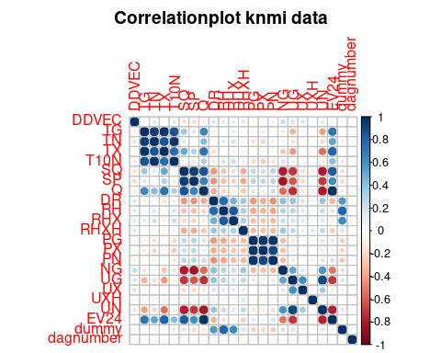

fractionTraining <- 0.60  
fractionValidation <- 0.20  
fractionTest <- 0.20  
  
sampleSizeTraining <- floor(fractionTraining * nrow(knmi))  
sampleSizeValidation <- floor(fractionValidation * nrow(knmi))  
sampleSizeTest <- floor(fractionTest * nrow(knmi))  
  
indicesTraining <- sort(sample(seq_len(nrow(knmi)), size=sampleSizeTraining))  
indicesNotTraining <- setdiff(seq_len(nrow(knmi)), indicesTraining)  
indicesValidation <- sort(sample(indicesNotTraining, size=sampleSizeValidation))  
indicesTest <- setdiff(indicesNotTraining, indicesValidation)  
  
dfTraining <- knmi[indicesTraining, ]  
dfValidation <- knmi[indicesValidation, ]  
dfTest <- knmi[indicesTest, ]

#test training set on variable daynumber  
  
## MODEL 0 ---  
  
plot(dfTraining$daynumber, dfTraining$dummy)  
abline(lm(dfTraining$dummy ~ dfTraining$daynumber, data = dfTraining), col = "blue")

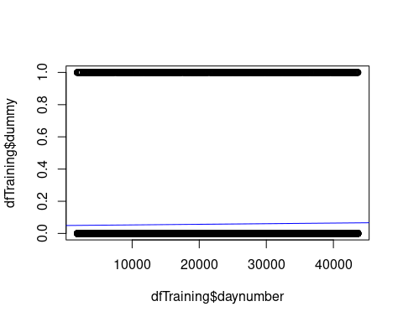

m0 <- lm(dfTraining$dummy ~ dfTraining$daynumber)  
  
m0

##   
## Call:  
## lm(formula = dfTraining$dummy ~ dfTraining$daynumber)  
##   
## Coefficients:  
## (Intercept) dfTraining$daynumber   
## 4.938e-02 3.762e-07

dfValidation$m0 <- 4.938e-02 + dfValidation$daynumber * 3.762e-07  
  
dfValidation$m0sq <- (dfValidation$m0 - dfValidation$dummy)^2  
m0sq <- sum(dfValidation$m0sq)  
m0sq

## [1] 434.367

## MODEL 1 ---  
plot(dfTraining$PG, dfTraining$dummy)  
abline(lm(dfTraining$dummy ~ dfTraining$PG, data = dfTraining), col = "blue")

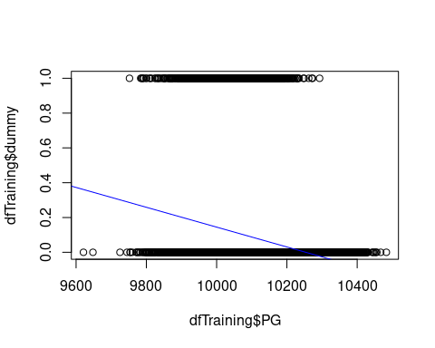

m1 <- lm(dfTraining$dummy ~ dfTraining$PG)  
  
m1

##   
## Call:  
## lm(formula = dfTraining$dummy ~ dfTraining$PG)  
##   
## Coefficients:  
## (Intercept) dfTraining$PG   
## 5.8461357 -0.0005702

dfValidation$m1 <- 5.8461357 + dfValidation$PG*-0.0005702   
  
dfValidation$m1sq <- (dfValidation$m1 - dfValidation$dummy)^2  
  
m1sq <- sum(dfValidation$m1sq)  
m1sq

## [1] 411.651

## MODEL 2 --  
plot(dfTraining$TN, dfTraining$dummy)  
abline(lm(dfTraining$dummy ~ dfTraining$TN, data = dfTraining), col = "blue")

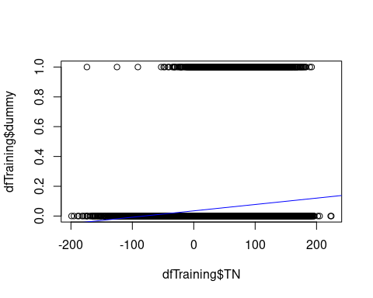

m2 <- lm(dfTraining$dummy ~ dfTraining$TN)  
  
m2

##   
## Call:  
## lm(formula = dfTraining$dummy ~ dfTraining$TN)  
##   
## Coefficients:  
## (Intercept) dfTraining$TN   
## 0.0350206 0.0004272

dfValidation$m2 <- 0.0350206 + dfValidation$TN*0.0004272  
  
dfValidation$m2sq <- (dfValidation$m2 - dfValidation$dummy)^2  
m2sq <- sum(dfValidation$m2sq)  
m2sq

## [1] 430.3193

m1

##   
## Call:  
## lm(formula = dfTraining$dummy ~ dfTraining$PG)  
##   
## Coefficients:  
## (Intercept) dfTraining$PG   
## 5.8461357 -0.0005702

dfTest$m1 <- 5.8461357 + dfValidation$PG*-0.0005702  
  
dfTest$m1sq <- (dfTest$m1 - dfTest$dummy)^2  
m1sqtest <- sum(dfTest$m1sq)  
m1sqtest

## [1] 469.4157

head(dfTest)

## YYYYMMDD DDVEC TG TN TX T10N SQ SP Q DR RH RHX RHXH PG PX  
## 39385 2008-10-30 63 26 -19 66 -43 35 36 471 0 -1 -1 1 10001 10026  
## 33169 1991-10-24 293 101 87 125 85 0 0 226 0 -1 -1 NA 10276 10296  
## 11152 1931-07-14 167 155 104 201 NA 68 42 NA 10 54 23 NA 10068 10096  
## 13875 1938-12-27 260 15 -47 48 NA 1 1 NA 39 51 14 NA 10099 10175  
## 17006 1947-07-24 331 205 149 260 NA 89 56 NA 0 1 1 NA 10198 10208  
## 34462 1995-05-09 293 95 81 116 71 14 9 946 42 37 12 12 10152 10176  
## PN NG UG UX UXH UN EV24 daynumber dummy m1 m1sq  
## 39385 9983 6 93 100 1 81 5 39385 0 0.1395741 1.948093e-02  
## 33169 10266 7 89 96 21 82 3 33169 0 0.0797031 6.352584e-03  
## 11152 10015 NA 80 NA NA NA NA 11152 0 0.1036515 1.074363e-02  
## 13875 10056 NA 96 NA NA NA NA 13875 0 0.0694395 4.821844e-03  
## 17006 10180 NA 68 NA NA NA NA 17006 0 -0.0092481 8.552735e-05  
## 34462 10116 7 85 95 2 74 14 34462 0 0.1635225 2.673961e-02

dfTest$dummyavg <- mean(dfTraining$dummy)  
dfTest$seavg <- (dfTest$dummyavg - dfTest$dummy)^2  
sum(dfTest$seavg)

## [1] 442.7182

m0

##   
## Call:  
## lm(formula = dfTraining$dummy ~ dfTraining$daynumber)  
##   
## Coefficients:  
## (Intercept) dfTraining$daynumber   
## 4.938e-02 3.762e-07

dfTest$m0 <- 4.938e-02 + dfValidation$daynumber*-3.762e-07  
  
dfTest$m0sq <- (dfTest$m0 - dfTest$dummy)^2  
m0sqtest <- sum(dfTest$m0sq)  
m0sqtest

## [1] 444.7274

head(dfTest)

## YYYYMMDD DDVEC TG TN TX T10N SQ SP Q DR RH RHX RHXH PG PX  
## 39385 2008-10-30 63 26 -19 66 -43 35 36 471 0 -1 -1 1 10001 10026  
## 33169 1991-10-24 293 101 87 125 85 0 0 226 0 -1 -1 NA 10276 10296  
## 11152 1931-07-14 167 155 104 201 NA 68 42 NA 10 54 23 NA 10068 10096  
## 13875 1938-12-27 260 15 -47 48 NA 1 1 NA 39 51 14 NA 10099 10175  
## 17006 1947-07-24 331 205 149 260 NA 89 56 NA 0 1 1 NA 10198 10208  
## 34462 1995-05-09 293 95 81 116 71 14 9 946 42 37 12 12 10152 10176  
## PN NG UG UX UXH UN EV24 daynumber dummy m1 m1sq  
## 39385 9983 6 93 100 1 81 5 39385 0 0.1395741 1.948093e-02  
## 33169 10266 7 89 96 21 82 3 33169 0 0.0797031 6.352584e-03  
## 11152 10015 NA 80 NA NA NA NA 11152 0 0.1036515 1.074363e-02  
## 13875 10056 NA 96 NA NA NA NA 13875 0 0.0694395 4.821844e-03  
## 17006 10180 NA 68 NA NA NA NA 17006 0 -0.0092481 8.552735e-05  
## 34462 10116 7 85 95 2 74 14 34462 0 0.1635225 2.673961e-02  
## dummyavg seavg m0 m0sq  
## 39385 0.05797448 0.003361041 0.04756973 0.002262879  
## 33169 0.05797448 0.003361041 0.03846117 0.001479262  
## 11152 0.05797448 0.003361041 0.04360082 0.001901031  
## 13875 0.05797448 0.003361041 0.03944945 0.001556259  
## 17006 0.05797448 0.003361041 0.03783781 0.001431700  
## 34462 0.05797448 0.003361041 0.04867763 0.002369512

dfTest$dummyavg <- mean(dfTraining$dummy)  
dfTest$seavg <- (dfTest$dummyavg - dfTest$dummy)^2  
sum(dfTest$seavg)

## [1] 442.7182

m2

##   
## Call:  
## lm(formula = dfTraining$dummy ~ dfTraining$TN)  
##   
## Coefficients:  
## (Intercept) dfTraining$TN   
## 0.0350206 0.0004272

dfTest$m2 <- 0.0350206 + dfValidation$TN*-0.0004272  
  
dfTest$m2sq <- (dfTest$m2 - dfTest$dummy)^2  
m2sqtest <- sum(dfTest$m2sq)  
m2sqtest

## [1] 463.3849

head(dfTest)

## YYYYMMDD DDVEC TG TN TX T10N SQ SP Q DR RH RHX RHXH PG PX  
## 39385 2008-10-30 63 26 -19 66 -43 35 36 471 0 -1 -1 1 10001 10026  
## 33169 1991-10-24 293 101 87 125 85 0 0 226 0 -1 -1 NA 10276 10296  
## 11152 1931-07-14 167 155 104 201 NA 68 42 NA 10 54 23 NA 10068 10096  
## 13875 1938-12-27 260 15 -47 48 NA 1 1 NA 39 51 14 NA 10099 10175  
## 17006 1947-07-24 331 205 149 260 NA 89 56 NA 0 1 1 NA 10198 10208  
## 34462 1995-05-09 293 95 81 116 71 14 9 946 42 37 12 12 10152 10176  
## PN NG UG UX UXH UN EV24 daynumber dummy m1 m1sq  
## 39385 9983 6 93 100 1 81 5 39385 0 0.1395741 1.948093e-02  
## 33169 10266 7 89 96 21 82 3 33169 0 0.0797031 6.352584e-03  
## 11152 10015 NA 80 NA NA NA NA 11152 0 0.1036515 1.074363e-02  
## 13875 10056 NA 96 NA NA NA NA 13875 0 0.0694395 4.821844e-03  
## 17006 10180 NA 68 NA NA NA NA 17006 0 -0.0092481 8.552735e-05  
## 34462 10116 7 85 95 2 74 14 34462 0 0.1635225 2.673961e-02  
## dummyavg seavg m0 m0sq m2 m2sq  
## 39385 0.05797448 0.003361041 0.04756973 0.002262879 0.0042622 1.816635e-05  
## 33169 0.05797448 0.003361041 0.03846117 0.001479262 -0.0064178 4.118816e-05  
## 11152 0.05797448 0.003361041 0.04360082 0.001901031 0.0046894 2.199047e-05  
## 13875 0.05797448 0.003361041 0.03944945 0.001556259 0.0405742 1.646266e-03  
## 17006 0.05797448 0.003361041 0.03783781 0.001431700 0.0371566 1.380613e-03  
## 34462 0.05797448 0.003361041 0.04867763 0.002369512 0.0478366 2.288340e-03

dfTest$dummyavg <- mean(dfTraining$dummy)  
dfTest$seavg <- (dfTest$dummyavg - dfTest$dummy)^2  
sum(dfTest$seavg)

## [1] 442.7182

plot(dfTraining$daynumber, dfTraining$dummy)  
abline(lm(dfTraining$dummy ~ dfTraining$daynumber, data = dfTraining), col = "blue")



m3 <- lm(dfTraining$dummy ~ dfTraining$PG + dfTraining$daynumber + dfTraining$TN)  
  
m3

##   
## Call:  
## lm(formula = dfTraining$dummy ~ dfTraining$PG + dfTraining$daynumber +   
## dfTraining$TN)  
##   
## Coefficients:  
## (Intercept) dfTraining$PG dfTraining$daynumber   
## 5.604e+00 -5.486e-04 2.930e-07   
## dfTraining$TN   
## 3.031e-04

dfValidation$m3 <- 5.604e+00 + dfValidation$daynumber * 2.930e-07 + dfValidation$PG*-5.486e-04 + dfValidation$TN*3.031e-04  
  
dfValidation$m3sq <- (dfValidation$m3 - dfValidation$dummy)^2  
m3sq <- sum(dfValidation$m3sq)  
m3sq

## [1] 409.0427

m3

##   
## Call:  
## lm(formula = dfTraining$dummy ~ dfTraining$PG + dfTraining$daynumber +   
## dfTraining$TN)  
##   
## Coefficients:  
## (Intercept) dfTraining$PG dfTraining$daynumber   
## 5.604e+00 -5.486e-04 2.930e-07   
## dfTraining$TN   
## 3.031e-04

dfTest$m3 <- 5.604e+00 + dfTest$daynumber * 2.930e-07 + dfTest$PG*-5.486e-04 + dfTest$TN*3.031e-04  
  
dfTest$m3sq <- (dfTest$m3 - dfTest$dummy)^2  
m3sqtest <- sum(dfTest$m3sq)  
m3sqtest

## [1] 416.6174

dfTest$dummyavg <- mean(dfTest$dummy)  
dfTest$m3sqavg <- (dfTest$dummyavg - dfTest$dummy)^2  
m3sqtestavg <- sum(dfTest$m3sqavg)  
m3sqtestavg

## [1] 442.6889

# 2030 Predictions for extreme precipitation(>=100mm)  
# We use the variable 'daynumber', PG (24HR average atmospheric pressure reduced to sea level in hPa) en TN (Lowest temperature in degrees Celsius)  
  
## On 10 July 2030:  
##TN = 66.28685  
##PG = 10156.25  
##daynumber = 43656 + 3652 = 47308 (+10 years)  
  
## initial dataset is until 10 July 2020  
  
PG2030 = lm(dfTraining$PG ~ dfTraining$daynumber)  
PG2030

##   
## Call:  
## lm(formula = dfTraining$PG ~ dfTraining$daynumber)  
##   
## Coefficients:  
## (Intercept) dfTraining$daynumber   
## 1.015e+04 1.322e-04

PG2030_value = 1.322e-04*47308 + 1.015e+04  
PG2030_value

## [1] 10156.25

## fill in the model:  
  
dfTest$m1 <- 5.8461357 + dfValidation$PG*-0.0005702  
  
Value_2030_July = 10156.25 * -0.0005702 + 5.8461357  
Value_2030_July

## [1] 0.05504195

0.05504195*365

## [1] 20.09031

## We have a probability of 0.05504195 that it will have more than 100mm precipitation on average each day * 365 = 20.09031 days a year.