**Cairo University Faculty of Computers and Information**



**Software Engineering II**

**Daily scrum meeting template**

**2020**

**Project Team**

|  |  |  |  |
| --- | --- | --- | --- |
| **ID** | **Name** | **Email** | **Mobile** |
| **20170253** | **Mohamed Mohsen Abdel Sallam** | **midomohsen11@gmail.com** |  |
| **20170232** | **Mohamed Sameh Omar** | **Mohamedsameh99909@gmail.com** |  |
| **20170224** | **Muhammad Bakr Abdel Hafez** | **mbakr7757@gamil.com** |  |

**Day 1 :**

**What will be done**

- **All Team : Discussion about the methodology to implement this sprint.**

**Current obstacles**

- **All Team : Using OOP in PHP for the first time.**

**Current Trello workspace**



**Day 2 :**

**Done requirements**

**- Mohamed Mohsen : create Data base using mysql and connect it with PHP.**

**What will be done**

**- Mohamed Sameh : Create Sequence diagram.**

**Current obstacles**

**- no obstacles faced.**

**Current Trello workspace**

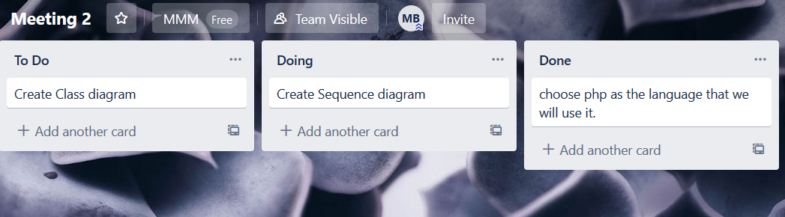

**Day 3 :**

**Done requirements**

**- Mohamed Bakr : Class Diagram.**

**- Mohamed Sameh : Sequence Diagram.**

**What will be done**

**- Mohamed Mohsen : create Data base using mysql and connect it with PHP.**

**Current obstacles**

**- no obstacles.**

**Current Trello workspace**

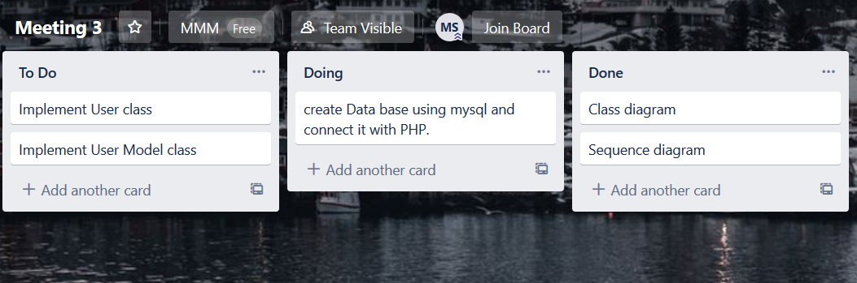

**Day 4 :**

**Done requirements**

**- Mohamed Mohsen : create Data base using mysql and connect it with PHP**

**- Mohamed Sameh : user Class.**

**What will be done**

**- Mohamed Mohsen : UserModel Class.**

**Current obstacles**

**- How to return 2D array which contains the data that will be get from data base.**

**Current Trello workspace**

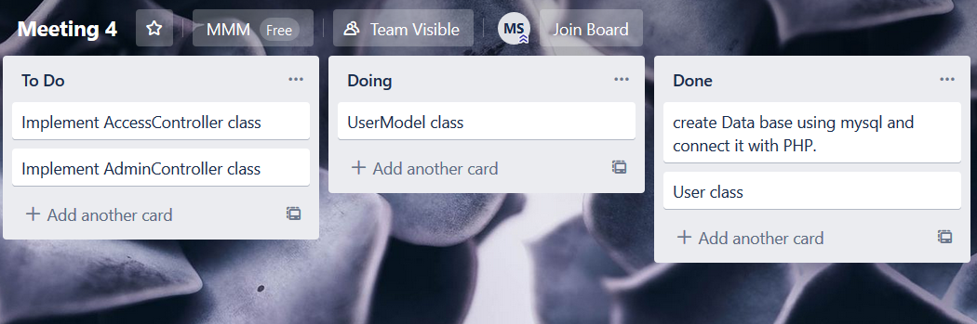

**Day 5 :**

**Done requirements**

**- Mohamed Mohsen : UserModel Class.**

**- Mohamed Bakr : AdminController Class.**

**What will be done**

**- Mohamed Mohsen : AccessController Class.**

**Current obstacles**

**- How to call a certain function based on URL.**

**- How to make ( if the url as example is localhost/onlinestore/register) calls function makeRegister() which is in a certain class in my code and if its localhost/onlinestore/signup calls function signup() which is in another class in my code without creating a file named regsiter.php & signUp.php**

**Current Trello workspace**

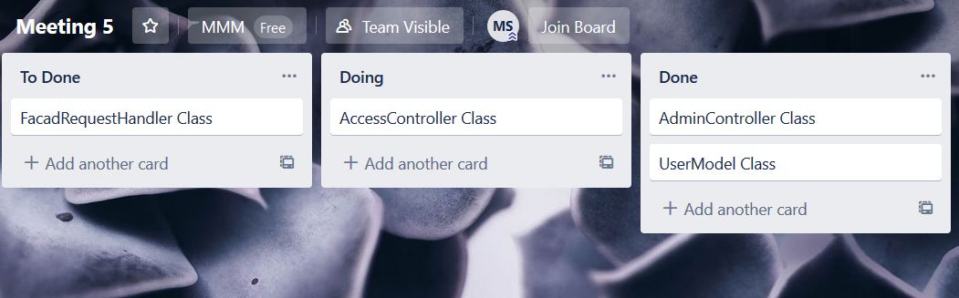

**Day 6 :**

**Done requirements**

**- Mohamed Mohsen : AccessController Class.**

**- Mohamed Bakr : FacadRequestHandler Class.**

**- All Team : Download postman and test our web services.**

**Current obstacles**

**- no obstacles.**

**Current Trello workspace**

