
ANALYTICS CAREER CONNECT

Name- Mohita Bamola

Data Analyst Internship – Assessment Task 1
REAL-TIME RESEARCH AND ANALYSIS OF SCAMS IN THE EDUCATION & IT SECTOR
Education • EdTech/Course Selling • IT Recruitment
Prepared as a public-source research report
28 August 2026

Summary
This report presents a structured public-source analysis of scams and misleading practices affecting students, learners and job seekers across education, EdTech/course-selling and IT recruitment. The working dataset contains 51 records collected from official regulatory sources and publicly reported news/case reports as of 28 August 2026.
The strongest evidence in the sample comes from regulatory action by the University Grants Commission (UGC) and the Central Consumer Protection Authority (CCPA), supplemented by police-reported and news-documented recruitment cases. UGC’s February 2026 list identifies 32 institutions in the extracted list as fake universities. CCPA reporting shows sustained enforcement against misleading coaching advertisements, including penalties against multiple coaching institutes in 2025–2026.
Across recruitment cases, repeated red flags include upfront payments, fake or impersonated employers, informal messaging channels, escalating payment demands, forged documents, and unrealistic earnings or salary promises. In the education/coaching sample, concealment of the exact course taken by successful candidates is a recurring regulatory concern.
The central analytical conclusion is that scams often combine credibility signals with pressure: a known brand name, government-style branding, a professional-looking offer letter, a successful-candidate photograph, or a convincing recruiter profile is paired with urgency, payment requests or incomplete information. Verification should therefore focus on evidence rather than presentation quality.

Introduction & Context
What is a “scam” in the context of education and IT jobs?
In the context of education and IT employment, a scam is treated broadly as a deceptive or fraudulent practice in which individuals are misled about an educational opportunity, course, qualification, internship, job, salary, employer or recruitment process in order to obtain money, personal information, unpaid work, or other benefits.
In the education sector, scams can include fake or unrecognized universities, invalid qualifications, misleading placement claims, exaggerated course outcomes, fake testimonials and advertisements that do not clearly disclose important information. The University Grants Commission (UGC), for example, maintains an official list of institutions identified as fake universities; its current list is stated to be as of February 2026.
In IT and recruitment, scams commonly involve fake job offers, impersonation of recruiters or companies, requests for registration/training/security fees, fake interviews or offer letters, and work-from-home schemes that require victims to make payments. India's National Cyber Crime Reporting Portal currently carries advisories about fraudulent job schemes, including fake CAPTCHA-filling jobs and fake job rackets targeting Indian youth.
A useful distinction is that not every poor-quality course or unsuccessful job experience is automatically a scam. For this research, the focus is on deceptive practices, fraudulent representations, impersonation, unauthorized institutions and publicly reported or officially identified cases.

Why are such scams increasing, especially in the digital and social-media era?
Several factors have made education and employment scams easier to conduct and scale.

Easy access to large numbers of potential victims
- Easy impersonation
- High demand for jobs and career oriented courses
- Digital payments make collection easier
- Fake credibility can be created quickly
- Social proof and viral content

Brief overview of the problem in India
India faces scam risks across both education and employment.

Education
The existence of fake or unrecognized institutions remains a documented issue. UGC maintains a state-wise list of fake universities and publishes related notices to state authorities. The February 2026 UGC list demonstrates that the issue is not limited to one state or region.
The problem also extends beyond completely fake institutions. Misleading advertising by coaching/course providers can involve the presentation of successful candidates, course outcomes or results without sufficient disclosure. This is important for the EdTech portion of this research because misleading marketing can influence students to purchase expensive courses based on incomplete information.

IT and recruitment
India's National Cyber Crime Reporting Portal has issued specific advisories concerning fake job schemes. In April 2025, it warned about a rise in fraudulent CAPTCHA-filling job scams, while another advisory warned about fake job rackets targeting Indian youth.
The Indian Cyber Crime Coordination Centre also maintains a database of reported cybercrime identifiers, while explicitly warning that the database is based on public complaints and does not certify that every complaint is authentic. This is an important methodological point for this assignment: publicly reported complaints should not automatically be treated as proven scams.

2. Education-System Scams
A major verified risk in higher education is the existence of institutions that are not recognized as universities under the applicable framework. UGC maintains a dedicated list of fake universities and advises students to verify the authenticity of higher educational institutions before admission.
The UGC list accessed for this research is marked as being current as of February 2026. The extracted list used in this dataset contains 32 institutions across multiple states and Union Territories, including Delhi, Uttar Pradesh, Karnataka, Kerala, Maharashtra and West Bengal.
The analytical lesson is that students should not rely only on an institution’s name, website, physical address or advertising. Recognition and regulatory status should be independently verified through the relevant official authority before paying admission or course fees.
- Verify the institution through UGC and the relevant statutory/regulatory body.
- Check the exact programme and approval status rather than assuming that an institution’s name proves recognition.
- Treat unusually broad claims about government recognition, international status or guaranteed career outcomes as verification triggers.
Source: UGC’s official HEIs Violating Regulations / Fake Universities page. citeturn0search0

3. EdTech & Course-Selling Scams / Misleading Practices
The strongest evidence in the EdTech/course-selling portion of this study comes from CCPA enforcement. The regulatory has repeatedly acted against coaching advertisements where material information about successful candidates’ courses was concealed or where claims were considered misleading.
In January 2025, CCPA imposed a ₹3 lakh penalty on Vision IAS regarding advertising of UPSC CSE 2020 results. The authority said the specific course information had been concealed, creating a misleading impression about course success.
In February 2025, CCPA imposed a ₹3 lakh penalty on IITian’s Prashikshan Kendra for misleading IIT-JEE result claims. 
In November 2025, CCPA imposed ₹8 lakh penalties each on Dikshant IAS and Abhimanu IAS after representations concerning the use of successful candidates’ names and photographs without consent in advertisements claiming credit for results.
In December 2025, CCPA imposed an ₹11 lakh penalty on Vision IAS concerning misleading advertisements for UPSC CSE 2022 and 2023.
In February 2026, CCPA imposed a ₹15 lakh penalty on Vajirao & Reddy Institute. The authority said successful candidates were advertised in a way that did not sufficiently disclose the specific programme they had actually used.
In May 2026, CCPA imposed penalties on Motion Education and Career Line Coaching for misleading advertisements and unfair trade practices, and stated that more than 60 notices had been issued and penalties exceeding ₹1.39 crore imposed on 31 coaching institutes at that point.
In May 2026, CCPA also imposed a ₹7 lakh penalty on Vajiram and Ravi IAS Study Centre, citing concealment of the nature of courses attended by successful candidates.
These cases demonstrate an important distinction: a course provider can be a legitimate business while still being found by a regulator to have used a particular misleading advertisement. The analysis therefore focuses on the practice and regulatory finding, not on generalized claims about an entire organization.

4. IT & Company-Related Scams
Recruitment scams typically exploit the urgency and emotional importance of employment. A common structure is: attractive vacancy → apparently credible recruiter → selection or interview → payment request → additional payment demands → no genuine job.
A March 2025 Delhi police case involved a fake call-centre operation in which a complainant was approached as if representing a reputed bank, directed toward an online course and asked for money under the guise of training. Police arrested suspects in the case.
In March 2025, a reported WhatsApp job scam involved a fake work-from-home scheme and a claimed loss of ₹1.2 lakh. The reported pattern included a supposed HR representative, high earnings and task-based work.
In April 2025, a Thiruvananthapuram case involved an alleged fake IRS officer, a forged offer letter and a promised government job; the reported loss was ₹21 lakh.
In December 2025, police reported a fake Archaeological Survey of India recruitment website that replicated government branding and allegedly attracted aspirants through social media, college groups and online forums.
In July 2026, an Indore student reportedly lost nearly ₹44,000 after repeated payments were demanded during a fake data-entry recruitment process, including selection, service and GST charges.
In July 2026, Noida police reportedly busted an alleged fake call centre that promised airline jobs and charged fraudulent recruitment fees.
In August 2026, a Bengaluru work-from-home case reportedly involved Telegram contact, fake prepaid-order tasks and escalating payments, with a reported loss of ₹44.8 lakh.
A separate August 2026 report described a Trichy victim losing ₹1 lakh after being promised airport ground-staff employment.

5. Data Collection & Methodology
Research date: 28 August 2026. The collection approach was manual public-source research followed by structured extraction into Excel. The dataset combines three evidence groups: official UGC listings, official PIB/CCPA regulatory actions, and publicly reported recruitment/job cases.
- Primary official sources: UGC and PIB/CCPA.
- Secondary reporting: Indian Express, Hindustan Times, Mint, Times of India and New Indian Express.
- Each record contains a source URL and a short evidence description.
- Organization names are included only where the source provides a public, attributable record.
- No private personal data was collected.
- Cases based on reports are described as reported cases rather than independently proven findings.
The final dataset contains 51 records: 32 UGC fake-university records, 8 EdTech/coaching regulatory records and 11 IT/recruitment records. This is a structured research sample, not a statistical estimate of the true prevalence of scams.

6. Data Cleaning & Categorization
The raw information came in different formats: regulator lists, press releases and narrative news articles. To make it analytically usable, the following fields were standardized: sector, scam type, platform, target group, red flag and verification status.
- Sector values were standardized to Education, EdTech/Course Selling and IT/Recruitment.
- Scam descriptions were converted into consistent analytical categories.
- Red flags were normalized so that similar behaviors could be counted together.
- Source type distinguishes official regulatory information from news reporting.
- Duplicate URLs were checked at the source level; records were retained when they represented distinct cases or regulatory actions.
A key limitation is source composition. The sample contains many official/regulatory records, so platform frequency should not be interpreted as a measure of where scams are most prevalent. It measures where the collected documented cases came from.

7. Data Analysis & Dashboard
The accompanying Excel workbook contains the cleaned dataset, a summary sheet and methodology with charts. The dataset contains 51 records.
The report is designed around five questions: What sectors dominate the sample? Which scam types recur? Which source/platform families contribute most records? Which red flags recur? How do dated records vary over time?
Sector finding: Education (32); IT/Recruitment (11); EdTech/Course Selling (8)
Scam type finding: Fake/Unrecognized Institution (32); Misleading result advertising (5); Misleading advertising / unfair trade practice (3); Fake job + training fee (1); Fake work-from-home/task job (1)
Platform finding: UGC Official (32); PIB/CCPA (8); Times of India (4); Indian Express (3); Hindustan Times (2)
The most important analytical caution is that counts represent the research sample. They are not presented as national incidence rates. A high count reflects easier access to official documentation, not necessarily higher real-world prevalence.

8. Case Studies

Case Study A – Fake government recruitment
A reported Kerala case involved a person allegedly impersonating an IRS officer, a forged offer letter and a promised government job. The reported victim paid ₹21 lakh before discovering the position did not exist. The case illustrates personation, forged documentation and the credibility of government employment as a lure.

Case Study B – Fake airline recruitment
In July 2026, police reportedly busted an alleged Noida call centre that promised airline jobs and collected fraudulent recruitment fees. The case illustrates how a recognizable employer/industry brand can be used to make a fake vacancy appear credible.

Case Study C – Fake internship using IIT identity
IIT Bhubaneswar issued a public advisory about a fraudulent internship scheme circulated through WhatsApp and other channels that falsely used the institute’s name. The institute warned people not to pay fees or share personal information.

Case Study D – Misleading coaching-result advertising
CCPA’s actions against coaching providers show that misleadingness can arise not only from outright fake institutions but also from incomplete disclosure. Successful candidates’ names or results may be presented without adequately identifying the course they actually attended.

9. Impact on Students & Job Seekers
Financial impact can be immediate and severe. The public cases in the dataset include reported losses ranging from tens of thousands of rupees to several lakh. In recruitment scams, losses may grow because victims are repeatedly told that another payment will unlock the next stage or refund previous amounts.
Career impact is less visible but important. A candidate can lose weeks or months following a false opportunity, delay genuine applications, or receive no meaningful experience after paying for a supposed internship or training programme.
Emotional impact can include embarrassment, anxiety, frustration and loss of confidence. Public reporting around task-based scams has also shown that severe financial pressure can be associated with serious personal distress; the report therefore treats emotional harm as a genuine risk rather than a secondary issue.

10. Red Flags & Warning Signs
- Upfront payment for a job, interview, selection, registration or training.
- Requests to pay through personal accounts or informal channels.
- Unrealistic salary, earnings or guaranteed-selection promises.
- Pressure to act immediately or lose the opportunity.
- Recruiter communication only through WhatsApp/Telegram or a private email address.
- Fake government or company logos, websites or offer letters.
- Repeated payment requests under new labels such as GST, verification, service or refundable deposit.
- Course advertisements that display success numbers without clearly explaining the exact programme or service used by successful candidates.
- No verifiable company domain, office information or independent confirmation.

11. Recommendations & Solutions

For students and job seekers
- Verify the vacancy independently using the employer’s official website and careers page.
- Never treat a professional-looking PDF, logo or LinkedIn profile as proof of authenticity.
- Do not pay a recruiter simply because payment is described as refundable.
- Cross-check the recruiter through an official company contact channel.
- Search for the organization plus terms such as 'scam', 'fraud', 'complaint' and 'official warning'.
- Before joining an educational institution, verify recognition through the appropriate regulator.

For companies
- Publish official recruitment channels and warn candidates about impersonation.
- Monitor social platforms for fake recruiters and fake vacancies.
- Use verifiable corporate email addresses and standardized offer-letter verification.
- Provide clear policies stating whether any candidate payment is ever required.

For platforms and regulators
- Improve identity verification for recruiters and education advertisers.
- Make reporting and escalation mechanisms easier to find.
- Require evidence for large placement/result claims.
- Promote standardized disclosures showing the exact course/service associated with success claims.
- Maintain searchable public warning databases.

12. Conclusion & Analytical Insights
The research indicates that education and employment scams are not defined by one single tactic. Instead, they repeatedly combine credibility, aspiration and pressure. In education, the credibility signal may be a university-style name or a successful candidate’s result. In recruitment, it may be a known employer, government identity or polished offer letter. The pressure component is often an immediate payment, an unrealistic opportunity or a deadline.
The strongest practical insight is therefore to separate 'appearance of legitimacy' from 'evidence of legitimacy'. Students should verify recognition and programme details. Job seekers should verify employers, recruiters and payment requests. Course buyers should demand transparent outcome data rather than relying on headline success numbers.
The dashboard and dataset accompanying this report demonstrate the analytical workflow requested by the assignment: public-source collection, structured categorization, cleaning, descriptive analysis and visual presentation.

References
UGC – HEIs Violating Regulations / Fake Universities — https://www.ugc.gov.in/universitydetails/HEIs_Violating_Regulations?tab=fakeuni
PIB/CCPA – Vision IAS, January 2025 — https://www.pib.gov.in/PressReleasePage.aspx?PRID=2096067
PIB/CCPA – IITPK, February 2025 — https://www.pib.gov.in/PressReleaseIframePage.aspx?PRID=2103128
PIB/CCPA – Dikshant IAS and Abhimanu IAS, November 2025 — https://www.pib.gov.in/PressReleasePage.aspx?PRID=2185094
PIB/CCPA – Vision IAS, December 2025 — https://www.pib.gov.in/PressReleasePage.aspx?PRID=2208482
PIB/CCPA – Vajirao & Reddy, February 2026 — https://www.pib.gov.in/PressReleasePage.aspx?PRID=2231796
PIB/CCPA – Motion Education and Career Line Coaching, May 2026 — https://www.pib.gov.in/PressReleasePage.aspx?PRID=2261329
PIB/CCPA – Vajiram and Ravi, May 2026 — https://www.pib.gov.in/PressReleasePage.aspx?PRID=2266932
Indian Express – Job scam red flags, May 2025 — https://indianexpress.com/article/technology/job-scams-key-red-flags-to-watch-out-for-before-you-apply-9978644/
Indian Express – Telegram/WhatsApp task scams, July 2025 — https://indianexpress.com/article/technology/online-task-scam-fake-job-offers-on-telegram-whatsapp-groups-10149116/
New Indian Express – Delhi fake call-centre case, March 2025 — https://www.newindianexpress.com/cities/delhi/2025/Mar/12/delhi-police-bust-fake-call-centre-18-people-arrested-for-cheating-job-seekers
Hindustan Times – WhatsApp job scam, March 2025 — https://www.hindustantimes.com/trending/whatsapp-job-scam-man-loses-1-2-lakh-after-falling-for-fake-work-from-home-scheme-101742549610270.html
Times of India – Kerala fake job case, April 2025 — https://timesofindia.indiatimes.com/city/thiruvananthapuram/job-scam-man-duped-of-21-lakh/articleshow/119916669.cms
Indian Express – Fake ASI recruitment, December 2025 — https://indianexpress.com/article/cities/delhi/a-fake-asi-website-and-an-entrance-exam-how-a-job-con-was-attempted-10431359/
Times of India – Indore fake job offer, July 2026 — https://timesofindia.indiatimes.com/city/indore/fake-job-offer-student-duped-of-rs-44000-in-online-scam/articleshow/132186707.cms
Indian Express – Fake SpiceJet recruitment, July 2026 — https://indianexpress.com/article/delhi/noida-police-bust-fake-spicejet-job-racket-operation-cyber-vajra-10786089/
Times of India – Bengaluru work-from-home task scam, August 2026 — https://timesofindia.indiatimes.com/city/bengaluru/fake-work-from-home-task-leaves-bengaluru-man-poorer-by-rs-44-8-lakh/articleshow/133407383.cms
Times of India – Trichy airport job scam, August 2026 — https://timesofindia.indiatimes.com/city/trichy/trichy-man-loses-rs-1-lakh-in-fake-airport-job-scam/articleshow/133549287.cms
Hindustan Times – Pune IT placement scam report, June 2026 — https://www.hindustantimes.com/cities/pune-news/it-grads-trapped-in-pune-job-scam-company-agent-nexus-exposed-101781120064117.html
IIT Bhubaneswar – Fake internship advisory — https://www.iitbbs.ac.in/index.php/public-advisory-fake-internship-scheme-misusing-iit-bhubaneswars-name/

Dashboard Screenshots
The following visuals are included inside the report to satisfy the dashboard screenshot requirement.

Figure 1 – Cases by Sector

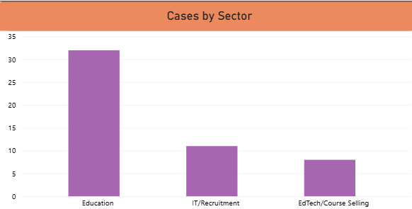

Figure 2 – Types of Scams vs Frequency

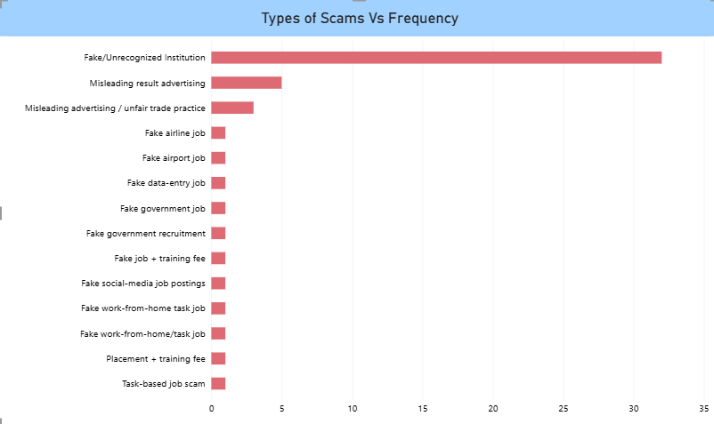

Figure 3 – Platform wise Complaint

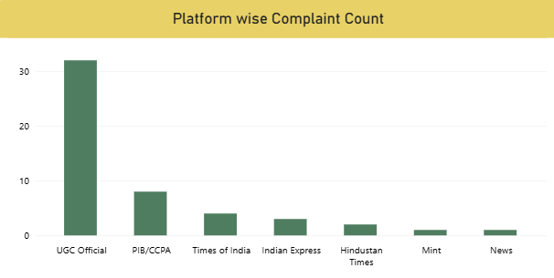

Figure 4 – Most Common Red Flags

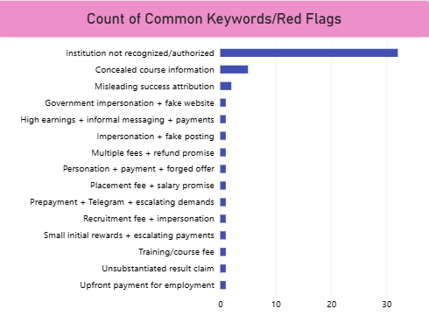

Figure 5 – Cases Over Time (Dated Records)

