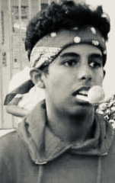

Mohammed Basahel / 9398389893 / gmail@yahoo.com

# About me

I am a curious person. I have questioned everything around me and that led to my love for physics and math. I love soccer as i watch is eveveryday.

# Academic Backround

**American curruculum   
Jeddah International School** 2018-2021

# Extracurricular

I worked for a store:  
I learnt how to be dicipline. I also learnt how to increase my toliration with other people. I had a lot of fun because it was a learnning experience more than me trying to make money.  
Captain :  
I was the captain for my class soccer team. I decided who was playing and in what position. I needed to be stubborn because of the type of people we had that were tough and fight a lot.

# Skills

* Leadership
* Critical-Thinking
* Self-Motivation