Foundational Graphing Support
For Session 5 — Next Chapter @ Smith Public Library
Optional extra grounding — no pressure, just a head start if graphs feel unfamiliar
Use this however it helps you: read through it before Session 5, work through it quietly during independent practice time, or bring it to Thursday office hours. There's no wrong way to use this.

Part 1: What Is a Graph, Really?
Think of a graph like a treasure map. Every point has directions: how far to go sideways, and how far to go up or down.
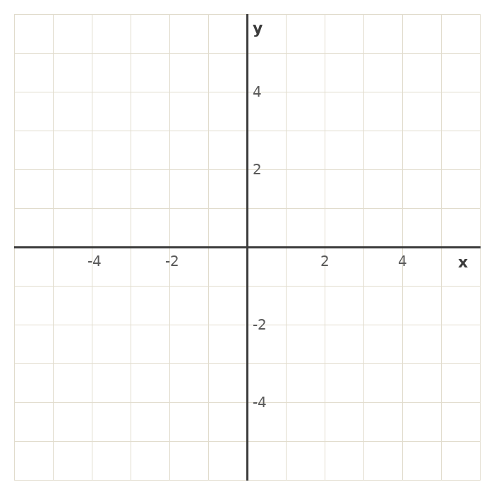
The flat line going left-right is the x-axis. The line going up-down is the y-axis. They cross at a spot called the origin — that's (0, 0), where every direction starts from.

Part 2: Plotting Points, Step by Step
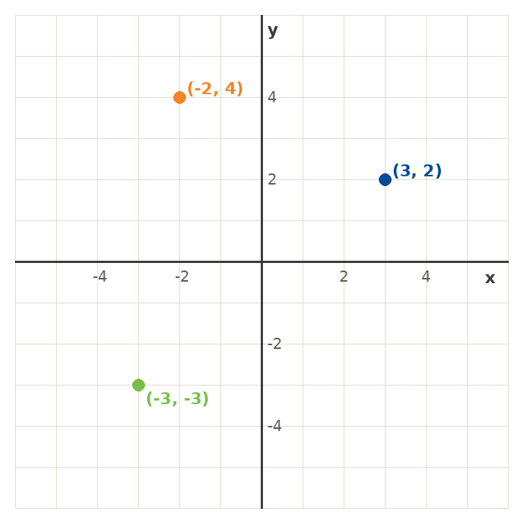
A point like (3, 2) is really just two directions in order:

Step 1: The first number (x) — go sideways
3 means go 3 steps to the RIGHT. A negative number would mean go LEFT instead.

Step 2: The second number (y) — go up or down
2 means go 2 steps UP. A negative number would mean go DOWN instead.
Memory trick: x comes before y in the alphabet, and sideways comes before up/down when you plot a point. “Over, then up.”

Part 3: What Is Slope, Really?
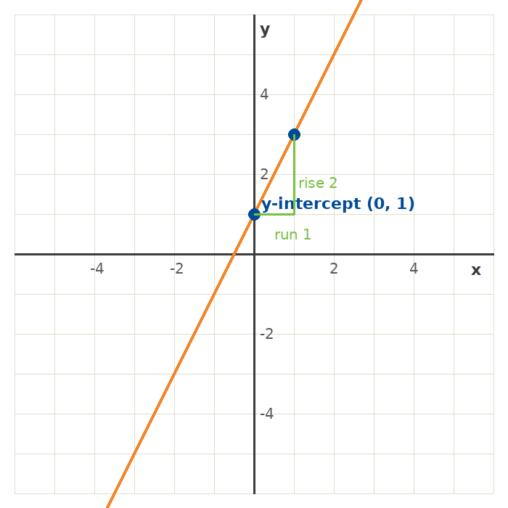
Slope just means: how steep is the hill? Think of it like climbing stairs — for every step you take sideways, how many steps do you go up?
That's why slope is sometimes called “rise over run” — rise is how far up, run is how far sideways.
A bigger slope number = a steeper line. A slope of 0 is flat. A negative slope means the line goes downhill instead of uphill.
To find slope from two points, subtract the y-values to get the rise, subtract the x-values to get the run, then divide. Rise ÷ run. Always subtract in the same order on top and bottom.

Part 4: Warm-Up Problems — Easy Numbers First
Same skills as tonight's class, with friendlier numbers. Try these first if the main practice set feels too fast.

Coordinates
Problem | Answer
A point is 2 right and 1 up from the origin. What are its coordinates? | (2, 1)
A point is 4 right and 3 up from the origin. What are its coordinates? | (4, 3)

Finding Points on a Line
Problem | Answer
For y = x + 1, what is y when x = 1? | y = 2
For y = x + 1, what is the y-intercept? | 1 (set x=0: y=0+1=1)

Slope & Intercept
Problem | Answer
What is the slope of y = 3x + 2? | 3 (the number times x)
What is the y-intercept of y = 3x + 2? | 2 (the number added at the end)

Slope from Two Points
Problem | Answer
Find the slope between (0, 0) and (2, 4). | 2 (4 ÷ 2)
Find the slope between (1, 1) and (3, 5). | 2 (rise 4 ÷ run 2)
A plant is 2 inches tall in week 1 and 6 inches tall in week 3. What is its growth rate? | 2 inches per week (4 ÷ 2)

Where to Go From Here
- If these felt good — you're ready for tonight's main practice set. Go for it.
- If graphs still feel unfamiliar — that's exactly what Thursday office hours are for. Bring this sheet and we'll work through it together.
- Either way, you're not behind. Reading a graph is a skill, not a talent — it gets easier every time you do it.

